THE BEGINNING DESIGN PHASE

1.Now that we have the plot drawing done to scale, it is time to identify the primary areas on the lot. These areas may not always stay in a specific place as the space or our needs will not allow it.

a. Place a sheet of tracing paper over your plot
plan and try to determine the primary public, private, and service areas. These drawings are referred to as bubble
diagrams.

2.PUBLIC AREA
a. This area usually identifies the main entrances and exits from the house. In most cases this is the front side of the home
and the area that most people will see first.

b. Due to curb appeal ( which could have an impact on a future sale ) and the fact that we only have a chance to make a first impression once, we should pay close attention to this area.

c. We can make the entry into the house as inviting and attractive as possible.

d. The walk to the front door should be a minimum of 4'
wide, often times wider. It is best if constructed out of one material so the eye is led to the door easily. The walk needs to
be well lit, not only for guests, and family, but as a crime deterrent as well.

e. We will want to keep most plant material in this area from encroaching on the walk. It is always nice to have an entry that will allow people enough area to stand out of the weather as they wait for the door to be answered.

f. If we have different elevations, consider giving people plenty of room to stand by the front door and make sure that all steps are well lit.

g. All the plantings in this area need to complement the
architectural features of the house. The lawn or lawn substitute areas should be open and in most cases can be designed
in a way that will help lead the eye to the entry.

h. If possible try to make it obvious where you would like your guests to park.

3.THE PRIVATE AREA
a. The private area is usually considered the outdoor living area of the home and should keep in mind corresponding indoor living areas such as the living room, family room, dining room, kitchen, master bedroom, etc.

b. To make this a more inviting private place to be, we will probably want to add some screening from the neighbors and street.

c. Based on the answers to the questionnaire, you will design the size and shape of these areas according to your needs.

d. Here we will consider the patio, deck or additional sitting areas. Always allow plenty of seating or table room for the type of entertaining you do.

e. We also want to consider the need for sun areas, shade areas, or wind protection.

f. It should tie into the access from the house, and not block the view from the house, but rather create an invitation to move outdoors and explore further.

g. We want to provide good access to the lawn and garden areas. Based on our needs and aesthetics here is where we will decide on the lawn area(s).

h. Children's play areas will be added here as needed, and for safety we will want to consider the ability to view this area from the house.

i. Pathways and walks will need to be added for access or interest.

j. Colorful plants and sculptural garden features can be used to create interest and a pleasant atmosphere.

k. We should think through our questionnaire and try to allow for the future, as the needs of the household may change and we will need to be flexible.

l. Most hardscape items should still be thought of as permanent additions.

4. THE SERVICE AREA

a. The service area is usually where we contain the items of delivery and maintenance of the house and landscape. It is usually found in the rear or side of the property.

b. It usually will coincide with the utility areas of the house, the kitchen, garage and garbage.

c. Most often this area is screened from the public and private areas.

d. Items found in the service area: storage buildings, garbage cans, vehicles, boats, clothes lines, wood storage, utility meters, fuel storage, heating /cooling equipment, dog kennels, delivery area, vegetable garden, potting shed, compost bins, and cleaning equipment.
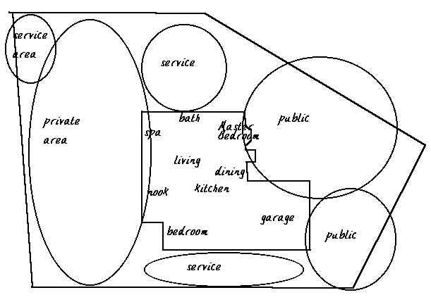
DESIGN PRINCIPLES

As we start our planning we should keep a few basic design principles in mind. We will, through careful planning, want to improve on the good, bad, and the ugly, logically to create a wonderful garden area. Most professional designers, after years of practice, will apply these principles automatically. The following is a list of a few basics.

UNITY: This is probably the most important area for the overall plan. A good plan will have unity in all things. This is where we look for all parts to interrelate with each other and also relate to the overall plan.

SCALE AND PROPORTION: Here we should keep all individual elements in proportion (in regard to size) with the rest of our garden and in scale as it relates to the structures, property, and the human elements.

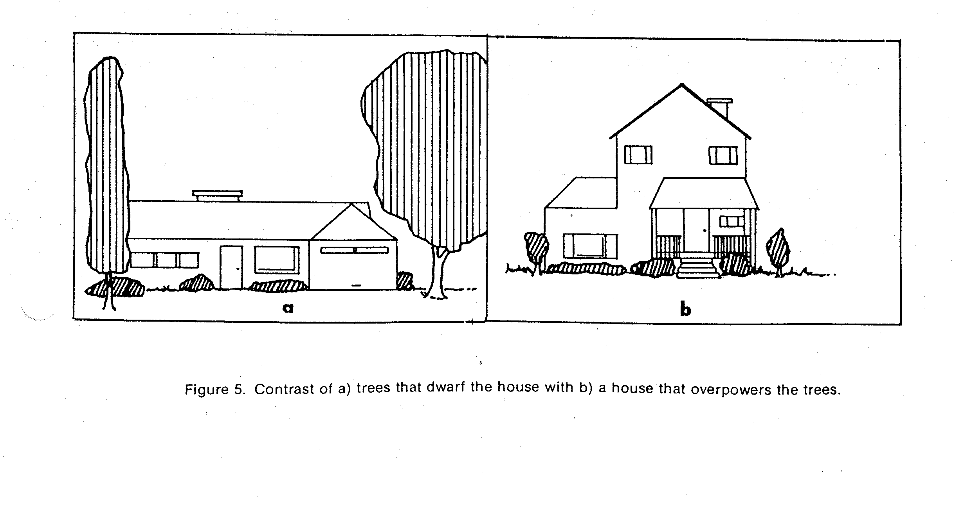

BALANCE: This area is very important as it could throw off the entire plan. It is how we relate visually to the various relationships between the landscape elements. If not careful we will create unbalanced and restless areas.

Symmetry is an equal balance where both sides of the view are the same. This would normally be used in a formal garden setting. In most cases the architectural elements are not symmetrical and we could cause unbalance using symmetry when viewing the house.

Asymmetry is an unequal balance where both sides of the view are different although weighted the same. If our eye is attracted equally to both sides of the view although different, we have balance.

FOCAL AREAS: Here we can select various plant or structural elements to accent a given area. An example would be the front of the house where the entry or front door would be our focal area. The entire plantings or hardscape material placement should be done so we are attracted to the front door. We can also use focal points to emphasis or create a view as well as accent a certain location in the garden. In most formal gardens the focal point will be at the end of an axis. Informal gardens may have focal points at various locations. Care must be used here as it is easy to create too many focal
points that instead of interest in a particular area we will allow our eyes to be distracted and jump around all over our garden areas.

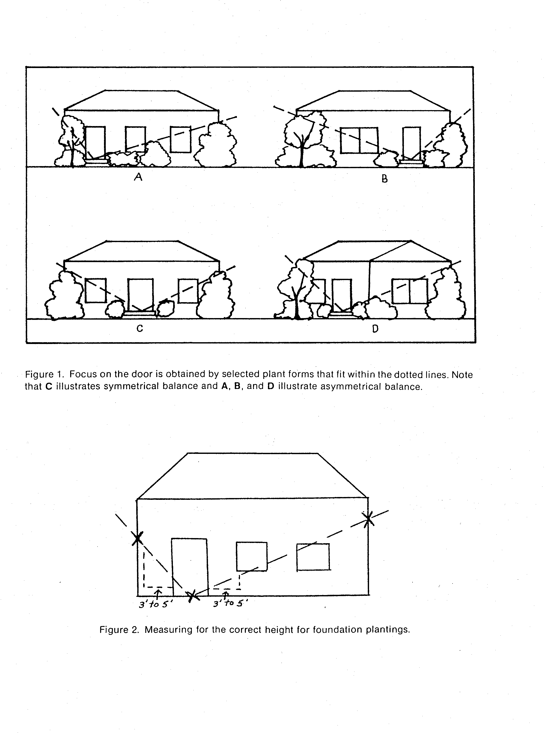
RHYTHM AND LINE: We will want to consider blending with harmony one element or area to another in a smooth fashion. We want all things to interrelate with each other and provide an uninterrupted connection within our plan. This can be done using gradual changes involving variety, textures, colors, form and sizes. Here the challenge is to keep the eye moving smoothly in rhythm from one area to another. In a formal garden this may be a small hedge on both sides of a walk, leading you to another area. Informal areas or flower border plantings will have a variety of heights that flow up and
down across the area or create well-blended shapes, textures, and colors. One of the most common ways to achieve this is with the duplication of plant material through out our plan. If we only plant one of everything we usually will lack continuity and the area will appear jumbled.

Lawns and pathways should be done with strong long curves (rather than
many small curves), and straight or diagonal lines to accent the space.
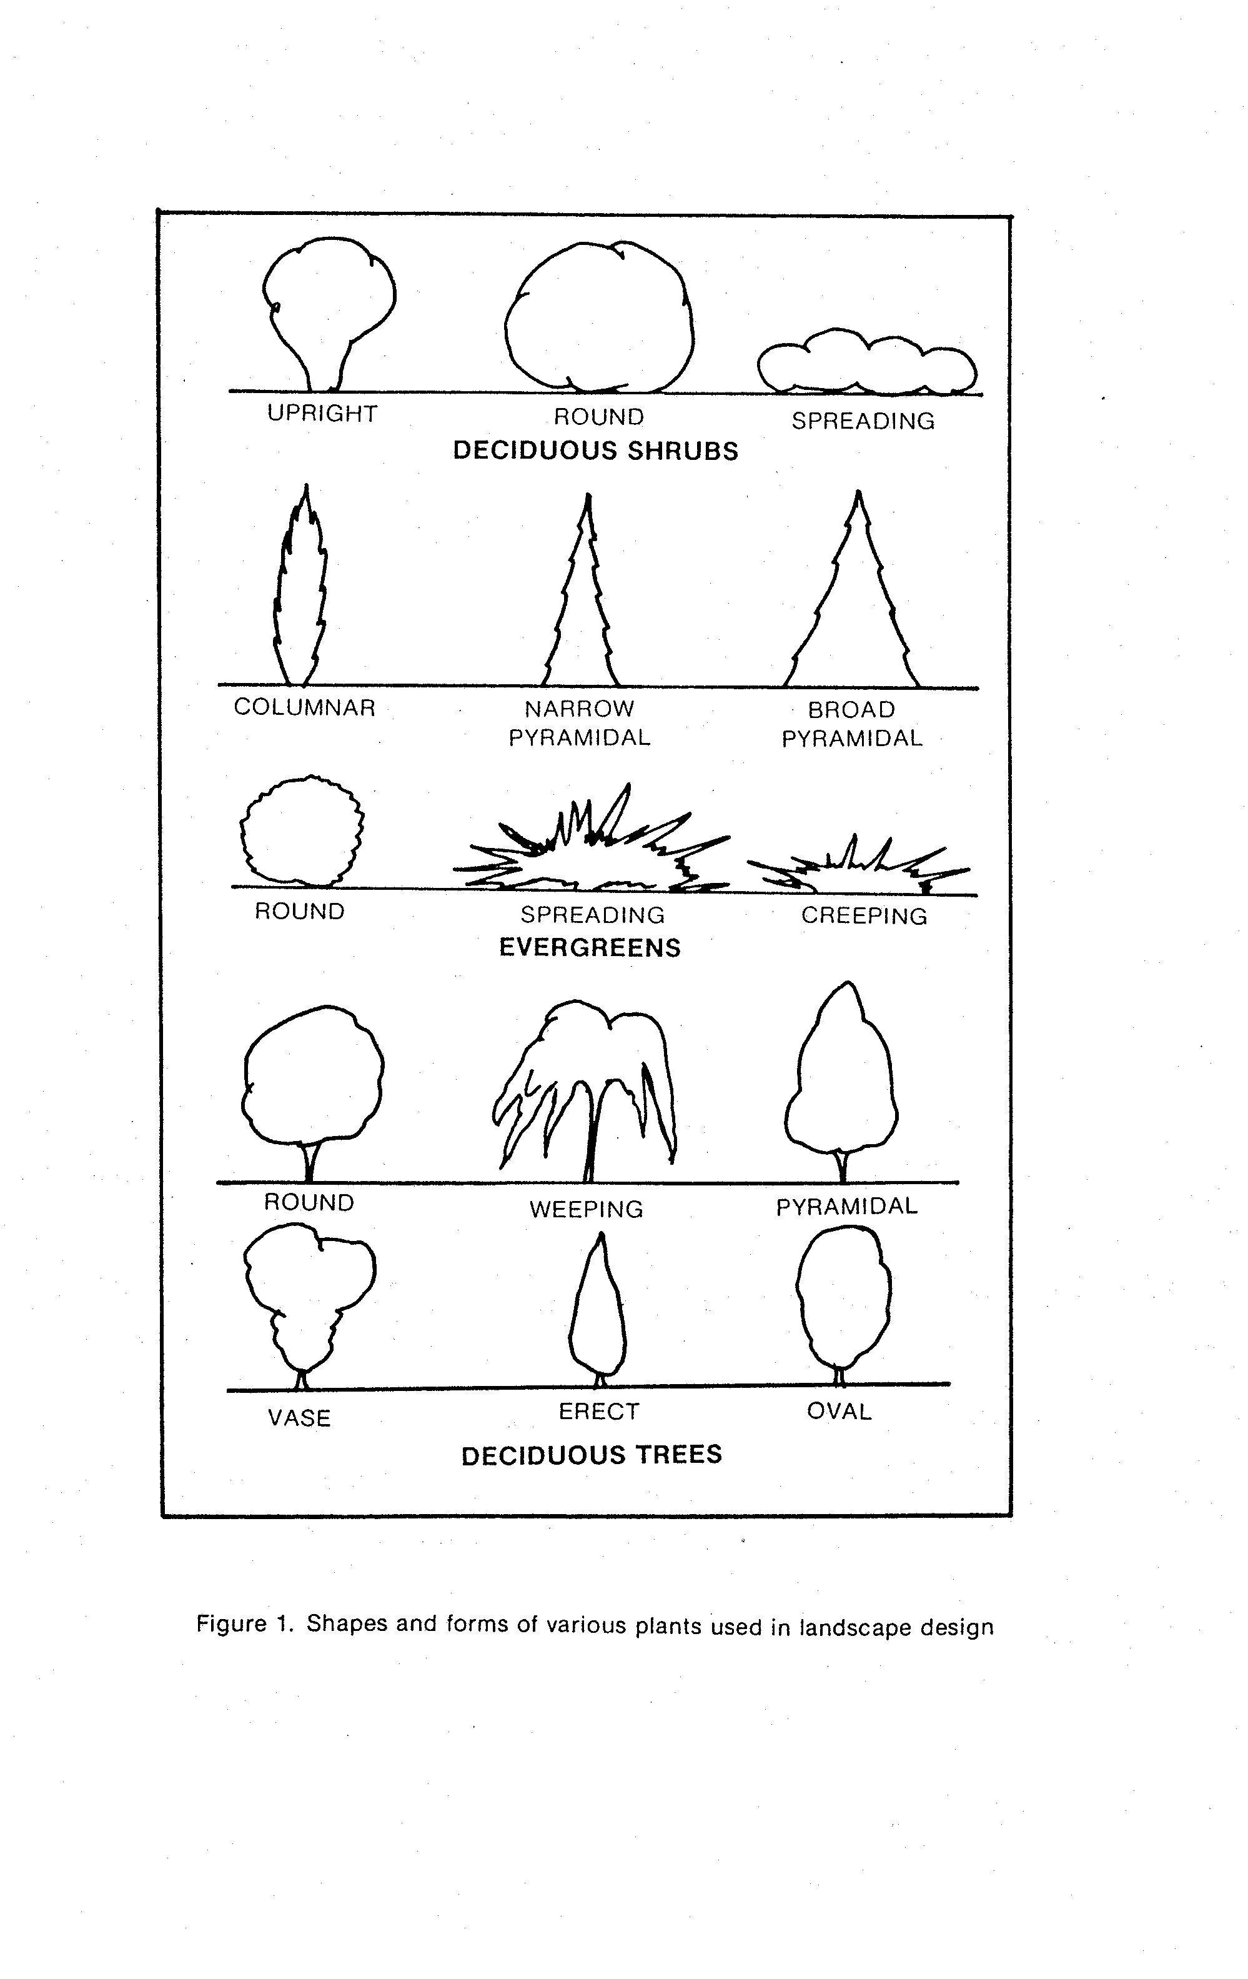
Design Concepts

In designing a landscape, consider the site inventory and analysis, the style of
architecture, and the family's personal landscape requirements. The objective is to create good visual relationships between the features on the site and the site itself. Creating spaces is important in accomplishing this objective. The finished design should reflect the priorities set by your family to satisfy its aesthetic values and functional requirements.

Emphasize by Group Planting

Rhododendrons, azaleas, and dogwoods can be mass planted in informal beds
Try to locate the plants so that a natural scene is created as they mature. Plant the shrubs or trees together in one large bed and mulch well. Consider adding bulbs for seasonalcolor.

Provide Privacy

If the site analysis reflected a need to screen unsightly views, provide a noise barrier, or create privacy, plant evergreen shrubs or build a screening fence. If room and time allow, a natural evergreen hedge may be the answer. For immediate privacy and low maintenance, you might choose to build a fence.

Specimen Plants
In selecting plants consider quality, not quantity. The plants used should be of specimen quality. Locate plants where they will create focal points and draw attention to a special area.

Energy Conservation Through Landscaping

Locate deciduous trees where you will benefit from summer shade and winter sun. Use a windbreak if necessary. Combining these landscape ideas with proper insulation and conservation habits can significantly decrease energy consumption.

Construction Materials: Wood, Brick, and Railroad Ties

For many people, the term residential landscaping immediately brings to mind
dogwoods, azaleas, and Kentucky 31 fescue. In other words, they think of landscaping and planting as synonymous. But you can broaden your idea of landscaping to include screening walls, patios, outdoor lighting, walks, and decks. Landscape architects incorporate many of these items as important landscape features.

Wood construction offers the homeowner a readily available and relatively simple way to create functional, pleasing outdoor garden features. Selecting the proper kind of wood is important because the finished product must withstand all kinds of weather and insect attacks. The wood must also be strong and resist wear, splintering, and warping.

Use either the heartwood of a decay-resistant species or lumber that has been treated with a preservative for outdoor construction. The naturally
decay-resistant woods are redwood, cypress, and western red cedar. Various outdoor grades of these woods are available, although all are quite expensive.

Treated lumber is more economical and is satisfactory for most projects.
Pressure-treated wood is the best choice. This lumber must meet certain standards for various uses and is marked accordingly. Several yellow pine species native to the South are often used for treated lumber.

Waterborne salts are the best wood preservatives. Wood treated with these salts can be painted or stained; it is odorless and nonleaching. To eliminate any confusion, ask for "salt pressure-treated lumber." It is also a good idea to help select the various sizes and lengths. Try to find lumber that is not warped or splintered and that has the fewest knots.

When designing a structure to be built with treated lumber, try to use the entire board. Common lumber lengths are 8, 10, and 12 feet. Longer boards are progressively more expensive. A deck designed to be built with 10-foot lumber will be much less expensive than one designed with planks 10 feet 8 inches long. Also, remember that you are working with "outdoor scale." Instead of an 8-foot ceiling and walls 12 to 15 feet apart, outdoor spaces might be defined by a 25-foot tall tree canopy or the backyard fence 75 feet away.

If you are designing a deck or patio for outdoor entertaining, imagine all your guests in the allotted space. Outdoor furniture is usually heavier and larger than that used indoors, and people are accustomed to more elbow room outside. Stake off the space you plan to use and see if it "feels" the right size.
Brick is one of the easiest construction materials to use and is readily available. Building a walk, terrace, or patio can be a weekend project. Laying brick on sand (with or without mortar) is an acceptable landscape practice.

Railroad ties offer many possibilities for landscaping. They make very attractive retaining walls, planters, or borders. Use care to square off rough ends and turn down ragged edges.

The Edible Landscape

The term "edible landscape" will become quite familiar to many in
future years. An edible landscape challenges the home gardener to incorporate fruit- and vegetable-producing plants into the overall design. It is not necessary to substitute these plants for all ornamentals in the landscape. The idea is to progress from the typical backyard garden and develop a plan that uses edible plants to solve functional landscape problems.
For example, try planting fruit trees. No matter how small the space, there is some variety of apple, pear, cherry, peach, or plum that can be planted. Dwarf varieties generally reach a height of 6 to 10 feet and should bear fruit within three to four years. Semi-dwarf varieties grow to approximately 15 to 20 feet.

Instead of planting junipers, liriope, or cotoneaster, think about planting strawberries as a ground cover. An area with well-drained soil that receives at least 6 to 7 hours of direct sunlight will produce lush green foliage, spring blossoms, and early summer fruit. Be certain to choose a variety adapted to your area, and plant disease- and insect-free plants. Set individual plants 12 to 18 inches apart in the spring, allowing runners to develop and mass over the entire bed. Clean cultivation is essential. Strawberries are perennials, but their beds need to be renovated every three to four years.

Blueberry bushes are a good substitute for a ligustrum or burford holly hedge. The rabbiteye type is more widely adapted to different soils than are high-bush varieties. Acid soils (with a pH of 4.5 to 5.5) usually promote best growth. Modify soils by adding plenty of organic matter and by mulching with 4 to 6 inches of decayed sawdust. Two or more varieties should be planted to
ensure proper pollination. Plant the bushes in full sun about 4-1/2 to 5 feet apart.
Principles for home landscaping
1. When possible, situate the drive and walk together to avoid breaking up the front lawn area.

2. Use trees to frame the house and provide background. Don't block the front view of the house with them.

3. Locate play and utility areas where they don't detract from the home.

4. Don't overplant. Know the ultimate sizes of plants and allow for growth.

5. Use most plants in borders. The uninterrupted lawn gives a look of spaciousness and is easier to mow.

6. Balance the landscape. Do not have one area more heavily planted or more colorful than another.

7. Observe scale in planting. Large shrubs and trees may dwarf a small house.

8. Not everything in the landscape should have equal interest. Create a center of interest with specimen plants, pools or statuary.

9. Don't create a botanical collection, but bring a variety of texture into the landscape. Coarse textures are dominant and should be used sparingly.

10. Border plants may define property lines or provide privacy. They may be
combined with fences, screens or other structures.

11. Use small shrubs near the door, tapering to larger shrubs at the corners.

12. Hiding the entire front base with shrubs is not necessary in many homes.
Groundcovers may tie plantings together.

13. Plants with brightly colored leaves should be used very sparingly.

14. Select plants for year-round interest as well as suitability for the environment in which they will be planted.

