PDF File
5.3.1
Contents  - Selecting Plants  - Holding Plants Until They Are Planted  - Planting in Individual Holes  - Planting in Beds  - Planting Annuals and Herbaceous Perennials  - Staking and Guying Trees  - Trunk Wrapping | Soil Preparation and Planting Procedures for Ornamental Plants in the Landscape  Prepared by Gary Wade, Extension Horticulturist | 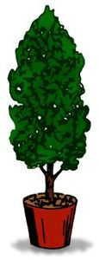
Proper planting is essential for healthy, vigorous growth of ornamental plants in the landscape. It assures rapid plant establishment by providing a favorable environment for the developing root system.
Planting involves more than merely digging a hole and sticking a plant in it. Careful consideration given to the preparation of the planting site, the time of year for best plant establishment and the handling requirements of different nursery stock will help you avoid problems later on.
This publication offers step-by-step guidelines that will ensure planting success.

Selecting Plants
Always purchase fresh, high quality plants. Poor quality plants are not a wise investment.
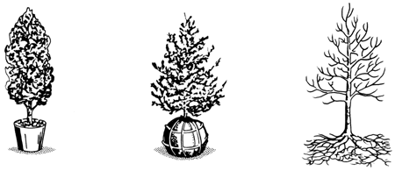
Figure 2. Woody ornamentals for the landscape are commonly sold three ways: container-grown (left), balled-and-burlapped (center), and bare-rooted (right).
Most ornamentals marketed today are grown and sold in containers, although field-grown plants, sold as balled-and-burlapped or packaged bare-root, are also available during certain times of the year. Container-grown plants should have healthy, vigorous tops and white feeder roots on the outer edge of the root ball. Do not be timid about inverting a few plants, removing the pot and examining the roots. Container-grown plants generally transplant well throughout most of the year with minimum shock, although fall and winter months are the best time to transplant.
Large trees and shrubs grown in the field are often sold as balled-and-burlapped plants. Because a large portion of the root system is destroyed during digging, they transplant best during the cooler months of the year (October through April). Some trees are grown and marketed in fabric bags. They can be transplanted throughout the year, but the fall and winter months are best.
Packaged bare-root plants should have plump, healthy stems and good root systems kept moist in a packing substance like sphagnum moss or wood shavings. The best planting time is from December to mid-March.

Holding Plants Until They Are Planted
If plants cannot be planted right away, place them in a shaded area and keep the roots moist. If balled-and-burlapped or bare-root plants must be held several days before planting, cover their roots with sawdust, pine straw or soil to conserve moisture. Avoid placing the roots in buckets or water for long periods of time. Container plants may need daily watering.
Make certain that the plants are well-watered before planting and that the root ball is thoroughly wet. A dry root ball is difficult to rewet after transplanting.
Planting in Individual Holes
The old adage "never put a ten-dollar tree in a two-dollar hole" applies when planting individual trees and shrubs. Research at the University of Georgia has shown that a large planting hole -- twice as wide as the root ball -- encourages rapid root growth and results in a larger, stronger plant. Dig the planting hole to the depth of the root ball and no deeper. If the hole is dug deeper, backfill with soil as necessary and tamp it firmly to prevent settling. Make certain the top of the root ball is level with the soil surface.
Research has also shown that it is not necessary to add organic amendments, such as peat moss, pine bark and leaf mold, to the soil. Simply backfill with the same soil removed from the hole after breaking apart any clods and removing stones or other debris.
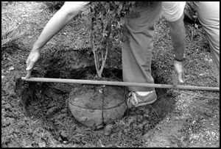 | 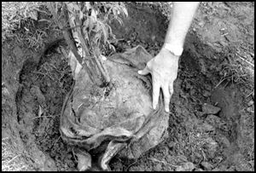
Figure 3. Dig the planting hole two times wider than the root ball of the plant. Make certain the top of the root ball is level with the soil surface. | Figure 4. This balled-and-burlapped plant, with the cord cut from around the trunk and the burlap pulled back, is ready for planting.
Before planting balled-and-burlapped plants, cut any wire or cord from around the trunk and pull back the burlap from the top third of the root ball. This will allow newly formed feeder roots to grow into the new environment. When planting on poorly drained soils, remove the burlap completely. When planting ornamentals grown in fabric bags, remove the entire bag before planting.
As the backfill soil is placed in the hole, water to eliminate air pockets. Use your hand, not you foot, to gently firm the soil around the roots. Water thoroughly when finished and water again several hours later.
Slow-release or liquid fertilizers can be added to the planting hole, but granular general-purpose fertilizers, such as 8-8-8 or 10-10-10, can damage tender feeder roots. Wait until the plants are established before applying a granular general-purpose fertilizer. (See section on caring for newly planted trees and shrubs.)
Finally, shape a small ring of soil along the perimeter of the planting hole. This helps direct water to the roots and prevents runoff. Then apply a three-inch layer of mulch uniformly over the soil surface. Mulches promote rapid rooting by maintaining uniform moisture levels and temperatures in the soil and by preventing weed competition. Landscape fabrics can be placed under the mulch to help prevent weeds and conserve moisture.
Planting in Beds
A group of ornamentals in one area of the landscape will grow more uniformly when planted in a well prepared bed rather than in individual holes. Begin by deep tilling to a depth of 12 to 15 inches. Then incorporate about one pound (two cups) of an eight to 10 percent nitrogen fertilizer, such as 8-8-8 or 10-10-10, over each 100 square feet of bed area. Lime can also be incorporated into the bed, but only if recommended by a soil analysis. After preparing the soil, follow the planting procedure recommended for planting in individual holes.
Planting Annuals and Herbaceous Perennials
To achieve the best color displays, annuals and herbaceous perennials must have good drainage, adequate nutrients and available water at all times. Begin by deep tilling the native soil to improve its structure and to assure good drainage. Then, elevate the bed six to 12 inches by adding soil amendments. A raised bed not only ensures good drainage, but also improves the visibility of the color display.
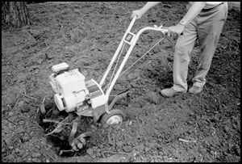
Figure 5. When planting a group of ornamentals in the landscape, prepare a good bed by deep tilling to a depth of 12 to 15 inches.
The type and quantity of soil amendments used depends on the structure and texture of the native soil. A combination of composted organic matter, composted animal manure and large-particle sand, such as Lithonia granite, are frequently used to amend beds. If bagged organic amendments are used, apply one 40-pound bag per 100 square feet of bed area and incorporate it to a 6 to 8-inch depth. An ideal soil will be one that is moist, yet well-drained.
Slow-release fertilizers, such as Osmocote or Agriform tablets, are excellent for flower beds because they give the plants an even supply of nutrients throughout the growing season. Several formulas are available, although one with at least an eight- to nine-month release duration is recommended. Follow manufacturer recommendations for application rate.
After planting, apply about three inches of mulch on the soil surface to conserve moisture and prevent weeds. Fine-textured mulches, such as pine straw or pine bark mini-nuggets, stay seated better on the bed than coarse-textured mulches.
Finally, water thoroughly. A liquid fertilizer can be applied with the water at planting to provide some immediate nutrients.
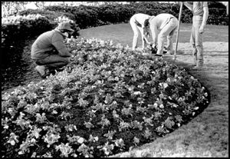 | 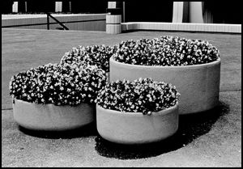
Figure 6. Plant annuals and perennials on raised beds to ensure good drainage and improved visibility. | Figure 7. Splashes of color in containers offer an alternative to flower beds and the containers let you put color where you want it, regardless of soil type. For best results, use quality potting soil and a well-drained container.
Staking and Guying Trees
Protective staking may be necessary for young trees, less than four feet tall, planted in high foot traffic areas, such as school grounds or shopping centers. Protective stakes also protect young trees from lawn mowers and weed eaters, which can severely damage the trunk. An area of mulch around the tree is an alternative to protective staking.
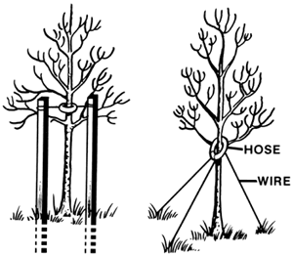
Figure 8. Trees having a trunk diameter greater than 1 inch and a height exceeding 4 feet usually require staking or guying.
Trees having a trunk diameter greater than one inch and height exceeding four feet need staking or guy wires to hold them in place until they are established. Trees having a trunk diameter up to three inches can be supported by two to four stakes, depending on the size of the canopy. After they are placed in the ground, the height of the stakes should equal the height of the lowest scaffold branches. Place the stakes along the perimeter of the planting hole, and pound them several inches into the ground to hold them firmly in place.
Secure the tree to the stakes with strong, 12-gauge wire. Place the wire encircling the tree in a piece of old garden hose. This will prevent bark injury. Attach the wire just above the lowest scaffold branches.
Use three guy wires for trees larger than four inches in trunk diameter. Again, use rubber hose around the portion of the wire touching the tree. Attach the guy wires to the tree just above the lowest scaffold branches.
Staking or guying a tree keeps it from blowing over and uprooting during establishment. Give the tree some slack so it can move slightly with the breeze. Research indicates that a tree allowed some movement during establishment develops a larger root system and stronger trunk than one that is kept stationary.
Remove stakes and guy wires 4 to 6 months after planting. Otherwise, girdling and trunk injury can result. Remove stakes from fall-planted trees at the start of the spring growing season and from spring-planted trees at the end of the summer growing season.
Trunk Wrapping
Trees often have their trunks wrapped to prevent injury during transport from the nursery to the garden center. If you purchase a tree with its trunk wrapped, remove the wrapping at planting time or shortly thereafter. It is not necessary to wrap the trunk of newly-planted trees.
Steps for Planting Success
- Survey the planting site. Modify the site if necessary to assure a good growing environment. Select plants adapted to the site conditions.
- Purchase healthy, pest-free plants.
- When holding plants for later planting, keep them in the shade and water them regularly.
- Water plants thoroughly before planting to saturate the root ball with water.
- Thorough soil preparation is essential for healthy plant growth. When planting a group of plants, rototill the soil to a depth of 12 to 15 inches. When planting a single tree or shrub, dig the planting hole two to three times wider than the root ball.
- Place the plant in the hole so the top of the root ball is level with the soil surface.
- Remove any wire of cord from around the stem of balled-and-burlapped plants. Pull back or remove the burlap from the root ball if possible.
- Water thoroughly immediately after planting to settle the soil and to eliminate air pockets that can dry out roots.
- Use stakes or guy wires to support trees or large shrubs in exposed, windy sites. Supporting devices are only temporary and should be removed a few weeks after transplanting.
- Apply 3 to 5 inches of mulch to the soil surface to conserve moisture and to prevent weeds.
- Water as necessary during the establishment period. Keep the soil uniformly moist -- not too wet or too dry.
- Allow trees and shrubs time to become established before applying fertilizer.

The University of Georgia and Ft. Valley State University, the U.S. Department of Agriculture and counties of the state cooperating. The Cooperative Extension Service, the University of Georgia College of Agricultural and Environmental Sciences offers educational programs, assistance and materials to all people without regard to race, color, national origin, age, sex or disability.
An Equal Opportunity Employer/Affirmative Action Organization Committed to a Diverse Work Force
Horticulture 1
Bulletin 932, July 1999
Issued in furtherance of Cooperative Extension work, Acts of May 8 and June 30, 1914, The University of Georgia College of Agricultural and Environmental Sciences and the U.S. Department of Agriculture cooperating.
Gale A. Buchanan, Dean and Director

