

Agriculture

PATHWAY: Plant Science - Horticulture
COURSE: Nursery and Landscape
UNIT: Pruning Nursery Crops

Introduction
Annotation:
Students will learn how to select proper pruning techniques for specific plants and demonstrate their use in the landscape.

Grade(s):
x | 9th
x | 10th
x | 11th
x | 12th

Time: 5 hours

Author: Rhonda Stone

Additional Author(s):

Students with Disabilities:
For students with disabilities, the instructor should refer to the student's IEP to be sure that the accommodations specified are being provided. Instructors should also familiarize themselves with the provisions of Behavior Intervention Plans that may be part of a student's IEP. Frequent consultation with a student's special education instructor will be beneficial in providing appropriate differentiation.

Focus Standards
GPS Focus Standards:
AG-NL-8. Students will install and maintain landscape plants to industry standards and recommended practices.
d. Describe and practice proper pruning techniques.

GPS Academic Standards:
SCSh2 Students will use standard safety practices for all classroom laboratory and field investigations.
SCSh4 Students use tools and instruments for observing, measuring, and manipulating scientific equipment and materials.
MM1P1 Students will solve problems (using appropriate technology).
ELA9RC3 The student acquires new vocabulary in each content area and uses it correctly.

National / Local Standards / Industry / ISTE:
Understandings & Goals
Enduring Understandings:
Students will learn how to select proper pruning techniques for specific plants and demonstrate their use in the landscape. Students will be able to give reasons why plants need pruning and list types of pruning methods.

Essential Questions:
Why do plants need pruning?
What are some techniques for pruning plants?

Knowledge from this Unit:
Students will be able to demonstrate proper pruning techniques at the correct time of year a plant is to be pruned. Students will know the difference in types of pruning and reasons for pruning.

Skills from this Unit:
1. Describe pruning tools and proper use of each.
2. Describe different growth habits of nursery plants and effects of pruning.
3. Prune nursery plants to achieve desired growth habits.
Assessment(s)
Assessment Method Type: Select one or more of the following. Please consider the type(s) of differentiated instruction you will be using in the classroom.

 | Pre-test
x | Objective assessment - multiple-choice, true- false, etc.
__ Quizzes/Tests
__ Unit test
x | Group project
x | Individual project
 | Self-assessment - May include practice quizzes, games, simulations, checklists, etc.
__ Self-check rubrics
__ Self-check during writing/planning process
__ Journal reflections on concepts, personal experiences and impact on one’s life
__ Reflect on evaluations of work from teachers, business partners, and competition judges
__ Academic prompts
__ Practice quizzes/tests
 | Subjective assessment/Informal observations
__ Essay tests
__ Observe students working with partners
__ Observe students role playing
 | Peer-assessment
__ Peer editing & commentary of products/projects/presentations using rubrics
__ Peer editing and/or critiquing
x | Dialogue and Discussion
__ Student/teacher conferences
__ Partner and small group discussions
__ Whole group discussions
__ Interaction with/feedback from community members/speakers and business partners
 | Constructed Responses
__ Chart good reading/writing/listening/speaking habits
__ Application of skills to real-life situations/scenarios
 | Post-test

Assessment(s) Title:
Test
Large Tree Pruning Quiz
Individual – Group Learning Activity

Assessment(s) Description/Directions:

Attachments for Assessment(s):
Test
Large Tree Pruning Quiz
Individual – Group Learning Activity
Learning Experiences
Instructional planning: Include lessons, activities and other learning experiences in this section with a brief description of the activities to ensure student acquisition of the knowledge and skills addressed in the standards. Complete the sequence of instruction for each lesson/task in the unit.

Sequence of Instruction
1. Identify the Standards. Standards should be posted in the classroom for each lesson.
2. Review Essential Questions.
3. Identify and review the unit vocabulary.
4. Have students complete the “Lesson Introduction Activity”
5. Introduction and Mental Set
Ask students: Why do we prune nursery stock? List their answers on the board. Direct students to the conclusion that the main purpose of pruning nursery stock is to promote and direct branching and to create a fuller plant as quickly as possible. A fuller plant is more marketable.

Why prune?
To remove dead, diseased, broken branches or insect infested wood.
To remove suckers.
To improve the structure of the plant.
To increase the density of the plant.
To develop a special shape- hedge, topiary, espalier
To change the size or proportion of the plant (overgrown)
To remove wilted or dead flowers and seed pods
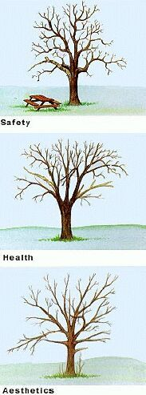

Discussion

- Compare and contrast the reasons for pruning plants in the landscape and plants for nursery production. List the reasons on the board.
A. In the landscape:
- To improve the health or appearance of a plant.
- To limit its growth.
B. In the nursery:
- To develop a fuller, denser plant that has more sales appeal.
- To develop a better structured plant with a stronger branching habit for more sales appeal.

2. When do we prune?
Lead students to recognize that when a plant is pruned depends on several factors:
A. the general type of plant
B the market for which it is being produced
C. the flowering season of the plant.
- Type of plant
- Most deciduous trees and shrubs- anytime after the new growth has fully expanded from summer throughout the dormant season.
- Broad-leaved evergreens- spring flowering shrubs such as azalea & rhododendron should be pruned after flowering; late summer or fall flowering shrubs such as camellia should be pruned in the spring; nonflowering shrubs should be pruned in the early spring before flush of growth for the season.
- Narrow-leaved evergreens- shrubs such as yews, arborvitae, and junipers put on multiple flushes of growth so they should be pruned in the summer and again in the dormant season; trees such as spruce and fir usually only have one flush of growth that is mature or in the dormant season. Pines must be pruned after the candles (new developing stems) are beginning to mature (usually June), removing 2 the candle.
- Fruit trees and small flowering trees- side shoots are removed at the end of the first growing season to develop a main leader, at the end of the second year the tip of this leader is removed to encourage the development of three to five main branches 2 to 5 ft. off the ground.

4. In addition, plants being grown as specialty items or as specimen plants might require more extensive or more frequent pruning with greater attention than those plants grown in mass.

5. Show students the video, Elements of Pruning. Discuss the video after viewing relating it to why, when, and how we prune. If desired, develop questions for the video.
Pruning enhances the beauty, directs the shape, promotes health and encourages new growth and better flowers and fruit. Learn how to use apical dominance, direction of bud growth and desired outcome to help make the following pruning cuts: pinching, heading back, thinning out, shearing and limb removal. Then, see how to prune ornamental trees, hedges, bush roses, conifers and flowering shrubs. Also, learn about types, uses and maintenance of common pruning tools. A supplement is included.
View a 2-minute preview of video at:
http://www.cevmultimedia.com/index.php?Nav=PreviewClip.php&Item=VEP00150

$80.00

6. Ask students to give examples of different growth habits of plants. A. Ask students how pruning should be used to achieve these growth habits. How can pruning be used to achieve the desired results?
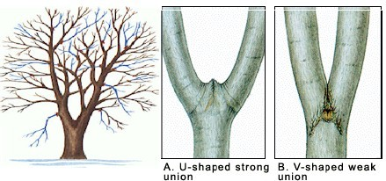
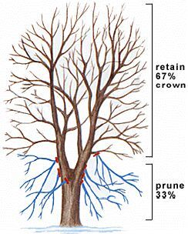

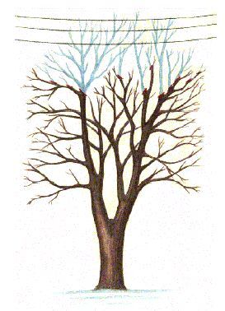
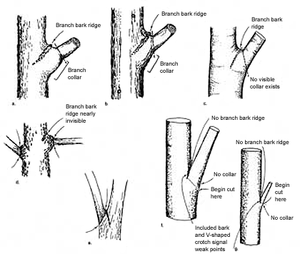
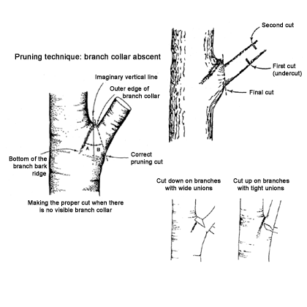
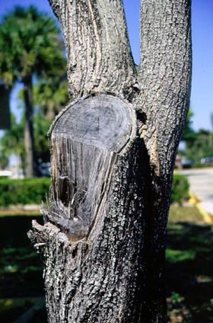Improper Cut

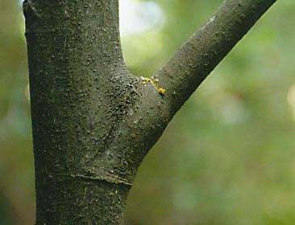Branch Before Removal
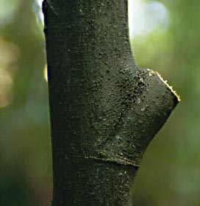After Removal
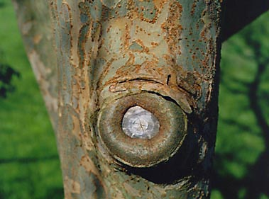One year later
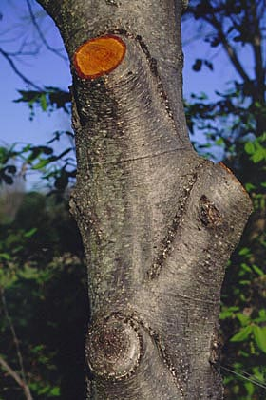Correct Cuts

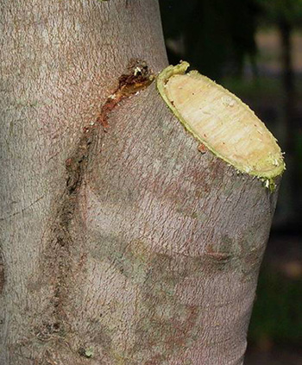
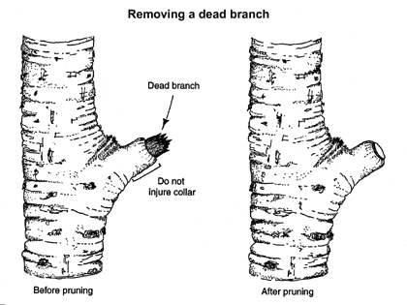

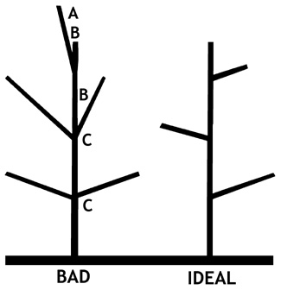

Faults: (A) side branch taller than main leader;
(B) narrow crotch; (C) co-dominant branches
Figure 1. Branching problems and using branch training to develop an ideal tree.

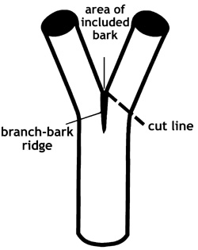 Correcting forks by removing one side early in tree life. Note the weak area of included bark
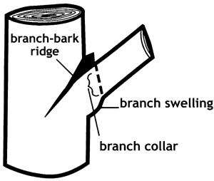 Getting ready to prune. Locate the branch-bark ridge and the extent of the branch collar at the base of each branch.
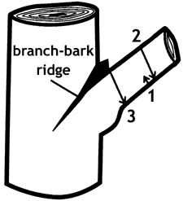Three Cut method of pruning hardwoods
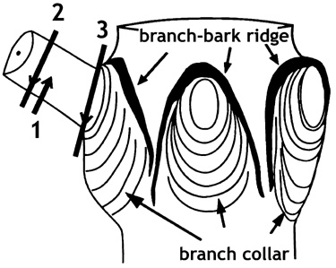Three cut pruning in conifers

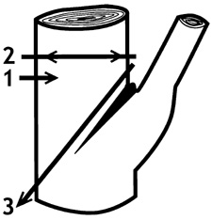Drop Crotch Cut
B. Examples:
- Upright (such as a shade or fruit tree) - The pruning procedure should be thinning: to open up the plant or to select major branches for good structure. Another pruning procedure for trees is limbing up: to gradually remove the lower branches of a tree to produce a high or lower canopy. This must be correlated to the caliper size to maintain proper standards for grading. Selective pruning: Selecting branches that grow toward the center of the plant, removal of extra branches at the tree crotch, or removal of branches growing across other branches.

Before thinning

Low and Dense (such as evergreen shrubs)
- The pruning procedure should be heading back: to cause new shoots to develop from dormant buds, therefore making the plant fuller and denser.
- 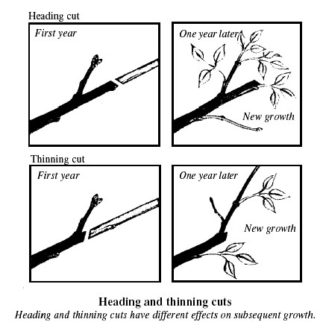

7. Have students inspect several different types of plants and note their growth habit and determine what type of pruning procedures should be used.

8. Ask students what different pruning methods should be used when producing field grown as compared to container grown plants?
A. Field grown plants must not only be top pruned but also root pruned.
B. Why?
- To develop a dense, fibrous root system close to the crown of the plant with a higher root to shoot ratio.

- Transplanted trees and shrubs that have been root pruned resume normal growth rates much more quickly than those that have not.
- Without root pruning most of the fibrous nutrient and water-absorbing roots would be lost at the time of harvest.)
C. How is root pruning done?
- It should be done in the late summer or early fall after new growth has hardened off. In the spring new top growth is reduced to compensate for the reduced root mass.
- In addition, each time a plant is transplanted from one stage to another the roots should be pruned.
- Root pruning is most beneficial for those plants that will be in the field five or more years.
- Large nurseries might use a U-blade which is pulled through the soil at the appropriate depth to cut the roots or a hydraulic tree spade. It may also be done with a shovel or hydraulic tree spade.

9. Show students the various types of pruning equipment and demonstrate the proper use of each.
A. Pruning Saw- Saws for cutting green (live) wood have coarse teeth.
- Finer teeth models are for dead or dry wood.
- Usually used for larger limbs and branches.
B. Lopping Shears- Pruning shears with longer handles for more leverage to cut larger limbs than hand models.
C. Hand Shears- Two types are available.
- One consists of a single blade that cuts against another piece of metal [called anvil shears].
- The other model has two blades that cut like scissors.
- These are used for smaller plant material and for finer precision pruning.
D. Hedge Shears- Scissor-action shears with long cutting blades to cover a large area.
- This is mainly a landscaping pruning tool.
E. Pole Pruner- A pruning tool on an extension pole to reach high tree limbs.

10. Give students nursery equipment catalogs and have them compare the various styles, types, and costs of pruning equipment.

- Show students the video, Advanced Pruning. Develop questions from the video to give to students. Relate the information in the video to application and techniques used.

Discover the effect of apical dominance and learn how pruning influences plant growth, basic tree forms and pruning needs at planting time You will also see methods that rejuvenate old trees and shrubs. Pruning techniques for conifers, hedges and deciduous fruit trees are demonstrated. A supplement is included.

http://www.cevmultimedia.com/itemdetail.php?Item=VEPD0151W

$80

- Demonstrate to students on some shrubs and trees on campus or brought in, the proper way to make pruning cuts.
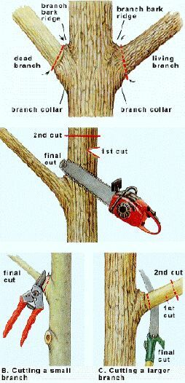

A. Trimming a tree leader requires cutting to a bud that can develop a strong leader.
B. The cut should be made at a slight angle parallel to the bud and about 1/4 in. above the bud.
C. Too close can cause the wound to dry and damage the bud; too far and die back of the stem will result.
D. When trimming lateral branches cut back to a bud pointing in the direction in which you wish the branch to grow.
E. If pointing inward, a more dense plant will result; if pointing outward, a more open and natural appearance will be the result.
F. When cutting branches from the trunk of the tree make the cut just outside of the branch collar to inhibit the spread of decay in the trunk.
G. Heading back a shrub is removal of shoots to both shape the plant and increase production of new growth from lateral buds.

13. Have students read section on pruning in Nursery Production, pages 122 to 126 and Unit 33, Techniques of Pruning, in Introductory Horticulture.
A. Have students make a list of the special pruning techniques for the special species or cultivars of plants in each text.
B. Have students answer the self-evaluation question in the Introductory Horticulture text.

14. Have students demonstrate the proper use of pruning tools and proper pruning procedures on plants on the school campus or other location or limbs of trees or shrubs collected from the woods.

- If possible visit a production nursery to observe pruning practices of nursery plants. 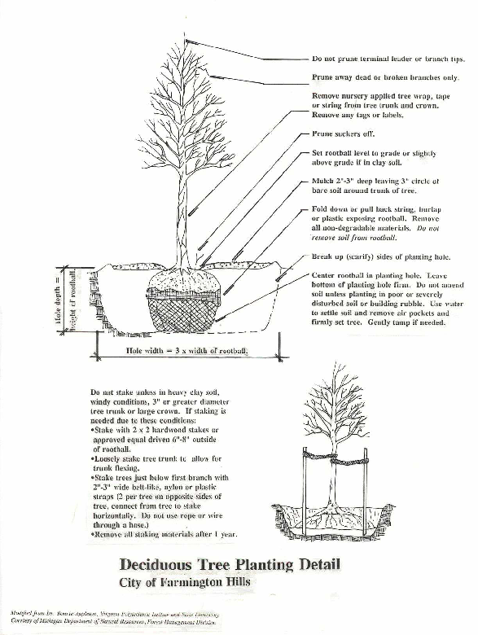
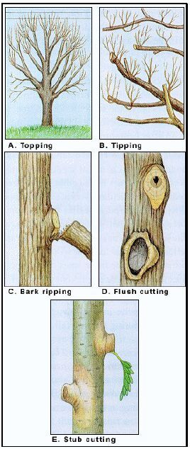

Figure 2. Large Tree Limb Pruning

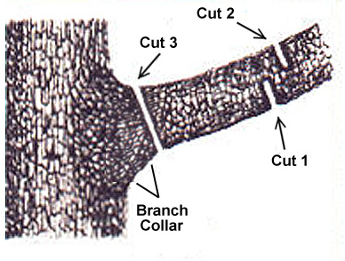

Summary
Although the techniques and procedures used in pruning nursery plants and those used in the landscape are in most cases the same, there are some differences mainly in the purposes of the pruning. Although this is the case much valuable teaching information can be pulled from books, videos, and publications written for the pruning of plants in the established landscape. The pruning practices of
deciduous ornamental and fruit trees are of greater variation and require more time to this area as a result. It should be noted that individual species and cultivars of plants may have very specific
pruning procedures that can only be determined with research and experience. This lesson may be spread over an entire semester, year or several years depending on the field and lab facilities of the program and the types of plants grown in order for students to see the results of pruning.

(Continue numbering as necessary)
Attachments for Learning Experiences:
Lesson Introduction Activity
Deciduous Tree Pruning Calendar
Pruning Terms
Pruning Word Search

Notes & Reflections:

Culminating Performance Task (Optional)
Culminating Unit Performance Task Title:

Culminating Unit Performance Task Description/Directions/Differentiated Instruction:

Attachments for Culminating Performance Task:
Unit Resources
Web Resources:
http://gaaged.org
http://ceinyo-mono.ucdavis.edu/newsletterfiles/Weekend_Farm_Fact_Sheets2468.pdf (handout)
http://www.spokane-county.wsu.edu/Spokane/eastside/Fact%20Sheets/C110%20Pruning%20Deciduous%20Shrubs%2005.pdf
http://www.lakechapalagardenclub.com/tree_prune_pdf.htm
http://www.tree-pruning.com/
http://www.videojug.com/film/the-art-and-science-of-pruning-lesson-2
http://www.villageofhoward.com/cm/pdfs/recreation/Proper%20Pruning.pdf
http://aggie-horticulture.tamu.edu/extension/pruning/pruning.html
http://www.dannylipford.com/diy-home-improvement/lawn-and-gardening/basic-shrub-pruning-techniques/
http://e-extension.us/pubs/_h/h-156.pdf
http://forestry.about.com/od/arboriculture/ss/why_prune_7.htm
http://www.hgtv.com/gl-trees-shrubs-pruning/proper-pruning-techniques/index.html
http://ag.arizona.edu/pubs/garden/mg/pruning/techniques.html
http://www.tlcfortrees.info/basic_pruning_techniques.htm
http://hort.ifas.ufl.edu/woody/documents/ch_12_mw04.pdf
http://hort.ifas.ufl.edu/woody/documents/ch_13_mw06.pdf
http://www.tlcfortrees.info/pruning_techniques.htm
http://www.wcainc.com/QualityControl/BeforeandAfter.aspx before and after photos

PowerPoints:
http://courses.extension.org/mod/resource/view.php?id=1614
http://extension.usu.edu/wasatch/files/uploads/pruning%20presentation%20handout.pdf
http://dane.uwex.edu/hort/ppt/CARINGTREEShandouts.pdf
http://hort.ifas.ufl.edu/woody/powerpoints.html
http://www.easy2diy.com/cm/easy/diy_ht_index.asp?page_id=35720699
http://www.arborday.org/trees/pruning/animation/launch.cfm- tree pruning guide animation

Attachment(s):

Materials & Equipment:
Examples of various trees and shrubs
Pruning saws, lopping shears, hand shears, hedge shears, pole pruner
Spade or shovel

What 21st Century Technology was used in this unit:
Top of Form
x | Slide Show Software |  | Graphing Software |  | Audio File(s)
 | Interactive Whiteboard |  | Calculator |  | Graphic Organizer
 | Student Response System |  | Desktop Publishing |  | Image File(s)
 | Web Design Software |  | Blog |  | Video
 | Animation Software |  | Wiki |  | Electronic Game or Puzzle Maker
 | Email | x | Website
Bottom of Form

