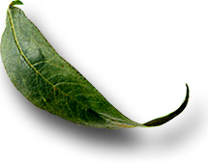
Unit: 3.3 Stem Tissues, Structures, and Function

 Introduction

Course: 02.441 Plant Science Biotechnology
Unit 3: Plant Vegetative Structures

Unit Development Template Annotation
(Briefly describe the topics, methods, technology integration, etc.)
In this unit students will identify the parts of a stem and distinguish between monocot and dicot stems. Students will explain the function of the stem and explain the functions of the internal and external parts of the stem. Students will discuss stem adaptations plants have made.

Grade(s)
- 9-Ninth
- 10-Tenth
- 11-Eleventh
- 12-Twelfth

Time: (Enter time in number of 50 minute periods)
1.5

Author

Notes to the Teacher (optional)

Students with disabilities: For students with disabilities, each instructor should refer to the student's IEP to be sure that the accommodations specified in the IEP are being provided within the classroom setting. Instructors should also familiarize themselves with the provisions of Behavior Intervention Plans that may be part of a student's IEP. Frequent consultation with a student's special education instructor will be beneficial in providing appropriate differentiation within any given instructional activity or requirement.

Standards

GPS Focus Standards:
AG-PSB-3-f: Distinguishes between monocot and dicot stems.
AG-PSB-3-g: Discusses and gives examples of adaptations plants have made.

GPS Academic Standards:
SCSh6, Students will communicate scientific investigations and information clearly.
SCSh9, Students will enhance reading in all curriculum areas.
SB1, Students will analyze the nature of the relationships between structures and functions in
living cells.
SB2 (e), Compare the advantages of sexual reproduction and asexual reproduction in different situations.

Understanding and Goals

Unit Understandings, Themes, and Concepts: Provide the deep understandings and concepts the student should retain as a result of this Unit. These are the enduring understandings.
Students will understand the importance of the stem to the plant.

Primary Learning Goals: Provide a list of the Essential Questions, Knowledge and Skills the student will know, understand, and be able to answer or demonstrate as a result of this Unit. All Primary Goals must be related to standards addressed in the Unit.
Why is it important to understand the difference between monocot and dicot stems?
What is the function of the stem?
Why is it important to understand the internal and external parts of the stem?

Balanced Assessment

Assessment Method/Type:
 | Constructed Response |  | Peer Assessment
x | Combined Methods |  | Selected Response
 | Informal Checks |  | Self Assessment

Assessment Title:

Description/Directions: Provide detailed description & directions so it will provide accurate results for any teacher wishing to replicate it.

Attachment – Supplemental Resource Title: (Optional) List the title of any attachment associated with the assessment.
Herren, Ray V. The Science of Agriculture: A Biological Approach. Delmar Publishers. Albany, NY. ISBN: 0-8273-5811-3. 1997.
Secondary Text for teacher planning and occasional student use:
Barden, John A., R. Gordon Halfacre, and David J. Parrish. Plant Science. McGraw-Hill Book Company, N.Y. 1987. ISBN 0-07-003669-1.
Campbell, Neil A. Biology. Fourth Edition. Benjamin/Cummings Publishing Company, Inc. Menlo Park, CA 1977.
Web Resources: (Optional) List the title of the web resource associated with this Unit Development Template Assessment.

Unit Performance Task(s)

Performance Task Title:

Description/Directions: Provide detailed description & directions so it will provide accurate results for any teacher wishing to replicate it.

Rubric for Performance Task: Attach rubric used in the assessment of this Unit Performance Task or submit as separate file.

Sequence of Instruction and Learning

Sequence of Instruction and Learning: List the sequence of instruction and learning for this Unit Development Template.

Materials and Equipment:
Transparency 3.3.1 - 3.3.2

Introduction and Mental Set
Do the attached exercise on monocot and dicot stems. Discuss the differences of each. Also, discuss the differences in woody and herbaceous plants.
Woody plants have heavily lignified cells; therefore, they have characteristics of wood, whereas the cells in herbaceous plants have thinner walls giving them herb like characteristics.

Discussion
1. What is the function of the stem?
-Water and mineral transport by capillary action and cohesion to the leaves.
-Transport food to the roots.
-Gas exchange.
-Produce and support new leaves, branches, and flowers

2. What are the internal parts of the stem?
Phloem
Xylem
Cambium
Pith
Ray
Cortex

3. What are their functions?
Phloem: transports sugars and carbohydrates to roots.
Xylem: transports water and nutrients from roots to rest of tree.
Cambium: lateral meristem. It is the growing part of the stem.
Pith: Occupies the central area of the stem.
Cortex: Composed of several layers of thick-walled cells, and an area of thin-walled parenchyma cells interior to the thick-walled.

4. How do monocots and dicots internal structure differ? Display and discuss transparency 3.3.1.

5. What are the external parts of the stem?
Buds: axillary and terminal
Nodes
Internodes

6. Some plants have developed modified stems. Have the students name as many as they can. Briefly discuss their functions. Display and discuss transparency 3.3.2.
-Rhizomes: horizontal underground stems(e.g. Bermuda grass)
- tolons: horizontal above ground stems( e.g. strawberries)
-Tubers: greatly enlarged tip of an underground stem(e.g. potato)
-Bulbs: budlike structure consisting of a small stem with closely crowded fleshy leaves or leaf bases(e.g. onion)
-Corms: fleshy underground stems with few nodes( e.g. gladiolus)

7. Laboratory
Provide each student with a stem(leaves removed). Have the students draw a stem from a sample stem. Then the students should label the various parts of the stem and state their functions.

Summary

Review the important points of stem parts and their functions.

Evaluation

Written test

3.3.1
Internal Structure

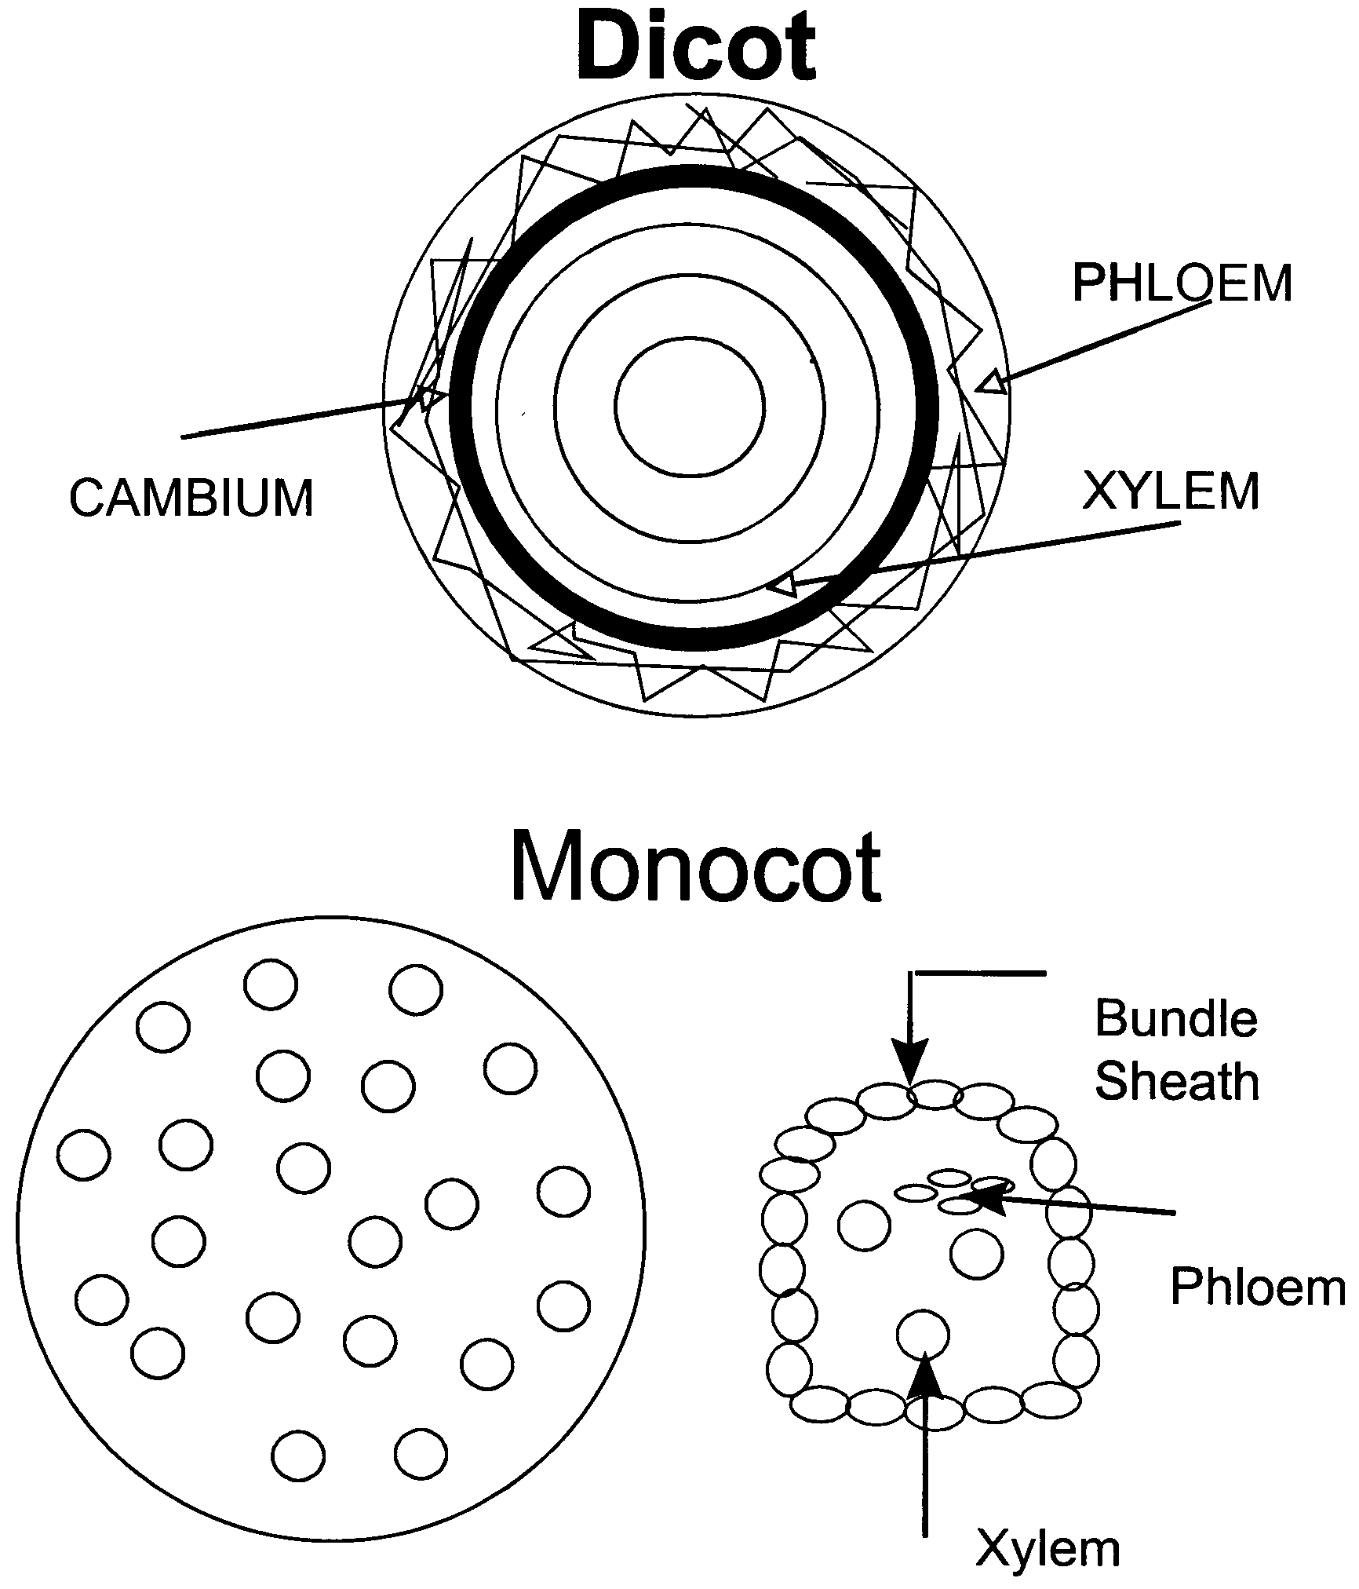

3.3.2
Modified Stems

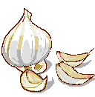

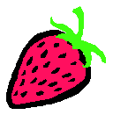
Rhizome Bermuda Grass

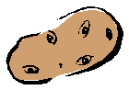
Stolon Strawberry

Tuber Potato

Bulbs Onion

Corms Gladiolus

