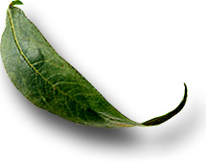
Unit: 4.1 Cell Components and Functions

 Introduction

Course: 02.441 Plant Science Biotechnology
Unit 4: Plant Cells—The Building Blocks of Life

Unit Development Template Annotation
(Briefly describe the topics, methods, technology integration, etc.)
In this unit students will identify components of the cell and describe the function of each component. Students will recognize a plant cell under the microscope and list the functions of a cell in relation to plant growth. Students will distinguish between a plant cell and an animal cell based on parts.

Grade(s)
- 9-Ninth
- 10-Tenth
- 11-Eleventh
- 12-Twelfth

Time: (Enter time in number of 50 minute periods)
1.5

Author

Notes to the Teacher (optional)

Students with disabilities: For students with disabilities, each instructor should refer to the student's IEP to be sure that the accommodations specified in the IEP are being provided within the classroom setting. Instructors should also familiarize themselves with the provisions of Behavior Intervention Plans that may be part of a student's IEP. Frequent consultation with a student's special education instructor will be beneficial in providing appropriate differentiation within any given instructional activity or requirement.

Standards

GPS Focus Standards:
AG-PSB-4-a: Identifies and describes the components of plant cells.
AG-PSB-4-b: Lists the functions of plant cell components in relation to plant growth.
AG-PSB-4-c: Distinguishes between plant cells and animal cells.

GPS Academic Standards:
SB1, Students will analyze the nature of the relationships between structures and functions in
living cells.
S7L2, Students will describe the structure and function of cells, tissues, organs, and organ systems.

Understanding and Goals

Unit Understandings, Themes, and Concepts: Provide the deep understandings and concepts the student should retain as a result of this Unit. These are the enduring understandings.
Students will understand how the plant cell affects the entire plant and how it applies to agriculture.

Primary Learning Goals: Provide a list of the Essential Questions, Knowledge and Skills the student will know, understand, and be able to answer or demonstrate as a result of this Unit. All Primary Goals must be related to standards addressed in the Unit.
Why is it important to understand the different parts of the plant cell?
What are the functions of each component of the plant cell?
Why is it important to understand the nature of the relationships between structures and functions in living cells?

Balanced Assessment

Assessment Method/Type:
 | Constructed Response |  | Peer Assessment
x | Combined Methods |  | Selected Response
 | Informal Checks |  | Self Assessment

Assessment Title:

Description/Directions: Provide detailed description & directions so it will provide accurate results for any teacher wishing to replicate it.

Attachment – Supplemental Resource Title: (Optional) List the title of any attachment associated with the assessment.
Herren, Ray V. The Science of Agriculture: A Biological Approach. Delmar Publishers. Albany, NY. ISBN: 0-8273-5811-3. 1997.
Secondary Text for teacher planning and occasional student use:
Comparing and Contrasting Plant and Animal Cells. Ohio Agricultural Education Curriculum Materials Service. Columbus, OH. 1990. Video: Cell Structure

Web Resources: (Optional) List the title of the web resource associated with this Unit Development Template Assessment.

Unit Performance Task(s)

Performance Task Title:

Description/Directions: Provide detailed description & directions so it will provide accurate results for any teacher wishing to replicate it.

Rubric for Performance Task: Attach rubric used in the assessment of this Unit Performance Task or submit as separate file.

Sequence of Instruction and Learning

Sequence of Instruction and Learning: List the sequence of instruction and learning for this Unit Development Template.

Materials and Equipment:
Unlabeled copies of cell drawing, microscope & plant cell and animal cell slides
a 1'x2' piece of card board (enough for each student), box of modeling clay (1 per 2 students), 14 toothpicks per cell per student, slips of white paper to cut into flags
Transparency 4.1.2
Handout 4.1.1

Introduction and Mental Set
Have students observe a plant cell under a microscope. Then have them observe an animal cell. Have them note noticeable differences between the two. Secure handout, “Comparing and Contrasting Plant and Animal Cells.”

Discussion

1. Have students help identify the components of a plant cell by listing and then labeling the parts of a plant cell. See handout 4.1.2 and drawing in reference book, page 61.
cytoplasm
golgi body
nucleus
mitochondria
lysosome
nucleolus
nuclear membrane
endoplasmic reticulum
ribosomes
cell wall
chloroplast
vacuole
cell membrane
pinocyctic vesicle

2. How can you distinguish between a plant cell and an animal cell based on cell components? Display and discuss transparency 4.1.1. A plant cell has a cell wall, plastids and large vacuoles.
Ask students if this is the difference they noticed during the mental set.

3. Describe the function of each component of the plant cell.
A. Cell wall gives protection, support, and form to the plant cell.
B. Cytoplasm: the living matter or physical substance of the cell.
C. Golgi bodies: store protein and prepares it for secretion.
D. Lysomes: contain hydrolytic enzymes for digestion of cellular particles.
E. Nuclear membrane: the membrane that surrounds and protects the nucleus.
F. Ribosomes: provide sites for protein synthesis.
G. Chloroplast: contains chlorophyll which captures energy from the sun for use in carbohydrate production.
H. Cell membrane: determines which molecules can enter and leave the cell.
I. Nucleus: directs activities of the rest of the cell.
J. Mitochondria: contain enzymes that release energy stored in food by the process of cellular respiration.
K. Nucleolus: a small, dense region in the nucleus of eukaryotic cells which consist of RNA molecules, ribosomal proteins, and loops of chromatin.
L. Endoplasmic reticulum: forms network of canals in cell and prepares protein for secretion.
M. Vacuole: house pigment concentrations that lead to flower, leaf or fruit color.
N. Plastids: help in food production.

4. What are the functions of a cell in order for plant growth to occur? Display and discuss transparency 4.1.3
A. Nutrition
B. Excretion
C. Digestion
D. Absorption
E. Response
F. Secretion
G. Reproduction
H. Respiration
I. Biosynthesis

5. Laboratory
A. Provide students with different colors of modeling clay. Have them construct their own clay model of a cell. Cut out a piece of cardboard to use as the base, place the pieces of clay on the base to represent a cell.
Tell students to make each component listed and identified on the drawing. Tell them to use as many different colors for each component as possible. Students should also label each component by sticking flag tooth picks at the site of the component. Cut out triangle slips of paper, label with component, glue to toothpick, and stick at site of that component. Students should use this model to study.
B. Video: “Introduction to Cell Structure” Carolina Biological, 1996, #K3-49-1003-V.

Summary
Review important points:
What are the components of cell?
What is the function of each component of a cell?
Describe the difference between a plant and an animal cell.

Evaluation
Laboratory activity
Written test

4.1.1

Animal Cell

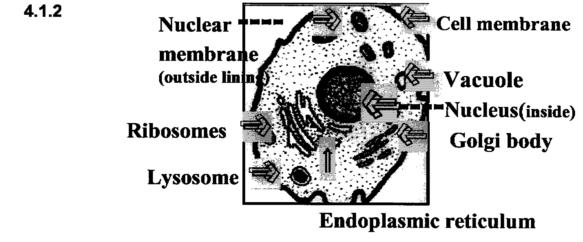

Excerpted from The American Heritage7 Dictionary of the English Language, Third Edition8 1996 by Houghton Mifflin Company. Electronic version licensed from INSO Corporation; further reproduction and distribution in accordance with the Copyright Law of the United States. All rights reserved.

4.1.3

Functions of a Plant Cell

Nutrition

Digestion

Absorption

Biosynthesis

Respiration

Excretion

Secretion

Response

Reproduction

