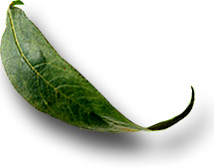
Unit: 6.1 Nutrients Essential to Plant Growth

 Introduction

Course: 02.441 Plant Science Biotechnology
Unit 6: Plant Nutrition

Unit Development Template Annotation
(Briefly describe the topics, methods, technology integration, etc.)
In this unit students will identify artificial sources of plant nutrients and describe why plants need nutrients. Students will list primary and secondary plant nutrients and understand the need for micro nutrients (trace nutrients). Students will identify natural ways of supplying plants with nutrients.

Grade(s)
- 9-Ninth
- 10-Tenth
- 11-Eleventh
- 12-Twelfth

Time: (Enter time in number of 50 minute periods)
0.5
1 hour lab (8 weeks total)

Author

Notes to the Teacher (optional)

Students with disabilities: For students with disabilities, each instructor should refer to the student's IEP to be sure that the accommodations specified in the IEP are being provided within the classroom setting. Instructors should also familiarize themselves with the provisions of Behavior Intervention Plans that may be part of a student's IEP. Frequent consultation with a student's special education instructor will be beneficial in providing appropriate differentiation within any given instructional activity or requirement.

Standards

GPS Focus Standards:
AG-PSB-6-a: Describes the role of nutrients in plant growth and development.
AG-PSB-6-b: Lists primary and secondary plant nutrients.
AG-PSB-6-c: Defines plant needs for micro nutrients (trace elements).

GPS Academic Standards:
SCSh6, Students will communicate scientific investigations and information clearly.
SB1, Students will analyze the nature of the relationships between structures and functions in living cells.

Understanding and Goals

Unit Understandings, Themes, and Concepts: Provide the deep understandings and concepts the student should retain as a result of this Unit. These are the enduring understandings.
Students will understand the importance of nutrients in plant growth.

Primary Learning Goals: Provide a list of the Essential Questions, Knowledge and Skills the student will know, understand, and be able to answer or demonstrate as a result of this Unit. All Primary Goals must be related to standards addressed in the Unit.
Why are primary and secondary nutrients important to agriculture?
What is the importance of micronutrients?
What are the sources of essential plant nutrients?
How do chemical fertilizers and soil interact?

Balanced Assessment

Assessment Method/Type:
 | Constructed Response |  | Peer Assessment
x | Combined Methods |  | Selected Response
 | Informal Checks |  | Self Assessment

Assessment Title:

Description/Directions: Provide detailed description & directions so it will provide accurate results for any teacher wishing to replicate it.

Attachment – Supplemental Resource Title: (Optional) List the title of any attachment associated with the assessment.
Barden, John A., R. Gordon Halfacre and David J. Parrish. Plant Science. McGraw-Hill, New York, NY. ISBN: 07-003669-1. 1987.
Burton, L. DeVere. AgriScience and Technology, Lab Manual. Delmar Publishers. Albany, NY. 1998.
Herren, Ray V. The Science of Agriculture: A Biological Approach. Delmar Publishers. Albany, NY. 1997.
Lee, Jasper S. & Diana L. Turner. Introduction to World AgriScience and Technology. Interstate Publishers, Inc. Danville, IL. 1997.
Web Resources: (Optional) List the title of the web resource associated with this Unit Development Template Assessment.

Unit Performance Task(s)

Performance Task Title:

Description/Directions: Provide detailed description & directions so it will provide accurate results for any teacher wishing to replicate it.

Rubric for Performance Task: Attach rubric used in the assessment of this Unit Performance Task or submit as separate file.

Sequence of Instruction and Learning

Sequence of Instruction and Learning: List the sequence of instruction and learning for this Unit Development Template.

Materials and Equipment:
Azalea suffering from iron chlorosis
Transparency 6.1.1
Handout 6.1.2 and 6.1.3
Consult laboratory activity for list of materials needed

Introduction and Mental Set
Display the azalea sample in class. Ask the students to come up with reasons for the azalea=s poor appearance. Explain that azaleas like acidic soils. Most soils in Georgia are acidic, however, soil around buildings or soil that has been limed will be more alkaline. Alkaline soils inhibit the uptake of iron by azaleas, which leads to iron chlorosis. This is just one example of a necessary plant nutrient.

Discussion

1. What are primary nutrients? Display and discuss transparency 6.1.1.
Those nutrients used in the largest quantities: Nitrogen, Phosphorus, and Potassium.
Always listed in that order.
For example a fertilizer tag that read 10-20-10 would mean 10% Nitrogen, 20% Phosphorous, and 10% Potassium.

2. What are secondary nutrients?
A. Calcium, Magnesium, and Sulfur.
B. These are required in slightly smaller amounts than the primary nutrients.

3. Micronutrients consist of seven essential elements that occur in very small amounts in soils and plants. What are the micronutrients?
A. Boron
B. Chlorine
C. Manganese
D. Zinc
E. Copper
F. Iron
G. Molybdenum

4. Are micronutrients as important as primary and secondary nutrients?
Yes, even though they occur in minute amounts their role is equally important.

5. Are there any elements required by plants that are not supplied by the soil?
Yes; carbon, hydrogen, and oxygen are used in the largest mounts, but they are supplied by air and water.

6. What are the sources of essential plant nutrients?
A. Natural/organic fertilizers and soil builders.
-Legumes
-Manures
-Green Manures
B. Chemical fertilizers.
-Nitrogen: ammonia nitrate, anhydrous ammonia, urea.
-Phosphorus: phosphoric acid( P2O5)
-Potassium: soluble potash (K2O)

7. What challenge do chemical fertilizers have in relationship to staying in the soil?
A. They leach easily. When it rains, they are easily washed from the soil.
B. Natural fertilizers stay in the soil longer.

8. Laboratory
A. Complete the laboratory exercise, “Effects of Soil Treatments on Crop Yield”, listed in Agriscience & Technology reference.
B. Complete the laboratory exercise, Nutrient Deficiencies in Plants. (Attached).

Summary

Review the important points of:
primary, secondary, and micronutrients.
sources of chemical and organic fertilizers.

Evaluation

Written test
Laboratory activity

6.1.1

Primary Nutrients
Nitrogen
Phosphorus
Potassium

Secondary Nutrients
Calcium
Magnesium
Sulfur

Seven Micronutrients
Boron
Chlorine
Manganese
Zinc
Copper
Iron
Molybdenum

6.1.2

Nutrient Deficiencies in Plants

Student’s Guide

Introduction
Plants need certain nutrients tomorrow properly. Carbon, hydrogen, and oxygen are obtained from the atmosphere. The rest are found in the soil and are absorbed through the roots. The macronutrients, needed in larger quantities, are nitrogen, phosphorus, potassium, calcium, magnesium, and sulfur. The micronutrients, needed in smaller quantities, are iron, manganese, zinc, boron, copper, molybdenum, sodium, and chlorine. If these nutrients are not available to the plant, then growth will be abnormal and yield will be reduced.

Objective
The objective of this exercise is to observe nutrient deficiencies in plants grown in various nutrient deficient solutions.

Procedure
A. Preparing the Containers
1. Wash a quart jar with detergent and rinse with distilled water several tunes to remove all traces of the detergent.
2. Cover the outside of the jar with aluminum foil. Make sure there are no holes in the foil.
3. Make sure the lid, with two holes punched in it, is clean.

B. Malting the Nutrient Solution
1. Fill the jar half full with distilled water.
2. Add each nutrient, one at a time, to the water. Your teacher will tell you which type of nutrient solution to make. For example, if you are assigned a solution with all nutrients except magnesium, then you would follow the chart for the “minus magnesium” row.
3. As you add each nutrient, gently shake the jar. This will allow the nutrient to mix with the water.
4. Once all the nutrients for your solution have been added, add more distilled water until the level is 0.5 to 1 inch below the top.

6.1.2
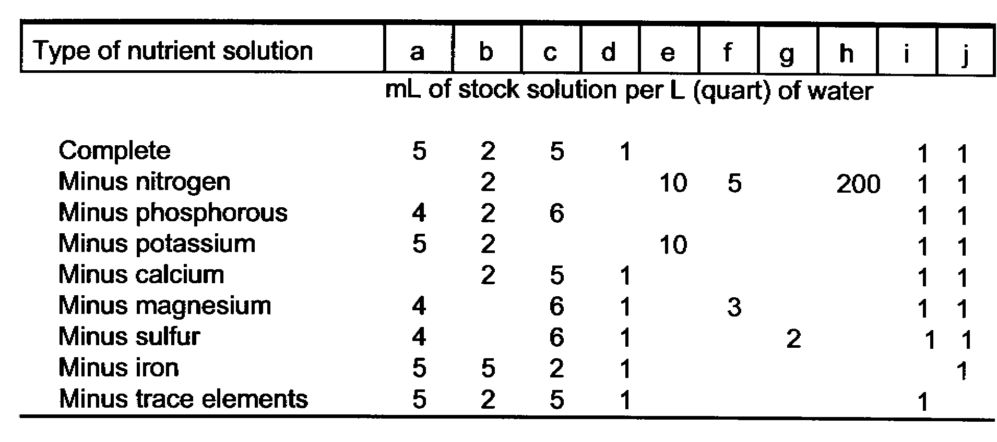 C. Preparing the Plant
1. Carefully remove the plant from the sand. Try not to break any roots.
2. Gently wash the sand off the roots with distilled water.
3. Pinch off the cotyledons without tearing the stem.
4. Measure root and shoot length. Count the number of leaves. Make notes on the general appearance of your plant.
5. Wrap a piece of cotton around the stem above the roots. This cotton will hold the plant up and protect it from the rough edges of the jar lid.

D. Final Set-Up and Maintenance
1. Place the plant through one of the holes in the jar lid, preferably the one closer to the center of the lid.
2. Place the lid on the jar and fasten. Make sure the cotton does not touch the solution because it will draw up the solution, causing the stem to rot. The plant may not stand upright right away but will straighten itself out in a few days.
3. About three times a week, take a clean pipette and blow air into the nutrient solution. Do not share pipettes unless they are first cleaned. (If your school has a pressurized air pump system, connect a rubber hose to the air valve, turn it on gently, and put the other end into the nutrient solution).
4. Add distilled water, when necessary, to maintain a solution level 0.5 to 1 inch below the top. As the plant grows, it will require more water.
5. The nutrient solution should be replaced each week with a fresh mixture, if directed by your teacher.
6. Observe your plant for any abnormal growth or development such as yellowing or striping of leaves, stunting, curling of leaves, abnormal root formation, discoloration of roots, or any thing else that is not typical for this species. Do this every week.
7. At the end of 4 weeks, carefully remove your plant from the jar. Measure the length of the roots and shoot. Count the number of leaves. Note any other growth characteristics.

Data Collection

1. Record plant measurements made at the beginning and end of the exercise.

Beginning End Difference

Root length

Shoot length

Leaf number

2. Record your weekly plant observations here.
Week 1:

Week 2:

Week 3:

Week 4:

Questions
1. What symptoms should you see with your assigned nutrient deficiency?

2. How do each of the following nutrients help in plant growth?
a. Nitrogen
b. Phosphorus
c. Potassium
d. Calcium
e. Magnesium
f. Sulfur
g. Iron
h. Other micronutrients

