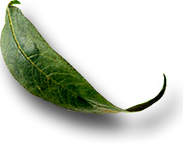
Unit: 10.5 Wind

 Introduction

Course: 02.441 Plant Science Biotechnology
Unit 10: Environmental Factors Affecting Plant Growth

Unit Development Template Annotation
(Briefly describe the topics, methods, technology integration, etc.)
In this unit students will describe wind and the various types and explain the means of measuring wind. Students will explain the effects of wind on plants and buildings and explain the importance of location for orchards, greenhouses, etc.

Grade(s)
- 9-Ninth
- 10-Tenth
- 11-Eleventh
- 12-Twelfth

Time: (Enter time in number of 50 minute periods)
2

Author

Notes to the Teacher (optional)

Students with disabilities: For students with disabilities, each instructor should refer to the student's IEP to be sure that the accommodations specified in the IEP are being provided within the classroom setting. Instructors should also familiarize themselves with the provisions of Behavior Intervention Plans that may be part of a student's IEP. Frequent consultation with a student's special education instructor will be beneficial in providing appropriate differentiation within any given instructional activity or requirement.

Standards

GPS Focus Standards:
AG-PSB-10-j: Measures wind velocity and explains the effects of wind on plants, structures, etc.
AG-PSB-10-k: Determines the best location for orchards, greenhouses, etc. based on climatic conditions.

GPS Academic Standards:
MM4P1 Students will solve problems (using appropriate technology).

Understanding and Goals

Unit Understandings, Themes, and Concepts: Provide the deep understandings and concepts the student should retain as a result of this Unit. These are the enduring understandings.
Students will understand the affect that wind has on agriculture.

Primary Learning Goals: Provide a list of the Essential Questions, Knowledge and Skills the student will know, understand, and be able to answer or demonstrate as a result of this Unit. All Primary Goals must be related to standards addressed in the Unit.
What would happen if there were no wind?
How is wind velocity measured?
How does wind move?
What is the difference in wind movement in the Northern and Southern hemispheres?
What are the effects of wind on plants?

Balanced Assessment

Assessment Method/Type:
 | Constructed Response |  | Peer Assessment
x | Combined Methods |  | Selected Response
 | Informal Checks |  | Self Assessment

Assessment Title:

Description/Directions: Provide detailed description & directions so it will provide accurate results for any teacher wishing to replicate it.

Attachment – Supplemental Resource Title: (Optional) List the title of any attachment associated with the assessment.
Herren, Ray V. The Science of Agriculture: A Biological Approach. Delmar Publishers, Inc. Albany, NY. ISBN: 0-8273-5811-3. 1997.
Encarta7 98 Desk Encyclopedia, Microsoft Corporation. 1993-1997.
Secondary Text for teacher planning and occasional student use:
Van Cleave, Janice. A + Projects in Biology. John Wiley & Sons, Inc. New York, NY. 1993. Botany - 49 Science Fair Ex.
Atlas of Georgia. Institute of Community and Area Development, University of Georgia. Athens, GA. 1996.
The American Horticulture Society: Encyclopedia of Gardening. 1993. An interactive CD-Rom version is available. 1996.
Janick, Jules. Horticultural Science. Fourth Edition. W.H. Freeman and Company, NY.

Web Resources: (Optional) List the title of the web resource associated with this Unit Development Template Assessment.

Unit Performance Task(s)

Performance Task Title:

Description/Directions: Provide detailed description & directions so it will provide accurate results for any teacher wishing to replicate it.

Rubric for Performance Task: Attach rubric used in the assessment of this Unit Performance Task or submit as separate file.

Sequence of Instruction and Learning

Sequence of Instruction and Learning: List the sequence of instruction and learning for this Unit Development Template.

Materials and Equipment:
Globe
Fan
Transparency 10.5.1

Introduction and Mental Set
Set up a fan and have a volunteer stand in front of the fan with their back to the fan. Place the fan on low speed.
What happens to the air pressure? A low pressure is created over the left arm and a high pressure is created over the right shoulder.
What controls the strength or intensity of the wind? The greater the difference between the low and high pressure masses the stronger the wind.

Discussion

1. Define wind.
Horizontal movement of air across the surface of the earth.

2. What would happen if there were no wind?
There would be no change in our day-to-day weather.

3. What is an anemometer?
An instrument used to measure wind speed.

4. What is the strongest wind speed recorded on the earth? Where?
(Let the students guess and write their responses on the board). Mt. Washington, NH. 231 MPH.

5. What are the four types of winds?
-Prevailing - winds in the middle latitudes of the earth.
-Seasonal - wind flows toward land in the winter because the water in warm than the land. The opposite for summer.
-Local - caused by local temperature conditions
-Cyclonic - The air circulates counterclockwise around low pressure in the northern hemisphere. The air circulates clockwise around low pressure in the Southern hemisphere.

6. How does wind move?
The rotation of the earth and changes in air pressure. Display and discuss transparency 10.5.1.
-Doldrums - A region of calm, light variable winds near the equator
The two polar caps have high air pressure
-Northern hemisphere - these winds flow north easterly
-Southern hemisphere - these winds flow south easterly

7. Take the globe and spin it. Explain air pressure as the globe rotates and the northeasterly and southeasterly winds.

8. Why do northern hemisphere hurricanes start in the Caribbean? What direction do they travel and why?
-A low pressure area near the doldrums
-High velocity winds surround the low pressure
-These winds spin counterclockwise, thus changing the northeasterly trade winds toward the Northwest (Caribbean and Florida) and eventually they turn back to the northeast as the winds die down

9. What happens to hurricanes in the Southern hemisphere?
Same concept as the northern hemisphere except the winds blow clockwise, thus taking the hurricane to the out to sea then to South America.

10. What is the jet stream?
Eastbound air that is several hundred miles wide
6 miles above the earth=s surface
In the summer - the winds blow about 50 MPH
In the winter - the winds blow about 150 MPH

11. What are the effects of wind on plants?
Erosion of the top soil
Dry the soil out
Minor to severe plant damage
Cause waves to rise and create flooding
Wind chill - winter
Wind burn - summer
Pollination enhanced
Draft challenges

12. What role does wind play in the location of an orchard or greenhouse?
Orchards in a higher elevation can be saved from a late spring frost because the air would be more likely to move.
Greenhouse - fuel consumption - breakage of plastic, glass

Summary

The wind is a factor that could affect agricultural production.

Evaluation

Have students orally explain the significance of winds and how they affect the earth.
Have students measure wind velocity for a local TV or radio station.

10.5.1

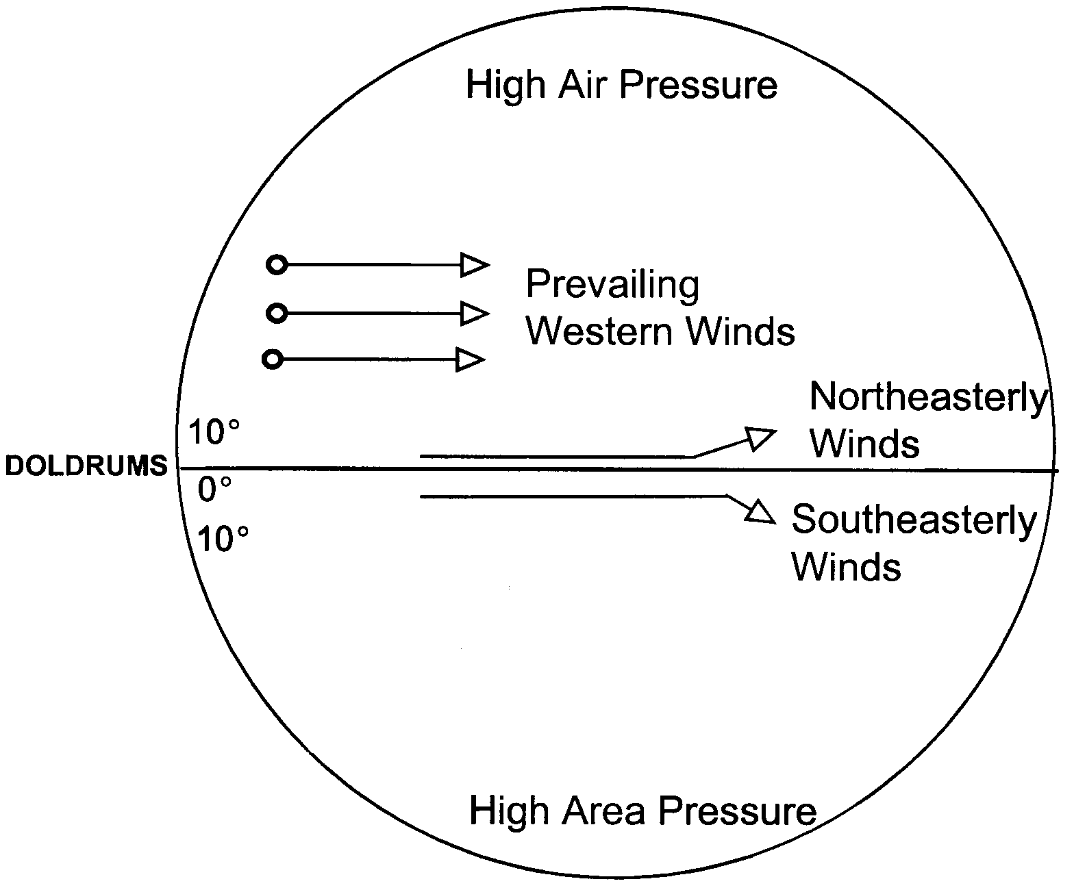
Earth Winds

