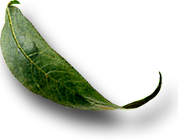
Unit: 18.5 Preventing Erosion

 Introduction

Course: 02.441 Plant Science Biotechnology
Unit 18: Plant Production and the Environment

Unit Development Template Annotation
(Briefly describe the topics, methods, technology integration, etc.)
In this unit students will discuss why we need to prevent erosion and list methods of erosion prevention. The students will also make recommendations for controlling erosion in specific areas.

Grade(s)
- 9-Ninth
- 10-Tenth
- 11-Eleventh
- 12-Twelfth

Time: (Enter time in number of 50 minute periods)
3

Author

Notes to the Teacher (optional)

Students with disabilities: For students with disabilities, each instructor should refer to the student's IEP to be sure that the accommodations specified in the IEP are being provided within the classroom setting. Instructors should also familiarize themselves with the provisions of Behavior Intervention Plans that may be part of a student's IEP. Frequent consultation with a student's special education instructor will be beneficial in providing appropriate differentiation within any given instructional activity or requirement.
Standards

GPS Focus Standards:
AG-PSB-1-b. Explains the role of plants in the food chain.
AG-PSB-18-j. Defines methods of erosion prevention and prescribes erosion control measures for a specific site in the community.

GPS Academic Standards:
SB4 Students will assess the dependence of all organisms on one another and the flow of energy and matter within their ecosystem.
SB2 (e) Compare the advantages of sexual reproduction and asexual reproduction in different situations.
ELA10RC4 (a) Explores life experiences related to subject area content.

Understanding and Goals

Unit Understandings, Themes, and Concepts: Provide the deep understandings and concepts the student should retain as a result of this Unit. These are the enduring understandings.
Students will understand how preventing erosion is important to agriculture.

Primary Learning Goals: Provide a list of the Essential Questions, Knowledge and Skills the student will know, understand, and be able to answer or demonstrate as a result of this Unit. All Primary Goals must be related to standards addressed in the Unit.
In what ways can you help control erosion?
What causes erosion?
How do the highly erodible land conservation (HELC) provisions of the 1996 Farm Bill help prevent erosion?

Balanced Assessment

Assessment Method/Type:
 | Constructed Response |  | Peer Assessment
x | Combined Methods |  | Selected Response
 | Informal Checks |  | Self Assessment

Assessment Title:

Description/Directions: Provide detailed description & directions so it will provide accurate results for any teacher wishing to replicate it.

Attachment – Supplemental Resource Title: (Optional) List the title of any attachment associated with the assessment.
Herren, Ray V. The Science of Agriculture: A Biological Approach. Delmar Publishers, Inc. Albany, NY. ISBN: 0-8273-5811-3. 1997.
Secondary Text for teacher planning and occasional student use:
Residue Management for Soil Erosion Control. The University of Nebraska at Lincoln. http://www.1anr.unl.edu/PUBS/fieldcrops/g544.htm.

Web Resources: (Optional) List the title of the web resource associated with this Unit Development Template Assessment.

Unit Performance Task(s)

Performance Task Title:

Description/Directions: Provide detailed description & directions so it will provide accurate results for any teacher wishing to replicate it.

Rubric for Performance Task: Attach rubric used in the assessment of this Unit Performance Task or submit as separate file.

Sequence of Instruction and Learning

Sequence of Instruction and Learning: List the sequence of instruction and learning for this Unit Development Template.

Materials and Equipment
Need sod
Bare soil
Pans
Water and buckets
Eye droppers
Paper
Introduction and Mental Set
Place sod in one pan and soil in the other. Tilt each pan slightly. Sprinkle water over each pan, allowing the water to run into the buckets. Let each student see the amount of soil that washes into each bucket. This illustrates one method of erosion prevention.

Discussion
1. Why do we need to prevent erosion?
Soil is a non-renewable resource
Topsoil is needed for crops, forests, and pastures
It takes approximately 100 years for nature to make one inch of topsoil
It clogs river ways and causes fish loss and other aquatic life.

2. What causes erosion?
Water
Wind

3. What are some methods or techniques used to prevent erosion?
Describe or illustrate each of the following:
Conservation tillage
Contour farming
Terracing
Grassed waterways
Silt screening
Pasture rotation
Cover crops
Crop rotation
Strip cropping
Windbreaks
Shelter belts
Mulching
Ditching
Not to build in flood plains
Do not destroy wetlands

4. What is the intent of the highly erodible land conservation (HELC) provisions of the 1996 Farm Bill?
Reduce the effects of cropland soil erosion
Help preserve the agricultural sustainability of the nation=s soil resources
Improve the air and water quality

5. What can an individual do to help control erosion?
Become educated
Implement conservation practices
Speak out about the importance of erosion control
Join Earth Team Volunteers
Contact your local Natural Resources Conservation Service (USDA) representative or call 1-888-LANDCARE.

6. Display and discuss transparency 18.5.1- Soil Erosion caused by rain.
Raindrops can splash soil particles up to three feet away
Soil particles are detached from one another by raindrops and carried off

7. Display and discuss transparency 18.5.2- Soil erosion caused in part, by wind.

8. Laboratory
Divide the class into groups. Have each group fill a bowl with loose soil, and another bowl with sod. Place each bowl on a large piece of paper. Using eye droppers or similar equipment, drop a single drop of water into each bowl. Measure the distance the water splashes the soil from each bowl. Next, have students stand on desks to try the experiment from a different height. Summarize observations and compare findings.

Summary
Review the following:
Why we need to prevent erosion?
Methods of preventing erosion.
What causes erosion?

Evaluation
Have each student identify a local area with erosion problems. The student should state whether the erosion is from wind or water. Next have the student come up with at least four methods to solve the problem.
Soil Loss Caused by Water

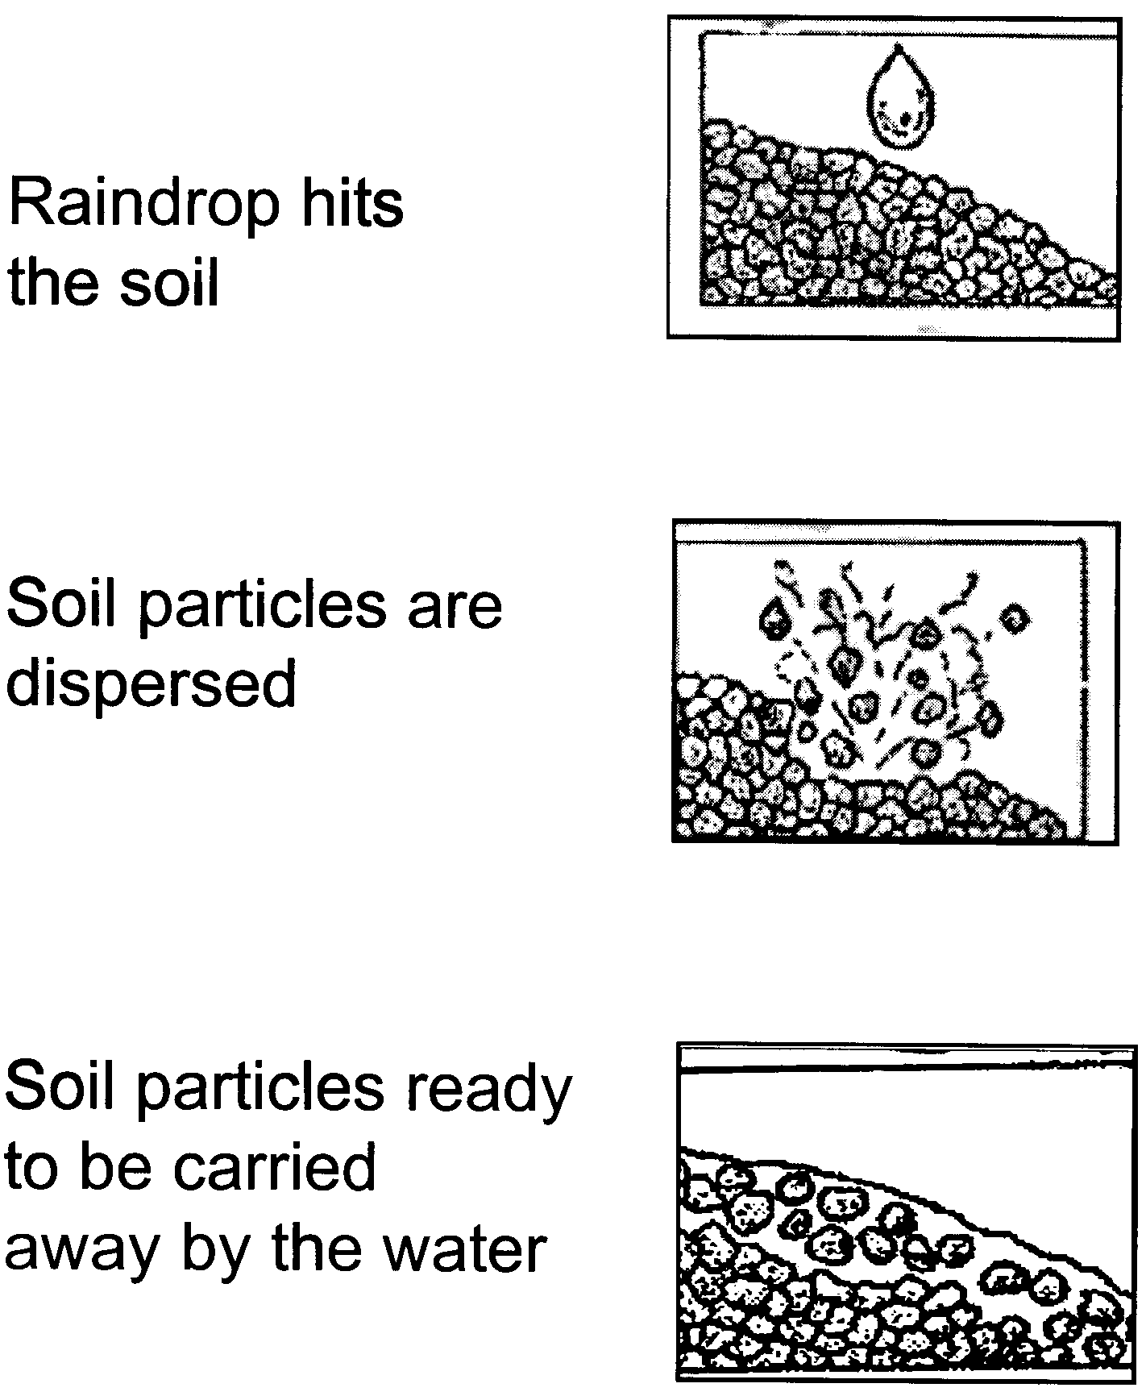

Table I. Measured surface cover and soil loss for various tillage systems.

Tillage System  Residue Type | Residue  Cover  (Percent) | Erosion  (Tons/Acre) | Erosion Reduction from Moldboard Plow  (Percent)
Corn Residue¹
Moldboard plow,  disk disk, plant | 7 | 7.8 | _
Chisel plow, disk, plant | 35 | 2.1 | 74
Disk, disk, plant | 21 | 2.2 | 72
Rotary-till, plant | 27 | 1.9 | 76
Till-plant | 34 | 1.1 | 86
No-till plant | 39 | 0.7 | 92
Soybean Residue²
Moldbboard plow, disk, disk, plant | 2 | 14.3 | _
Chisel plow, disk, plant | 7 | 9.6 | 32
Disk, plant | 8 | 10.6 | 26
Field cultivate, plant | 18 | 7.6 | 46
No-till plant | 27 | 5.1 | 64

Wheat Residue³
Moldboard plow, harrow, rod weed, drill | 9 | 4.2 | _
Blade plow three times, rod weed, drill | 29 | 1.2 | 72
No-till drill | 86 | 0.2 | 96

¹ Nebraska tests after tillage and planting on a silt loam soil having a 10 percent slope, 2 inches water applied in 45 minutes.
² Nebraska tests after tillage and planting on a silty clay loam having a 5 percent slope, 2 inches water applied in 45 minutes.
³ Nebraska tests after tillage and planting on a silt loam soil having a 4 percent slope, 3 inches water applied in 75 minutes.

Note: a 20% residue cover can reduce erosion by up to 50 percent.

Residue Management for Soil Erosion, University of Nebraska at Lincoln
http://www.ianr.unl.edu/PUBS/fieldcrops/g554.htm

