Drawing Cabinet Elevations

Step 1 Provide a drawing of the floor plan.
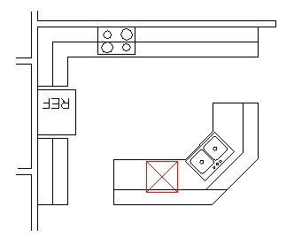

Step 2 Project lines perpendicular from the floor plan outline at each corner.
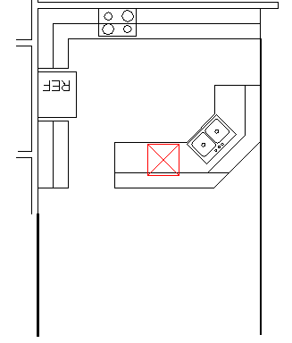
Step 3 Add ceiling lines and floor lines to give each wall its specified height.
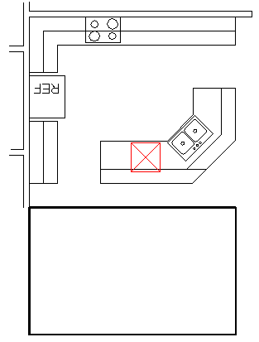
Step 4 Project lines directly from the key locations on the floor plan to each elevation drawing. This includes cabinets, appliances, windows and other details.
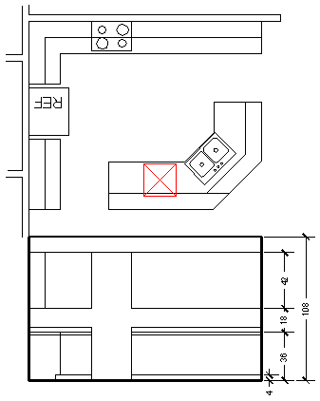
Step 5 Add detail of drawers, doors and hardware.
Step 6 Continue by elevating the front view of each line of cabinets.

