Electrical Symbols
Architectural Drawing & Design II
Unit 1: Residential Electrical Symbols

1. Single-pole switch | 
2. Three-way switch
3. Four-way switch
4. Dimmer switch | 
5. Weatherproof switch | 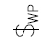
6. Ceiling outlet fixture | 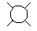
7. Wall-mounted light fixture | 
8. Recessed light fixture | 
9. Ceiling fan | 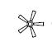
10. Fluorescent light | 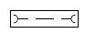
11. Telephone jack | 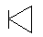
12. Chime
13. Push button
14. Bell | 
15. Duplex receptacle outlet
16. Split-wire outlet | 
17. Ground fault interrupted weatherproof duplex outlet | 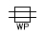
18. Floor outlet
19. 220-volt outlet receptacle | 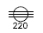
20. Exhaust fan | 
21. Smoke detector
22. Lighting distribution panel
23. Thermostat | 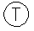
24. Junction box | 

