Electrical Symbols Test
Architectural Drawing & Design II
Unit 1: Residential Electrical Systems

Matching: (Match the following term to the correct symbol):

_____ 1. Floor outlet A. 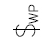

_____ 2. Three-way switch B. 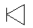

_____ 3. Duplex receptacle outlet C. 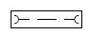

_____ 4. Exhaust fan D.

_____ 5. Bell E.

_____ 6. Telephone jack F. 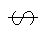

_____ 7. Recessed light fixture G. 

_____ 8. Dimmer switch H.
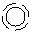
_____ 9. Single-pole switch I.

_____10. Push button J. 

_____11. Ground fault interrupted
weatherproof duplex outlet K.

_____12. Smoke detector L. 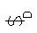

_____13. Fluorescent light M.

_____14. Junction box N. 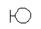

_____15. Weatherproof switch O. 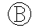

_____16. Lighting distribution panel P. 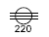

_____17. Four-way switch Q.

_____18. 220-volt outlet receptacle R. 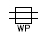

_____19. Wall-mounted light fixture S.
_____20. Ceiling outlet fixture T. 