Pictorials Quiz
Name ________________________

Use either inclined or vertical lettering to fill in the blanks.

Label each type of drawing in the blanks below.

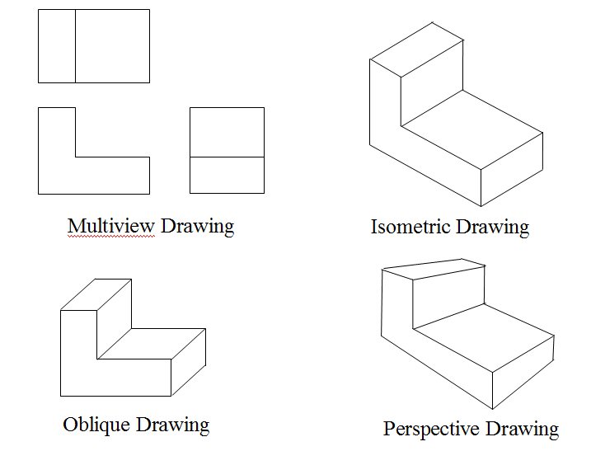

5. Which of these is not a pictorial drawing?

Isometric
Oblique
Orthographic

6. A circle will appear in an isometric as a(n)_____________.

template
ellipse
parabola
arc

7. In what kind of pictorial does the front view show its true shape?

An isometric
A perspective
An oblique

8. What kind of oblique shows its depth at half its true distance?
Cabinet

- To make true measurements in isometrics, you only measure along the isometric axes.

- What type of pictorial gives you a view of how an object actually looks to the eye?
A perspective

