Pictorial Drawings

Mechanical Sketches and Drawings:

There are four common types of drawings that you need to learn. During Graphic Communications, you will be expected to use three of these four types.

Multiview Drawing
Isometric Drawing

Perspective Drawing
Oblique Drawing

Of these four drawing types, Isometric, Oblique, and Perspective are called Pictorial Drawings.

They are used to convey general shape and structure of an object.
They are much easier for people who do not have a background reading blueprints and multiview drawings to comprehend.

For specific size information, multiview drawings are heavily relied on and are the most common technical choice.

Isometric Drawings:

For the isometric drawings that you will be creating in this class, you will be allowed and expected to use the isometric sketch paper.

If you look at a sheet of isometric sketch paper, you will see light lines running along 3 directions.
Depth
60º
Width
Height
60º
30º
30º

These represent the principle or isometric axes directions.
They typically indicate Width, Depth, and Height as shown.

Lines parallel to these directions will be very important for construction of isometric drawings because these are the only directions along which lengths will not be distorted.

So these will be the only lines you are allowed to measure along when setting off distances in an isometric drawing.

A cube shown as an isometric drawing would look like:
Depth
Width
Height
30º
30º
front
top
side

Also note, the corner angles of any side which we know to be 90 degree angles are not drawn at 90 degrees in this type of drawing.

Distances, angles, and shapes may appear distorted in an isometric drawing.

How do you create an isometric drawing which has a shape like this when seen from the front and has uniform depth dimension?
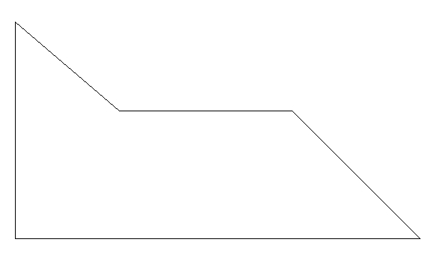

Draw the shape of the isometric. paper (supplied by instructor)
Does your drawing look

offset
dim
something like this?

Notice that certain points
had to be located using
offset dimensions.

If length and angle are distorted in an isometric
drawing, what do you think happens to circular shapes?
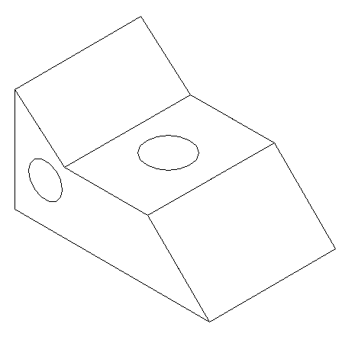

They end up being elliptical.

An easy way to draw an ellipse for a circle in an isometric view is to use an ellipse template. If you would need to draw an ellipse of a size other than your template, you might want to learn to use a method for drawing an approximate four-point ellipse.
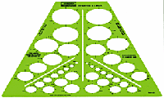

Oblique Drawings:
To create oblique drawings you will use the paper with the square grid background.

Oblique drawings have one major advantage over isometric drawings. One side of the object represented will be drawn in true size and true shape. The other two sides will be distorted as were the isometric drawings.
Width
Depth
Height
45º
front
top
side

Notice how the depth direction is angled back such that all lines indicating depth are parallel.

Most oblique drawings have depth lines which go back at 45 degrees, but any angle is possible to use. Use of 60 and 30 degree angles for depth are also common.

There are two common variations of oblique drawings.

Cavalier Drawing: Uses a depth dimension that is at equal scale to the Width and Height dimensions. Due to how we perceive shapes, this type of drawing looks excessively deep and distorted. (Scale: H:W:D )

Cabinet Drawing: Uses a depth dimension that is only ½ the scale of the dimensions used for Width and Height dimensions. This produces a visually more pleasing, well-proportioned appearance.
Scale: (H : W: ½ D)
Compare the appearance of the cube drawn by each method below.
Width
Depth
Height
Cavalier Drawing
Height
Width
½ Depth
Cabinet Drawing

But notice that the front view of both drawings is the same size; it is the depth only that is changed.

In oblique drawings, circles will show their true shape if they are placed in the front plane or face. Circles will appear elliptical if they are in the top or side views.

As a general rule, when using oblique drawings, it is best to try to keep complicated features (especially circular ones) in the front view.

Create an oblique drawing of this object which has this shape for its front view and having a consistent depth dimension.

General comments about pictorial drawings:

Construction of drawings should proceed in this order:
- Create a box of construction (very light) lines along the principal axes which enclose the entire overall form and general shape of the body.
- Next add other construction lines along principal axes to locate features of the body (usually edges of planes and surfaces).
- Use offset dimensions to locate lines which don't follow the principle axes and lightly construct them.
- Locate the center of circular features, and make construction boxes for creating the arcs.
- Darken in the final lines starting with
  - Circles and Arcs
  - Straight Lines (starting from the front of the object)
- Construction lines need not be erased if they’re drawn very lightly.
- Final lines should be dark, sharp, and consistent in width.
- Do not show hidden lines in pictorial drawings.
- Do not show center lines in pictorial drawings

Construction of an Approximate Four-Center Ellipse:
When drawing circles in isometric drawings that are not of a size available on your template, use the following method to construct an approximate four point ellipse.

The orientation of the construction rhombus depends upon the view in which the circular feature is to be drawn. The one shown below is for a circular feature in the top plane.

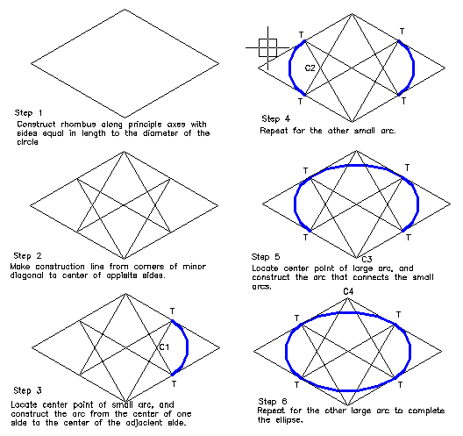
Fitting an ellipse to an isometric drawing:
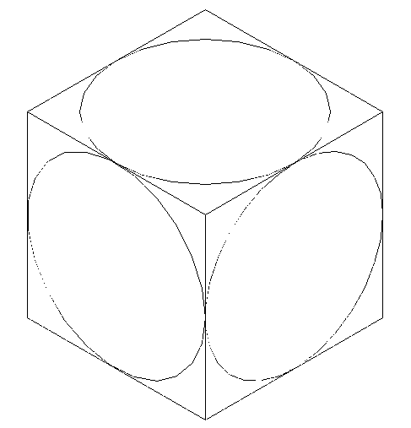

To fit a properly oriented ellipse
on an isometric drawing you need
to select both the proper size and
proper orientation of the ellipse.

Notice that the orientation depends
on which side the ellipse fall on.

The best way to size and orient an
ellipse is to box it in with a properly
sized rhombus. The sides of the
rhombus will be equal to the diameter
of the circle.

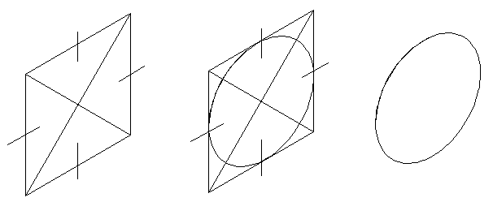

Step 1: Lightly draw in Step 2: Fit the template Step 3: Clean
a rhombus with sides equal guidelines to the box and up the line work.
in length to the diameter. draw the ellipse.

