Technical drawing

From Wikipedia, the free encyclopedia

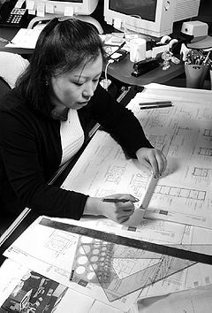

CAD Drafter at work.
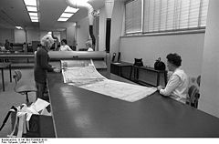

Copying technical drawings in 1973
Technical drawing is the discipline of creating standardized technical drawing by architects, CAD drafters, design engineers, and related professionals. Technical drawing includes the various fields and technologies underpinning electronics, which has in turn revolutionized the art with new tools in the form of Computer Aided Design (CAD).
A technical drawing or engineering drawing is a type of drawing and form of graphic communication, used in the transforming of an idea into physical form. This type of drawing is used to fully and clearly define requirements for engineered items, and is usually created in accordance with standardized conventions for layout, nomenclature, interpretation, appearance (such as typefaces and line styles), size, etc.
The process of creating a technical drawing is called drafting or technical drawing. A person who does drafting is known as a drafter. In some areas this person may be referred to as a drafting technician, draftsperson, or draughtsperson. A technical drawing differs from a common drawing by how it is interpreted. A common drawing can hold many purposes and meanings, while a technical drawing is intended to concisely and clearly communicate all needed specifications of a created object or objects.

Contents
[]
- 1 Overview
- 2 History
- 3 Fields of technical drawing
- 4 Types of technical drawings
  - 4.1 Construction drawing
  - 4.2 Cutaway drawings
  - 4.3 Exploded view drawing
  - 4.4 Patent drawing
  - 4.5 Technical illustrations
  - 4.6 Technical sketches
- 5 Manual drafting
- 6 Computer Aided Design
- 7 CAD drafters
- 8 See also
- 9 References
- 10 Further reading
- 11 External links

[] Overview
Technical drawing, also known as drafting, refers to the discipline of producing precise illustrations of things in fields like architecture and engineering. Generally, the term technical drawing pertains to any kind of drawing fashioned with technical ideas. Good examples of technical drawing are mechanical drawings, charts, and sketches.^{[1]} Technical drawings are a means of graphic communication, which aims to clearly and concisely communicate information about transforming technical ideas or concepts into reality. A technical drawing often contains both a graphic representation of its subject, and dimensions, notes and specifications.^{[2]}
Today the mechanics of the drafting task have been greatly accelerated through the use of computer-aided design and drafting systems, but regardless of whether a draft is drawn by hand or with computer assistance, the field-use-drawing must be reproducible with a version control system to maintain authorized and approved changes to the master document (or computer files, the modern analog).
In some fields, particularly electronics, draftsmen are also known by the ambiguous "designer", whose job would be distinct and separate from the engineers specifying and working out the design details. In short, draftsmen are communicators that are part of an engineering team charged with producing specialty documentation packaged as a design, which following the standards of the field, can be understood by others with the same training.Technical drawing in perspective is a universal picture language by which ideas and information may be readily available for others.

[] History
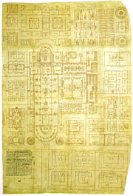

Plan of Saint Gall. Reichenau, early 9th century.
Drawing to communicate technical ideas may predate the written language. The oldest drawing instruments known, a drawing board inscripted with a temple plan, date from the 3th millennium BC from the city of Lagash in Babylon. The ancient Greeks influenced drawing through their work in geometry, and tools such as the compass and triangles used in engineering were then developed.^{[3]}
One of few surviving medieval architectural drawings from the period between the fall of the Roman Empire and the 13th century is the Plan of Saint Gall, an architectural drawing of a monastic compound dating from the early 9th century. The Plan depicts an entire Benedictine monastic compound including churches, houses, stables, kitchens, workshops, brewery, infirmary, and even a special house for bloodletting. The Plan was never actually built, and was so named because it was kept at the famous medieval monastery library of the Abbey of St. Gall, where it remains to this day.
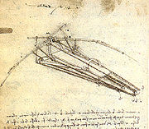

Design for a Flying Machine, Leonardo da Vinci, 1488.
The beginning of contemporary technical drawing originates from 15th century renaissance artists like the Italian Architect Filippo Brunelleschi, who in about 1415 demonstrated the geometrical method of perspective, used today by artists, by painting the outlines of various Florentine buildings onto a mirror. Leonardo da Vinci further developed perspective and technical drawing, using geometric principles from famous Greek mathematicians like Pythagoras of Samos, and Euclid of Alexandria. In the 18th century the mathematician Gaspard Monge developed descriptive geometry, when designing a complicated fortress in a star shape using orthgraphic projection. Early 19th century isometric drawing was introduced by the Englishman William Farish.^{[3]}
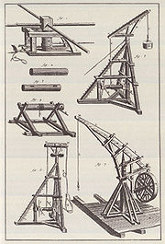

18th century Cranes.^{[4]}
Prior to the 18th century there was no need for interchangeable parts, the ability to select components for assembly at random and fit them together within proper tolerances, and acurate drawings were not necessary. Inventors, engineers and builders made each product one at a time, and each product was unique. Many designs used through the 19th century were accomplished by first completing a hand sketch of the object to build. These were then converted into wooden models from which patterns were constructed . This practice followed well into the 20th century by some. One of the first efforts to create a program to standardize drawing and establish a mechanical drawing school came from the Franklin Institute in Philadelphia in 1824.^{[5]}
The 18th century architectural practice technical drawing had become the normal medium for design. Architects were among the first design discipline to make use of conventions of plan, elevation and section in design and production control. It was the scale of the projects and number of crafts involved, that called for a separation between design and construction. By the time the Industrial revolution began, these architectural conventions were readily available to engineers.^{[6]}
Since the Industrial Revolution specialized fields of engineering design have developed to meet the needs of industry. Military and civil engineering were the first, from which others developed such as mechanical, electrical, chemical, aerospace industrial engineering, and many others.^{[7]}
Eventually the development of the computer had a major impact on the methods used to design and create technical drawings.^{[3]}

[] Fields of technical drawing
The field of technical drawing and drafting work is applied in many specialties, such as:^{[8]}
- Aeronautical drafters : prepare engineering drawings detailing plans and specifications used in the manufacture of aircraft, missiles, and related parts.
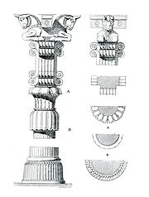

Architectural drawings of details of the Palace of Persepolis,Persia
- Architectural drawing : draw architectural and structural features of buildings and other structures. These workers may specialize in a type of structure, such as residential or commercial, or in a kind of material used, such as reinforced concrete, masonry, steel, or timber. Architectural drawing can include all architectural contracts and drawings such as plot plans, floor plans, elevations, sections, details, schedules, etc., and any architectural drawing that forms a part of the contract documents.^{[9]}
- Civil drafters : prepare drawings and topographical and relief maps used in major construction or civil engineering projects, such as highways, bridges, pipelines, flood control projects, and water and sewage systems.
- Electrical drafters : prepare wiring and layout diagrams used by workers who erect, install, and repair electrical equipment and wiring in communication centers, power plants, electrical distribution systems, and buildings.
- Electronics drafters : draw wiring diagrams, circuit board assembly diagrams, schematics, and layout drawings used in the manufacture, installation, and repair of electronic devices and components.
- Mechanical drafters : prepare drawings showing the detail and assembly of a wide variety of machinery and mechanical devices, indicating dimensions, fastening methods, and other requirements.
- Process piping or pipeline drafters : prepare drawings used in the layout, construction, and operation of oil and gas fields, refineries, chemical plants, and process piping systems.
Further, special fields of technical drawings, such as the drawing of gears and cams, welding, riveting, electrical components and circuits, piping, structures, and mapping and typography have evolved to support the specialized fields of engineering.^{[3]}

[] Types of technical drawings

[] Construction drawing
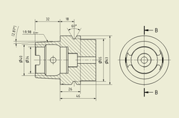

Construction drawing of a Machine tool part.
Construction drawing is a type of technical drawing, created within the engineering discipline, and used to fully and clearly define requirements for engineered items.
Construction drawings are usually created in accordance with standardized conventions for layout, nomenclature, interpretation, appearance (such as typefaces and line styles), size, etc.
Its purpose is to accurately and unambiguously capture all the geometric features of a product or a component. The end goal of an engineering drawing is to convey all the required information that will allow a manufacturer to produce that component.

[] Cutaway drawings
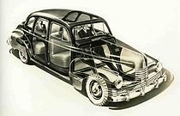

Cutaway drawing of a Nash 600.
A cutaway drawing is a technical illustration, in which surface elements a three-dimensional model are selectively removing, to make internal features visible, but without sacrificing the outer context entirely.
The purpose of a cutaway drawing is to allow the viewer to have a look into an otherwise solid opaque object. Instead of letting the inner object shine through the surrounding surface, parts of outside object are simply removed. This produces a visual appearance as if someone had cutout a piece of the object or sliced it into parts. Cutaway illustrations avoid ambiguities with respect to spatial ordering, provide a sharp contrast between foreground and background objects, and facilitate a good understanding of spatial ordering.^{[10]}

[] Exploded view drawing
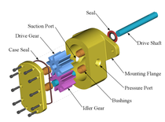

Gear pump exploded.
An exploded view drawing is a technical drawing of an object that shows the relationship or order of assembly of the various parts.^{[11]} It shows the components of an object slightly separated by distance, or suspended in surrounding space in the case of a three-dimensional exploded diagram. An object is represented as if there had been a small controlled explosion emanating from the middle of the object, causing the object's parts to be separated an equal distance away from their original locations.
An exploded view drawing can show the intended assembly of mechanical or other parts. In mechanical systems usually the component closest to the center are assembled first, or is the main part in which the other parts get assembled. This drawing can also help to represent disassembly of parts, where the parts on the outside normally get removed first.^{[12]}

[] Patent drawing
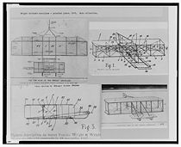

Wright brothers Patent drawing, 1908.
A patent drawing is a technical drawing of an patent invention, that shows the nature of the invention. The drawing must show every feature of the invention specified in the claims, and is required by the patent office rules to be in a particular form.
The applicant for a patent will be required by law to furnish a drawing of the invention whenever the nature of the case requires a drawing to understand the invention. This drawing must be filed with the application. This includes practically all inventions except compositions of matter or processes, but a drawing may also be useful in the case of many processes.^{[11]}
The drawing must show every feature of the invention specified in the claims, and is required by the patent office rules to be in a particular form. The Office specifies the size of the sheet on which the drawing is made, the type of paper, the margins, and other details relating to the making of the drawing. The reason for specifying the standards in detail is that the drawings are printed and published in a uniform style when the patent issues, and the drawings must also be such that they can be readily understood by persons using the patent descriptions.^{[11]}

[] Technical illustrations
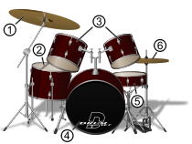

Illustration of a drum set.
Technical illustration is the use of illustration to visually communicate information of a technical nature. Technical illustrations can be component technical drawings or diagrams. The aim of technical illustration is to generate expressive images that effectively convey certain information via the visual channel to the human observer.^{[13]}
The main purpose of technical illustration is to describe or explain these items to a more or less nontechnical audience. The visual image should be accurate in terms of dimensions and proportions, and should provide an overall impression of what an object is or does, to enhance the viewer’s interest and understanding.^{[14]}
Illustrative techniques are often designed in way that even a person with no technical understanding clearly understands the piece of art. The use of varying line widths to emphasize mass, proximity, and scale helped to make a simple line drawing more understandable to the lay person. Cross hatching, stippling, and other low abstraction techniques gave greater depth and dimension to the subject matter.^{[13]}
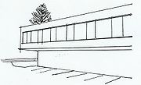

Sketch for a government building.

[] Technical sketches
A sketch is a rapidly executed freehand drawing that is not intended as a finished work. In general, a sketch is a quick way to record an idea for later use. Architect's sketches primarily serve as a way to try out different ideas and establish a composition before undertaking a more finished work, especially when the finished work is expensive and time consuming.
Architectural sketches, for example, are a kind of diagrams.^{[15]} These sketches, like metaphors, are used by architects as a mean of communication in aiding design collaboration. This tool helps architects to abstract attributes of hypothetical provisional design solutions and summerize their complex patters, hereby enhancing the design process.^{[15]}

[] Manual drafting
The basic drafting procedure is to place a piece of paper (or other material) on a smooth surface with right-angle corners and straight sides—typically a drafting table. A sliding straightedge known as a T-square is then placed on one of the sides, allowing it to be slid across the side of the table, and over the surface of the paper.
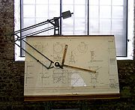

A drafting table
"Parallel lines" can be drawn simply by moving the T-square and running a pencil or technical pen along the T-square's edge, but more typically the T-square is used as a tool to hold other devices such as set squares or triangles. In this case the draftsman places one or more triangles of known angles on the T-square—which is itself at right angles to the edge of the table—and can then draw lines at any chosen angle to others on the page. Modern drafting tables (which have by now largely been replaced by CAD workstations) come equipped with a parallel rule that is supported on both sides of the table to slide over a large piece of paper. Because it is secured on both sides, lines drawn along the edge are guaranteed to be parallel.
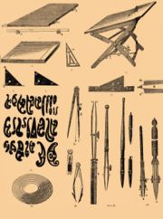

Technical drawing instruments
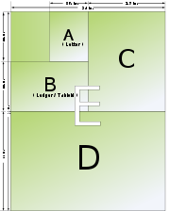

Size chart with ANSI sizes
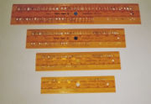

Stencils for correct technical writing.
In addition, the draftsperson uses several tools to draw curves and circles. Primary among these are the compasses, used for drawing simple arcs and circles, and the: French curve, typically a piece of plastic with complex curves on it. A spline is a rubber coated articulated metal that can be manually bent to most curves.
Drafting templates assist the draftsperson with creating recurring objects in a drawing without having to reproduce the object from scratch every time. This is especially useful when using common symbols; i.e. in the context of stagecraft, a lighting designer will typically draw from: the USITT standard library of lighting fixture symbols to indicate the position of a common fixture across multiple positions. Templates are sold commercially by a number of vendors, usually customized to a specific task, but it is also not uncommon for a draftsperson to create their own templates.
Basic drafting system
Drawing  type "name" | Dimensions  (width X height) | Drawing  type "name" | Dimensions  (width X height)
A-size | 8.5 by 11.0 inches  22 cm by 28 cm | B-size | 11.0 by 17.0 inches  28 cm by 43 cm
C-size | 17.0 by 22.0 inches  43 cm by 56 cm | D-size | 22.0 by 34.0 inches  56 cm by 86 cm
E-size | 34.0 by 44.0 inches  86 cm by 112 cm | F-size | 44.0 by 68.0 inches  112 cm by 173 cm
G-size | 68.0 by 88.0 inches  224 cm by 173 cm | H-size | 88.0 by 136 inches  173 cm by 345 cm
As can be seen in the series, the height of the previous drawing
size becomes double the height of the next size in the sequence.
This basic drafting system requires an accurate table and constant attention to the positioning of the tools. A common error is to allow the triangles to push the top of the T-square down slightly, thereby throwing off all angles. Even tasks as simple as drawing two angled lines meeting at a point require a number of moves of the T-square and triangles, and in general drafting can be a time consuming process.
A solution to these problems was the introduction of the mechanical "drafting machine", an application of the pantograph (sometimes referred to incorrectly as a "pentagraph" in these situations) which allowed the draftsman to have an accurate right angle at any point on the page quite quickly. These machines often included the ability to change the angle, thereby removing the need for the triangles as well.
In addition to the mastery of the mechanics of drawing lines, arcs and circles (and text) onto a piece of paper—with respect to the detailing of physical objects—the drafting effort requires a thorough understanding of geometry, trigonometry and spatial comprehension, and in all cases demands precision and accuracy, and attention to detail of high order.
Although drafting is sometimes accomplished by a project engineer, architect—or even by shop personnel such as a machinist—skilled drafters (and/or designers) usually accomplish the task and are always in demand to some level.

[] Computer Aided Design
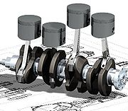

An oblique view of a four-cylinder inline crankshaft with pistons.
Today, the mechanics of the drafting task have largely been automated and accelerated through the use of Computer Aided Design systems (CAD). Computer-aided design is the use of computer technology to aid in the design and particularly the drafting of a part or product, including entire buildings. It is both a visual (or drawing) and symbol-based method of communication whose conventions are particular to a specific technical field.
Drafting can be done in two dimensions ("2D") and three dimensions ("3D"). Drafting is the integral communication of technical or engineering drawings and is the industrial arts sub-discipline that underlies all involved technical endeavors. In representing complex, three-dimensional objects in two-dimensional drawings, these objects have traditionally been represented by three projected views at right angles.

[] CAD drafters
CAD drafters prepare technical drawings and plans, which are used to build everything from manufactured products such as toys, toasters, industrial machinery, and spacecraft to structures such as houses, office buildings, and oil and gas pipelines.^{[8]}
In the past, drafters sat at drawing boards and used pencils, pens, compasses, protractors, triangles, and other drafting devices to prepare a drawing by hand. Now, most drafters use Computer Aided Design and Drafting (CADD) systems to prepare drawings. Consequently, some drafters may be referred to as CADD operators.^{[8]}
With CADD systems, drafters can create and store drawings electronically so that they can be viewed, printed, or programmed directly into automated manufacturing systems. CADD systems also permit drafters to quickly prepare variations of a design. Although drafters use CADD extensively, it is only a tool. Drafters still need knowledge of traditional drafting techniques, in addition to CADD skills. Despite the nearly universal use of CADD systems, manual drafting and sketching are used in certain applications.^{[8]}

[] See also
- Topic outline of drawing
- Architectural drawing
- Engineering drawing
- ISO 128 Technical drawings -- General principles of presentation
- Plan (drawing)
- Shop drawing
- Technical lettering

[] References
- ^ What is Technical Drawing?. Accessed 26 feb 2009.
- ^ David L. Goetsch et al. (2005). Technical Drawing. Cengage Learning, 2005. ISBN 1401857604. p.3.
- ^ ª ^{b} ^{c} ^{d} Gary R. Bertoline et al. (2002) Technical Graphics Communication‎. McGraw-Hill Professional, 2002. ISBN 0073655988, p.12.
- ^ From Diderot and d'Alembert, Encyclopédie (1751-72).
- ^ James Folkestad er al. (2001). Engineering Drawing & Design. Cengage Learning, 2001. ISBN 0766816346. pp 1-2.
- ^ Ken Baynes, Francis Pugh (1981) The Art of the Engineer‎. James Clarke & Co., 1981. ISBN 0718825063. p.31.
- ^ Gary Robert Bertoline and Eric N. Wiebe (2004). Fundamentals of Graphics Communication‎. McGraw-Hill Professional, 2004. ISBN 0072973137, p. 15.
- ^ ª ^{b} ^{c} ^{d} Bureau of Labor Statistics. Occupational Outlook Handbook, 2008-09 Edition: Drafters dated: 2007-12-18. accessed: 2008-09-24.
- ^ Glossary of Terms. triangleofficeguide.com. Accessed 10 Feb 2009.
- ^ J. Diepstraten, D. Weiskopf & T. Ertl (2003). "Interactive Cutaway Illustrations". in: Eurographics 2003. P. Brunet and D. Fellner (ed). Vol 22 (2003), Nr 3.
- ^ ª ^{b} ^{c} United States Patent and Trademark Office (2005), General Information Concerning Patents § 1.84 Standards for drawings (Revised January 2005). Accessed 13 Feb 2009.
- ^ Michael E. Brumbach, Jeffrey A. Clade (2003). Industrial Maintenance. Cengage Learning, 2003 ISBN 0766826953, p.65
- ^ ª ^{b} Ivan Viola and Meister E. Gröller (2005). "Smart Visibility in Visualization". In: Computational Aesthetics in Graphics, Visualization and Imaging. L. Neumann et al. (Ed.)
- ^ www.industriegrafik.com website, Last modified: Juni 15, 2002. Accessed 15 feb 2009.
- ^ ª ^{b} Richard Boland and Fred Collopy (2004). Managing as designing. Stanford University Press, 2004. ISBN 0804746745, p.69.
 | This article needs additional citations for verification. Please help improve this article by adding reliable references. Unsourced material may be challenged and removed. (February 2009)

[] Further reading
- Peter J. Booker (1963). A History of Engineering Drawing. London: Northgate.
- Franz Maria Feldhaus (1963). The History of Technical Drawing
- Wolfgang Lefèvre ed. (2004). Picturing Machines 1400-1700 : How technical drawings shaped early engineering practice. MIT Press, 2004. ISBN 0262122693

[] External links
 | Wikimedia Commons has media related to: Technical drawing
- Historical technical diagrams and drawings at NASA.

