What are Engineers and Engineering?

The Engineering Profession:
Engineers apply the principles of science and mathematics to develop economical solutions to technical problems. Their work is the link between perceived social needs and commercial applications. Engineers consider many factors when developing a new product.

For example, in developing an industrial robot an engineer’s work might include:
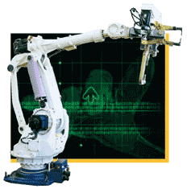
- precisely specifying the functional requirements
- designing and testing the robot’s components
- integrating the components to finalalize the design
- evaluating the design’s overall effectiveness, cost, reliability, and safety.

Such a process applies to the development of many different products such as chemicals, computers, gas turbines, helicopters, and toys.

In addition to design and development, many engineers work in testing, production, or maintenance. This might include work such as:
- supervising production in factories
- determining the causes of component failure
- testing manufactured products to maintain quality
- estimating the time and cost to complete projects
- engineering management or technical sales

Engineers use computers extensively. Some of the ways in which the computer is used are:
- to produce and analyze designs
- to simulate and test how a machine, structure, or system operates
- to generate specifications for parts
- to monitor product quality and control process efficiency

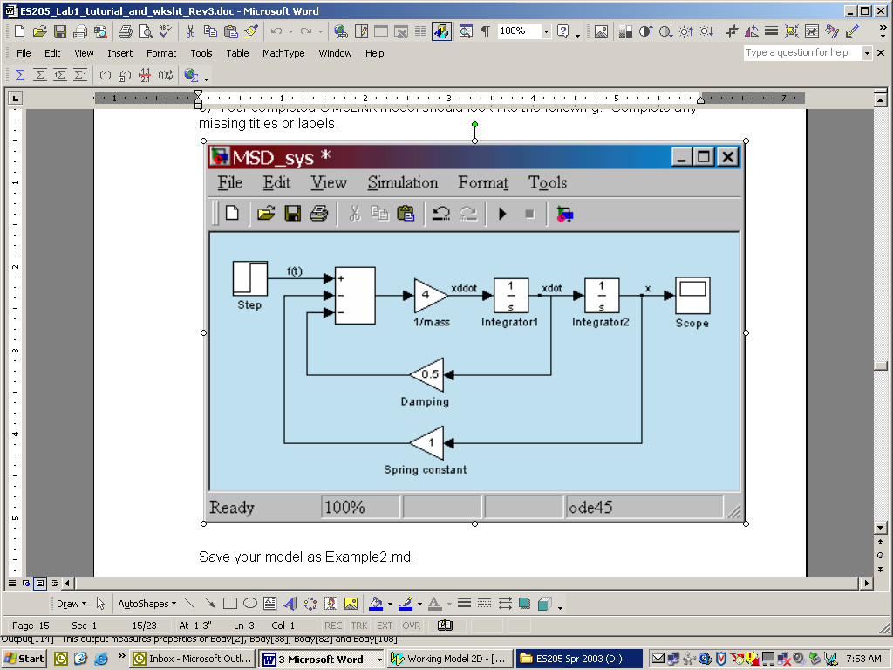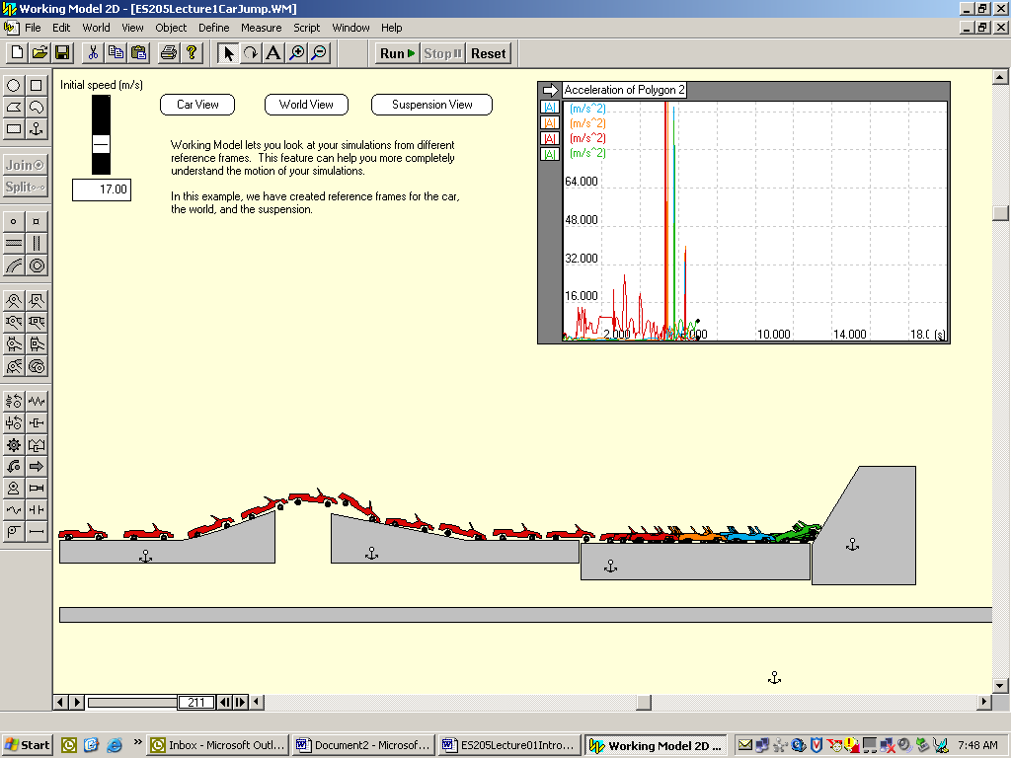

Traits of a successful engineer:
Interpersonal skills Communication skills
Leadership Competence
Logical thinking Quantitative thinking
Follow through Continues with Education
Maintains a professional library Dependability
Honest
Organization Common sense
Curiosity
Involvement in the community Creativity

What traits does a creative engineer have?
Stick-to-itness…does not give up.
Asks why…curious about the world and wants to understand
Is never satisfied…Compelled to do things better
Learns from accidents….grows from unexpected results
Makes analogies…solutions are often found along parallel paths
Generalizes…looks for a broader implication
Develops qualitative and quantitative understanding
Has good visualization skills…thinks and communicates in 3-D
Posseses unbounded thinking…able to think outside the box.
Has broad interests…helps balance career, family, and life.
Collects obscure information…more knowledge is never bad.
Works with nature, not against it…sometimes the best solution
Keeps an engineering "toolbox"...build a set of tools as you learn.

Most engineers specialize. Numerous specialties are recognized by professional societies, and the major branches of engineering have numerous subdivisions. For example, structural and transportation engineering are often considered subdivisions of civil engineering. Ceramic, metallurgical, and polymer engineering are considered subdivisions of materials engineering.

Major Branches of Engineering include:
- Aerospace engineers design, develop, and test aircraft, spacecraft, and missiles and supervise the manufacture of these products. Those who work with aircraft are called aeronautical engineers, and those working specifically with spacecraft are astronautical engineers. Aerospace engineers develop new technologies for use in aviation, defense systems, and space exploration, often specializing in areas such as structural design, guidance, navigation and control, instrumentation and communication, or production methods.

- Agricultural engineers apply knowledge of engineering technology and science to agriculture and the efficient use of biological resources. They design agricultural machinery and equipment and agricultural structures. They develop ways to conserve soil and water and to improve the processing of agricultural products. Agricultural engineers often work in research and development, production, sales, or management.

- Biomedical engineers develop devices and procedures that solve medical and health-related problems by combining their knowledge of biology and medicine with engineering principles and practices. Many do research, along with life scientists, chemists, and medical scientists, to develop and evaluate systems and products such as artificial organs, prostheses, instrumentation, medical information systems, and health management and care delivery systems. Most engineers in this specialty need a sound background in another engineering specialty, such as mechanical or electronics engineering, in addition to specialized biomedical training.

- Chemical engineers apply the principles of chemistry to solve problems involving the production or use of chemicals and biochemicals. They design equipment and processes for large-scale chemical manufacturing, plan and test methods of manufacturing products and treating byproducts, and supervise production. Chemical engineers also work in a variety of manufacturing industries other than chemical manufacturing, such as those producing energy, electronics, food, clothing, and paper. They must be aware of all aspects of chemicals manufacturing and how the manufacturing process affects the environment and the safety of workers and consumers.

- Civil engineers design and supervise the construction of roads, buildings, airports, tunnels, dams, bridges, and water supply and sewage systems. They must consider many factors in the design process, from the construction costs and expected lifetime of a project to government regulations and potential environmental hazards such as earthquakes. Civil engineering, considered one of the oldest engineering disciplines, encompasses many specialties. The major specialties are structural, water resources, construction, environmental, transportation, and geotechnical engineering. Many civil engineers hold supervisory or administrative positions, from supervisor of a construction site to city engineer. Others may work in design, construction, research, and teaching.
- Computer hardware engineers research, design, develop, test, and oversee the installation of computer hardware and supervise its manufacture and installation. Hardware refers to computer chips, circuit boards, computer systems, and related equipment such as keyboards, modems, and printers. The work of computer hardware engineers is very similar to that of electronics engineers, but, unlike electronics engineers, computer hardware engineers work exclusively with computers and computer-related equipment.

- Electrical engineers design, develop, test, and supervise the manufacture of electrical equipment. Some of this equipment includes electric motors; machinery controls, lighting, and wiring in buildings; automobiles; aircraft; radar and navigation systems; and power-generating, -controlling, and transmission devices used by electric utilities. Although the terms “electrical” and “electronics” engineering often are used interchangeably in academia and industry, electrical engineers have traditionally focused on the generation and supply of power, whereas electronics engineers have worked on applications of electricity to control systems or signal processing. Electrical engineers specialize in areas such as power systems engineering or electrical equipment manufacturing.

- Electronics engineers, except computer, are responsible for a wide range of technologies, from portable music players to the global positioning system (GPS), which can continuously provide the location of a vehicle. Electronics engineers design, develop, test, and supervise the manufacture of electronic equipment such as broadcast and communications systems. Many electronics engineers also work in areas closely related to computers. However, engineers whose work is related exclusively to computer hardware are considered computer hardware engineers. Electronics engineers specialize in areas such as communications, signal processing, and control systems or have a specialty within one of these areas—industrial robot control systems or aviation electronics, for example.

- Environmental engineers develop solutions to environmental problems using the principles of biology and chemistry. They are involved in water and air pollution control, recycling, waste disposal, and public health issues. Environmental engineers conduct hazardous-waste management studies in which they evaluate the significance of the hazard, advise on treatment and containment, and develop regulations to prevent mishaps. They design municipal water supply and industrial wastewater treatment systems. They conduct research on the environmental impact of proposed construction projects, analyze scientific data, and perform quality-control checks.

- Health and safety engineers promote worksite or product safety by applying knowledge of industrial processes and mechanical, chemical, and human performance principles. Using this specialized knowledge, they identify and measure potential hazards to people or property, such as the risk of fires or the dangers involved in the handling of toxic chemicals. Health and safety engineers develop procedures and designs to reduce the risk of injury or damage. Some work in manufacturing industries to ensure the designs of new products do not create unnecessary hazards. They must be able to anticipate, recognize, and evaluate hazardous conditions, as well as develop hazard control methods.

- Industrial engineers determine the most effective ways to use the basic factors of production—people, machines, materials, information, and energy—to make a product or to provide a service. They are mostly concerned with increasing productivity through the management of people, methods of business organization, and technology. They develop management control systems to aid in financial planning and cost analysis, and design production planning and control systems to coordinate activities and ensure product quality. They also design or improve systems for the physical distribution of goods and services, as well as determine the most efficient plant locations. Many industrial engineers move into management positions because the work is closely related to the work of managers.

- Marine engineers and naval architects are involved in the design, construction, and maintenance of ships, boats, and related equipment. They design and supervise the construction of everything from aircraft carriers to submarines, and from sailboats to tankers. Naval architects work on the basic design of ships, including hull form and stability. Marine engineers work on the propulsion, steering, and other systems of ships. Marine engineers and naval architects apply knowledge from a range of fields to the entire design and production process of all water vehicles.

- Materials engineers are involved in the development, processing, and testing of the materials used to create a range of products, from computer chips and television screens to golf clubs and snow skis. They work with metals, ceramics, plastics, semiconductors, and composites to create new materials that meet certain mechanical, electrical, and chemical requirements. They also are involved in selecting materials for new applications. Materials engineers have developed the ability to create and then study materials at an atomic level, using advanced processes to replicate the characteristics of materials and their components with computers.

- Mechanical engineers research, develop, design, manufacture, and test tools, engines, machines, and other mechanical devices. They work on power-producing machines such as electric generators, internal combustion engines, and steam and gas turbines, as well as power-using machines such as refrigeration and air-conditioning equipment, machine tools, material handling systems, elevators and escalators, industrial production equipment, and robots used in manufacturing. Mechanical engineers also design tools that other engineers need for their work. Mechanical engineering is one of the broadest engineering disciplines. Mechanical engineers may work in production operations in manufacturing or agriculture, maintenance, or technical sales; many are administrators or managers.

- Mining and geological engineers find, extract, and prepare coal, metals, and minerals for use by manufacturing industries and utilities. They design open-pit and underground mines, supervise the construction of mine shafts and tunnels in underground operations, and devise methods for transporting minerals to processing plants. Mining engineers are responsible for the safe, economical, and environmentally sound operation of mines. Some mining engineers work with geologists and metallurgical engineers to locate and appraise new ore deposits. Others develop new mining equipment or direct mineral- processing operations that separate minerals from the dirt, rock, and other materials with which they are mixed.

- Nuclear engineers research and develop the processes, instruments, and systems used to derive benefits from nuclear energy and radiation. They design, develop, monitor, and operate nuclear plants to generate power. They may work on the nuclear fuel cycle—the production, handling, and use of nuclear fuel and the safe disposal of waste produced by the generation of nuclear energy—or on the development of fusion energy. Some specialize in the development of nuclear power sources for spacecraft; others find industrial and medical uses for radioactive materials, as in equipment used to diagnose and treat medical problems.

- Petroleum engineers search the world for reservoirs containing oil or natural gas. Once these resources are discovered, petroleum engineers work with geologists and other specialists to understand the geologic formation and properties of the rock containing the reservoir, determine the drilling methods to be used, and monitor drilling and production operations. They design equipment and processes to achieve the maximum profitable recovery of oil and gas. Petroleum engineers research and develop technology and methods to increase recovery and lower the cost of drilling and production operations.
Engineering Functions:
These represent some of the different work roles which you may find exist throughout the engineering specialties.

Research: search for new knowledge to solve difficult problems that do not have readily apparent solutions. A research position usually requires attainment of an advanced degree.

Development: apply existing and new knowledge to develop prototypes of new devices, structures, and processes.

Testing: perform test on engineered products to determine their reliability and suitability for particular applications.

Design: apply the results of research and development engineers to produce detailed designs of devices, structures, and processes that will be used by the public.

Analysis: use mathematical and computer tools to analyze and make predictions about how specific designs or products perform.

Systems: involve in the integration of many individual smaller systems and components into a large, often complex function process or product.

Manufacturing and Construction: concern with specifying production schedules, determine raw materials availability, and optimizing assembly lines to mass produce the devices conceived by design engineers.

Operations and Maintenance: run and maintain large production facilities such as factories, power production plants, and chemical plants.

Technical and Customer Support: usually are involved with creating, storing, and disseminating documented technical information either in written or verbal forms for use by employees, customers, and/or public.

Sales: engineers with good communication skills and a technical background to facilitate determination of a customer’s needs.

Consulting: specialists who are called upon by companies to supplement their in-house engineering talent and with skills not available in the company.

Management: coordinate the activities and work of other engineering and nonengineering employees involved in research, development, design, or production.
Working Conditions:
Most engineers work in office buildings, laboratories, or industrial plants. Others may spend time outdoors at construction sites and oil and gas exploration and production sites, where they monitor or direct operations or solve onsite problems. Some engineers travel extensively to plants or worksites.
Many engineers work a standard 40-hour week. At times, deadlines or design standards may bring extra pressure to a job, requiring engineers to work longer hours.

Education, Training, Licensing, and Advancement:
A bachelor’s degree in engineering is required for almost all entry-level engineering jobs. However, engineers trained in one branch may work in related branches. It also allows engineers to shift to fields with better employment prospects or to those that more closely match their interests.
Most engineering programs involve a concentration of study in an engineering specialty, along with courses in both mathematics and the physical and life sciences. General courses not directly related to engineering, such as those in the social sciences or humanities, are often a required component of programs. A design course is part of the curriculum of most programs.
Graduate training is essential for engineering faculty positions and many research and development programs but is not required for the majority of entry-level engineering jobs. Many engineers obtain graduate degrees in engineering or business administration to learn new technology and broaden their education. Many high-level executives in government and industry began their careers as engineers.
All 50 States and the District of Columbia require licensure for engineers who offer their services directly to the public. Engineers who are licensed are called professional engineers (PE). This licensure generally requires a degree from an accredited engineering program, 4 years of relevant work experience, and successful completion of a State examination.
Engineers should be creative, inquisitive, analytical, and detail-oriented. They should be able to work as part of a team and to communicate well, both orally and in writing. Communication abilities are important because engineers often interact with specialists in a wide range of fields outside engineering.
Beginning engineering graduates usually work under the supervision of experienced engineers and, in large companies, also may receive formal classroom or seminar-type training. As new engineers gain knowledge and experience, they are assigned more difficult projects with greater independence to develop designs, solve problems, and make decisions. Engineers may advance to become technical specialists or to supervise a staff or team of engineers and technicians. Some may eventually become engineering managers or enter other managerial or sales jobs.

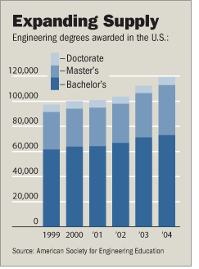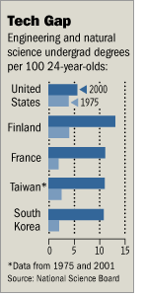

Earnings and Salary Information:
Earnings for engineers vary significantly by specialty, industry, and education. Even so, as a group, engineers earn some of the highest average starting salaries among those holding bachelor’s degrees. The following tabulation shows average starting salary offers for engineers, according to a 2005 survey by the National Association of Colleges and Employers.

Earnings by education and selected field:
Curriculum | Bachelor's | Master's | Ph.D.
Aerospace/aeronautical/astronautical | $50,993 | $62,930 | $72,529
Agricultural | 46,172 | 53,022 | —
Bioengineering and biomedical | 48,503 | 59,667 | —
Chemical | 53,813 | 57,260 | 79,591
Civil | 43,679 | 48,050 | 59,625
Computer | 52,464 | 60,354 | 69,625
Electrical/electronics and communications | 51,888 | 64,416 | 80,206
Environmental/environmental health | 47,384 | — | —
Industrial/manufacturing | 49,567 | 56,561 | 85,000
Materials | 50,982 | — | —
Mechanical | 50,236 | 59,880 | 68,299
Mining & mineral | 48,643 | — | —
Nuclear | 51,182 | 58,814 | —
Petroleum | 61,516 | 58,000 | —

Variation in median earnings and in the earnings distributions for engineers in the various branches of engineering also is significant. For engineers in specialties covered in this statement, earnings distributions by percentile in May 2004 are shown in the following tabulation.
Distribution of engineering salaries by specialty...May 2004
Specialty | 10% | 25% | 50% | 75% | 90%
Aerospace | $52,820 | $64,380 | $79,100 | $94,900 | $113,520
Agricultural | 37,680 | 43,270 | 56,520 | 77,740 | 90,410
Biomedical | 41,260 | 51,620 | 67,690 | 86,400 | 107,530
Chemical | 49,030 | 60,920 | 76,770 | 94,740 | 115,180
Civil | 42,610 | 51,430 | 64,230 | 79,920 | 94,660
Computer hardware | 50,490 | 63,730 | 81,150 | 102,100 | 123,560
Electrical | 47,310 | 57,540 | 71,610 | 88,400 | 108,070
Electronics, except computer | 49,120 | 60,280 | 75,770 | 92,870 | 112,200
Environmental | 40,620 | 50,740 | 66,480 | 83,690 | 100,050
Health and safety, except mining safety | 39,930 | 49,900 | 63,730 | 79,500 | 92,870
Industrial | 42,450 | 52,210 | 65,020 | 79,830 | 93,950
Marine engineers and naval architects | 43,790 | 54,530 | 72,040 | 89,900 | 109,190
Materials | 44,130 | 53,510 | 67,110 | 83,830 | 101,120
Mechanical | 43,900 | 53,070 | 66,320 | 82,380 | 97,850
Mining and geological, including mining safety | 39,700 | 50,500 | 64,690 | 83,050 | 103,790
Nuclear | 61,790 | 73,340 | 84,880 | 100,220 | 118,870
Petroleum | 48,260 | 65,350 | 88,500 | 113,180 | 140,800

Practicing Engineers in US
Engineering  specialty | % | Number in thousands
Electrical | 23% | 360
Mechanical | 15% | 240
Civil | 13% | 200
Aerospace | 8% | 130
Industrial | 4% | 70
Chemical | 4% | 60
Materials | 2% | 30
Nuclear | 1% | 20
Petroleum | 1% | 15
Mining | 1% | 15
Other | 27% | 420
according to Bureau of Labor Statistics (1999)

References: (much of the information presented here was found from the following sources)

--Oakes, Leone, and Potter, Engineering Your Future, published by Great Lakes Press

--U.S. Department of Labor, Occupational Outlook Handbook,
on the web at http://www.bls.gov/oco/ocos027.htm

--Hotzapple and Reece, Foundation of Engineering, published by McGrawHill

