Constructing polygons

Choose from Draw panel or type pol.
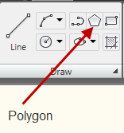

You are first prompted for the number of sides. Then you must decide whether you want it inscribed or circumscribed.

Think of inscribed as the figure being inside an imaginary circle with its points touching the inside of the circle.

Circumscribed is the figure on the outside of an imaginary circle with its flats touching the outside of the circle.

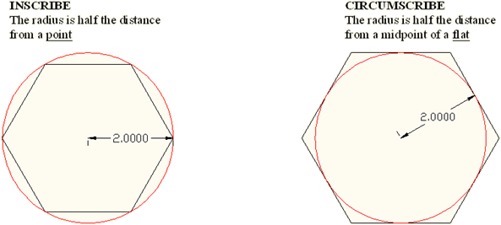

If you know the distance from point If you know the distance across the
to point on your polygon, you would flats, you would circumscribe it.
inscribe it.

Polygons are made up of polylines, a connected sequence of segments created as a single object. If you selected a side of a polygon, you would choose the whole figure. To modify a part of your polygon, you must first explode it it (Modify panel>explode).

