Draw, Zoom, Pan and Infocenter

This lesson is based on Autodesk’s AutoCAD 2009. If you are running another version, use the appropriate tutorial from Autodesk for your software.

Hand out student notes and vocabulary sheets. Have students note definitions on sheet.

Discuss that there are various ways to enter commands, but start students by choosing symbols in the Draw menu.

Access http://usa.autodesk.com/adsk/servlet/item?siteID=123112&id=13202153&linkID=9240615, show video “Getting Started with the Basics.”

After showing video, project a drawing and go through steps below. When finished, have students practice same steps.

Start by choosing line command in Draw.

Choose 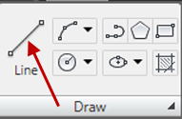
Demonstrate.

Drag mouse to draw and enter x and y coordinates from keyboard to enter distances. Separate coordinates with a comma to enter x value. Tab between dynamic input boxes.
Demonstrate.

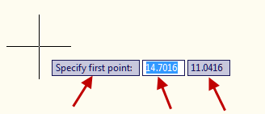

Entering command, either:
- Escape
- Enter
- Space bar
- Right click>enter
Demonstrate all four.

Show how to select a line and either delete or right click>Erase.

Explain the difference in a window selection (l to r) and a crossing selection (r to l). Demonstrate.

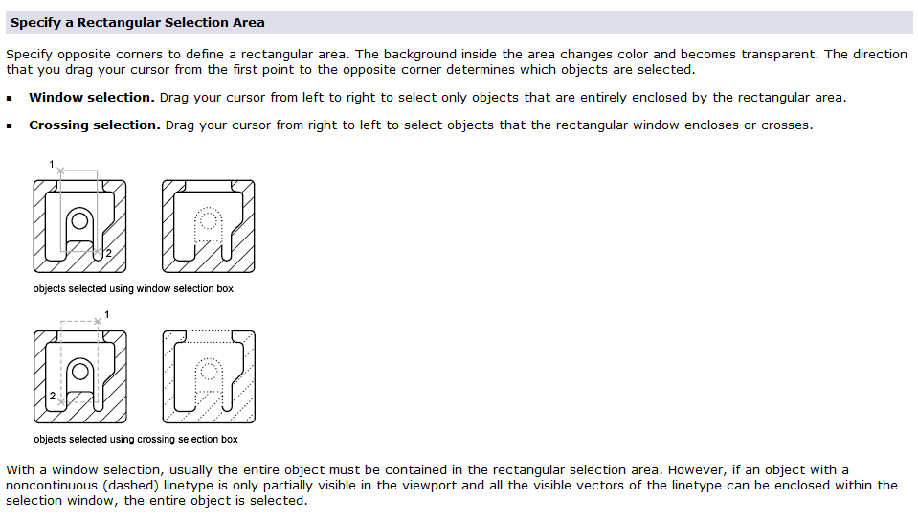

Concept: Difference in Zoom and Pan:

Zoom is as though you are able to move closer to the drawing and Pan is as though you can move the drawing around. Using a camera as an example, Zoom is getting closer with the camera and Pan is moving the camera around.

Zoom most easily by rolling the wheel on the mouse. Double click to reset drawing to fill screen. This is zoom extents.

Pan most easily by holding down mouse and moving on screen. A hand will show during Pan rather than the cursor.

Infocenter
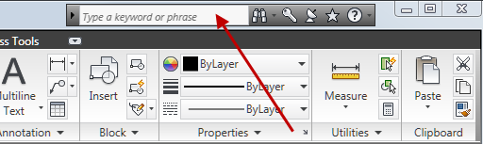

Enter keywords to access online or tutorial help.

Vocabulary and concepts

Line command
Dynamic prompt
Dynamic input
x and y coordinates
Entering commands
Deleting lines
Window selection
Crossing selection
Zoom
Zoom extents
Pan
Infocenter

