Draw, Zoom, Pan and Infocenter

Name ___________________________________________

Vocabulary and concepts

Line command

Dynamic prompt

Dynamic input

x and y coordinates

Entering commands

Deleting lines

Window selection

Crossing selection

Zoom

Zoom extents

Pan

Infocenter

Start by choosing line command in Draw.

Choose 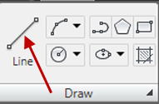

Drag mouse to draw and enter x and y coordinates from keyboard to enter distances. Separate coordinates with a comma to enter x value. Tab between dynamic input boxes.

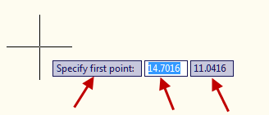

Entering command, either:
- Escape
- Enter
- Space bar
- Right click>enter

Select a line and either delete or right click>Erase.

Note the difference in a window selection (l to r) and a crossing selection (r to l).

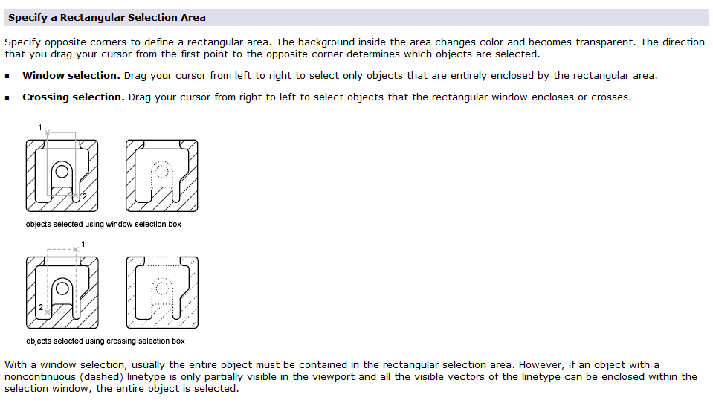

Concept: Difference in Zoom and Pan:

Zoom is as though you are able to move closer to the drawing and Pan is as though you can move the drawing around. Using a camera as an example, Zoom is getting closer with the camera and Pan is moving the camera around.

Zoom most easily by rolling the wheel on the mouse. Double click to reset drawing to fill screen. This is zoom extents.

Pan most easily by holding down mouse and moving on screen. A hand will show during Pan rather than the cursor.

Infocenter
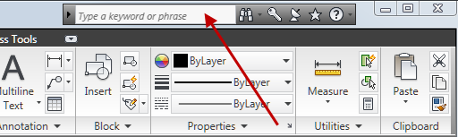

Enter keywords to access online or tutorial help.

