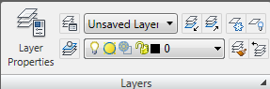
Turn a layer on or off
Freeze or thaw in all viewports
Freeze or thaw in current viewport
Lock or unlock a layer
Layer color
Layer control

