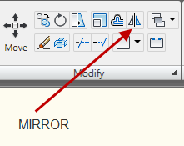

This command is a timesaver when drawing symmetrical objects. It lets you draw half the object and copy that half to replicate it along a center line.

MIRROR can also be used along with your Polar tracking to draw a fourth of an object that is symmetric in more than one direction and mirror it in two directions to complete the object.

