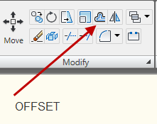

OFFSET is used to create copies of objects, arcs and circles that will be parallel and a designated distance from the original entity.

After entering command, you are prompted for a distance to offset. Enter a distance and then move your cursor in the direction you wish to offset.

