Object Snaps

A precision tool that allows you to snap to specific points in the geometry.

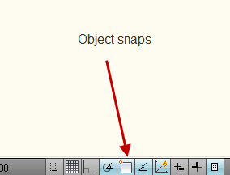

Right click to see Osnaps.

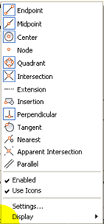

Choose Settings to see which Osnaps to set.

You can hover over each snap to see its purpose.

Most often used snaps are

Endpoint will snap your cursor to an end of another line segment.
Midpoint will snap your cursor to the middle of a segment. This is the same concept as bisecting a segment.
Intersection will snap to the intersection of two lines.

Center will find the center point of a circle or an arc.
Perpendicular snaps a line to a 90 degree intersection to another line.
Tangent will snap to a circular object. It’s easier to start a line to find the tangent than trying to find the tangent point first.
Nearest makes sure that a line makes a true intersection with another.
Parallel allows you to hesitate over another line and then it will show a vector you can follow to draw parallel to another figure or line.

