PLOTTING ON SIZE "A" DRAWING PAPER

- Select the Plot option in the Files Pull-down menu. A Plot-Model Configuration dialog box will appear on the screen.

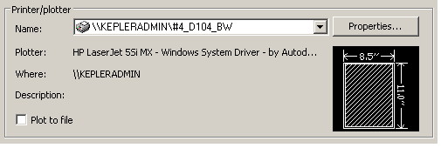
- In the “Printer/Plotter” section click on the “Name:” drop down box and select the #2_D104_BW plotter.

- 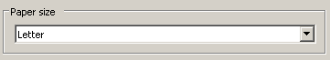In the “Paper size” section click on the drop down arrow and select the "Letter” paper size.

- In the "Plot Area" section click on the drip down arrow and select "Limits” in the “What to Plot drop down box.
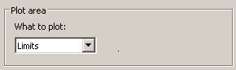
- In the “Plot offset (origin set to printable area)” section select “Center the Plot.”
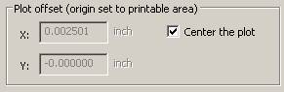

PRINTER-PLOTTING ON THE #4_D104_BW PRINTER
PLOTTING ON SIZE "A" DRAWING PAPER

- In the “Plot Scale” section set the plot scale to 1:1.
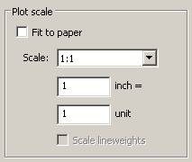

- Expand the Plot-Model Configuration dialog box by clicking on the Arrow icon in the lower right corner of the dialog box.

- In the Plot style table (pen assignments) section select monochrome.ctb
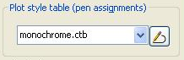

- 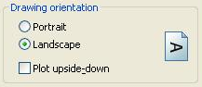In the Drawing orientation section select the Landscape option

- Click on the Preview button at the bottom of the dialog box. Always examine the correctness of the plot before sending it to the printer. By previewing the plot before sending, you can save paper and valuable printing time. If any errors are detected in the plot, you can go back to the Plot configuration dialog box and make corrections. Be sure to preview the plot again to make sure the new settings are correct.

- When you are finished with the Plot Preview, press the right mouse button and select "exit" to return to the "Plot-Model" dialog box. Click on the OK box to resume printing.

