Object or visible Lines: Thick, dark solid lines used to show the location of edges, planes in edge views, and curved surfaces which turn normal to the projection plane which are visible from the projection plane view.

Hidden Lines: Thin, dark dashed lines (approximately " to " long separated with " to " gaps) used to show edges, planes in edge view, and curved surfaces where they turn normal to the projection plane, but are not visible in the projected view because they fall behind other solid features of the object.

Center Lines: Thin, dark lines that consist of alternating short and long dashes. They are used to show axes of circular or symmetrical features and paths of motion. These lines usually extend out past the feature associated with the axis by " to ".

Order of Importance: On some drawings object, hidden, and enter lines will all occur at exactly the same location. If this happens draw only the line of highest precedence.

Highest Object line
↓
to Hidden line
↓
Lowest Center line

Alphabet of Line Types:

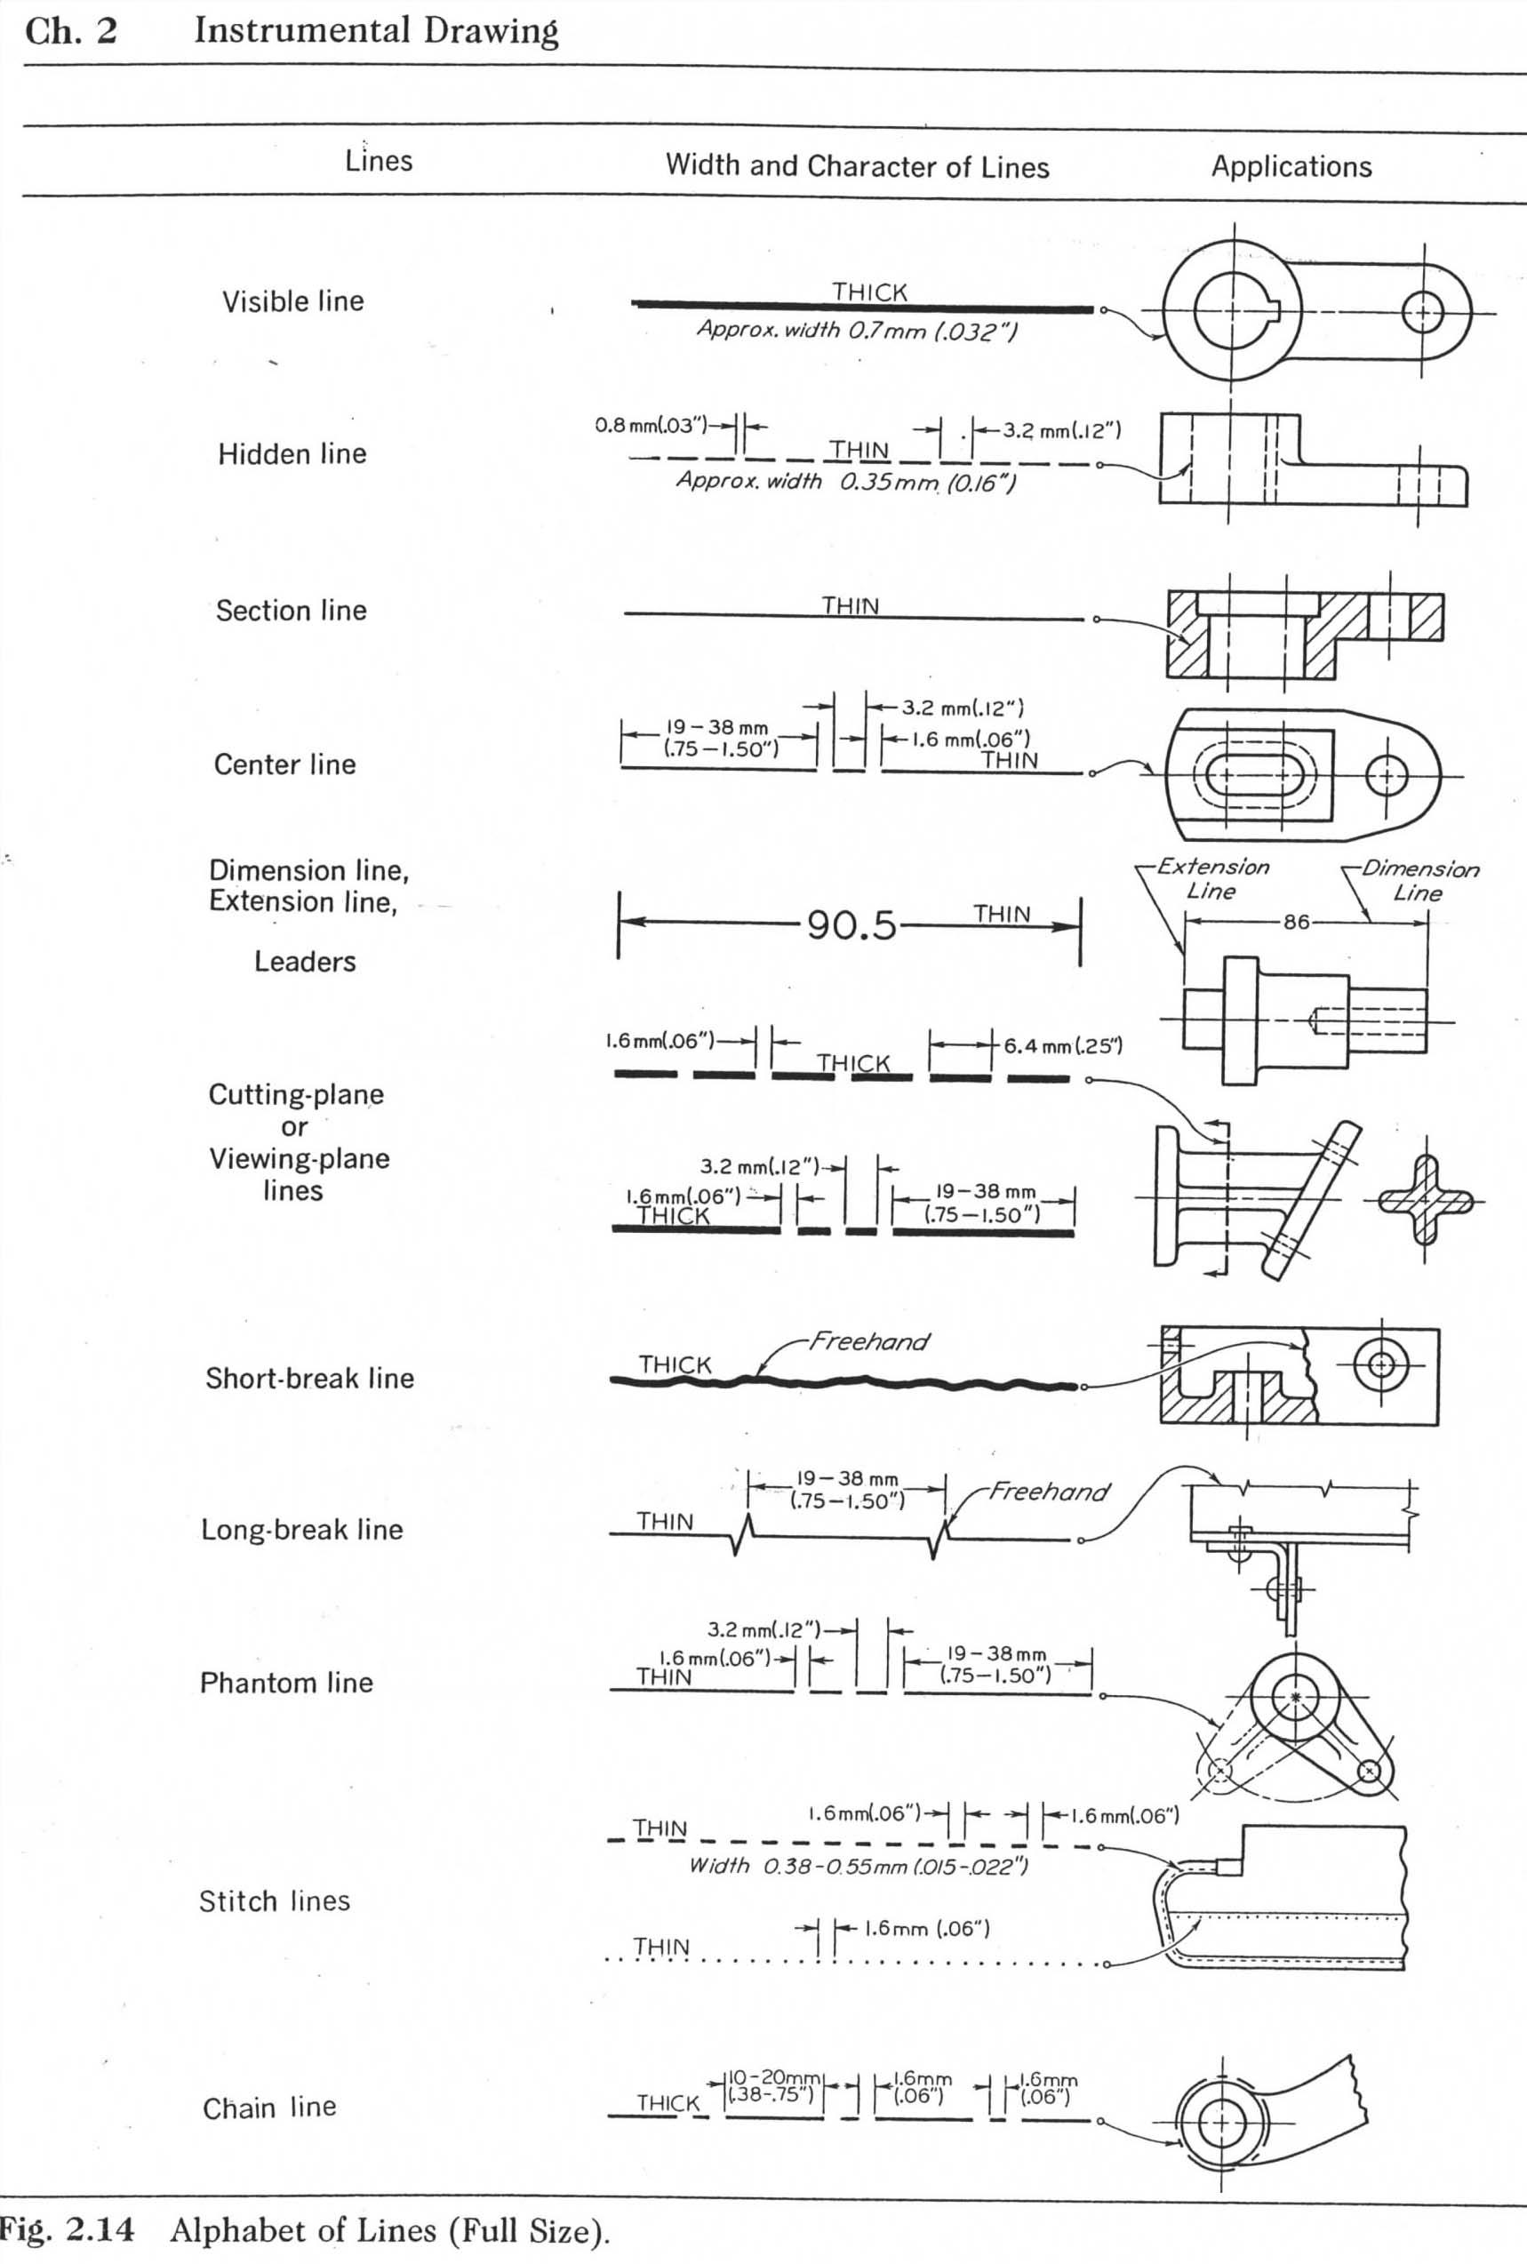

Some Do's and Don't of Hidden Lines:
General rule: A hidden line should connect and make a corner with other lines, except if it makes a visible line appear to extend farther than it actually does.

Examples:
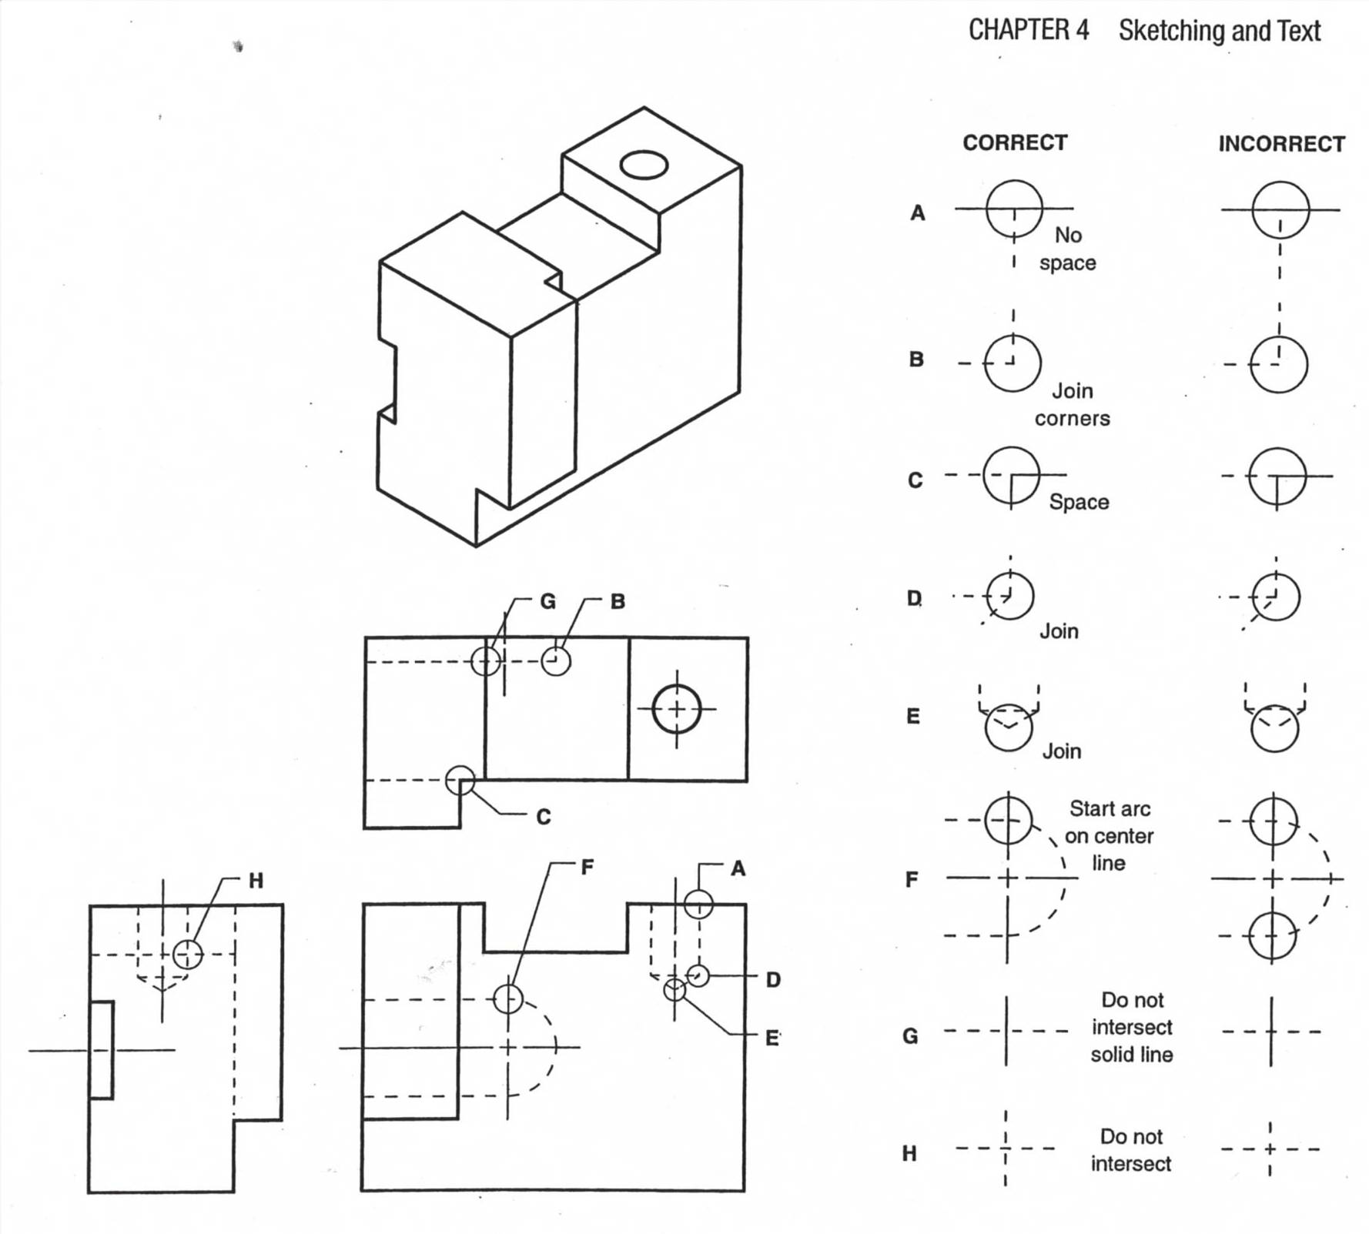

Some Dos and Don'ts of Center Lines:
When an axis is seen as a point, two center lines are used and cross with the short dashes intersecting at the axis.

When an axis is seen from the side, a single center line is used.

Examples:
