Reading a rule

- There is a very good PowerPoint at Reading a Ruler from Escambia County, Florida’s site.

Measuring must be done accurately and quickly. and.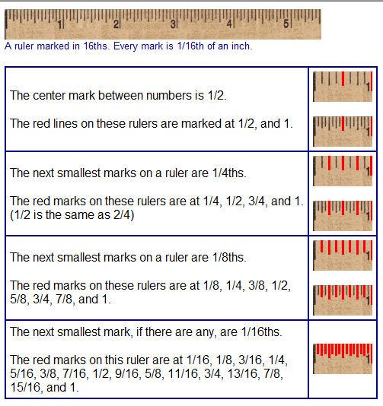

Line up zero on the left end of the line segment.
Read whole number closest to the right hand end of the line but not past it and then read the fraction.

Some quick tricks…..

All proper fractions when measuring on the regular scale or rule have an odd numerator (top number) and an even denominator (lower number).

For a standard rule divided into 1/16ths,

numerators will be only 1, 3, 5, 7, 9, 11, 13 or 15.

denominators will be only 16, 8, 4, or 2.

Stop from counting marks.

Don’t worry about equivalency of units, i.e., an inch = 25.4 mm. Students need to visualize how much a millimeter or centimeter is, not what they’re equal to.

Re-teach and revisit measuring on every quiz.

Students should learn the names of the marks. What two marks equal is inconsequential. It’s what that mark stands for. Use an analogy of telling time. You don’t look at a clock and see the big hand on the 4 and think 4x5 = 20. So it must be 20 minutes after. You recognize the 4 as meaning 20.

Same process to stress with students. Each mark has its names. After the names of the marks are memorized, you can work on adding fractions if needed.

Students should also learn to identify the length of each mark with its denominator. Shortest must be 16ths, next longer are 8ths, next longer are 4ths, next is a half, and longest are whole inches.

When you teach reading a metric scale, use similar steps.

