Setting Units in AutoCAD is simple. When you first open AutoCAD’ it starts with decimal units with 4 places to the right of the decimal point. So four ten- thousandths of an inch is .0004.  To check or change your units, go to the format pull down menu and click on drawing units or type units in the command line.  The dialog box to the right appears and you have choices for changes. | 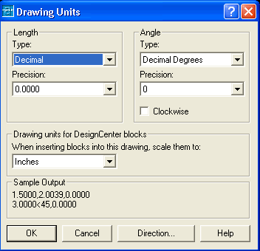
Under Length Type: you have the different choices for drawing units. The Default Setting is Decimal, but when you click on the dropdown you have the following other choices: Architectural, Engineering, Fractional and Scientific units. | 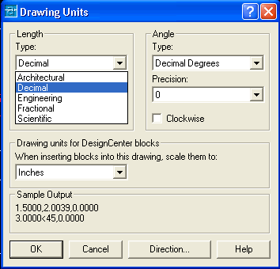
The next choice concerns precision. How many decimal places of accuracy does the drawing require? The Default setting is a four place decimal, but it can be changed just by clicking on the example.  Decimal degrees are also the Default for angular measure, but there are additional choice;, you may use Surveyor's Units for Architectural angle precision. | 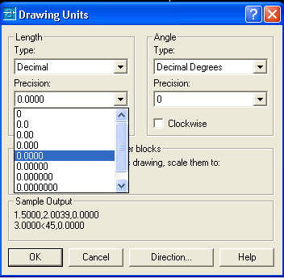
When you choose Architectural Units for your length, then you get a fractional inch precision down to 1/256". | 