Here is the text styles dialog box. Click on the format drop down menu; then click on Text Styles to access it. A new style has been created in this example. Notice that the font name is a Windows TrueType Font and it appears in the Preview Window how it looks and its height. | 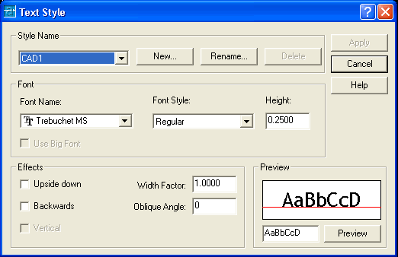
This example shows the Font Name drop down box. Depending on the Fonts that are installed on the computer, this list will be long or longer. All TrueType fonts are available as well as the Standard AutoCAD.shx Font styles. | 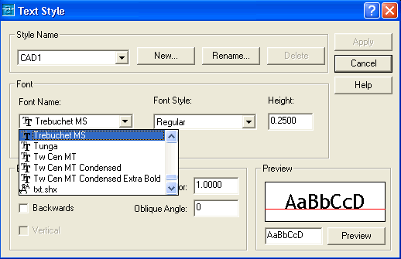
When you use TrueType Fonts you can use the Upside down Effect. You can see the result in the Preview window. | 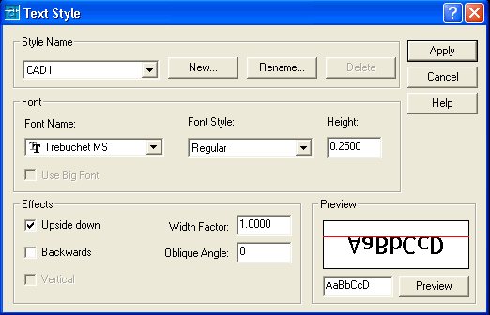
Backwards is also an effect that can be used. It can be used in combination with Upside down if necessary. | 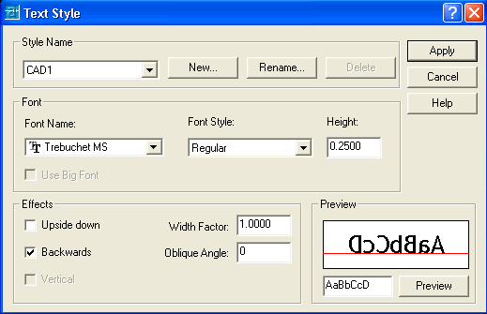
The Standard AutoCAD font name is txt.shx. This type of font cannot be used in any other program. It is a shape style that has been used since the beginning of AutoCAD. | 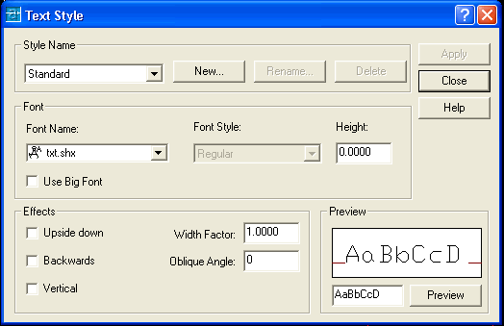
The Standard TXT font can be used Vertical. The other choices of Upside down and Backwards are also available in any combination with this font style. | 