Tips for working with fractions

To quickly divide a fraction in half, leave the numerator the same and double the denominator.

- Half of 3/8 is 3/16.

- Half of 7/32 is 7/64.

To quickly divide a mixed number in half, use the tips below.

If the whole number is even,

- Divide the whole number by 2 and write that down as the first number.
- Leave the numerator the same.
- Double the denominator.

Half of 8-3/4 is 4-3/8.

Half of 2-3/8 is 1-3/16.

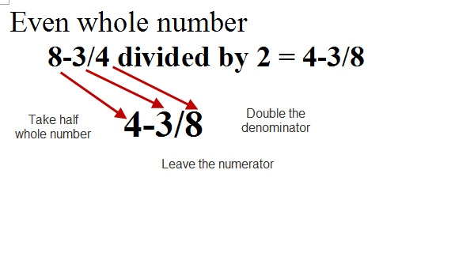

If the whole number is odd,

- Divide the whole number in half and write down the whole number.

Let’s use 7-3/4 as an example. Divide the 7 by 2 (3-1/2 ) and write down the 3.

- Add the numerator and denominator (3 + 4 = 7) and write the 7 as the numerator.

- Double the denominator (2 x 4 = 8) and write the 8 as the denominator.

Half of 7-3/4 is 3-7/8.

Half of 3-7/8 is 1-15/16.

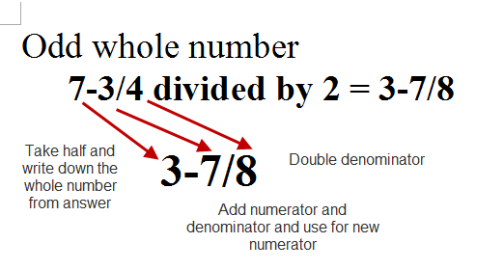

Based on the whether the whole number is even or odd, remember that after dividing whole number by 2 and use one of these rules.

- If it’s even, leave ‘em. (Leave numerator the same and double the denominator.)

- If it’s odd, add ‘em. (Add the numerator and denominator and double the denominator.)

