TRIM and EXTEND Commands

For both commands you must choose a boundary edge to either trim to or extend to.

TRIM is used to trim lines to the edges of other objects.

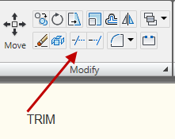
To use TRIM, you must set a cutting edge. This is a line you select that will act as a boundary to delineate what can be trimmed. Select the boundary line and trim on either side of it. TRIM only works for lines that intersect; it will not work for lines that only touch the boundary line in one point. Use ERASE for those segments.

To trim multiple lines, enter TRIM and right click and choose FENCE. Fence works like a crossing box in that everything it touches can be trimmed at once.

EXTEND is used to extend lines to the edges of other objects.

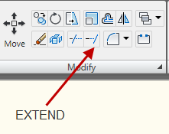

To use EXTEND, choose and hit space bar with defaults to Select All. Any line you choose then will extend itself to the next line.

By holding down Shift, you can toggle back and forth between EXTEND and Trim without reentering commands.

