Undo and Redo (Your new best friends)

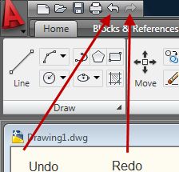

AutoCAD tracks commands and actions. To undo an action, use the Undo button in the Quick Access or the Redo to reverse the Undo. You can go back as far as the last time you saved the drawing unless you make another command after you use Undo and Redo.
These commands can be accessed in a number of ways, but the easiest way is Cntrl+Z to Undo and Cntrl+Y to Redo.

Either of these commands entered from the keyboard offer in depth applications.

