User Interface
This lesson is based on Autodesk’s AutoCAD 2009. If you are running another version, use the appropriate tutorial from Autodesk for your software.

Hand out worksheet including vocabulary. Have students note definitions on sheet.

Give students big picture of either creating drawings or modifying and changing.

Access http://usa.autodesk.com/adsk/servlet/item?siteID=123112&id=13202153&linkID=9240615, show video “AutoCAD User Interface Overview.”

After showing video, project browser window and show places again shown in the video below. When finished, have students practice using pull downs, tack and untack, etc.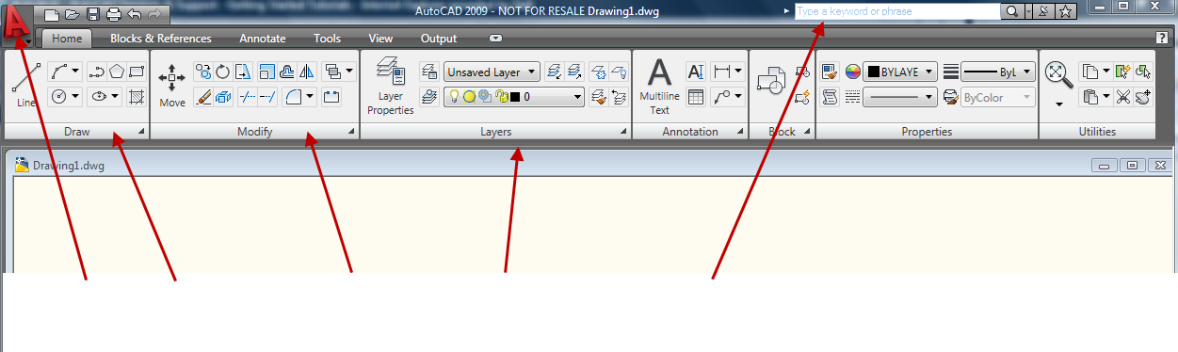

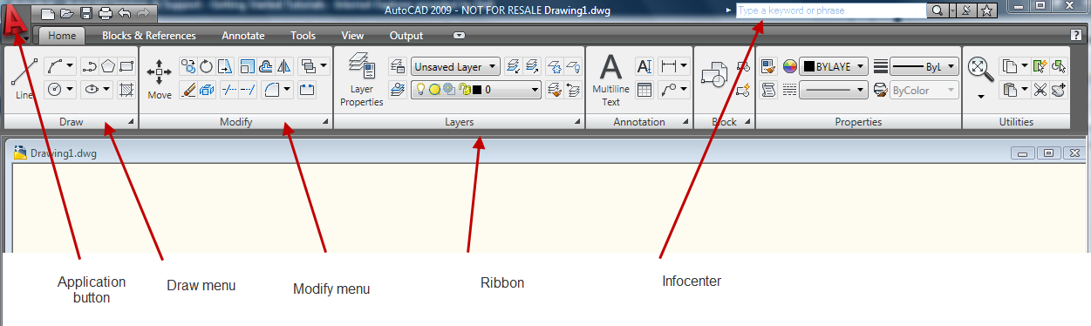

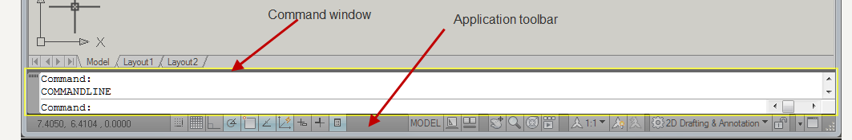

Vocabulary

User interface
Ribbon
Draw menu
Modify menu
Application button
Command window
Application status bar
History of commands

