User Interface

Fill in the blanks for the name of each element of the user interface shown.

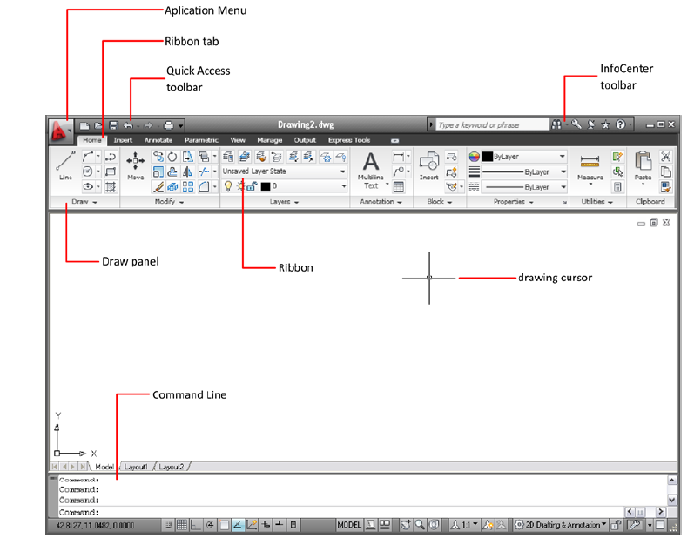

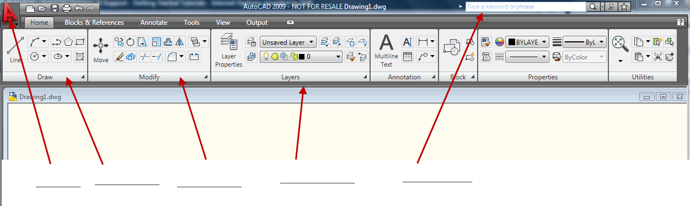

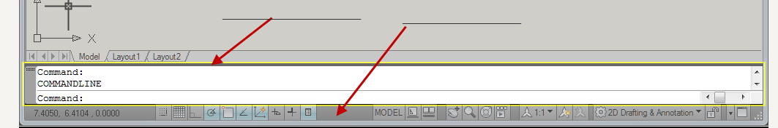

Besides Line, what is another command from the Draw menu?

If you need to use the Move command, in what menu would you find it?

Where do you find the history of your commands?

User Interface vocabulary

User interface

Ribbon

Draw menu

Modify menu

Application button

Command window

Application status bar

History of commands

