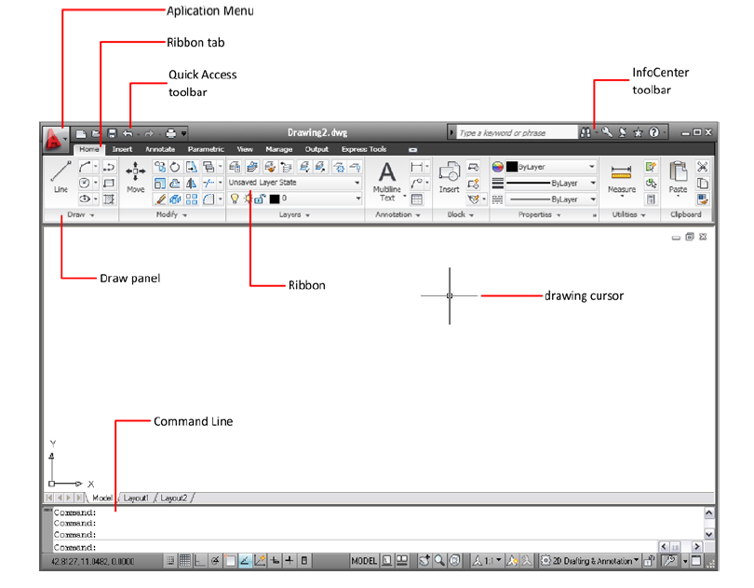

- Application menu (or button)

- Ribbon

- Quick Access toolbar

- Draw menu (or panel)

- Ribbon

- Cursor

- Command line

