Step 1- Setup the environment by creating LAYERS
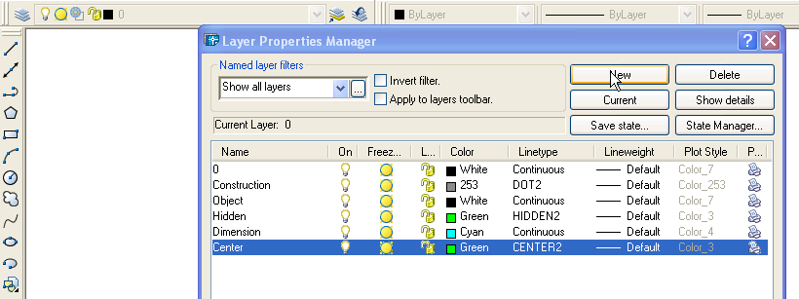Select the LAYER icon as shown above. Select the New button, assign a name, color and linetype for each layer as described above. To access linetypes select the Load button and scroll to locate the desired linetype.

Step 2- Layout the top, front and right sides of the object by creating construction lines on the construction line layer.
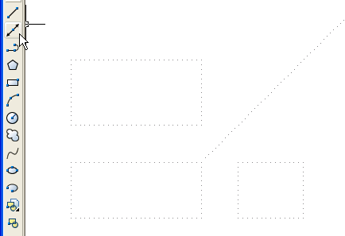
Top
Front

Right
Leave 1” between views. Draw a 45 degree line from the top right of the front view to transfer the top view to the right side view.

Step 3- Draft the views using the given information using the line and circle commands on the object layer.
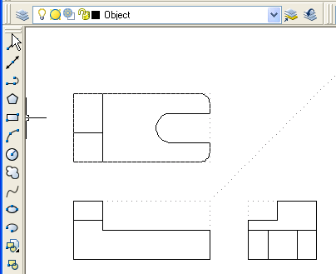
Notice that all features are in line with each other in all three views.

Step 4- Draft the necessary hidden lines using the line command on the Hidden Layer where features are hidden from the line of sight.
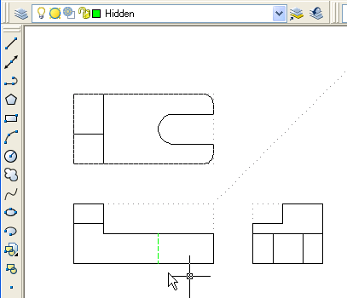

Step 5- Draft the necessary center lines using the line command and center mark command on the Center Layer to illustrate the center of round features.
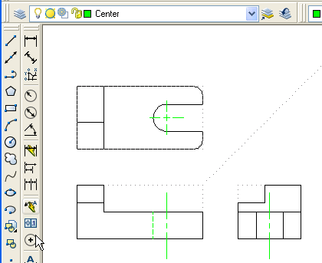

Step 6- Dimension the views using the dimension toolbar and Dimension Layer to communicate the size of the object.
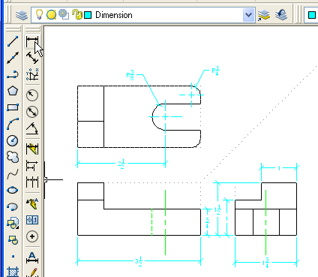

Step 7- Insert a title block and print the drawing using 1:1 scale. Be sure to set the Layer to 0 before inserting the title block. Freeze layer Construction before printing.
