Hole Quiz -key

Name __________________________________

Fill in the blanks to answer the questions about the holes drawn below.

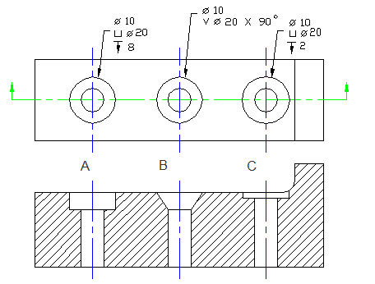

HOLE A

- A is a counterbore hole.

- The dimension of the smaller hole is 10 and the diameter of the larger hole is 20.

- How deep is the larger hole? 8

- What is the purpose of hole A?

HOLE B

- B is a countersunk hole.

- What angle would you use to draw each angle of the larger hole? 45

- What is the purpose of hole B?
HOLE C

- C is a spotface hole.

- How deep is the larger hole cut? 2

- What is the purpose of hole C?

- What does the symbol mean? Diameter

- stands for depth.

