Hole Quiz

Name __________________________________

Fill in the blanks to answer the questions about the holes drawn below.

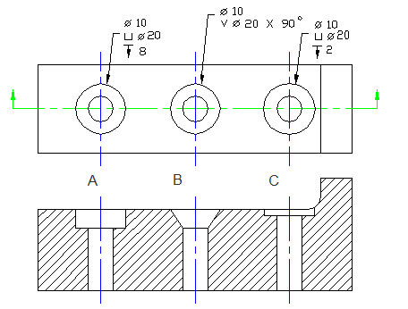

HOLE A

- A is a _____________________________ hole.

- The dimension of the smaller hole is ____ and the diameter of the larger hole is _________.

- How deep is the larger hole? __________

- What is the purpose of hole A?

HOLE B

- B is a _________________________hole.

- What angle would you use to draw each angle of the larger hole? _________

- What is the purpose of hole B?

HOLE C

- C is a __________ hole.

- How deep is the larger hole cut? _________

- What is the purpose of hole C?

- What does the symbol mean? _______________

- stands for ________________.

