Holes and Hole Notes:
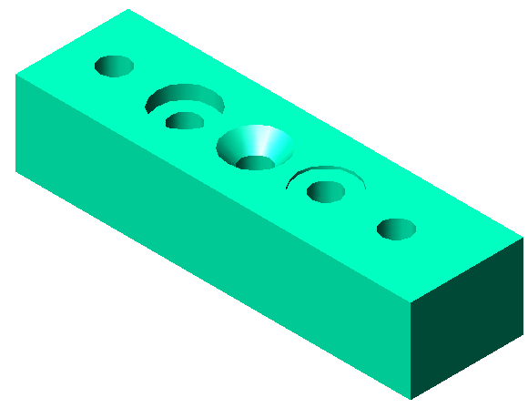
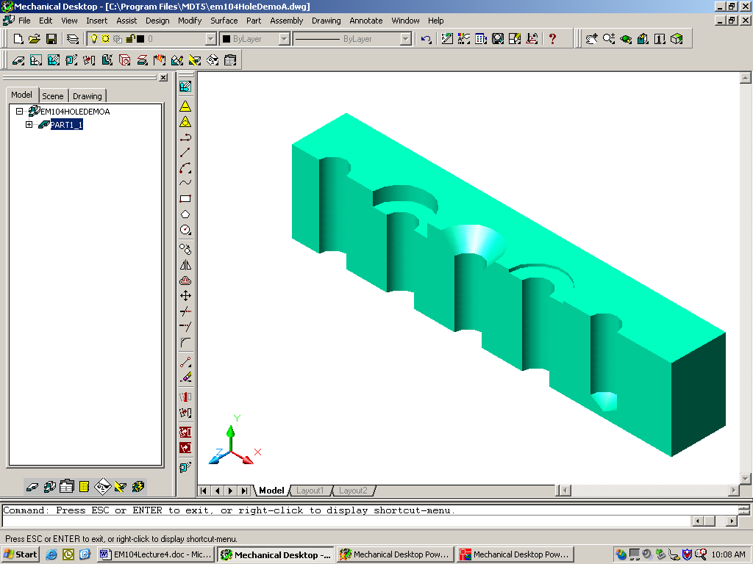

Drilled through

Counterbore

Countersink

Spotface

Blind

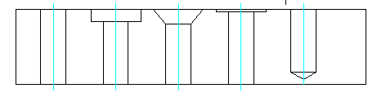

Hole Notes for different kinds of holes:

Old Standard New Standard
