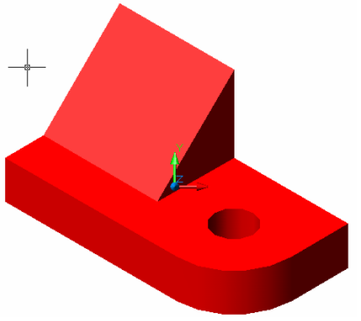

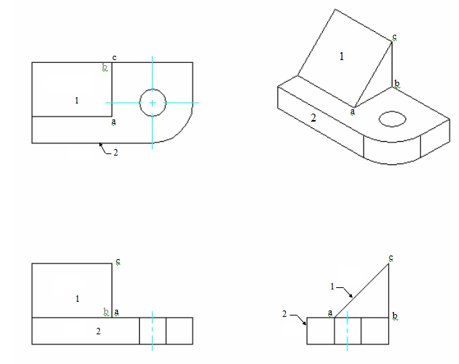

For each plane shown on this isometric, place the number that shows it in the
views below.
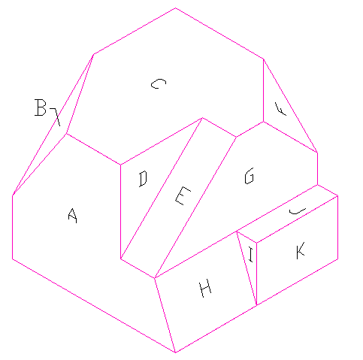

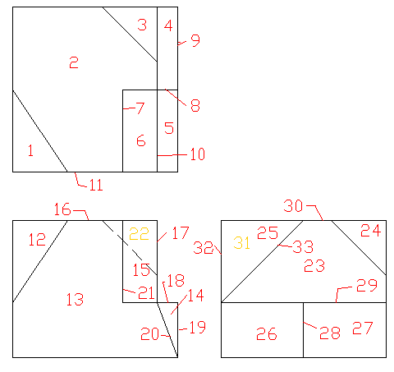
Surface Top Front Side
A
B
C
D
E
F
G
H
I
J
K

11 13 32 N
1 12 31 O
2 16 30 N
7 21 25 N
6 15 33 I
3 22 24 O
10 17 23 N
5 20 26 I
8 14 28 N
4 18 29 N
9 19 27 K

