Orthographic Projections

Pictorial drawings attempt to show the entire object using a single projection of a 3-dimensional object on a two dimensional medium.

Done correctly, these offer a great visualization tool, but they do so at the cost of including distortion of angles, shapes, and lengths.

There is a better drawing method for showing exact shape and size. The most commonly used method to communicate exact shape and size is the method known as multiview drawing.

A multiview drawing consists of a number of orthographic projections which show an object from several different sides or views and taken together, completely specify all sizes and features of the object. (This also means that no one view shows all the information needed to specify a unique object. Therefore, you have to develop the ability to visualize three views together to describe the object.)
Front
View
Top
View
Right
Side View

Orthographic Projection: A two dimensional projection of an object using parallel projection lines that run from the edges and corners of an object out to a projection plane which is normal to the projection lines. (You can think of this as the view that is seen by an observer who is standing an infinite distance away from the object on the other side of a perpendicular projection plane.)

Projection
Plane
Parallel
Projectors

Projection
Projection
Plane

Multiview drawings extend this concept of orthographic planar projection to include views from more than one side.

The most common views include front view, top view and either a right or left side view.
Multiple Projection
Views

Top View
(Horizontal Plane)
Front View
(Frontal Plane)
Right Side View
(Profile Plane)

Compare the previous views to a multiview which includes the left side view
Top View
(Horizontal Plane)
Front View
(Frontal Plane)
Left Side View
(Profile Plane)

It's important to notice that the different views align. The arrangement is a standard which is why views are never titled. Their place in the drawing in relation to the other views denotes which view they are.

Each view shows two dimensions:

Top view: Shows width and depth
Front view: Shows height and width
Side view: Shows depth and height

Multiview example:
Draw the front, top, and right side views of the object.
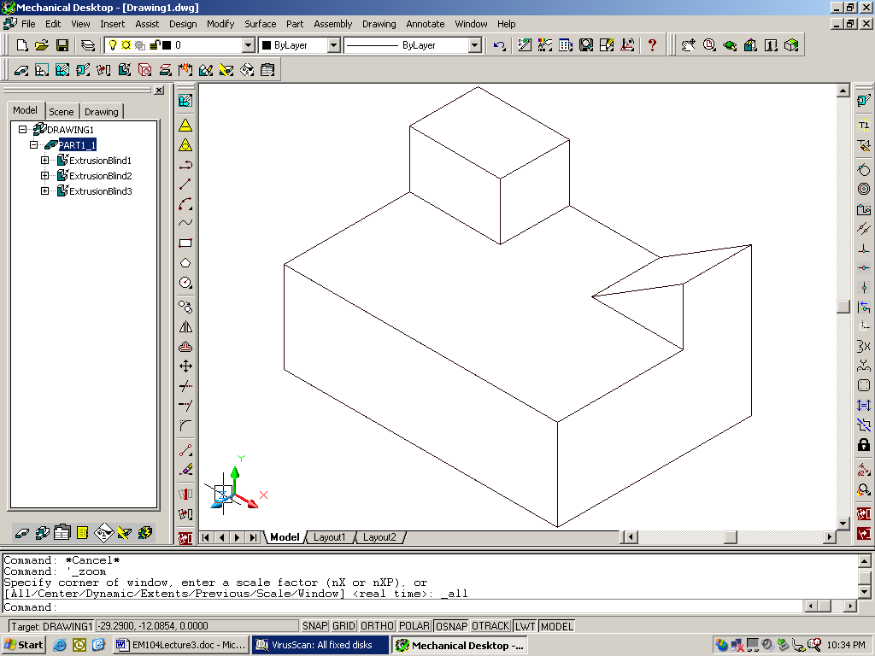
Front View

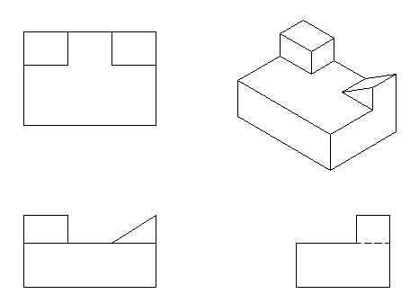

How would this change if we cut some additional features into this object?
-- oblique surface
-- cylindrical hole
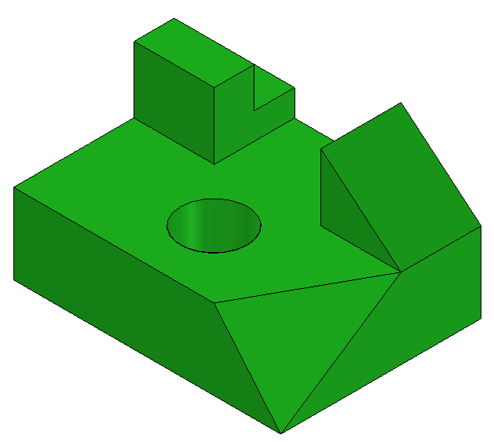

The multiview would now look like this.
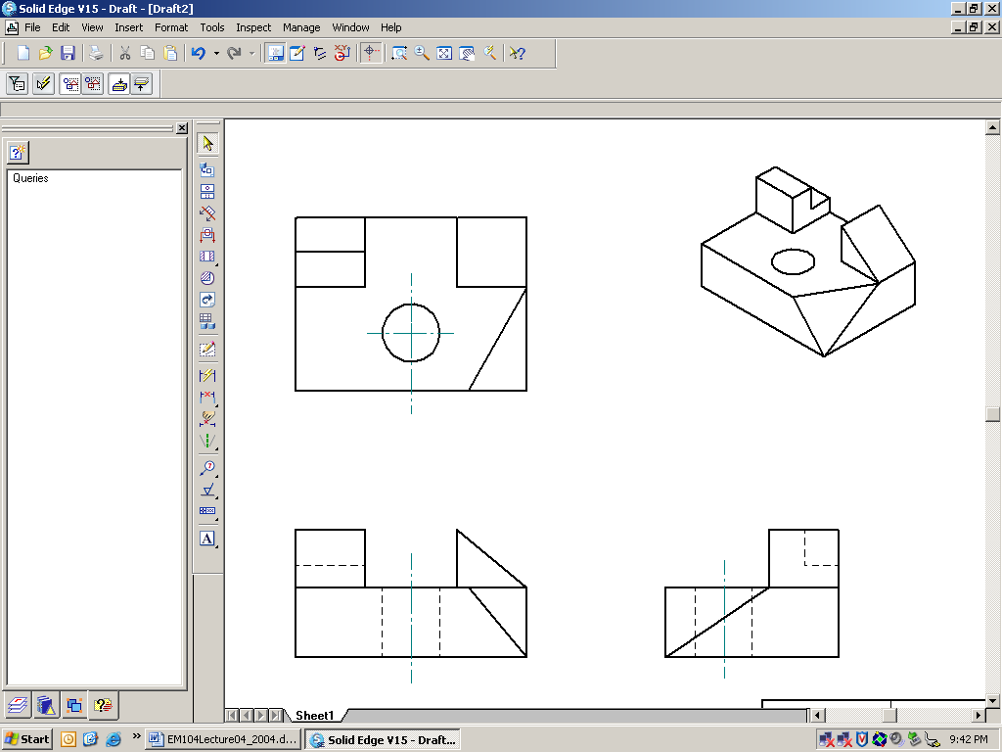
A
B
C

Notice the following characteristics:

Plane A is called a normal plane. How does it show up in the three different views? _______________________________________

Plane B is called an inclined plane. How does it show up in the three different views? ________________________________________

Plane C is called an oblique plane. How does it show up in the three views? ________________________________________________

How does the cylindrical hole show up in the three views?
______________________________________________________
Note the center lines used to show its axis.

