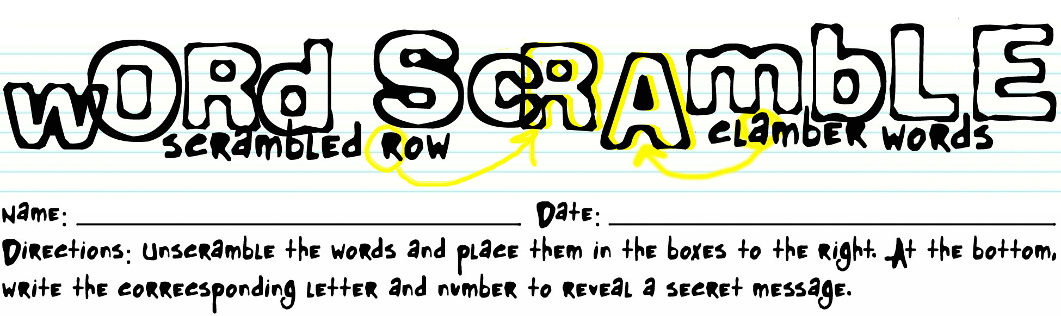

Subject: Studio Operations
Lighting ANLTEIRG
Def: A _______ of light formed by the Key, Fill, and Back lights. The Key and Fill lights are opposite one another while the Back light is behind the subject. |  |  | 5

DBCUGOROKAN Lighting
Def: Lights for the set and _______. Also used for chroma keying. |  |  |  |  |  |  |  | 3

EYK Light
Def: Main light source.

RPEOTTEENMTOI
Def: Knob that controls the amount of signal input to a channel or effect. |  |  |  |  |  |  |  | 6

VU RTEEM
Def: Meter that measures the main audio level.

WPEEVIR Bus
Def: Video signal about to be broadcast.

DREAF
Def: Vertical slider that increases or deceases output levels. |  |  | 4

NNOOCCTSRE
Def: XLR, Quarter (1/4) Inch, Eighth (1/8) Inch, RCA |  |  |  |  |  |  | 2

MRAPROG Bus
Def: Video signal being broadcast

VESSOIDL
Def: Transition where one source is gradually replaced by another |  |  |  | 1

1 | 2 | 3 | 4 | 5 | 6 | 7 | 8

Key

Lighting ANLTEIRG | T | R | I | A | N | G | L | E
Def: A _______ of light formed by the Key, Fill, and Back lights. The Key and Fill lights are opposite one another while the Back light is behind the subject. |  |  | 5

DBCUGOROKAN Lighting | B | A | C | K | G | R | O | U | N | D
Def: Lights for the set and _______. Also used for chroma keying |  |  |  |  |  |  |  | 3

EYK Light | K | E | Y
Def: Main light source

RPEOTTEENMTOI | P | O | T | E | N | T | I | O | M | E | T | E | R
Def: Knob that controls the amount of signal input to a channel or effect |  |  |  |  |  |  |  | 6

VU RTEEM | M | E | T | E | R
Def: Meter that measures the main audio level

WPEEVIR Bus | P | R | E | V | I | E | W
Def: Video signal about to be broadcast

DREAF | F | A | D | E | R
Def: Vertical slider that increases or deceases output levels |  |  | 4

NNOOCCTSRE | C | O | N | N | E | C | T | O | R | S
Def: XLR, Quarter (1/4) Inch, Eighth (1/8) Inch, RCA |  |  |  |  |  |  | 2

MRAPROG Bus | P | R | O | G | R | A | M
Def: Video signal being broadcast

VESSOIDL | D | I | S | S | O | L | V | E
Def: Transition where one source is gradually replaced by another |  |  |  | 1

S | T | U | D | I | O
1 | 2 | 3 | 4 | 5 | 6

