Name______
Date_______
Period_____
Broadcast/Video Production 1

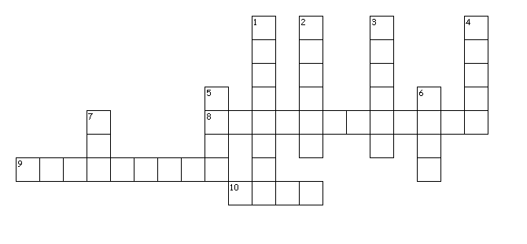
UNIT 3: TRADE TERMS
CROSSWORD PUZZLE

Across
8. Refers to the creative elements of a production such as the writer, producer, director and actors.
9. The gradual mix of sound sources accomplished by the simultaneous manipulation of two or more mix console faders.
10. An ellipsoidal reflector spot light.
Down
1. A transition between two scenes where the first merges imperceptibly into the second.
2. A device for varying power to the lights.
3. The chief lighting technician for a production who is in charge of the electrical department.
4. The individual picture image on a strip of motion picture film.
5. An optical effect in which the image of a scene is gradually replaced by a uniform dark area or vice versa.
6. An optical transition effect in which one image is replaced by another with a boundary edge that moves in a selected pattern across the frame
7. A mixing network that combines the output of two or more channels.

