Camera Moves and Composition Test

Name: ______________________________ Date: ____________

Directions: Choose the best possible answer.

1) To point the lens of a camera up or down is called:
A) Arc
B) Dolly
C) Pan
D) Tilt

2) To move the camera toward or away from an object is called:
A) Arc
B) Dolly
C) Pan
D) Tilt

3) The director tells you to truck left, you must:
A) Move the back of the camera to the left
B) Move the entire camera to the left
C) Point the lens of the camera to the left
D) Walk to your left and keep the camera in one place.

4) Moving the camera in a slightly curved dolly or truck is called a(n):
A) Arc
B) Curve
C) Dolly
D) Pan

5) When you cant your camera you:
A) Adjust the lens
B) Shut off the camera
C) Tilt the camera up
D) Tilt the camera sideways

6) To move a camera up or down using a studio pedestal is called:
A) Arc
B) Boom
C) Pedestal
D) Tilt

7) When you turn the camera from side to side, you:
A) Arc
B) Dolly
C) Pan
D) Tilt

8) A person framed from head to foot is called a(n):
A) Close up
B) Far away shot
C) Extreme long shot
D) Long shot

9) This shot is framed from a great distance in order to establish the location of a scene. Minor details are indistinguishable.
A) Close up
B) Far away shot
C) Extreme long shot
D) Long shot

10) An object or any part of it seen at close range and framed very tightly. such as a person’s eye, is called a(n):
A) Close up
B) Far away shot
C) Extreme long shot
D) Long shot

11) A shot of the head and shoulders of the talent is called a(n):
A) Close up
B) Far away shot
C) Extreme long shot
D) Long shot

12) Vector refers to:
A) An outside force
B) Directional screen force
C) Photograph
D) Wavy lines

13) The space between the top of a person’s head and the upper screen edge is called:
A) Headroom
B) Leadroom
C) Noseroom
D) Upper screen room

14) The space in front of a moving object is called:
A) Headroom
B) Leadroom
C) Noseroom
D) Upper screen room

15) Graphic, index and motion are all examples of:
A) Camera shots
B) Camera composition
C) Vectors

16) Headroom, leadroom, and Noseroom are all example of:
A) Camera shots
B) Camera composition
C) Vectors

17) A three legged camera mount is a:
A) Camera head
B) Tripod
C) Monopod
D) Quick Release Plate

18) A one legged camera mount is called a:
A) Camera head
B) Tripod
C) Monopod
D) Quick Release Plate

19) the rectangular metal piece that screws into the bottom of the camera and then hold the camera securely on the tripod is called a :
A) Camera head
B) Tripod
C) Monopod
D) Quick Release Plate

20) A directional screen force is called a:
A) Camera Composition
B) Noseroom
C) Pan
D) Vector

Identify the following shots.

21) 
A) Over the Shoulder
B) Long Shot
C) Medium Shot
D) Close Up
E) Extreme Close Up

22) 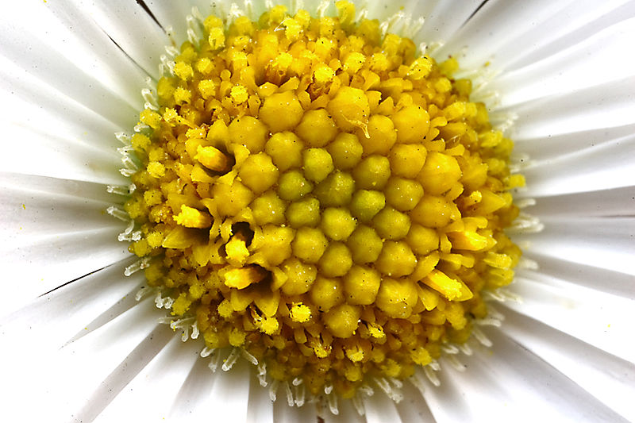
A) Over the Shoulder
B) Long Shot
C) Medium Shot
D) Close Up
E) Extreme Close Up

23) 
A) Over the Shoulder
B) Long Shot
C) Medium Shot
D) Extreme Long Shot

24) 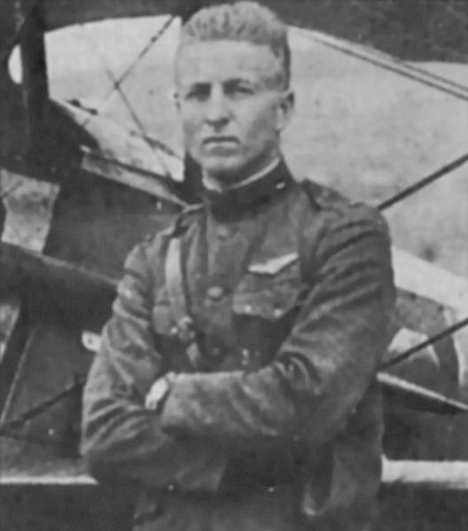
A) Over the Shoulder
B) Long Shot
C) Medium Shot
D) Extreme Long Shot

25) 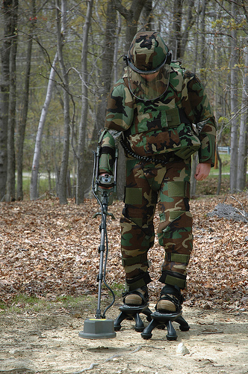
A) Over the Shoulder
B) Long Shot
C) Medium Shot
D) Close Up
E) Extreme Close Up

