Editing Test

1. What is the most important aspect of editing?
a. Cleaning up your video b. Making a movie c. Putting clips in order d. Telling a story

2. Bringing video into the computer is called:
a. Editing b. Export c. Import d. Shooting

3. Any time you take your video project and send it to the internet, compress it to a Quicktime movie or burn it to a DVD, you are doing what?
a. Exporting b. Transporting c. Saving d. Reformatting

4. In between clips is the only place to put these. It looks nice going from one clip to the next.
a.. Black b. Continuity c. Time codes d. Transitions

5. Final Cut Pro is an example of what kind of editing?
a. Creative b. Linear c. Non-linear d. Seamless

6. This is because it can randomly access:
a. Effects b. Files c. Mistakes d. Music

7. Whenever VCR’s are used in the editing process, it is called this kind of editing.
a. Creative b. Linear c. Non-linear d. Seamless

8. What kind of editing is like word processing where you can easily move clips around and change their order?
a. Creative b. Linear c. Non-linear d. Seamless

9. What kind of editing must you access your video consecutively?
a. Creative b. Linear c. Non-linear d. Seamless

10. Copying sections of the source tape to the edit master tape in a desired sequence describes what type of editing?
a. Creative b. Linear c. Non-linear d. Seamless

11. What provides a unique address from each frame of recorded video?
a. Control Track b. Date Stamp c. SMPTE Time Code d. Special Effects

12. Identify the different parts of this time code. 03:37:25:18

13. The :03 indicates: a. Frames b. Hours c. Minutes d. Seconds

14. The :37 indicates: a. Frames b. Hours c. Minutes d. Seconds

15. The :25 indicates: a. Frames b. Hours c. Minutes d. Seconds
16. The :18 indicates: a. Frames b. Hours c. Minutes d. Seconds

17. How many frames are in one second of NTSC video?
a. 24 b. 29 c. 30 d. 60

18. Putting together various pieces of video in a sequence is called:
a. Build editing
b. Combine Editing
c. Condense Editing
d. Continuity Editing
e. Correct Editing

19. Reducing the overall length of a video in a sequence is called:
a. Build editing
b. Combine Editing
c. Condense Editing
d. Continuity Editing
e. Correct Editing

20. When an editor fixes production mistakes during the editing process, it is called:
a. Build editing
b. Combine Editing
c. Condense Editing
d. Continuity Editing
e. Correct Editing

21. When a show is constructed from a variety of carefully planned and taped shots, it is called:
a. Build editing
b. Combine Editing
c. Condense Editing
d. Continuity Editing
e. Correct Editing

22. This kind of editing creates seamless transitions from one event to another.
a. Build editing
b. Combine Editing
c. Condense Editing
d. Continuity Editing
e. Correct Editing

23. Mental map, vectors and on and off screen positions are parts of what kind of editing?
a. Build editing
b. Combine Editing
c. Condense Editing
d. Continuity Editing
e. Correct Editing

24. If a person on camera is holding a glass in their right hand in one shot and then holding it in their left hand in the next shot, what kind of error is it?
a. Build error
b. Combine error
c. Condense error
d. Continuity error
e. Correct error

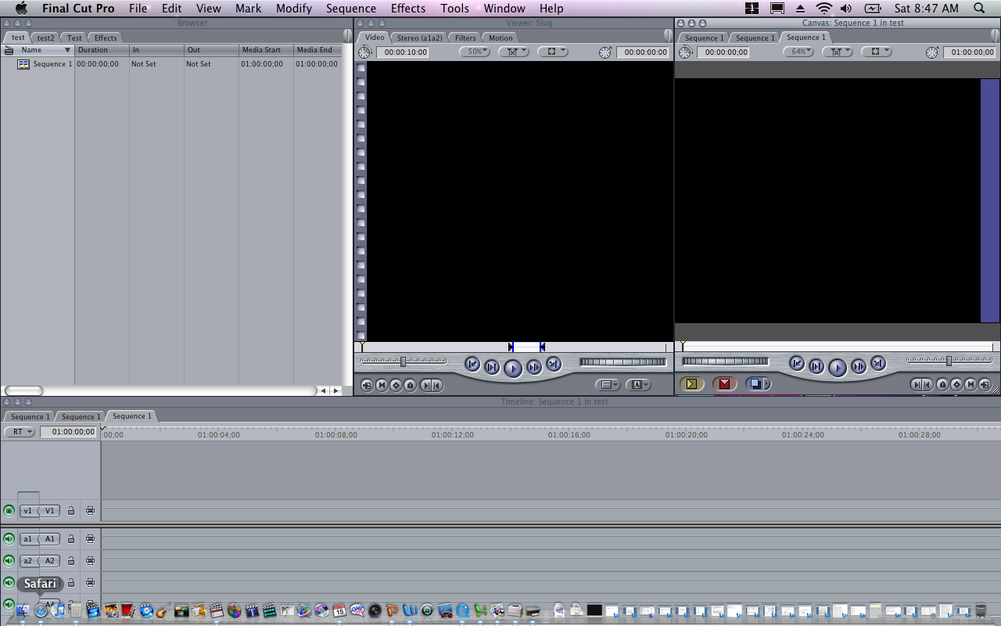
A
B
C
D

DIRECTIONS: For the following questions, please refer to the picture above.

25. What is the name of the editing window labeled “A”?
a. Browser b. Canvas c. Timeline d. Viewer

26. What is the name of the editing window labeled “B”?
a. Browser b. Canvas c. Timeline d. Viewer

27. What is the name of the editing window labeled “C”?
a. Browser b. Canvas c. Timeline d. Viewer

28. 28. What is the name of the editing window labeled “D”?
a. Browser b. Canvas c. Timeline d. Viewer

29. What is the purpose of the Canvas?
a. To build your project, clip by clip
b. To view a selected clip, adjust effects or transitions
c. To view various clips files, music files, transitions and effects
d. To view your finished project

30. What is the purpose of the Timeline?
a. To build your project, clip by clip
b. To view a selected clip, adjust effects or transitions
c. To view various clips files, music files, transitions and effects
d. To view your finished project

31. What is the purpose of the Browser?
a. To build your project, clip by clip
b. To view a selected clip, adjust effects or transitions
c. To view various clips files, music files, transitions and effects
d. To view your finished project

32. What is the purpose of the Viewer?
a. To build your project, clip by clip
b. To view a selected clip, adjust effects or transitions
c. To view various clips files, music files, transitions and effects
d. To view your finished project

33. A cutaway is:
a. A condensed story
b. An extra shot of the talent
c. A shot that is related to the essence of the the story
d. A short shot that is cut in half

34. A sound bite is:
a. A burst of sound related to the story
b. Any sound in a microphone
c. A type of sound effect
d. A very short snippet of a longer speech, usually around :10

35. When a photographer goes out to shoot a story, he/she must always to remember to get the following three types of shots:
a. Clipped shots
b. Establishing shot, close up of talent, cutaways
c. Long shot, medium shot, close up
d. Pickup shots, sound bites and close ups

