BINGO
CTAE Resource Network, Curriculum Office
March, 2009

Directions for the Instructor

1. Print the bingo cards. Twenty six different cards are included. Print additional cards at random if needed. Cut each sheet to separate the cards. Cards may be laminated for durability.

2. Give each student a bingo card and chips, markers, or scrap paper. If paper is to be used, ask students to tear or cut 25 pieces of paper about one-half inch square. If the cards have been laminated, students can mark their cards with erasable markers.

3. Explain to the students that you will read the definitions to the class and that they should mark the correct answer on their card. Note that all cards do not have all the answers.

4. Read the definitions only, at random, from the definitions list. Mark the definitions that have been used. The student should place a chip on the cell with the correct response.

5. When a student has placed chips on 5 spaces in a row (diagonally, vertically, or horizontally) the student should call “Bingo”. Ask the winning student to call out their answers. Check their answers to make sure those definitions have been used.

Optional Bingo Variations:

- T-Bingo: The card must be marked in the shape of a “T” to call Bingo.

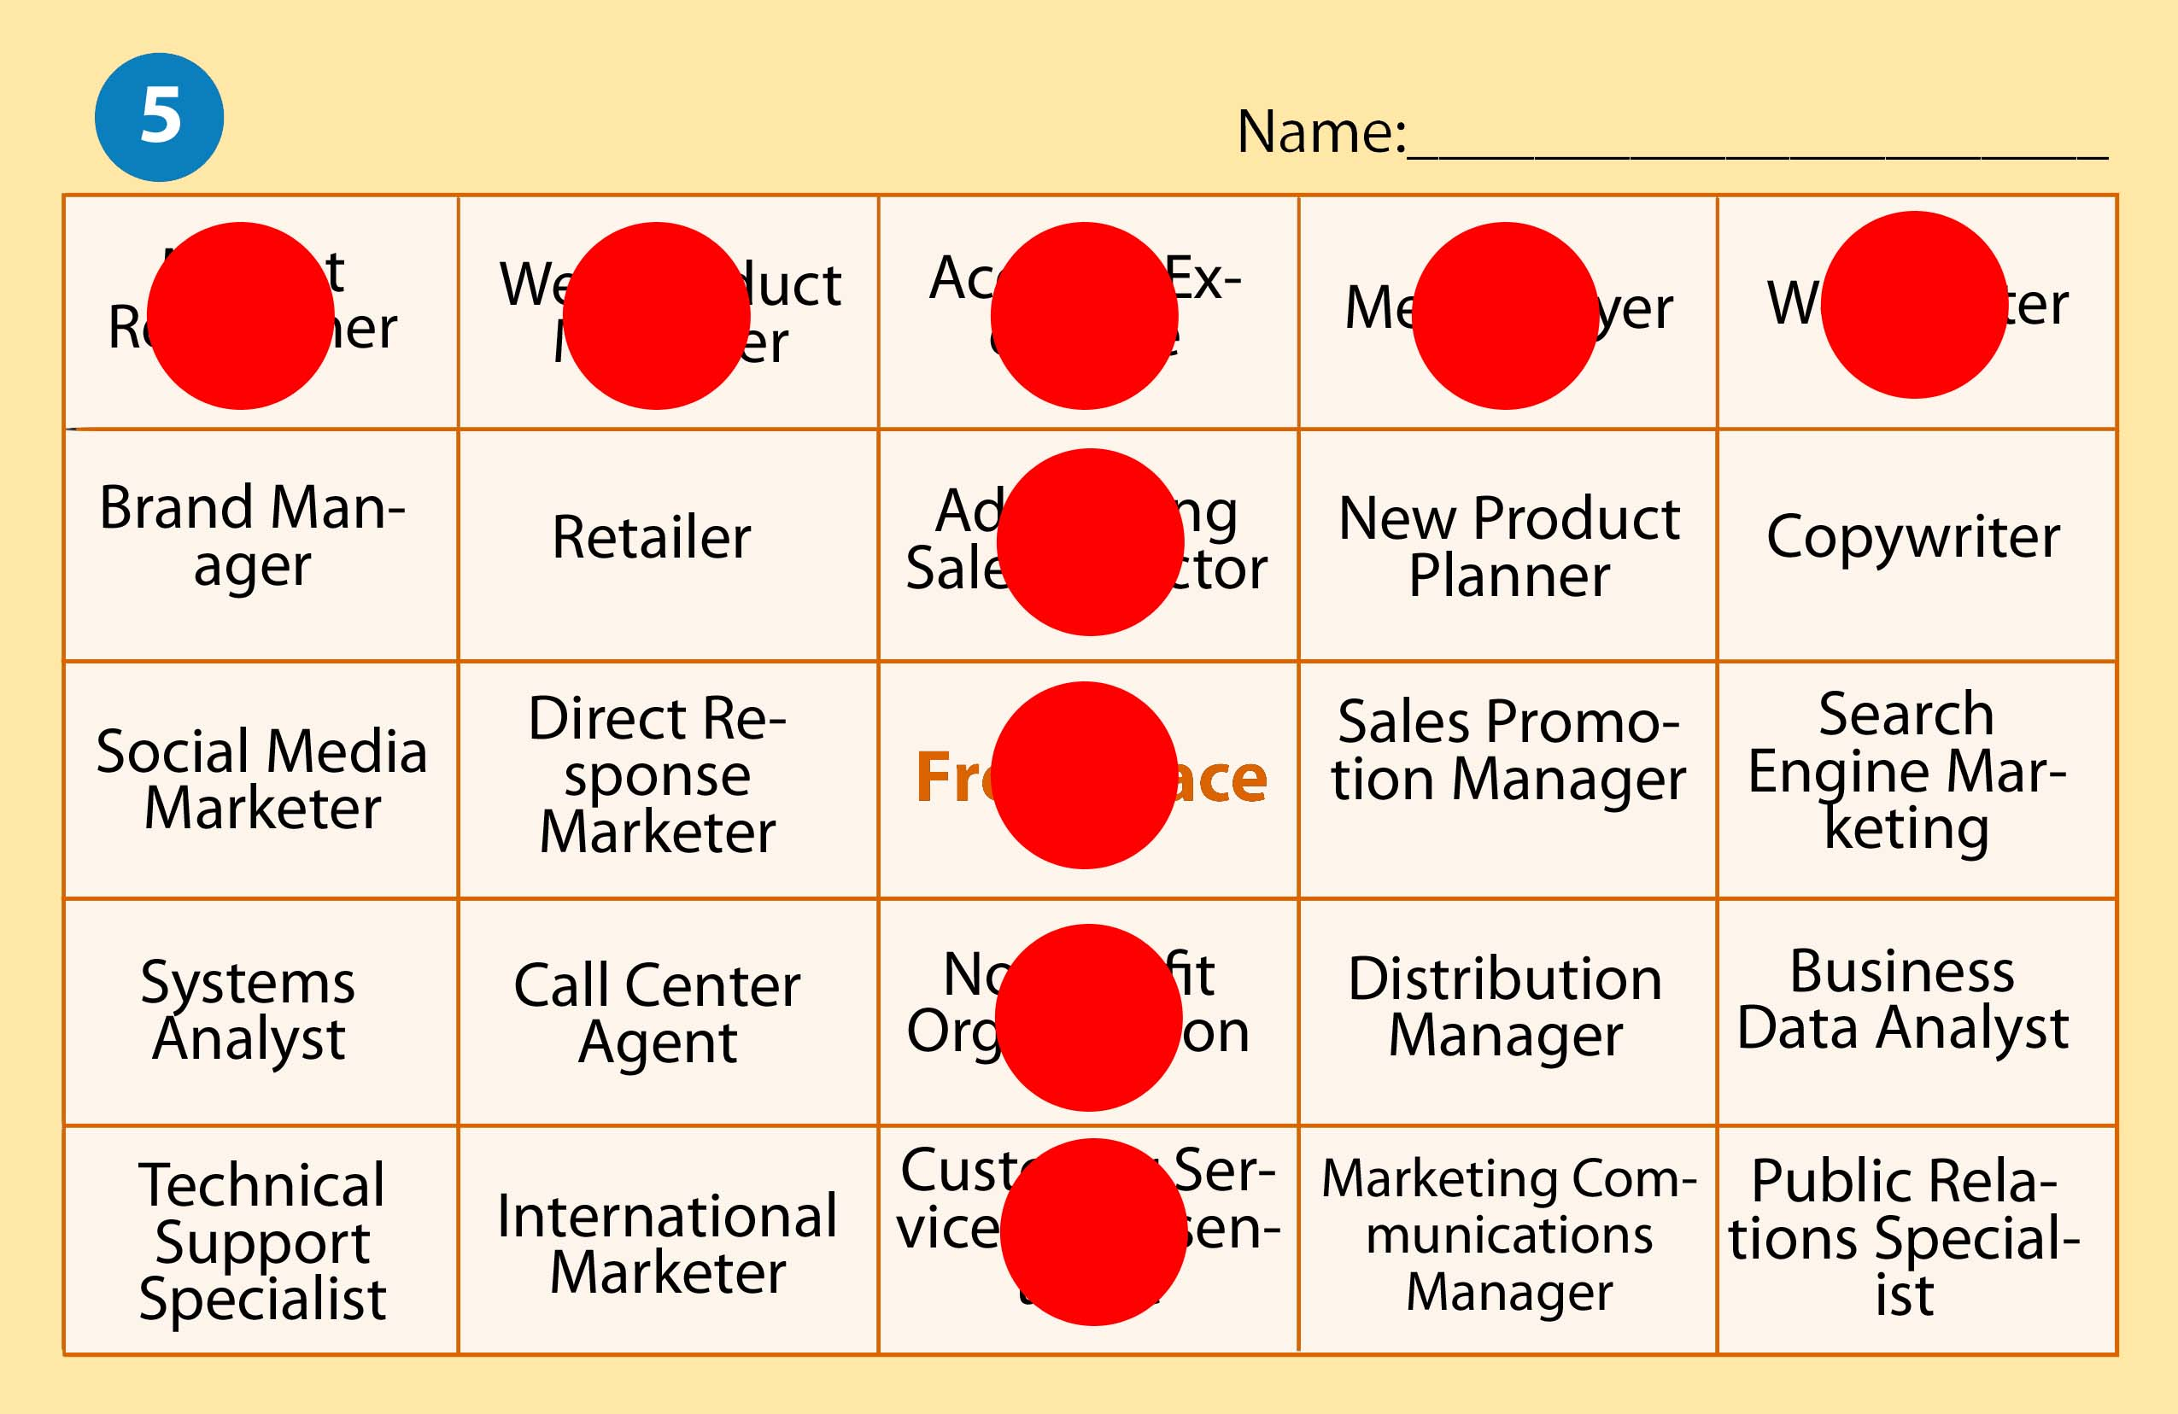

- Corners Bingo: The four outer corners of the card must be marked to get Bingo.

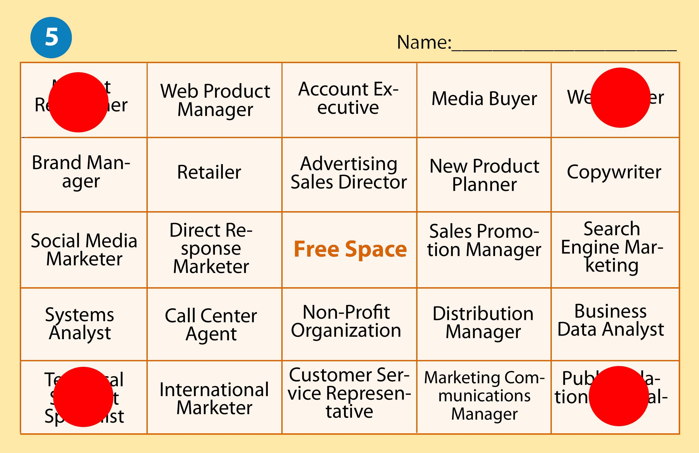

- U-Bingo: The card must be marked in the shape of a “U” to call Bingo.

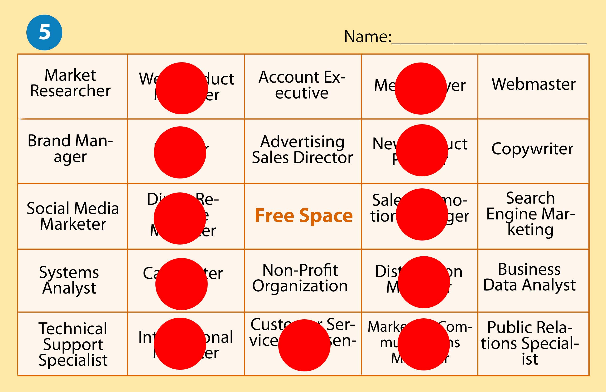

Definition | Correct Response
Planning, Recording, Analyzing, and interpreting financial information. | Accounting
Planned process for providing financial information that will be useful to management. | Accounting System
Summaries of a business’s financial activities. | Accounting Records
Reports that summarize the financial condition and operations of a business. | Financial Statements
Performs an activity for a fee. | Service Business
Business owned by one person. | Proprietorship
Anything of value that is owned or controlled. | Asset
Financial rights to the assets of a business. | Equities
Amount of money owed to the creditors of a business. | Liability
Amount remaining after the value of all liabilities is subtracted from the value of all assets. | Owner’s Equity
Shows relationship among assets, liabilities, and owner’s equity. | Accounting Equation
Principles of right and wrong. | Ethics
Use of ethics in making business decisions. | Business Ethics
Business activity that changes assets, liabilities, or owner’s equity. | Transaction
Record Summarizing all the info pertaining to a single item in the accounting equation. | Account
Name given to an account | Account Title
Amount in an account. | Account Balance
Account used to summarize the owner’s equity. | Capital
Increase in owner’s equity resulting from the operation of a business. | Revenue
Sale for which cash will be received at a later date. | Sale on Account
Decrease in owner’s equity resulting from the operation of a business. | Expense
Assets taken out of business for the owner’s personal use. | Withdrawals
Asset on the balance sheet which is expected to be sold or otherwise used up in the near future, usually within one year. | Current Assets
Permanent assets of a company required for the regular conduct of business which will not be converted into cash during the next year. | Fixed Assets

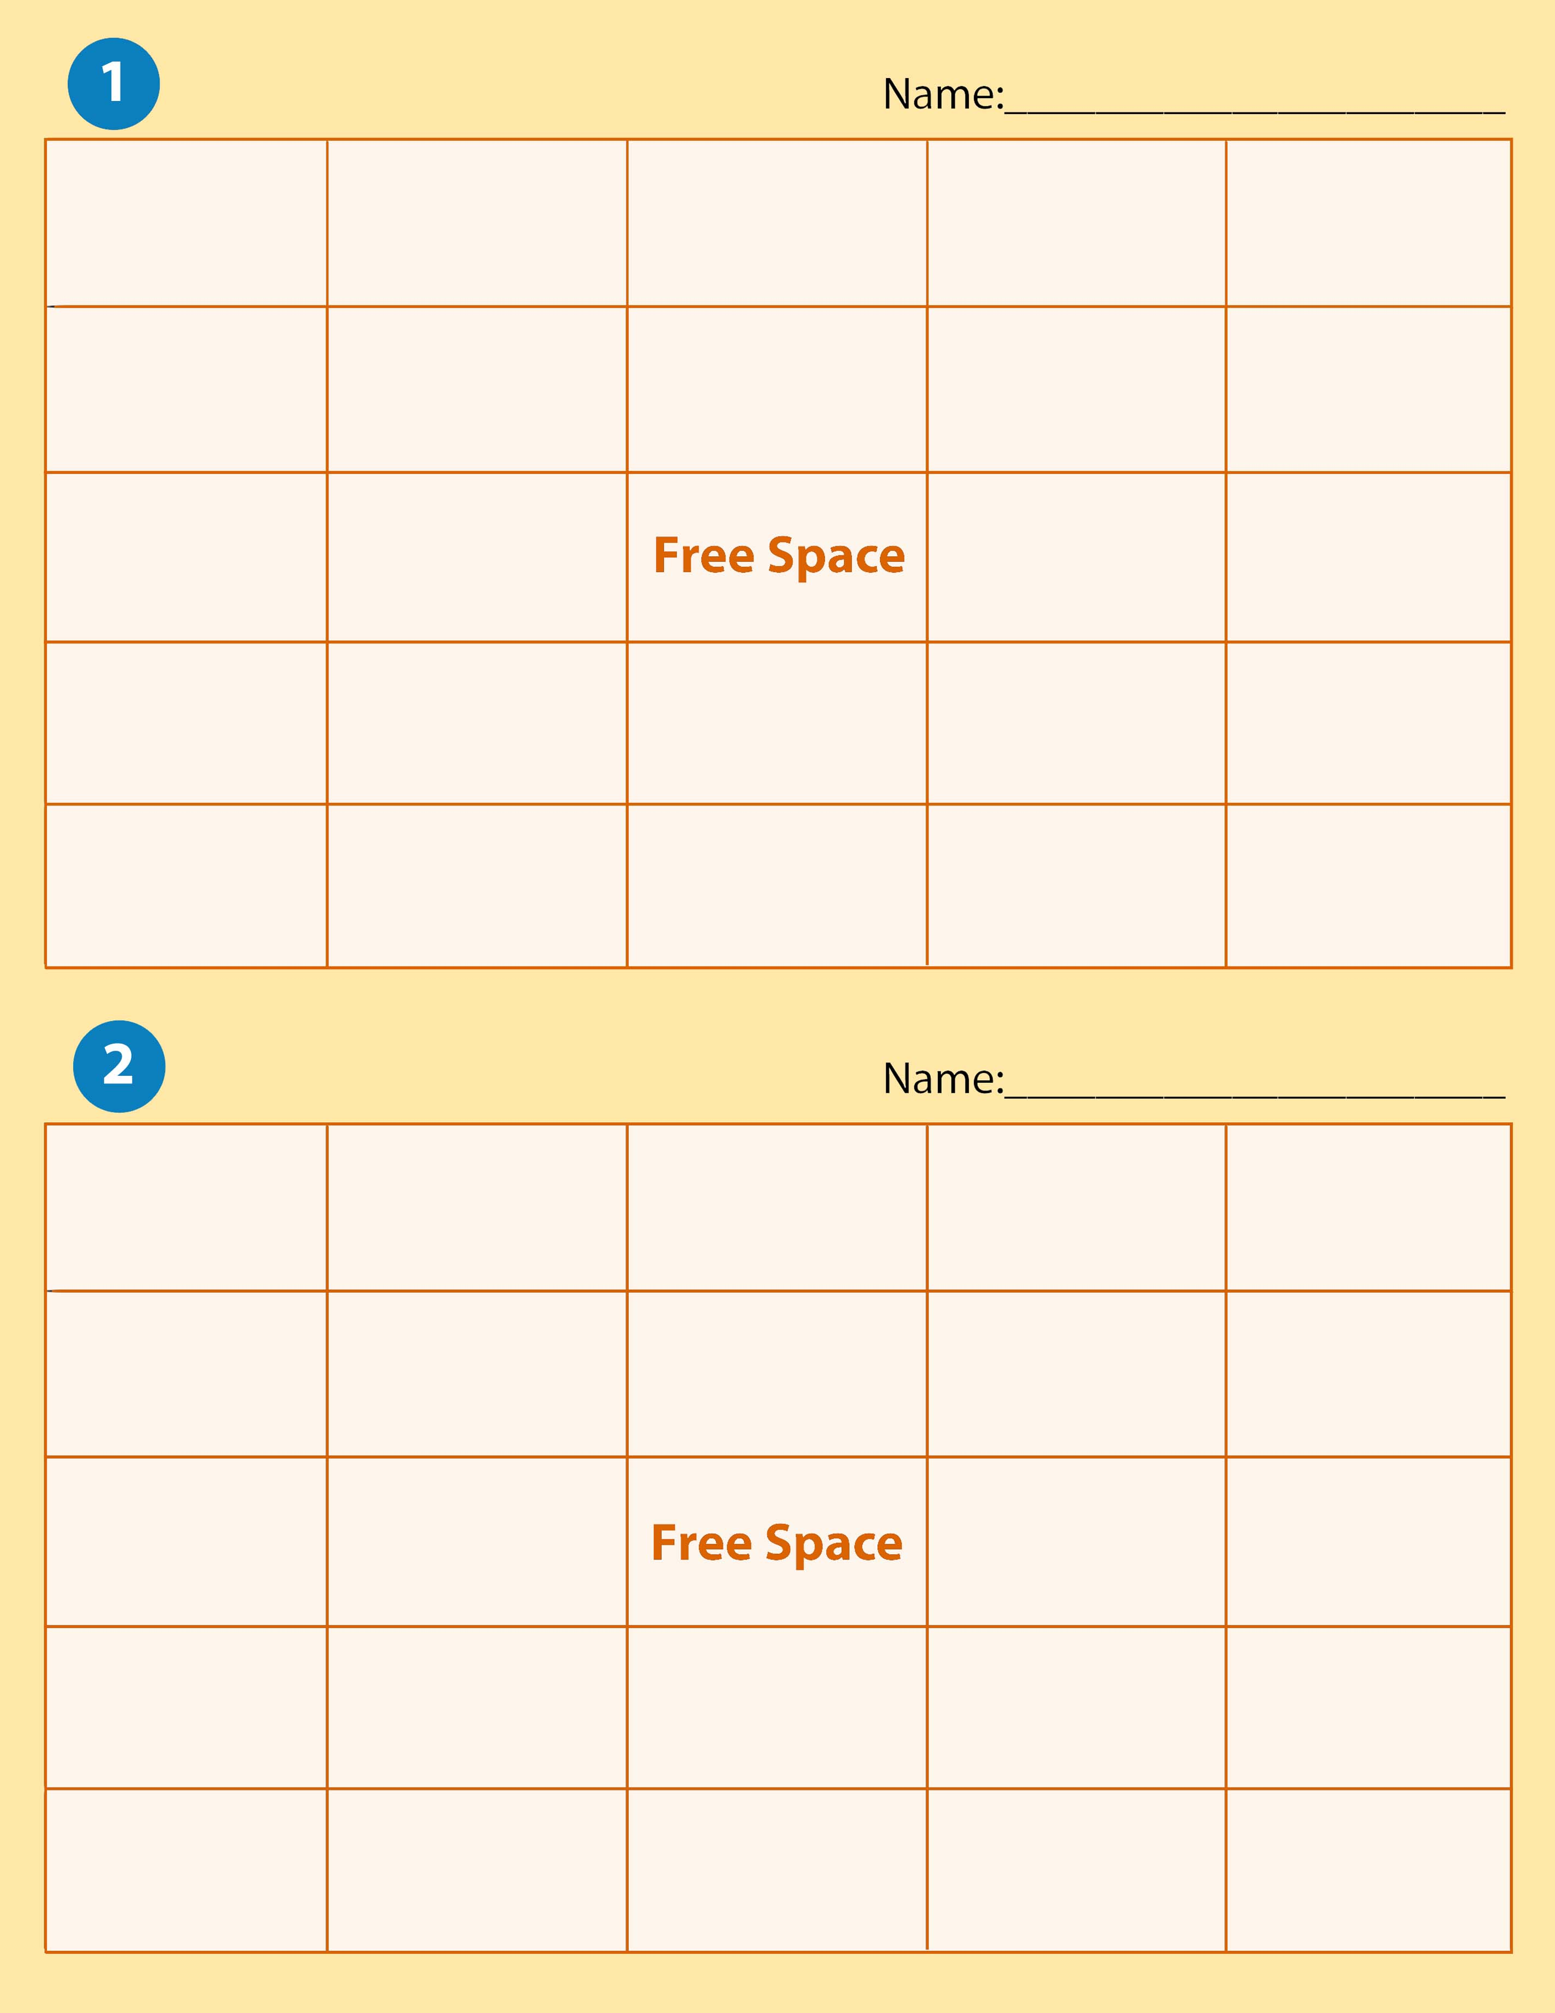

Capital | Proprietorship | Equities | Accounting | Revenue
Withdrawals | Expense | Accounting Equation | Asset | Service Business
Ethics | Sale on Account |  | Account | Accounting Records
Liability | Financial Statement | Current Assets | Business Ethics | Owner’s Equity
Accounting System | Account Title | Fixed Assets | Account Balance | Transaction

Sale on Account | Equities | Capital | Service Business | Expense
Fixed Assets | Owner’s Equity | Accounting Records | Account Title | Accounting System
Liability | Withdrawals |  | Financial Statement | Ethics
Accounting Equation | Account Balance | Account | Accounting | Proprietorship
Business Ethics | Asset | Current Assets | Transaction | Revenue

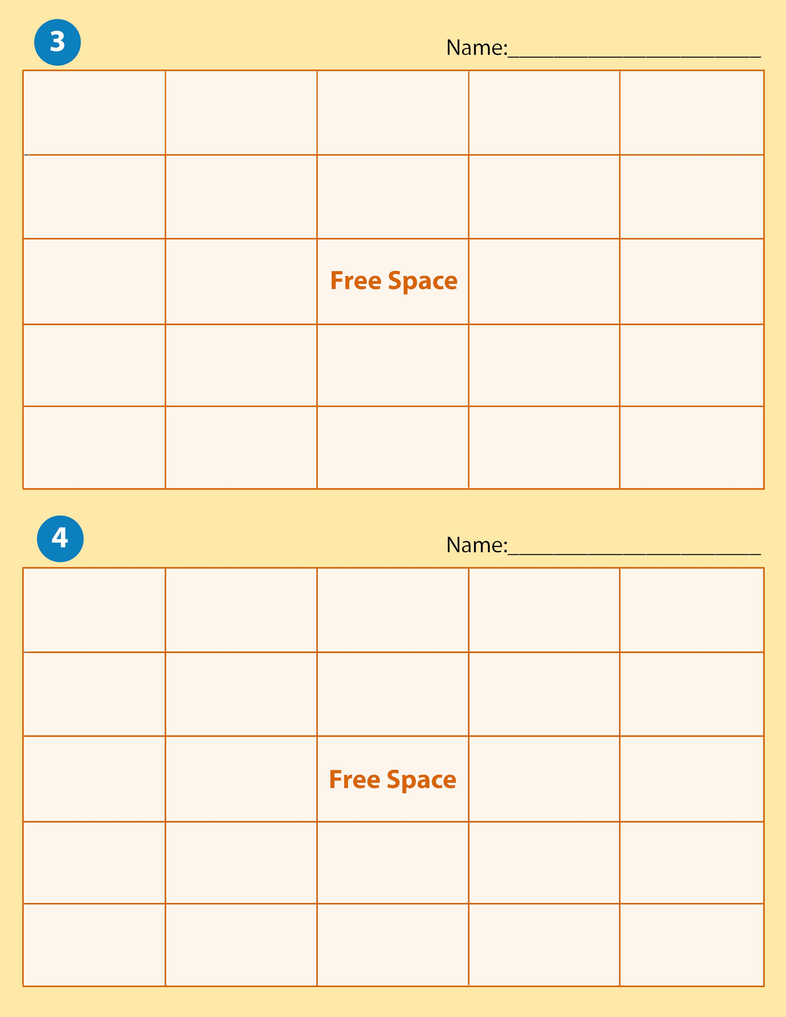
Owner’s Equity | Transaction | Account Title | Fixed Assets | Sale on Account
Accounting System | Service Business | Capital | Business Ethics | Asset
Liability | Withdrawals |  | Financial Statement | Account Balance
Ethics | Proprietorship | Revenue | Current Assets | Accounting Equation
Accounting | Equities | Expense | Accounting Records | Account

Capital | Equities | Withdrawals | Service Business | Accounting Equation
Current Assets | Sale on Account | Account | Accounting System | Asset
Revenue | Financial Statement |  | Business Ethics | Liability
Proprietorship | Accounting Records | Account Balance | Expense | Accounting
Owner’s Equity | Fixed Assets | Account Title | Ethics | Transaction

Account Balance | Equities | Account Title | Financial Statement | Withdrawals
Proprietorship | Accounting | Ethics | Transaction | Expense
Fixed Assets | Business Ethics |  | Accounting System | Account
Revenue | Liability | Accounting Equation | Service Business | Sale on Account
Accounting Records | Owner’s Equity | Current Assets | Capital | Asset
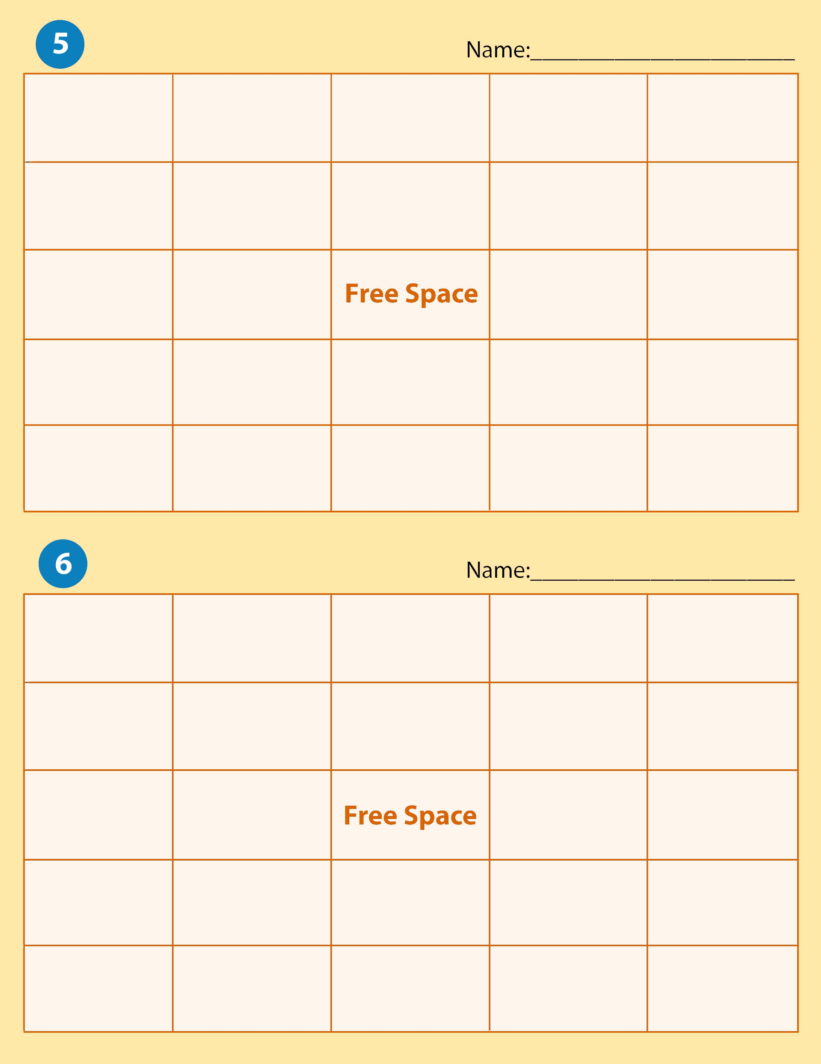

Sale on Account | Service Business | Asset | Accounting System | Current Assets
Expense | Transaction | Accounting Equation | Capital | Equities
Account Title | Withdrawals |  | Proprietorship | Business Ethics
Fixed Assets | Revenue | Account | Accounting Records | Liability
Accounting | Ethics | Financial Statement | Owner’s Equity | Account Balance

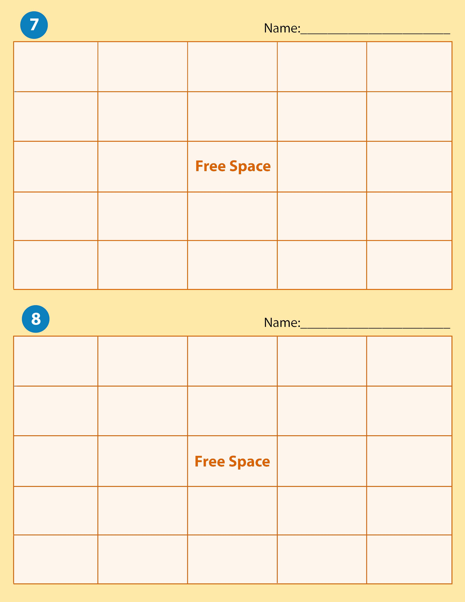

Withdrawals | Proprietorship | Accounting Records | Account Balance | Equities
Fixed Assets | Expense | Account | Accounting | Asset
Ethics | Financial Statement |  | Liability | Current Assets
Revenue | Service Business | Capital | Accounting System | Account Title
Transaction | Sale on Account | Owner’s Equity | Business ethics | Accounting Equation

Accounting System | Business Ethics | Account Balance | Transaction | Financial Statement
Current Assets | Ethics | Accounting Records | Account Title | Revenue
Accounting | Liability |  | Service Business | Expense
Fixed Assets | Accounting Equation | Asset | Capital | Account
Owner’s Equity | Equities | Sale on Account | Withdrawals | Proprietorship

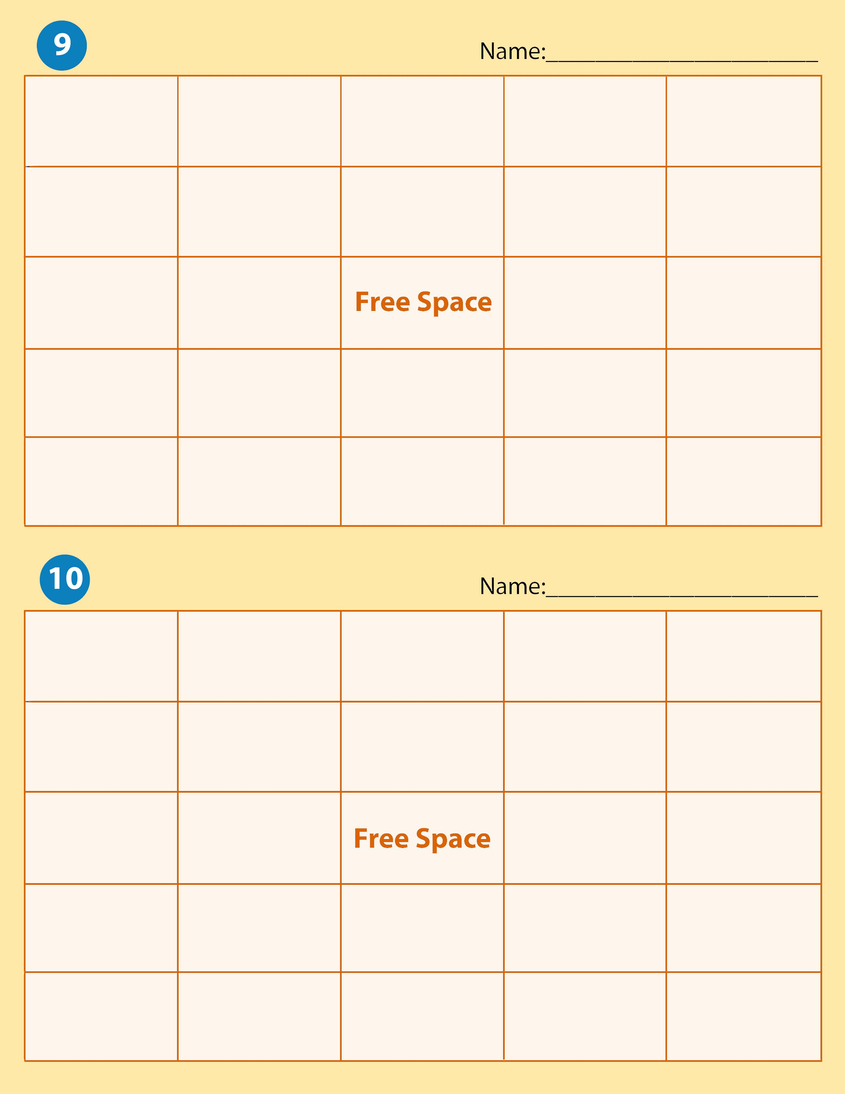

Financial Statement | Owner’s Equity | Asset | Withdrawals | Service Business
Proprietorship | Accounting Equation | Capital | Accounting | Sale on Account
Account | Expense |  | Current Assets | Ethics
Fixed Assets | Liability | Revenue | Account Title | Equities
Business Ethics | Account Balance | Transaction | Accounting Records | Accounting System

Account Title | Current Assets | Withdrawals | Liability | Asset
Fixed Assets | Owner’s Equity | Transaction | Accounting Records | Service Business
Revenue | Capital |  | Financial Statement | Accounting System
Equities | Accounting Equation | Expense | Account | Account Balance
Proprietorship | Accounting | Sale on Account | Ethics | Business Ethics

Expense | Asset | Accounting Equation | Fixed Assets | Withdrawals
Financial Statement | Ethics | Equities | Service Business | Revenue
Account Balance | Accounting System |  | Owner’s Equity | Current Assets
Account Title | Proprietorship | Accounting Records | Account | Accounting
Transaction | Capital | Liability | Business Ethics | Sale on Account
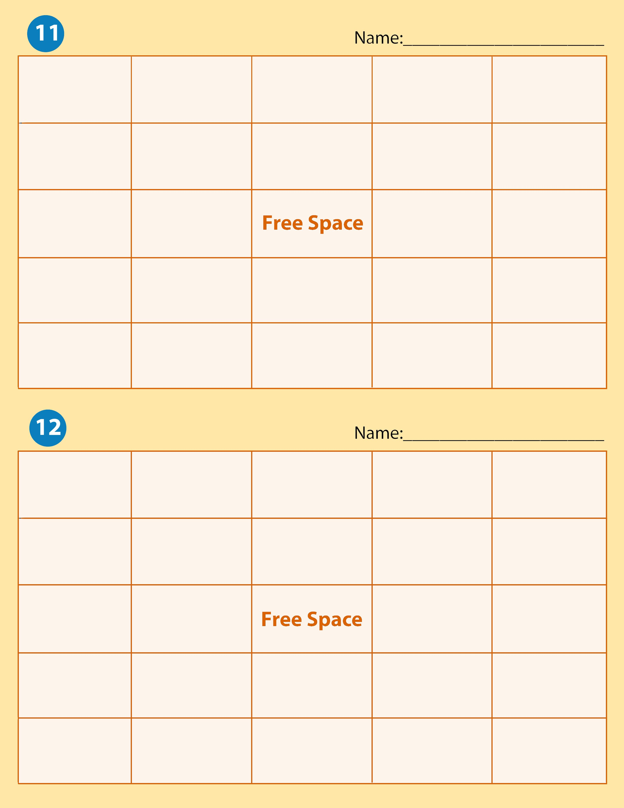

Account Title | Sale on Account | Fixed Assets | Transaction | Accouting Equation
Withdrawals | Account | Accounting | Account balance | Accounting System
Proprietorship | Liability |  | Service Business | Capital
Current Assets | Equities | Business Ethics | Financial Statement | Ethics
Revenue | Accounting Records | Owner’s Equity | Asset | Expense

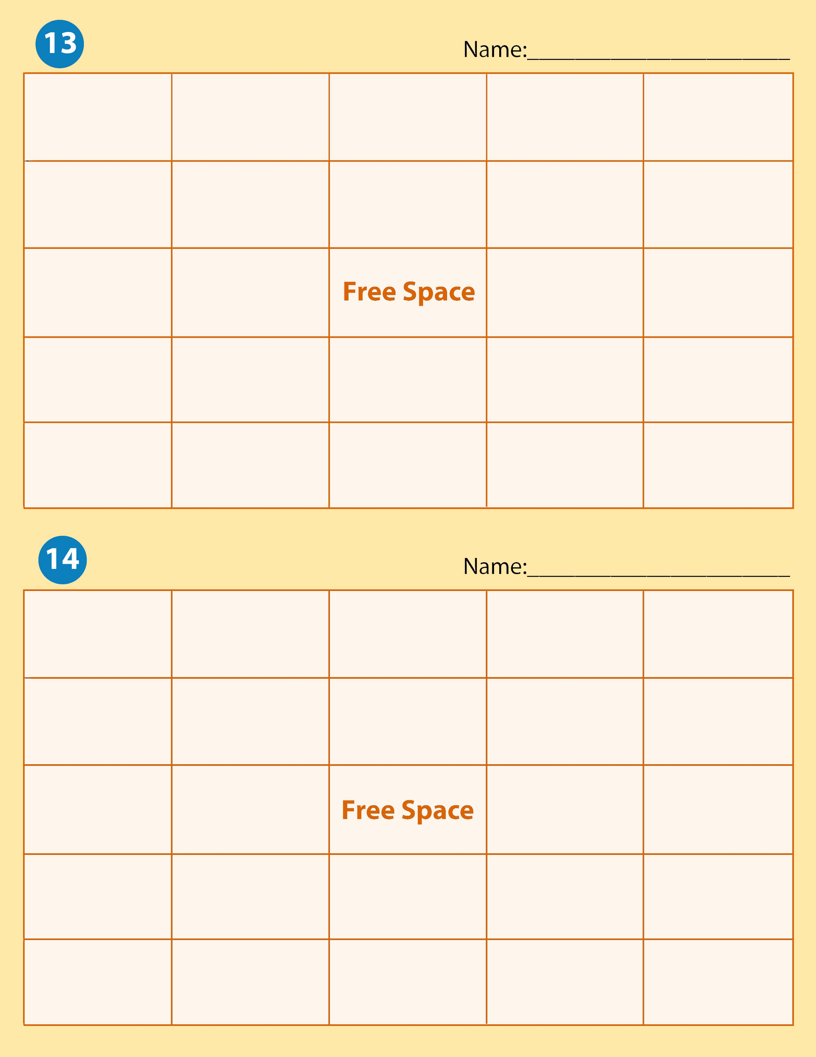

Financial Statement | Current Assets | Expense | Revenue | Account Balance
Account | Accounting | Accounting Records | Proprietorship | Equities
Owner’s Equity | Ethics |  | Transaction | Fixed Assets
Withdrawals | Sale on Account | Capital | Account Title | Accounting System
Service Business | Asset | Liability | Accounting Equation | Business Ethics

Accounting System | Service Business | Asset | Liability | Accounting Equation
Business Ethics | Account Title | Capital | Sale on Account | Withdrawals
Fixed Assets | Accounting |  | Accounting Records | Proprietorship
Equities | Owner’s Equity | Ethics | Transaction | Account
Account Balance | Revenue | Expense | Current Assets | Financial Statement

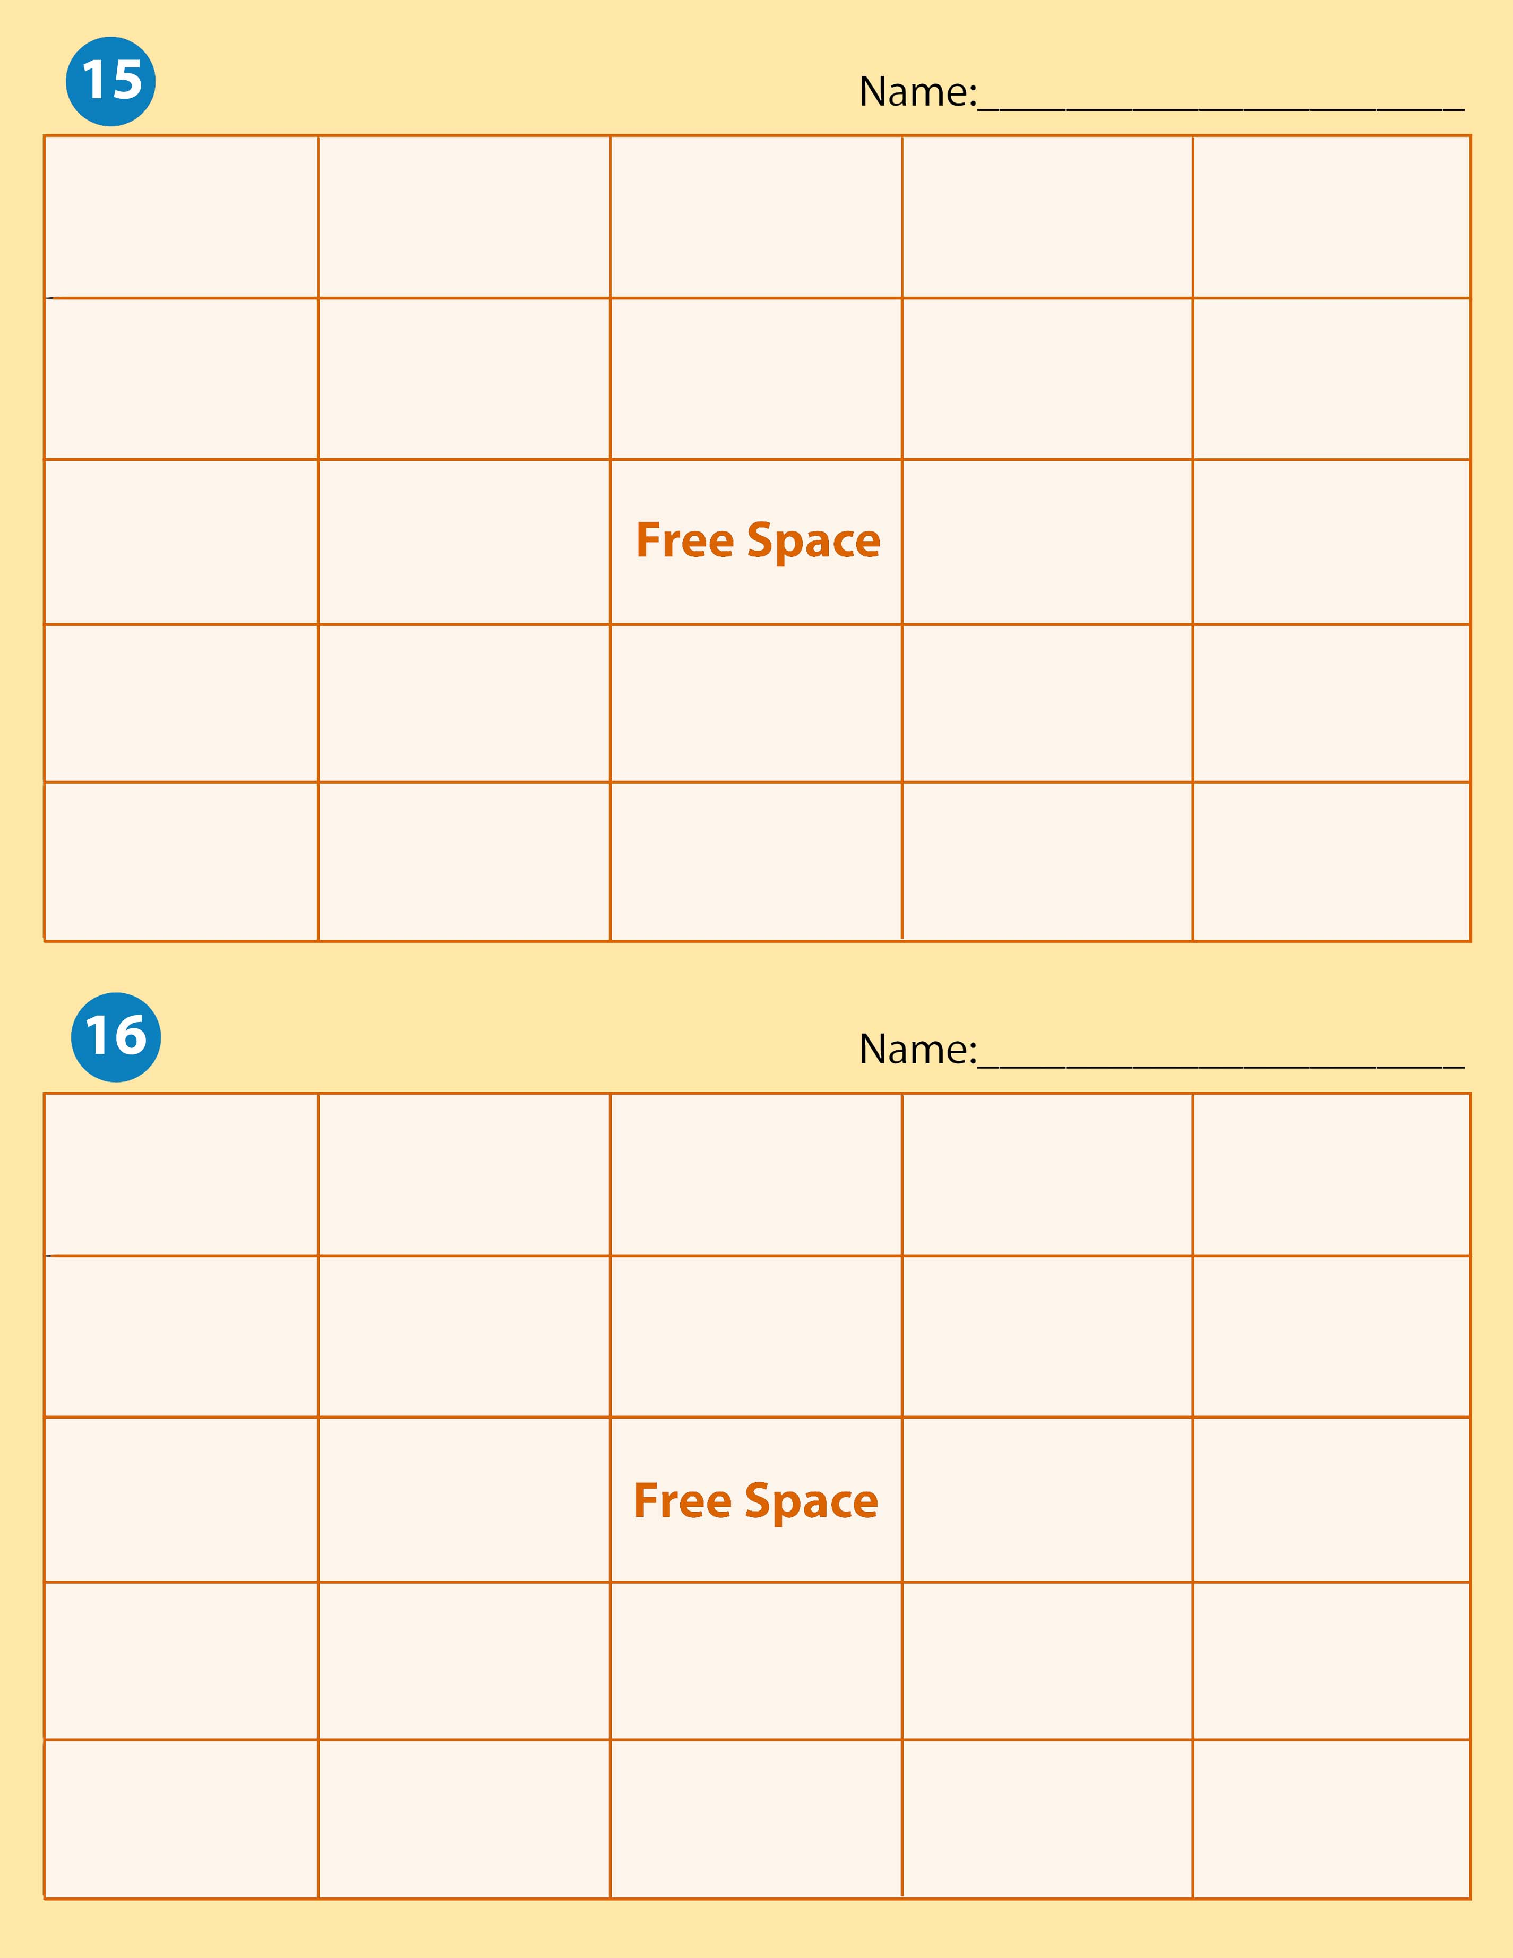
Business Ethics | Account Title | Accounting | Transaction | Fixed Assets
Equities | Accounting System | Capital | Current Assets | Asset
Ethics | Account |  | Service Business | Revenue
Account Balance | Sale on Account | Liability | Accounting Equation | Financial Statement
Expense | Accounting Records | Owner’s Equity | Proprietorship | Withdrawal

Proprietorship | Accounting Equation | Liability | Accounting | Account Title
Financial Statement | Transaction | Equities | Ethics | Account Balance
Fixed Assets | Account |  | Accounting Records | Accounting System
Asset | Revenue | Current Assets | Expense | Business Ethics
Owner’s Equity | Service Business | Capital | Withdrawals | Sale on Account

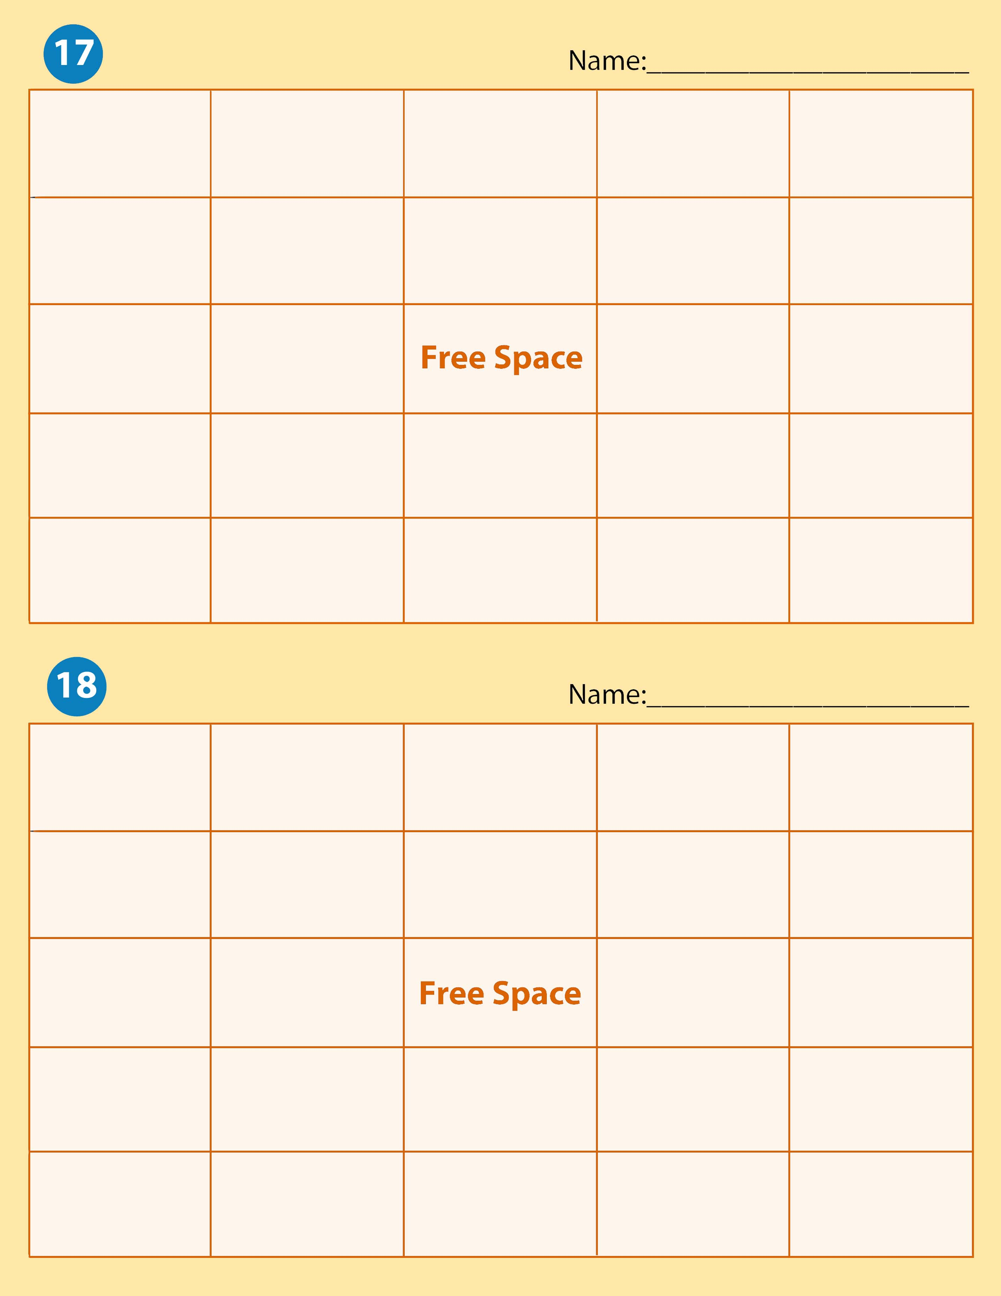

Account Title | Business Ethics | Transaction | Accounting Records | Accounting System
Account | Accounting Equation | Current Assets | Accounting | Capital
Asset | Withdrawals |  | Liability | Sale on Account
Service Business | Account Balance | Ethics | Financial Statement | Proprietorship
Expense | Owner’s Equity | Revenue | Equities | Fixed Assets

Sale on Account | Asset | Expense | Equities | Withdrawals
Liability | Current Assets | Owner’s Equity | Fixed Assets | Accounting Equation
Financial Statement | Ethics |  | Account | Accounting
Account Title | Accounting System | Account Balance | Accounting Records | Capital
Service Business | Revenue | Proprietorship | Business Ethics | Transaction

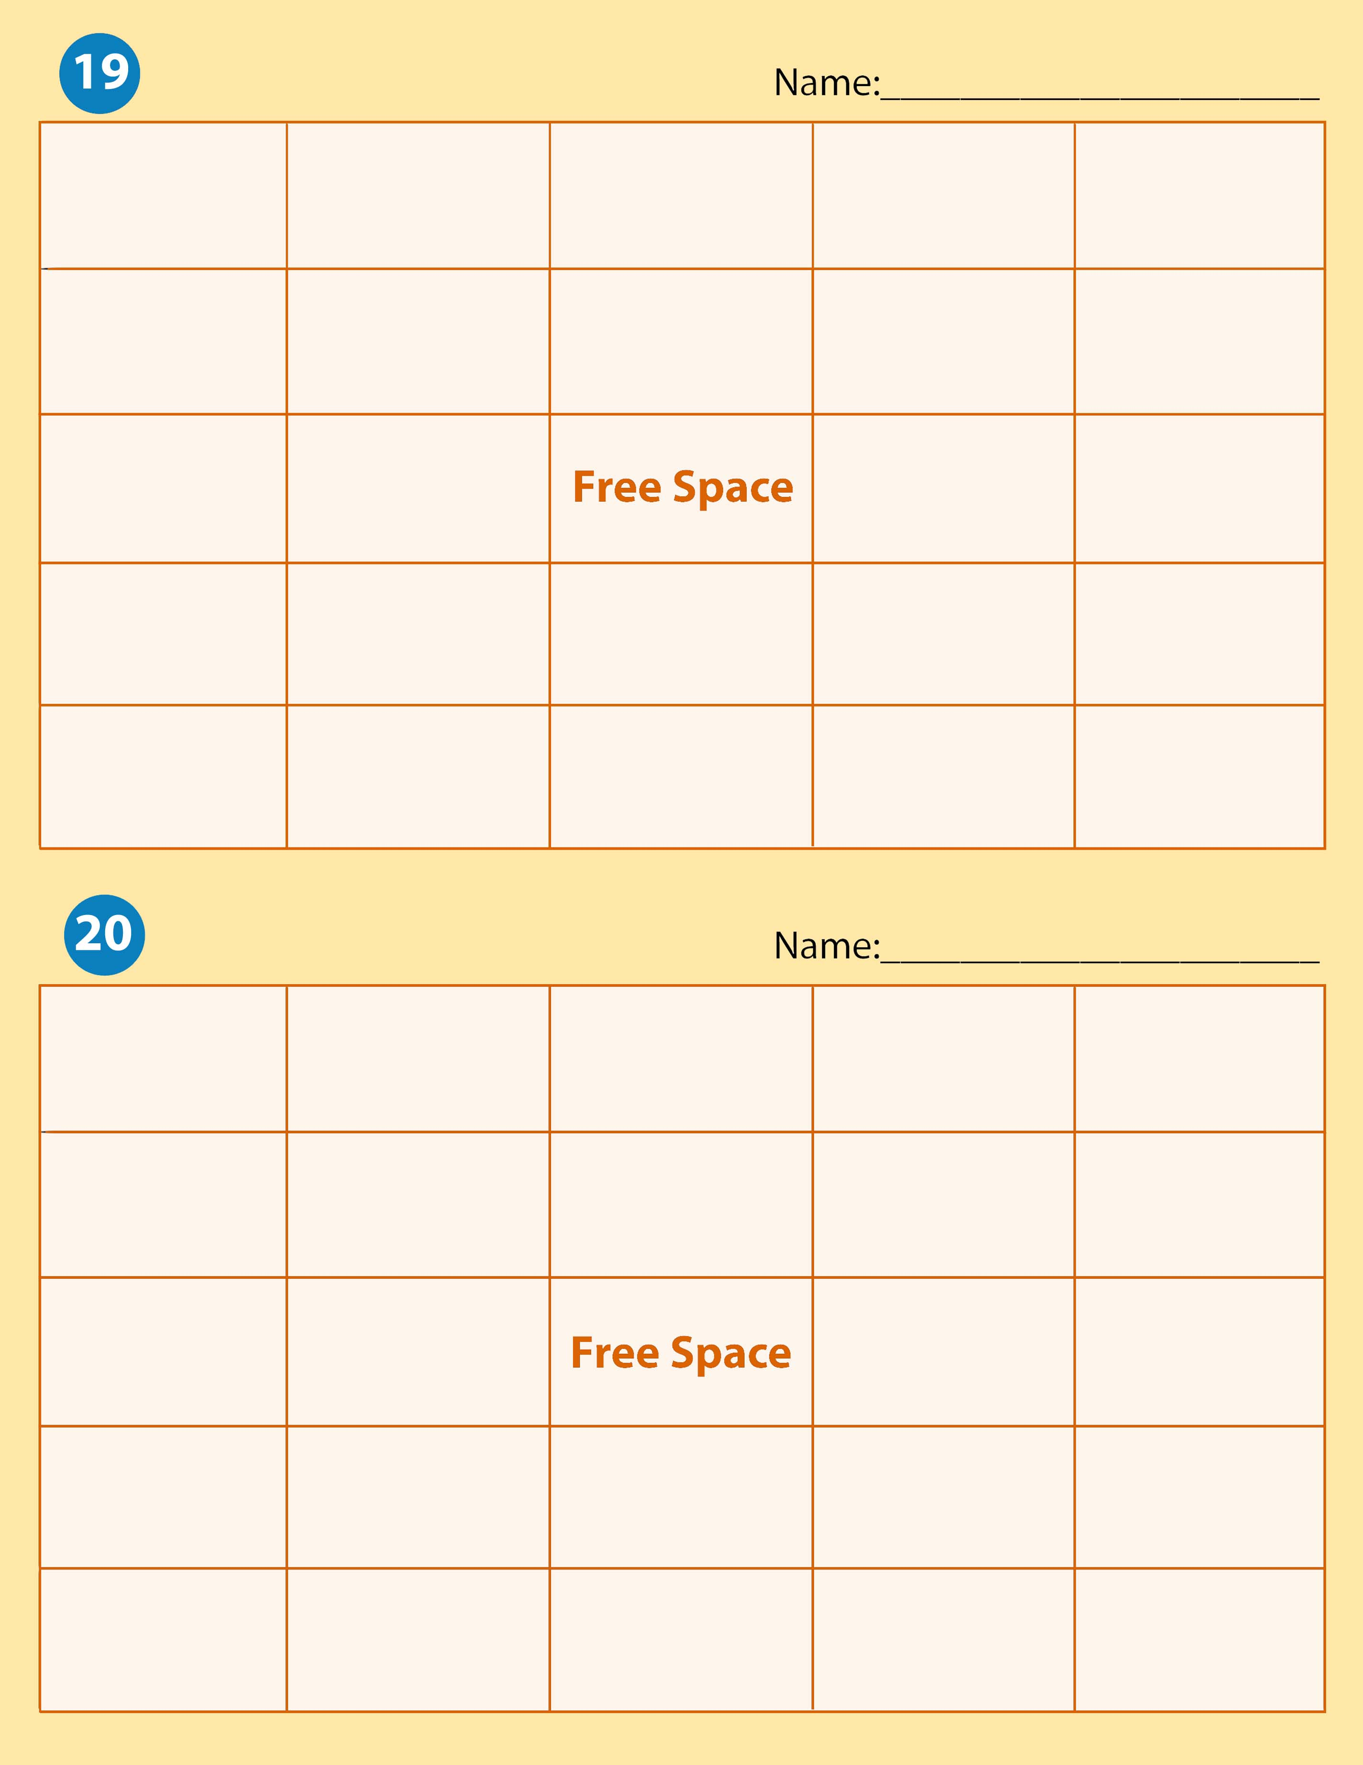
Capital | Liability | Withdrawals | Accounting Records | Sale on account
Owner’s Equity | Fixed Assets | Service Business | Revenue | Proprietorship
Current Assets | Accounting |  | Account | Asset
Expense | Transaction | Financial Statement | Equities | Account Balance
Business Ethics | Account Title | Accounting Equation | Accounting System | Ethics

Revenue | Withdrawals |  | Ethics | Transaction | Fixed Assets
Expense |  | Accounting System | Proprietorship | Current Assets | Capital
Liability |  | Accounting Equation |  | Financial Statement | Sale on Account
Asset |  | Accounting | Account Balance | Account Title | Accounting Records
Equities |  | Account | Owner’s Equity | Business Ethics | Service Business

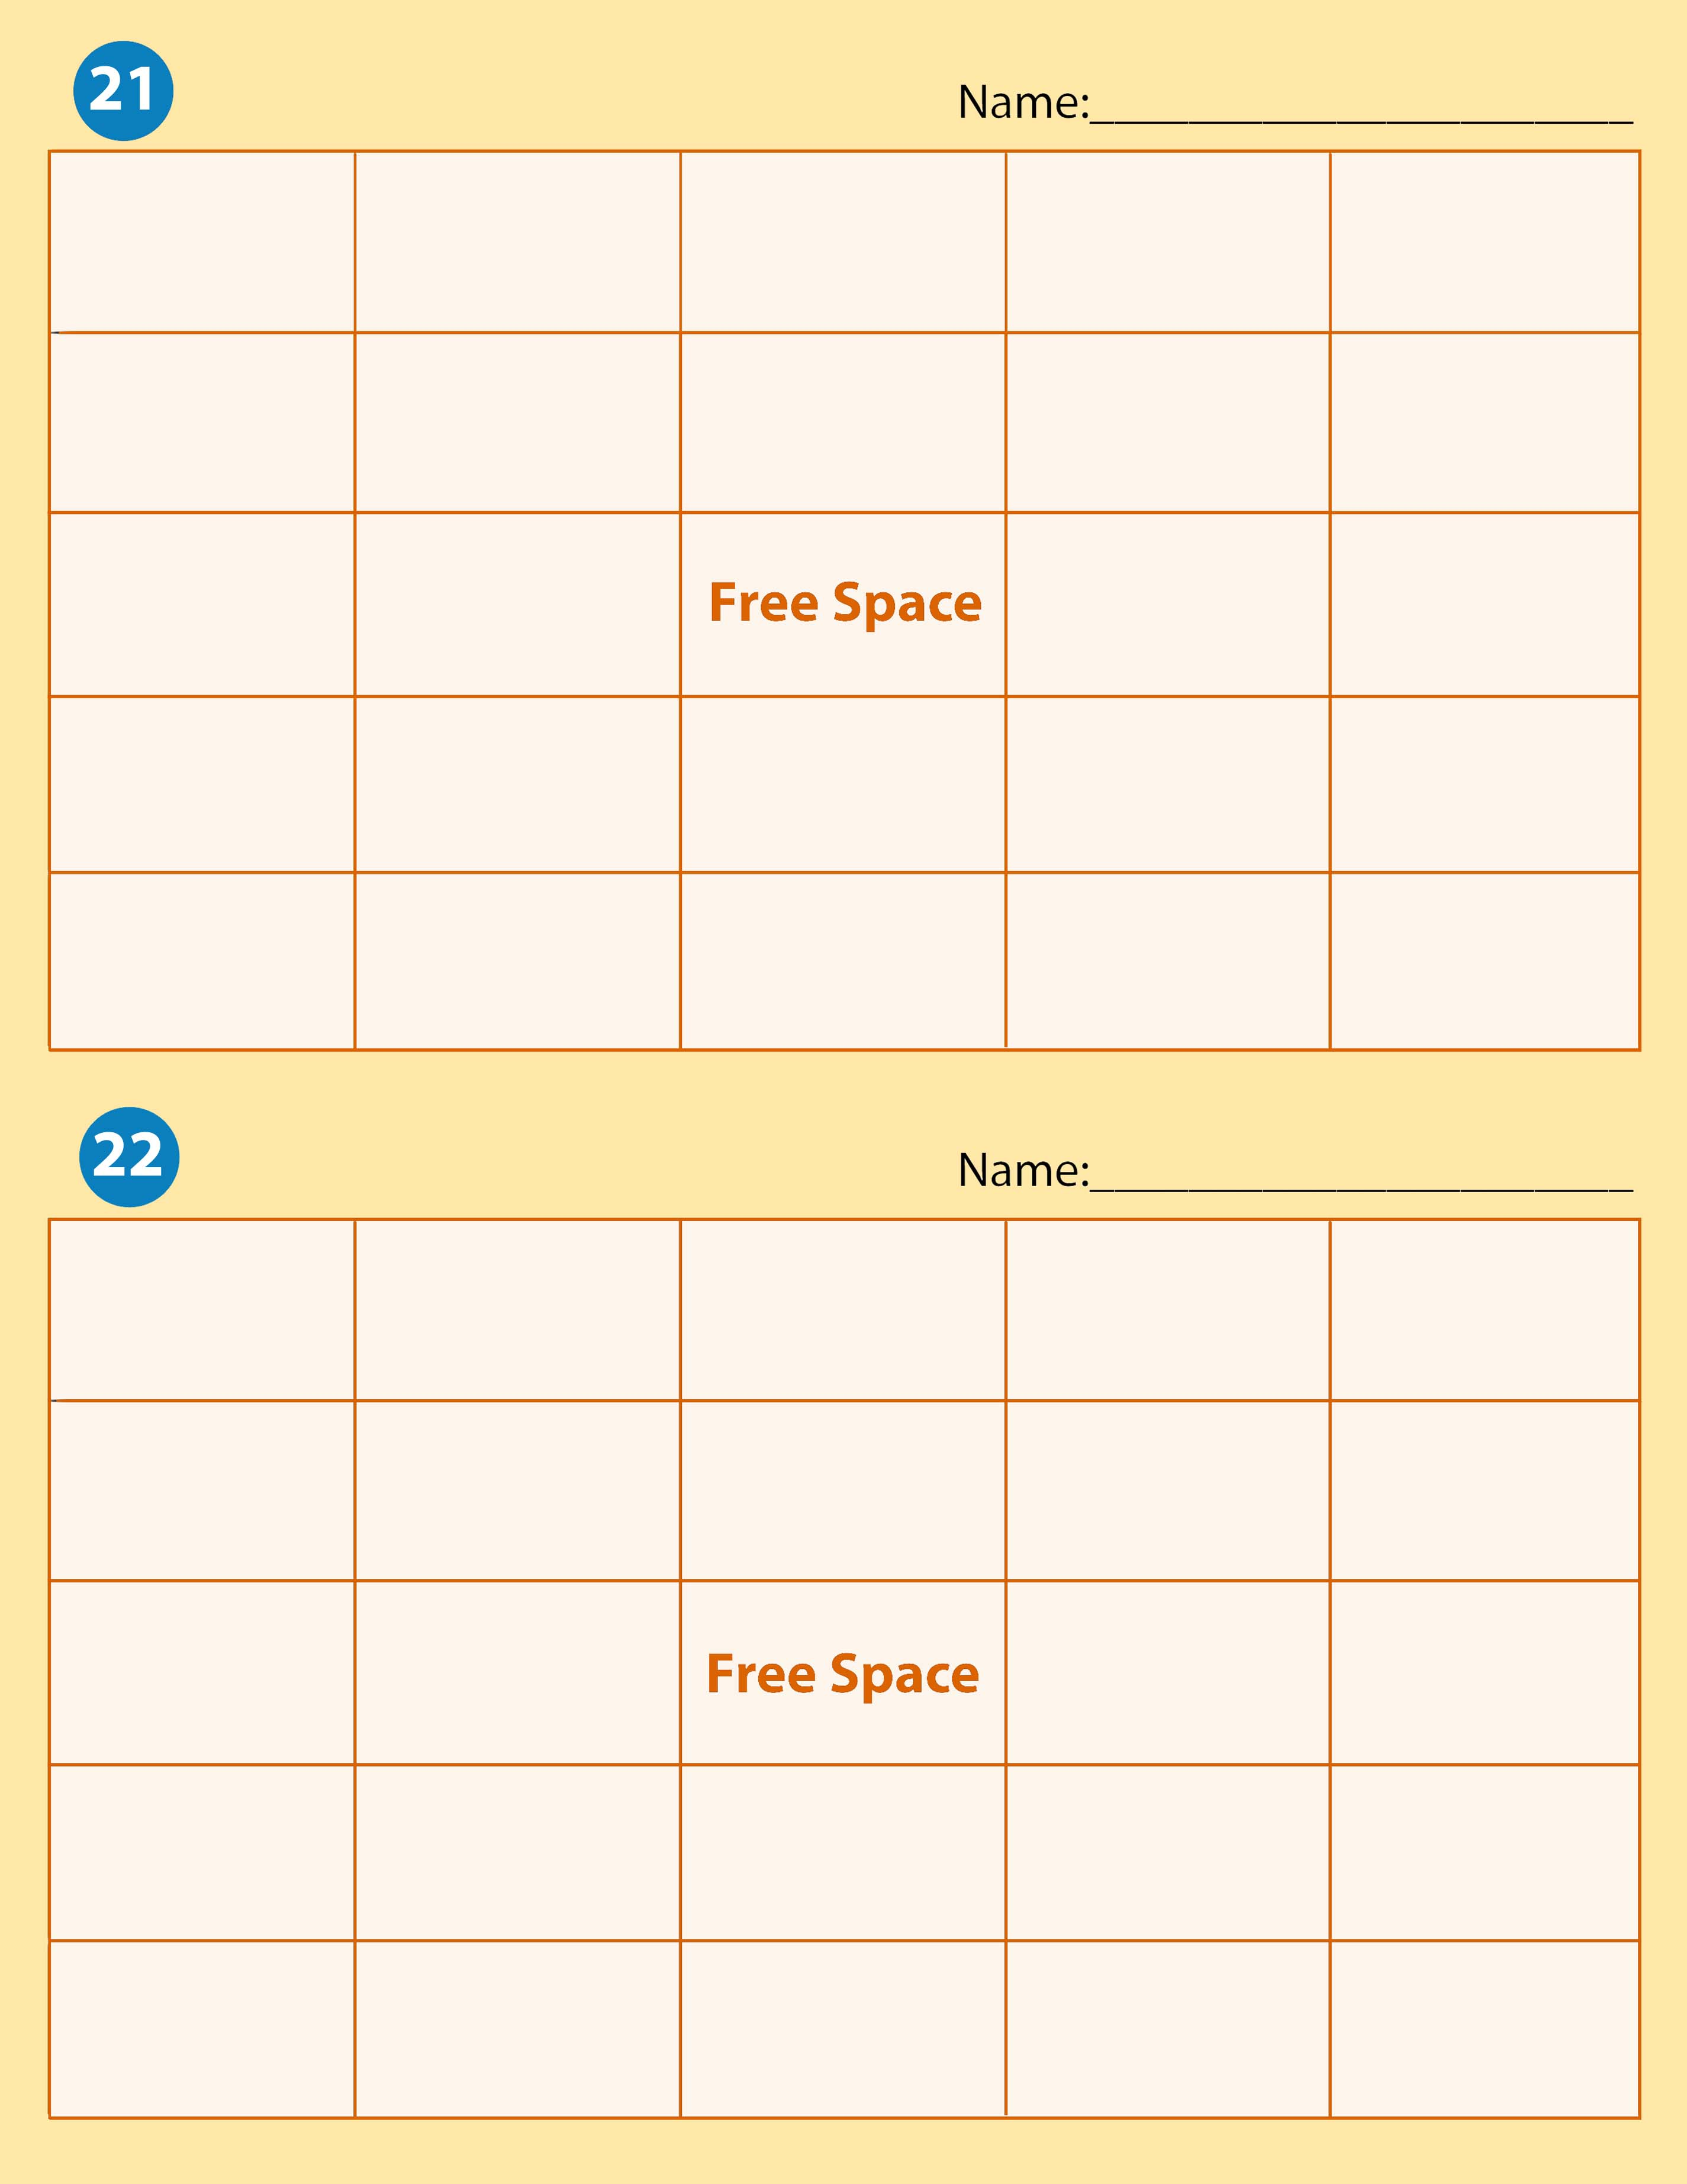

Fixed Assets | Owner’s Equity | Transaction | Account | Liability
Current Assets | Revenue | Asset | Accounting | Ethics
Financial Statement | Expense |  | Accounting Equation | Sale on Account
Equities | Service Business | Account Title | Business Ethics | Capital
Accounting System | Withdrawals | Proprietorship | Account Balance | Accounting Records

Financial Statement | Ethics | Sale on Account | Accounting System | Current Assets
Business Ethics | Owner’s Equity | Capital | Service Business | Account
Accounting Records | Account Title |  | Expense | Transaction
Equities | Accounting Equation | Withdrawals | Asset | Account Balance
Accounting | Liability | Fixed Assets | Proprietorship | Revenue

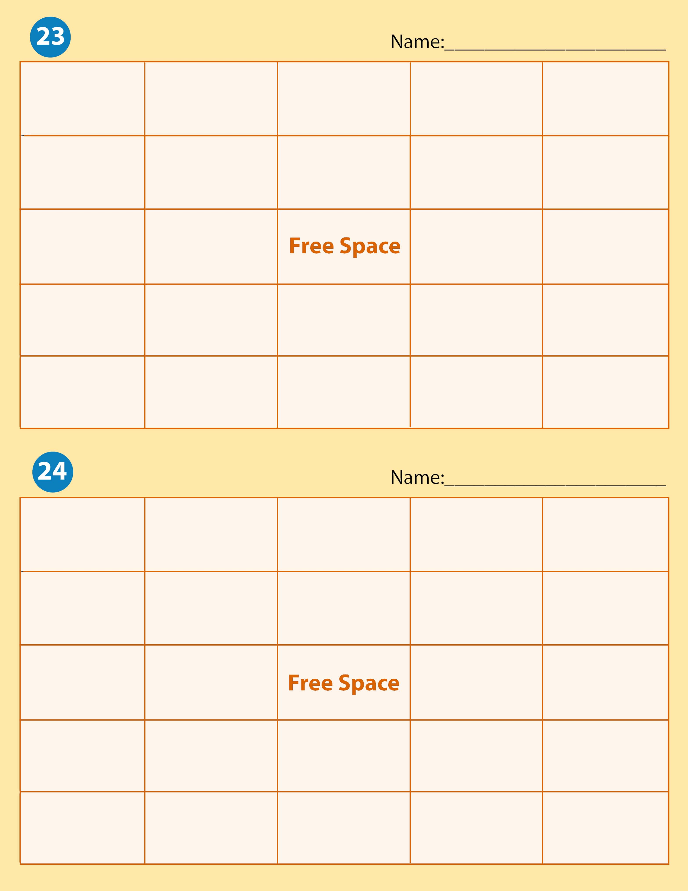

Account | Accounting System | Asset | Withdrawals | Liability
Account Balance | Service Business | Account Title | Financial Statement | Owner’s Equity
Sale on Account | Accounting |  | Revenue | Transaction
Current Assets | Capital | Proprietorship | Fixed Assets | Ethics
Expense | Accounting Records | Accounting Equation | Equities | Business Ethics

Capital | Sale on Account | Equities | Withdrawals | Proprietorship
Fixed Assets | Account | Liability | Transaction | Expense
Accounting | Owner’s Equity |  | Revenue | Accounting Records
Asset | Account Balance | Accounting System | Financial Statement | Account Title
Ethics | Service Business | Business Ethics | Current Assets | Accounting Equation

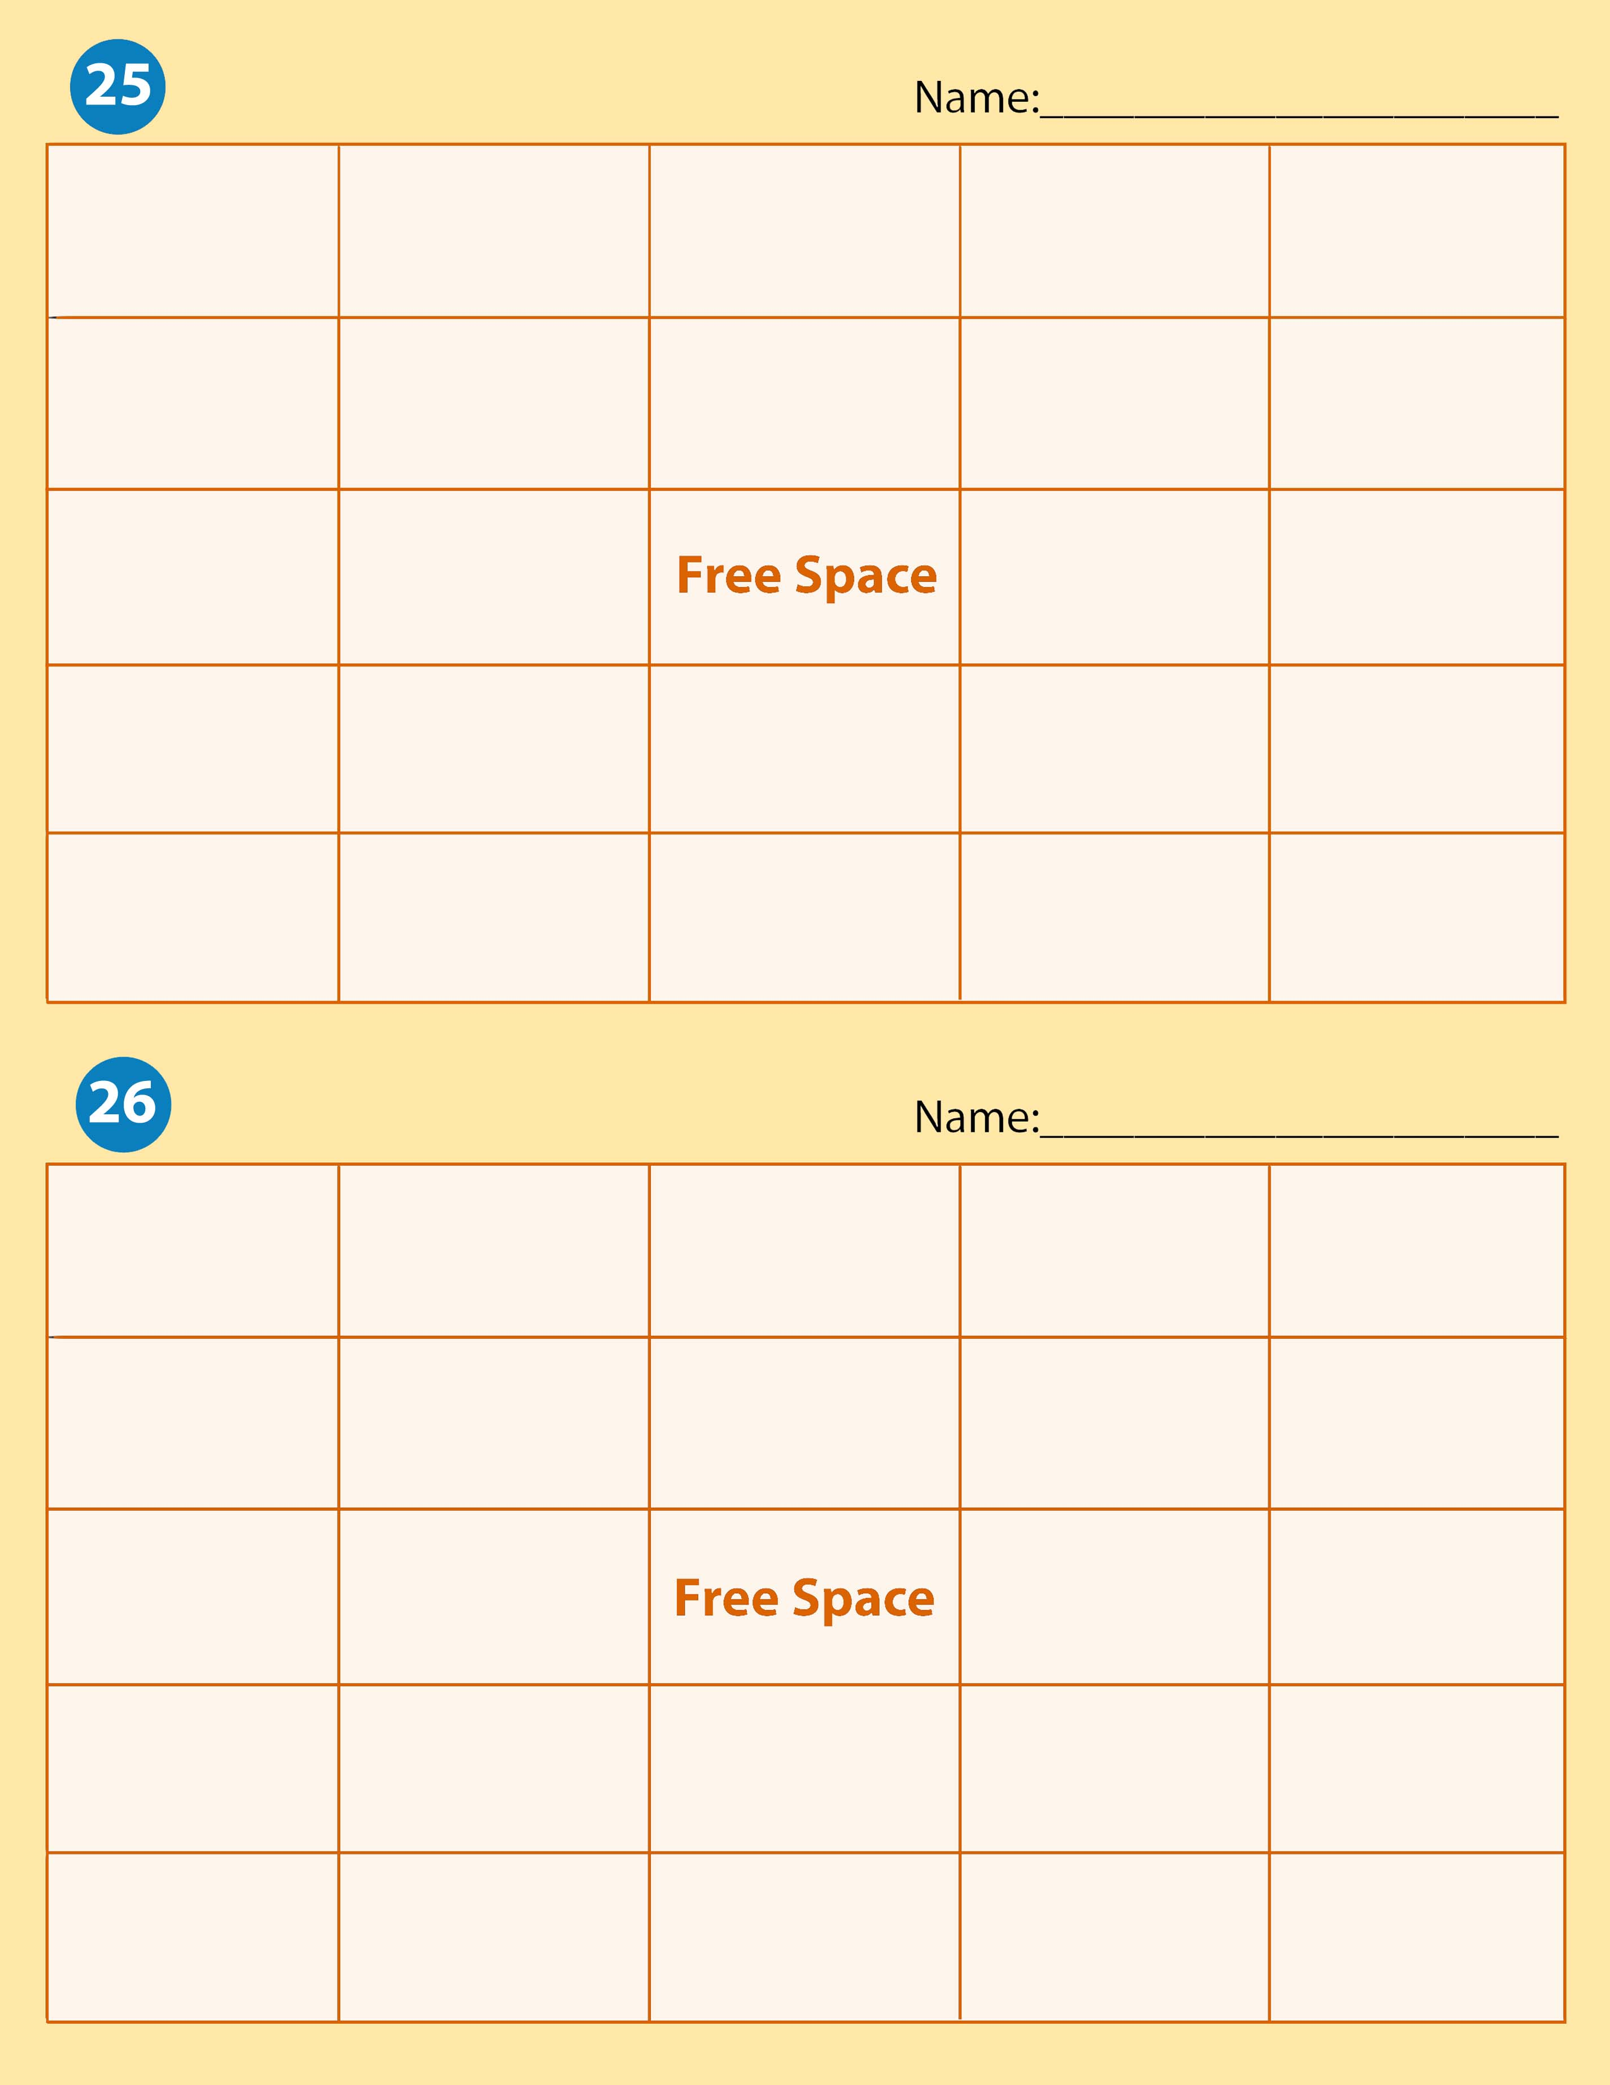
Accounting | Revenue | Accounting Records | Service Business | Accounting System
Account Balance | Current Assets | Accounting Equation | Transaction | Fixed Assets
Owner’s Equity | Withdrawals |  | Asset | Account
Sale on Account | Ethics | Equities | Account Title | Financial Statement
Proprietorship | Capital | Business Ethics | Liability | Expense

Accounting | Accounting System | Accounting Records | Service Business | Proprietorship
Asset | Equities | Liability | Owner’s Equity | Accounting Equation
Ethics | Business Ethics |  | Transaction | Account
Account Title | Account Balance | Capital | Revenue | Sale on Account
Expense | Withdrawals | Current Assets | Fixed Assets | Financial Statement

