BINGO
CTAE Resource Network, Curriculum Office
March, 2009

Directions for the Instructor

1. Print the bingo cards. Twenty six different cards are included. Print additional cards at random if needed. Cut each sheet to separate the cards. Cards may be laminated for durability.

2. Give each student a bingo card and chips, markers, or scrap paper. If paper is to be used, ask students to tear or cut 25 pieces of paper about one-half inch square. If the cards have been laminated, students can mark their cards with erasable markers.

3. Explain to the students that you will read the definitions to the class and that they should mark the correct answer on their card. Note that all cards do not have all the answers.

4. Read the definitions only, at random, from the definitions list. Mark the definitions that have been used. The student should place a chip on the cell with the correct response.

5. When a student has placed chips on 5 spaces in a row (diagonally, vertically, or horizontally) the student should call “Bingo”. Ask the winning student to call out their answers. Check their answers to make sure those definitions have been used.

Optional Bingo Variations:

- T-Bingo: The card must be marked in the shape of a “T” to call Bingo.

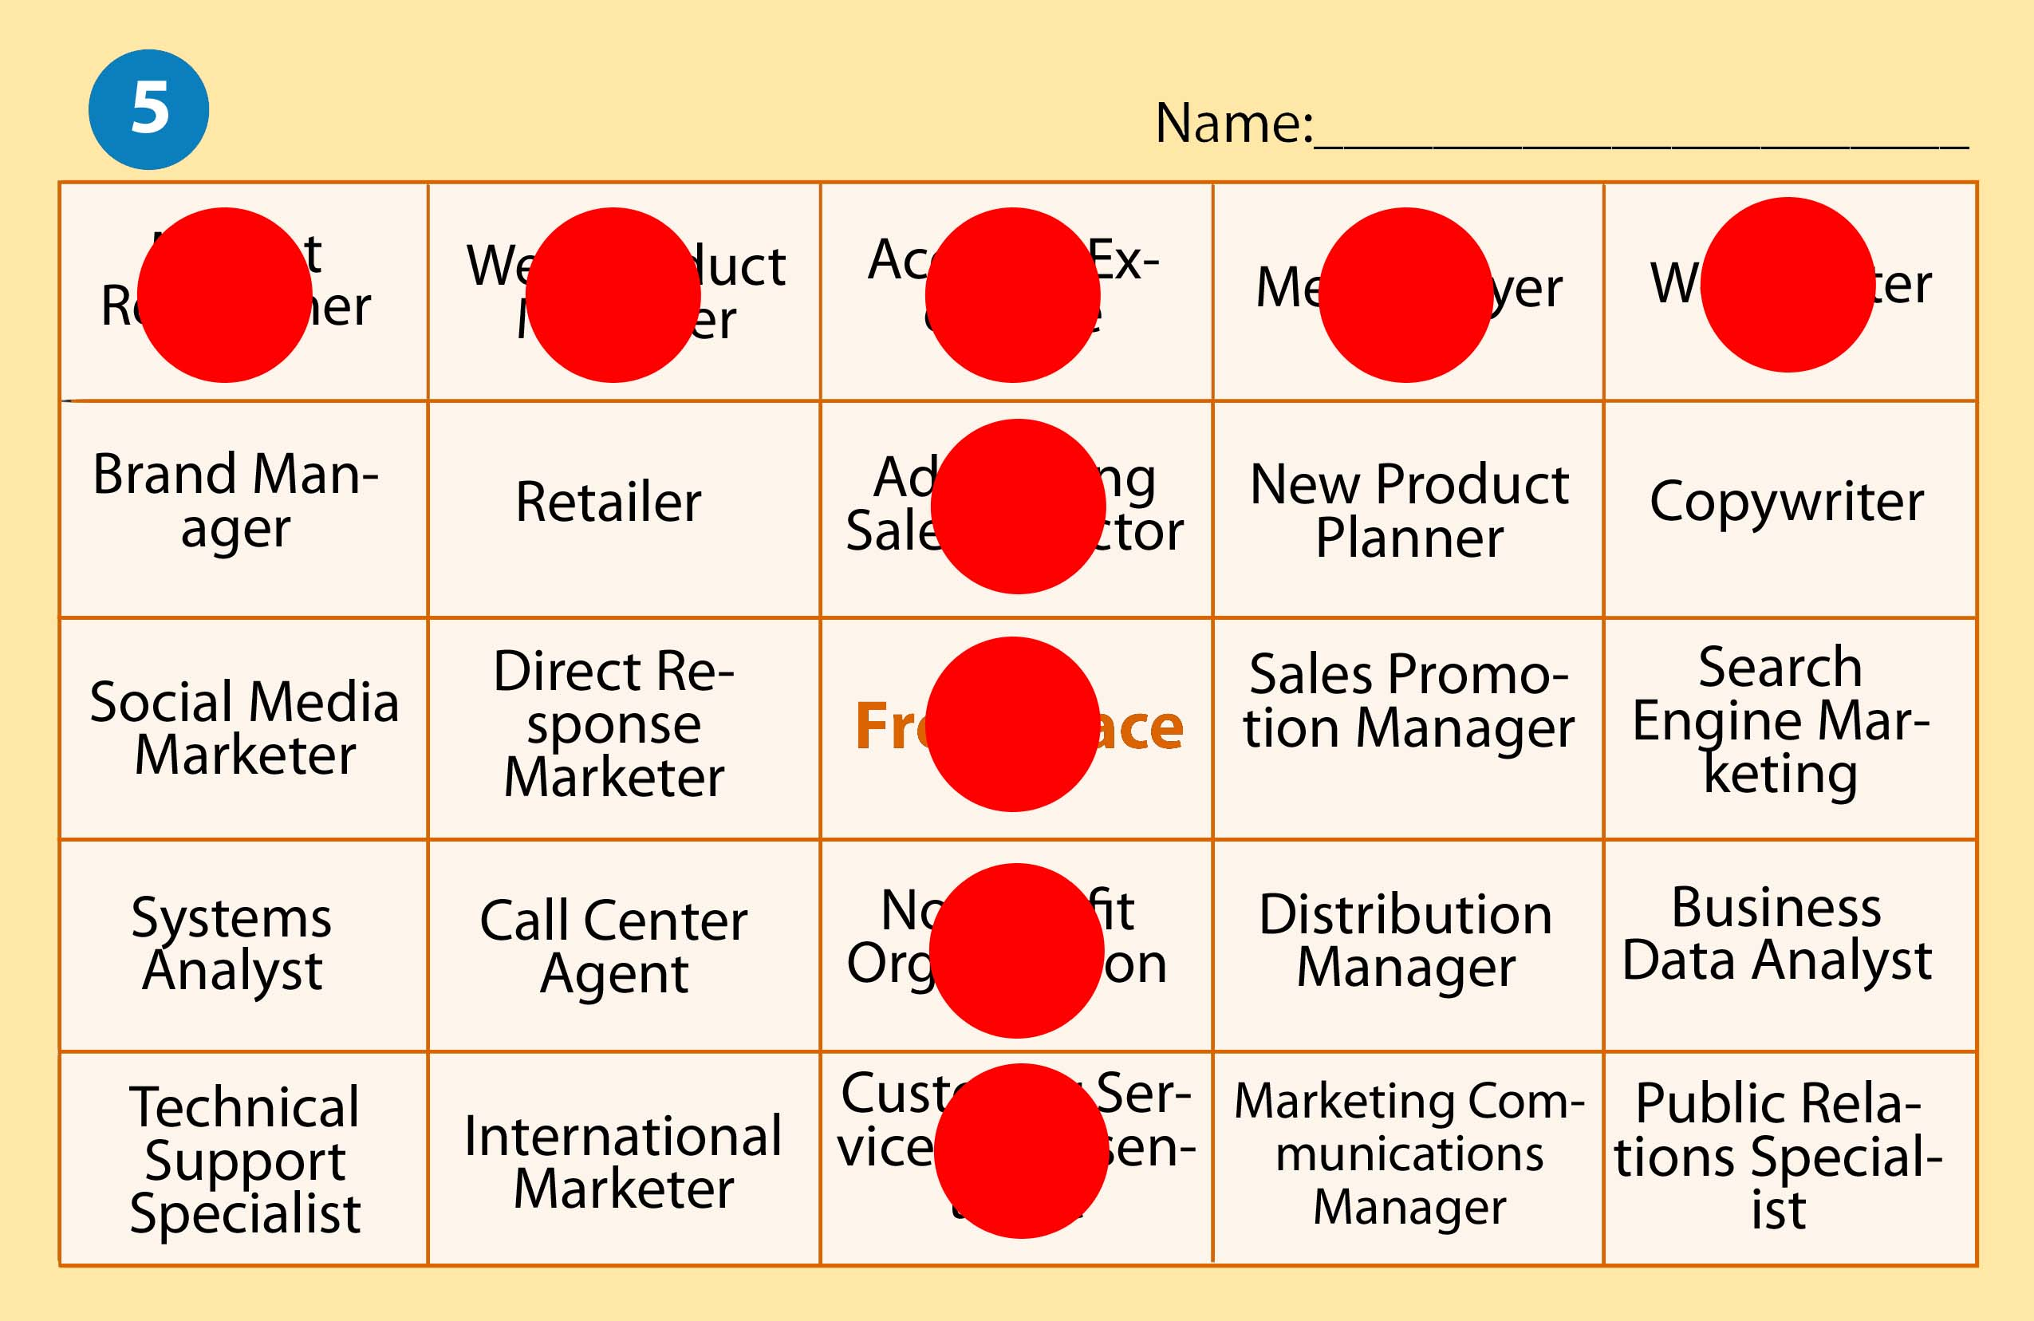

- Corners Bingo: The four outer corners of the card must be marked to get Bingo.

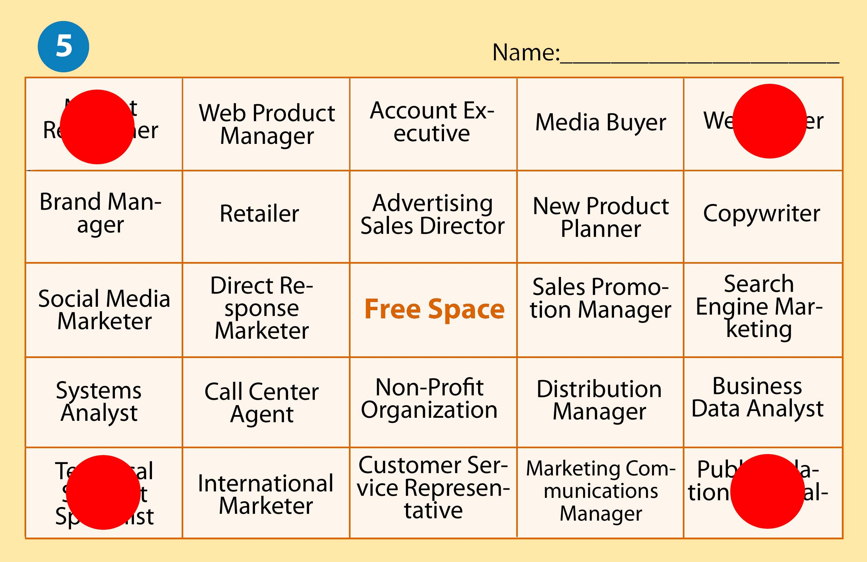

- U-Bingo: The card must be marked in the shape of a “U” to call Bingo.

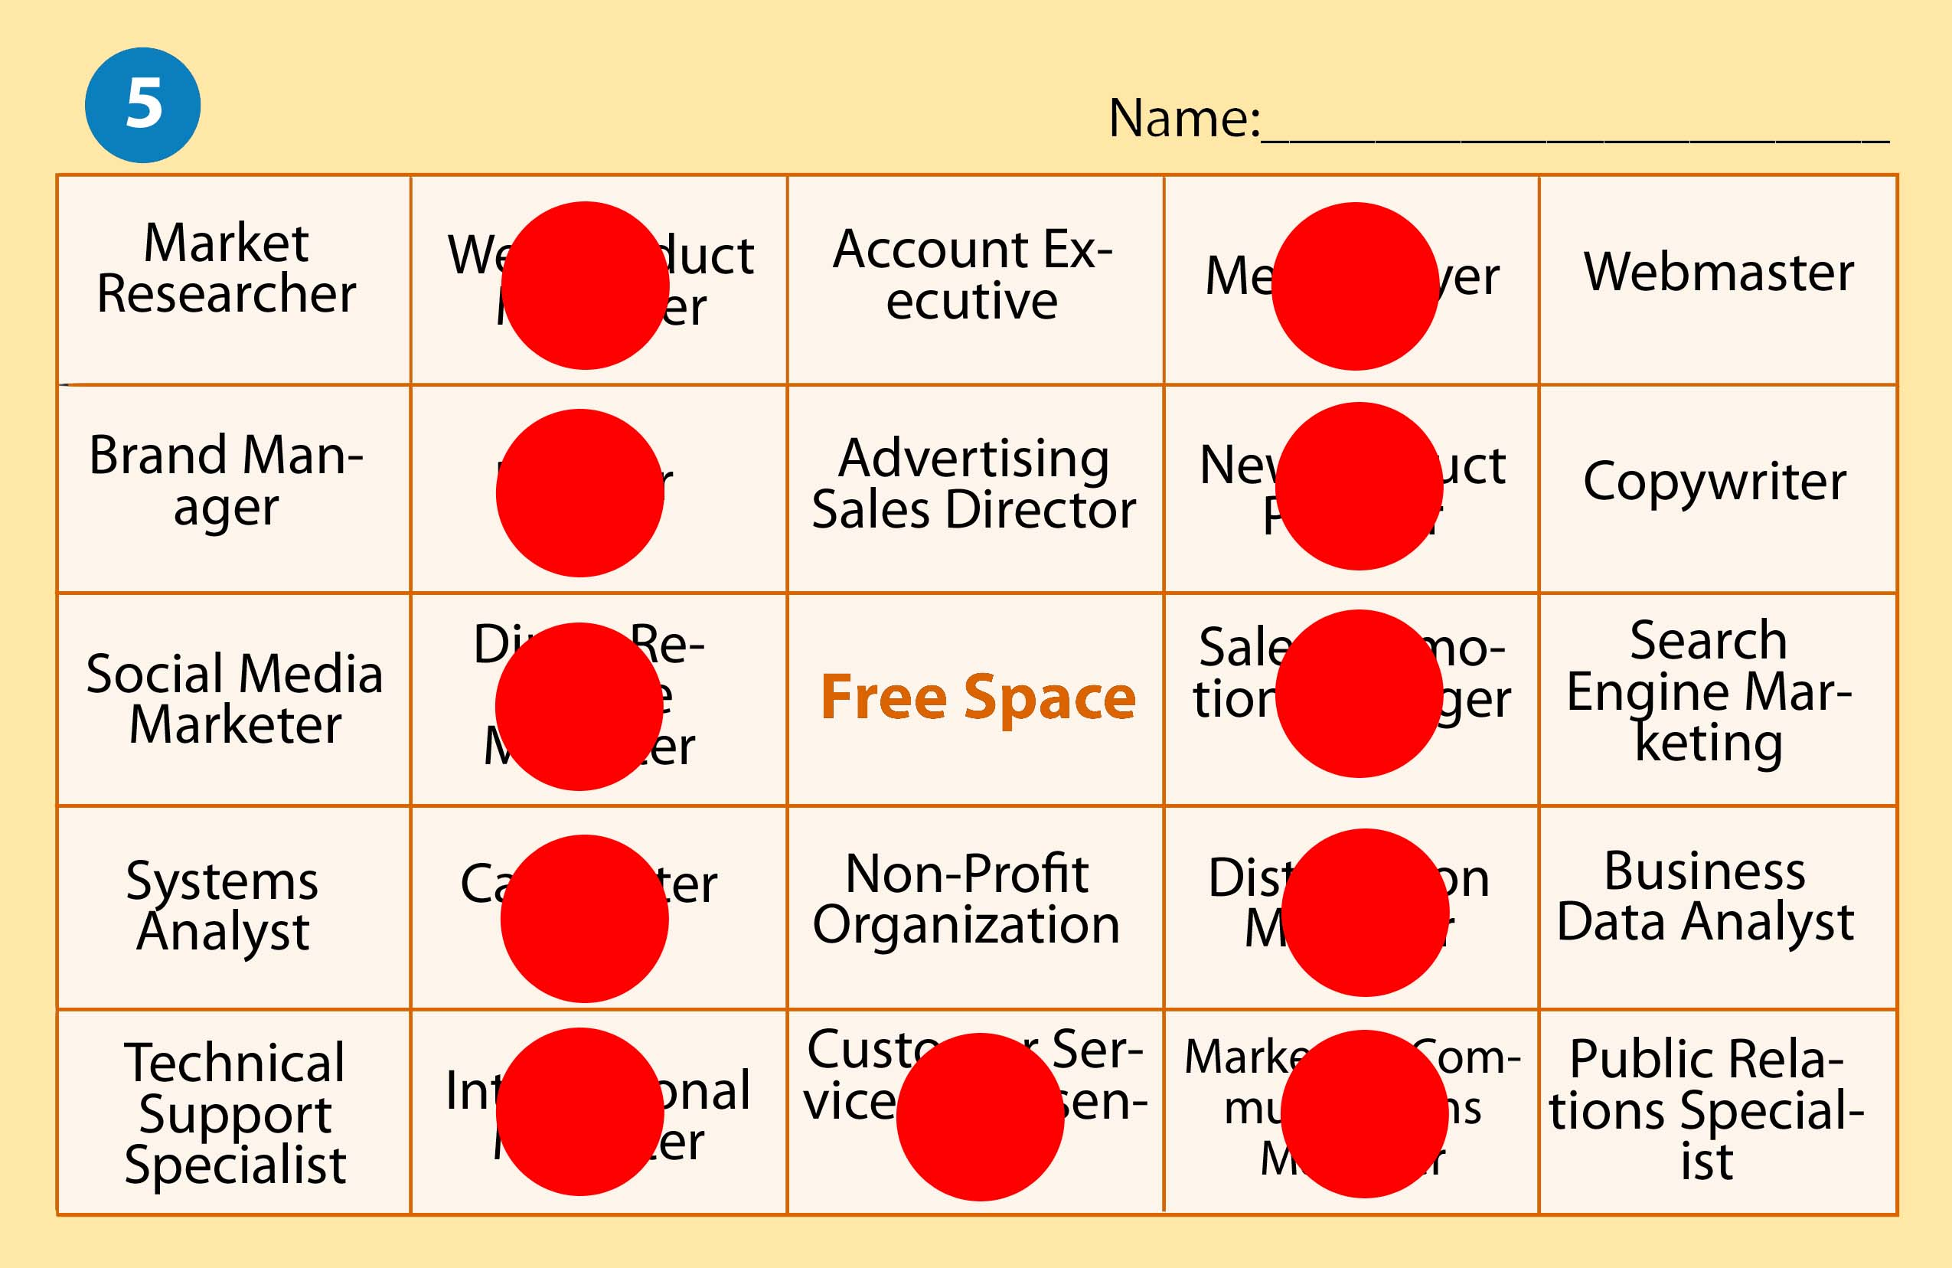

Definition | Correct Response
Asset on the balance sheet which is expected to be sold or otherwise used up in the near future, usually within one year. | Current Assets
Permanent assets of a company required for the regular conduct of business which will not be converted into cash during the next year. | Fixed Assets
Money in the form of bills or coins. | Cash
An accounting procedure or system designed to promote efficiency or assure the implementation of a policy or safeguard assets or avoid fraud. | Internal Control
Small fund of cash that a firm keeps for the payment of incidental expenses | Petty Cash
An amount of cash held by a department or office and used to give change to customers when they are paying for goods or services. | Change Fund
Shortage of cash. | Cash Short
Overage of cash. | Cash Over
A form signed by a depositor upon opening an account at a financial institution. | Signature Card
An itemized slip showing the exact amount of paper money, coin, and checks being deposited to a particular account. | Deposit Slip
A signature that validates something such as a check. | Endorsement
A written order directing a bank to pay money. | Check
The person who writes a check or draft instructing the drawee to pay someone else. | Drawer
The person (or bank) who is expected to pay a check or draft when it is presented for payment. | Drawee
An account statement or a bank statement is the summary of all financial transactions occurring over a given period of time on a deposit account. | Bank Statement
In accounting, reconciliation refers to a process that compares two sets of records (usually the balances of two accounts) to make sure they are in agreement. | Reconciliation
Amount in an account. | Account Balance
Money owed to a company for goods and services it has sold. | Accounts Receivable
Increase in owner’s equity resulting from the operation of a business. | Revenue
The subsidiary ledger provides more specific information that is not able to be provided in the General Ledger, such as the name and demographics of each customer and the customer’s balance. | Subsidiary Leger
Decrease in owner’s equity resulting from the operation of a business. | Expense
Assets taken out of business for the owner’s personal use. | Withdrawals
Decrease in value of an asset due to obsolescence or use. | Depreciation
A listing of customer accounts, account balances, and total amount due from all customers. | Schedule of Accounts

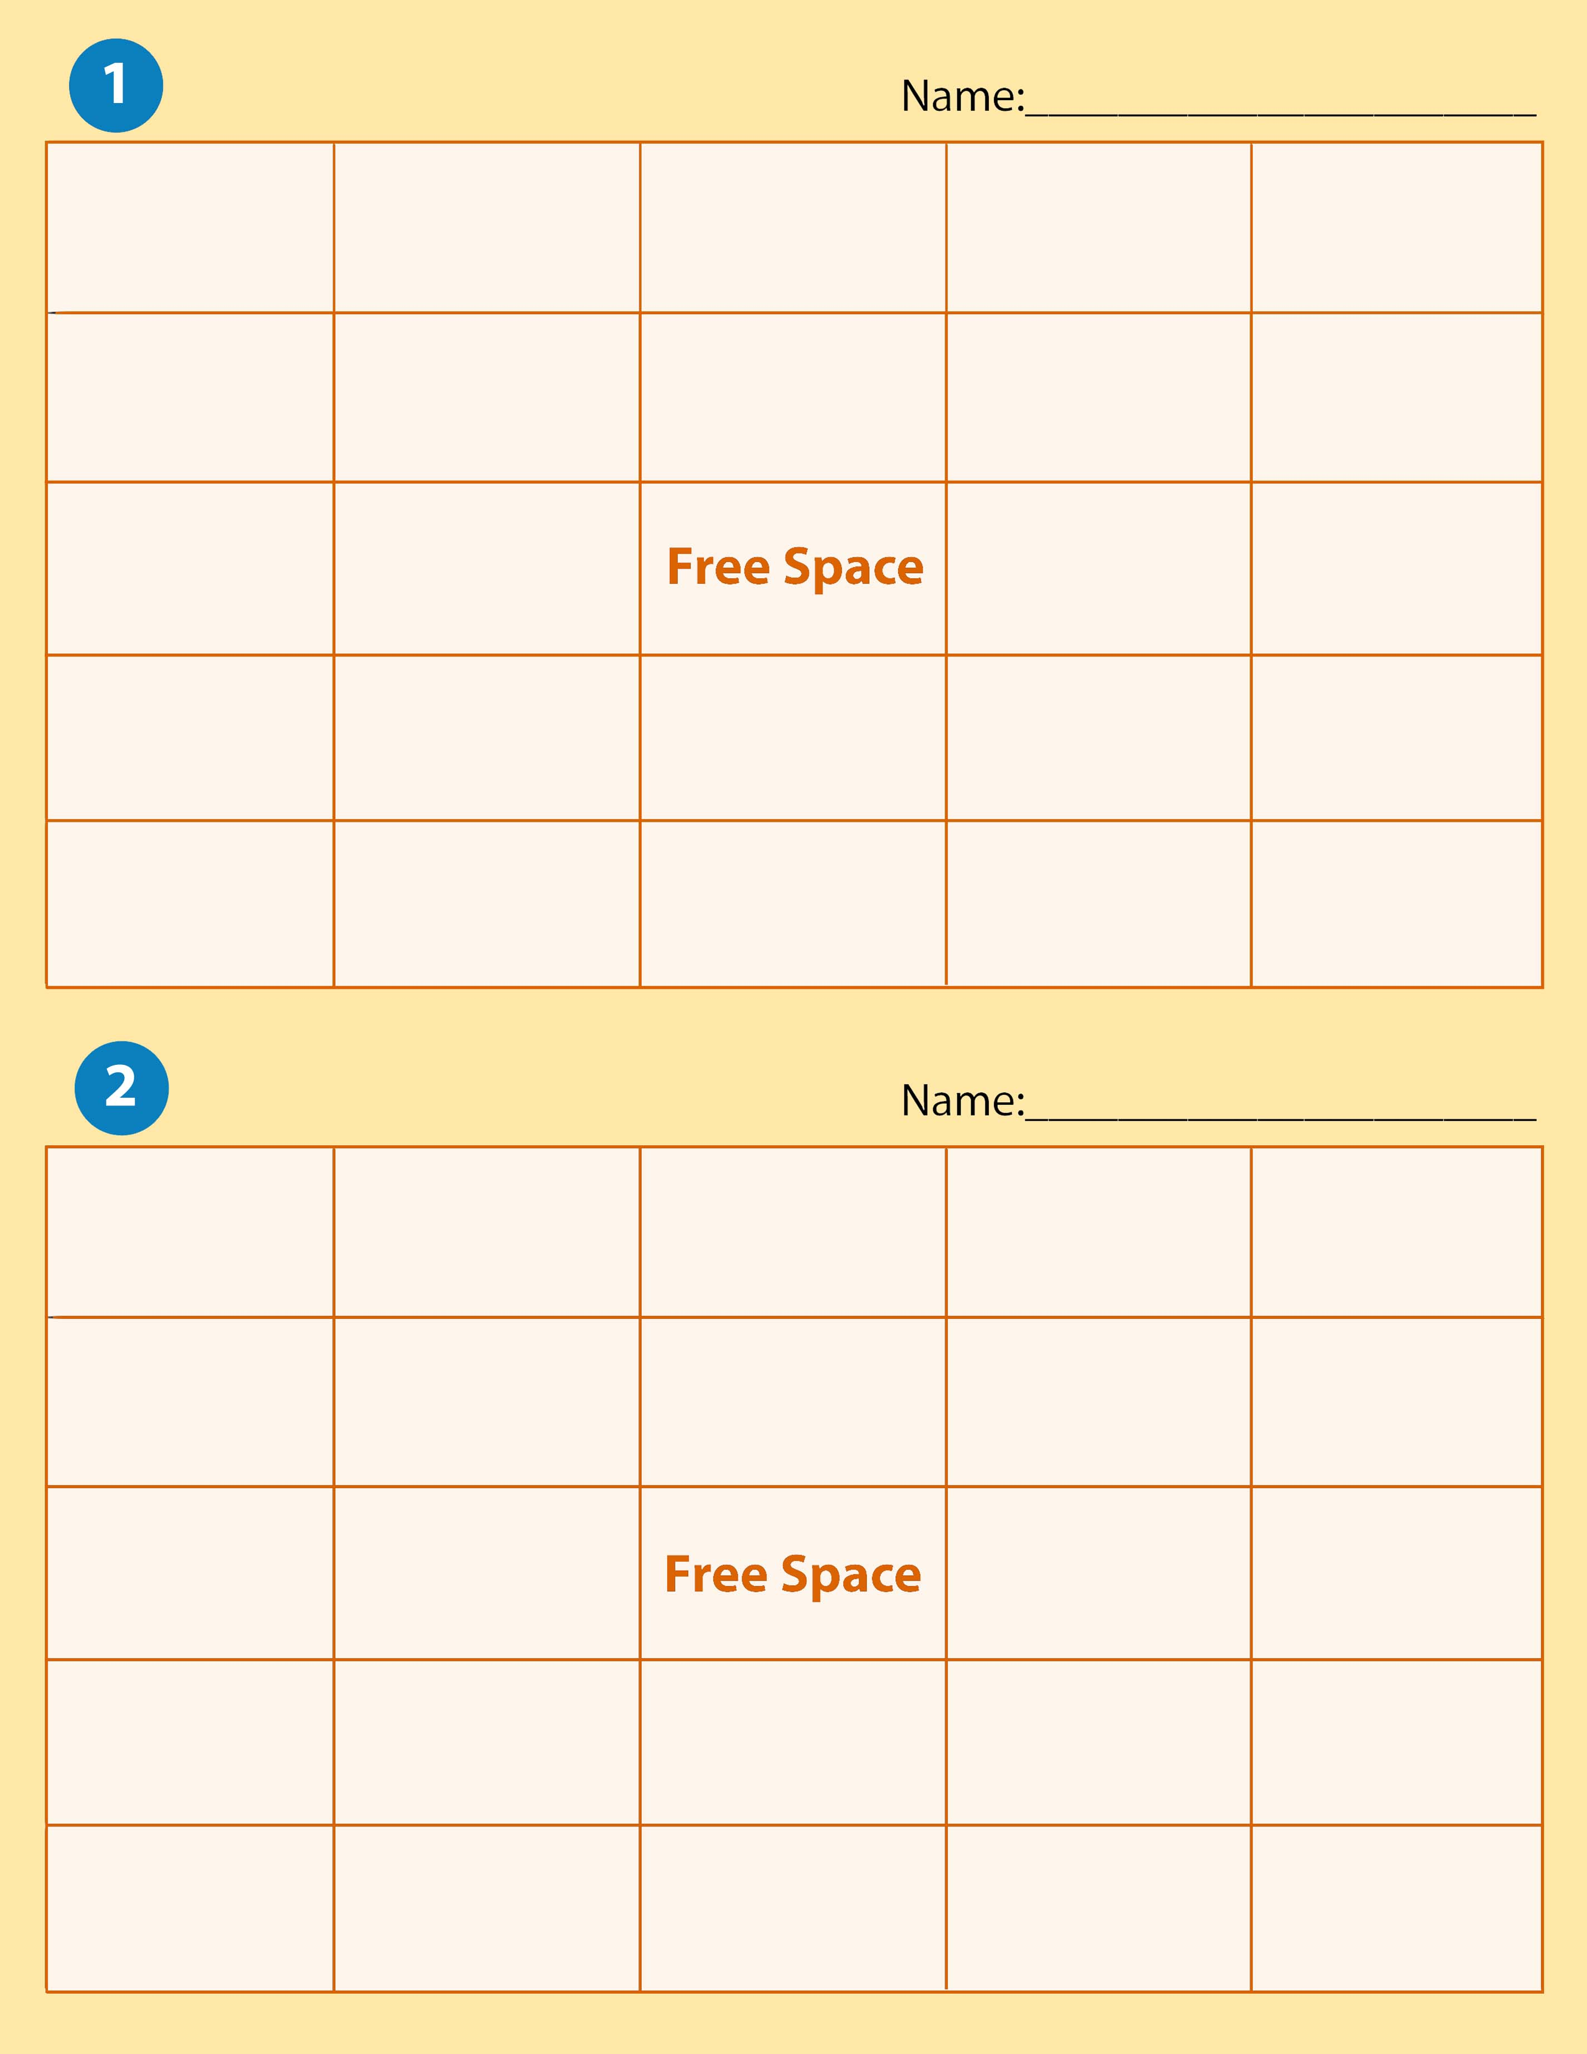

Revenue | Bank Statement | Cash Short | Endorsement | Drawer
Petty Cash | Subsidiary Ledger | Check | Cash Over | Expense
Current Assets | Change Fund |  | Cash | Deposit Slip
Reconciliation | Schedule of Accounts | Account Balance | Withdrawals | Fixed Assets
Internal Control | Signature Card | Drawee | Depreciation | Accounts Receivable

Withdrawals | Expense | Reconciliation | Signature Card | Petty Cash
Fixed Assets | Account Balance | Accounts Receivable | Check | Change Fund
Drawee | Cash Short |  | Bank Statement | Schedule of Accounts
Revenue | Current Assets | Endorsement | Internal control | Depreciation
Cash | Subsidiary Ledger | Drawer | Deposit Slip | Cash Over

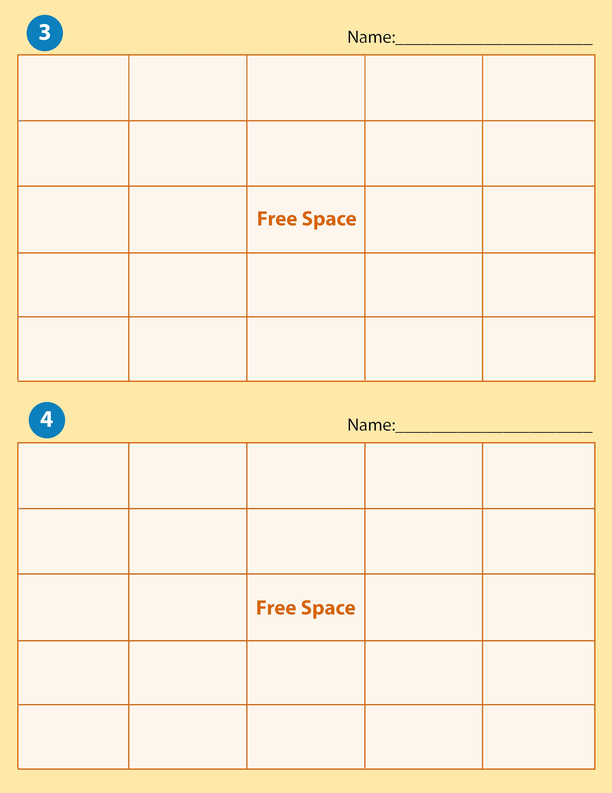
Endorsement | Internal Control | Drawee | Subsidiary Ledger | Signature Card
Schedule of Accounts | Current Assets | Cash Over | Change Fund | Revenue
Bank Statement | Fixed Assets |  | Accounts Receivable | Cash Short
Deposit Slip | Expense | Cash | Check | Depreciation
Petty Cash | Withdrawals | Account Balance | Reconciliation | Drawer

Change Fund | Deposit Slip | Internal Control | Accounts Receivable | Cash Short
Revenue | Bank Statement | Withdrawals | Account Balance | Drawee
Depreciation | Fixed Assets |  | Check | Petty Cash
Cash Over | Reconciliation | Endorsement | Subsidiary Ledger | Expense
Drawer | Current Assets | Signature Card | Cash | Schedule of Accounts

Expense | Bank Statement | Endorsement | Deposit Slip | Petty Cash
Signature Card | Account Balance | Schedule of Accounts | Accounts Receivable | Drawee
Depreciation | Withdrawals |  | Cash Over | Revenue
Fixed Assets | Internal Control | Reconciliation | Cash Short | Drawer
Cash | Current Assets | Subsidiary Ledger | Check | Change Fund
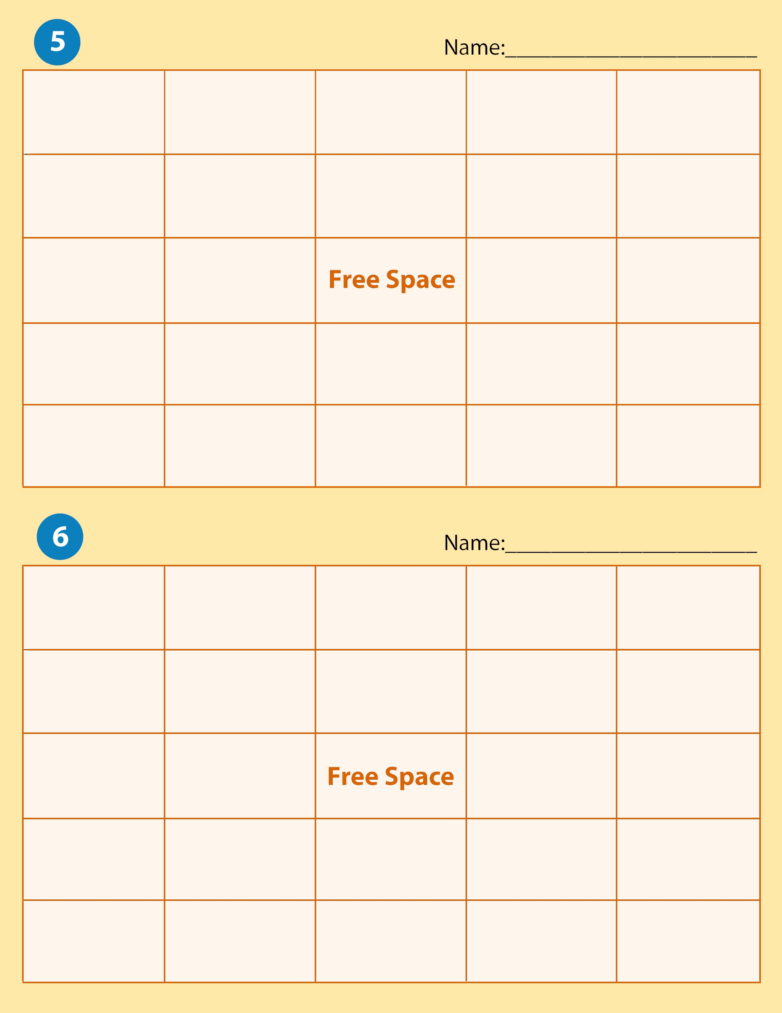

Drawer | Change Fund | Schedule of Accounts | Revenue | Deposit Slip
Current Assets | Drawee | Internal Control | Cash Over | Check
Accounts Receivable | Account Balance |  | Fixed Assets | Endorsement
Reconciliation | Withdrawals | Depeciation | Cash | Bank Statement
Signature Card | Subsidiary Ledger | Petty Cash | Expense | Cash Short

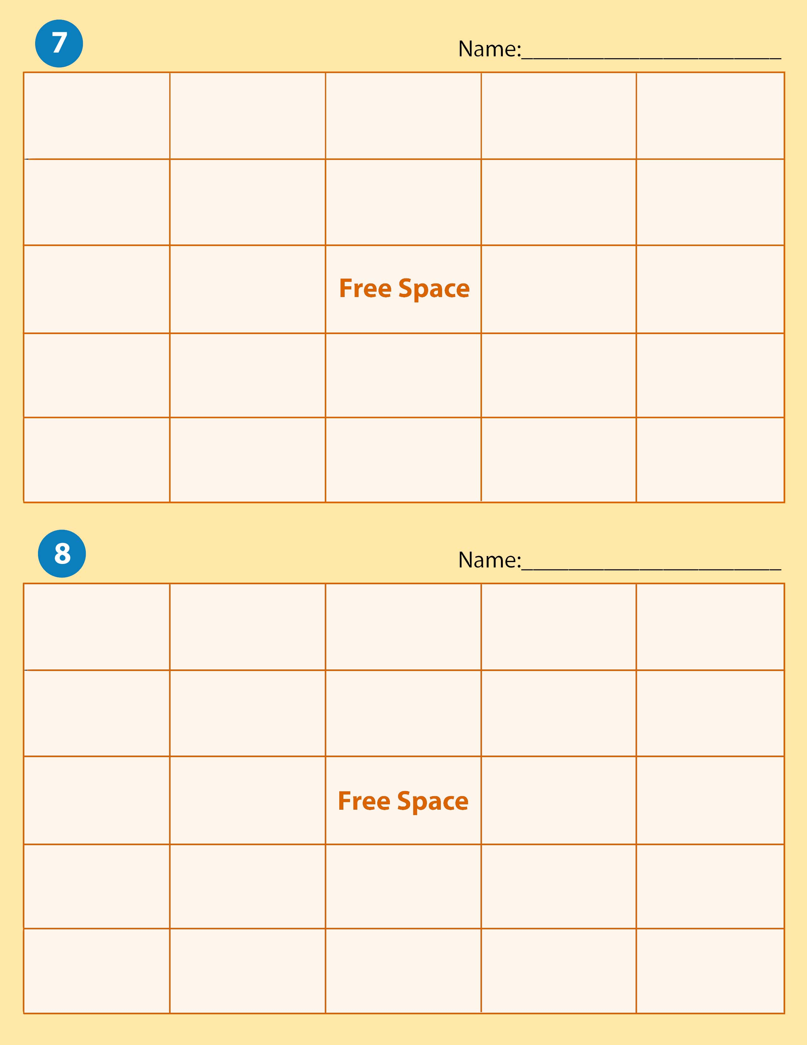

Reconciliation | Drawer | Subsidiary Ledger | Signature Card | Cash Short
Expense | Internal Control | Endorsement | Cash | Bank Statement
Account Balance | Fixed Assets |  | Accounts Receivable | Check
Current Assets | Change Fund | Withdrawals | Schedule of Accounts | Drawee
Petty Cash | Deposit Slip | Cash Over | Depreciation | Revenue

Bank Statement | Petty Cash | Account Balance | Check | Schedule of Accounts
Fixed Assets | Accounts Receivable | Signature Cards | Cash | Expense
Cash Short | Revenue |  | Change Fund | Reconciliation
Deposit Slip | Drawer | Depreciation | Drawee | Cash Over
Withdrawals | Subsidiary Ledger | Current Assets | Endorsement | Internal Control

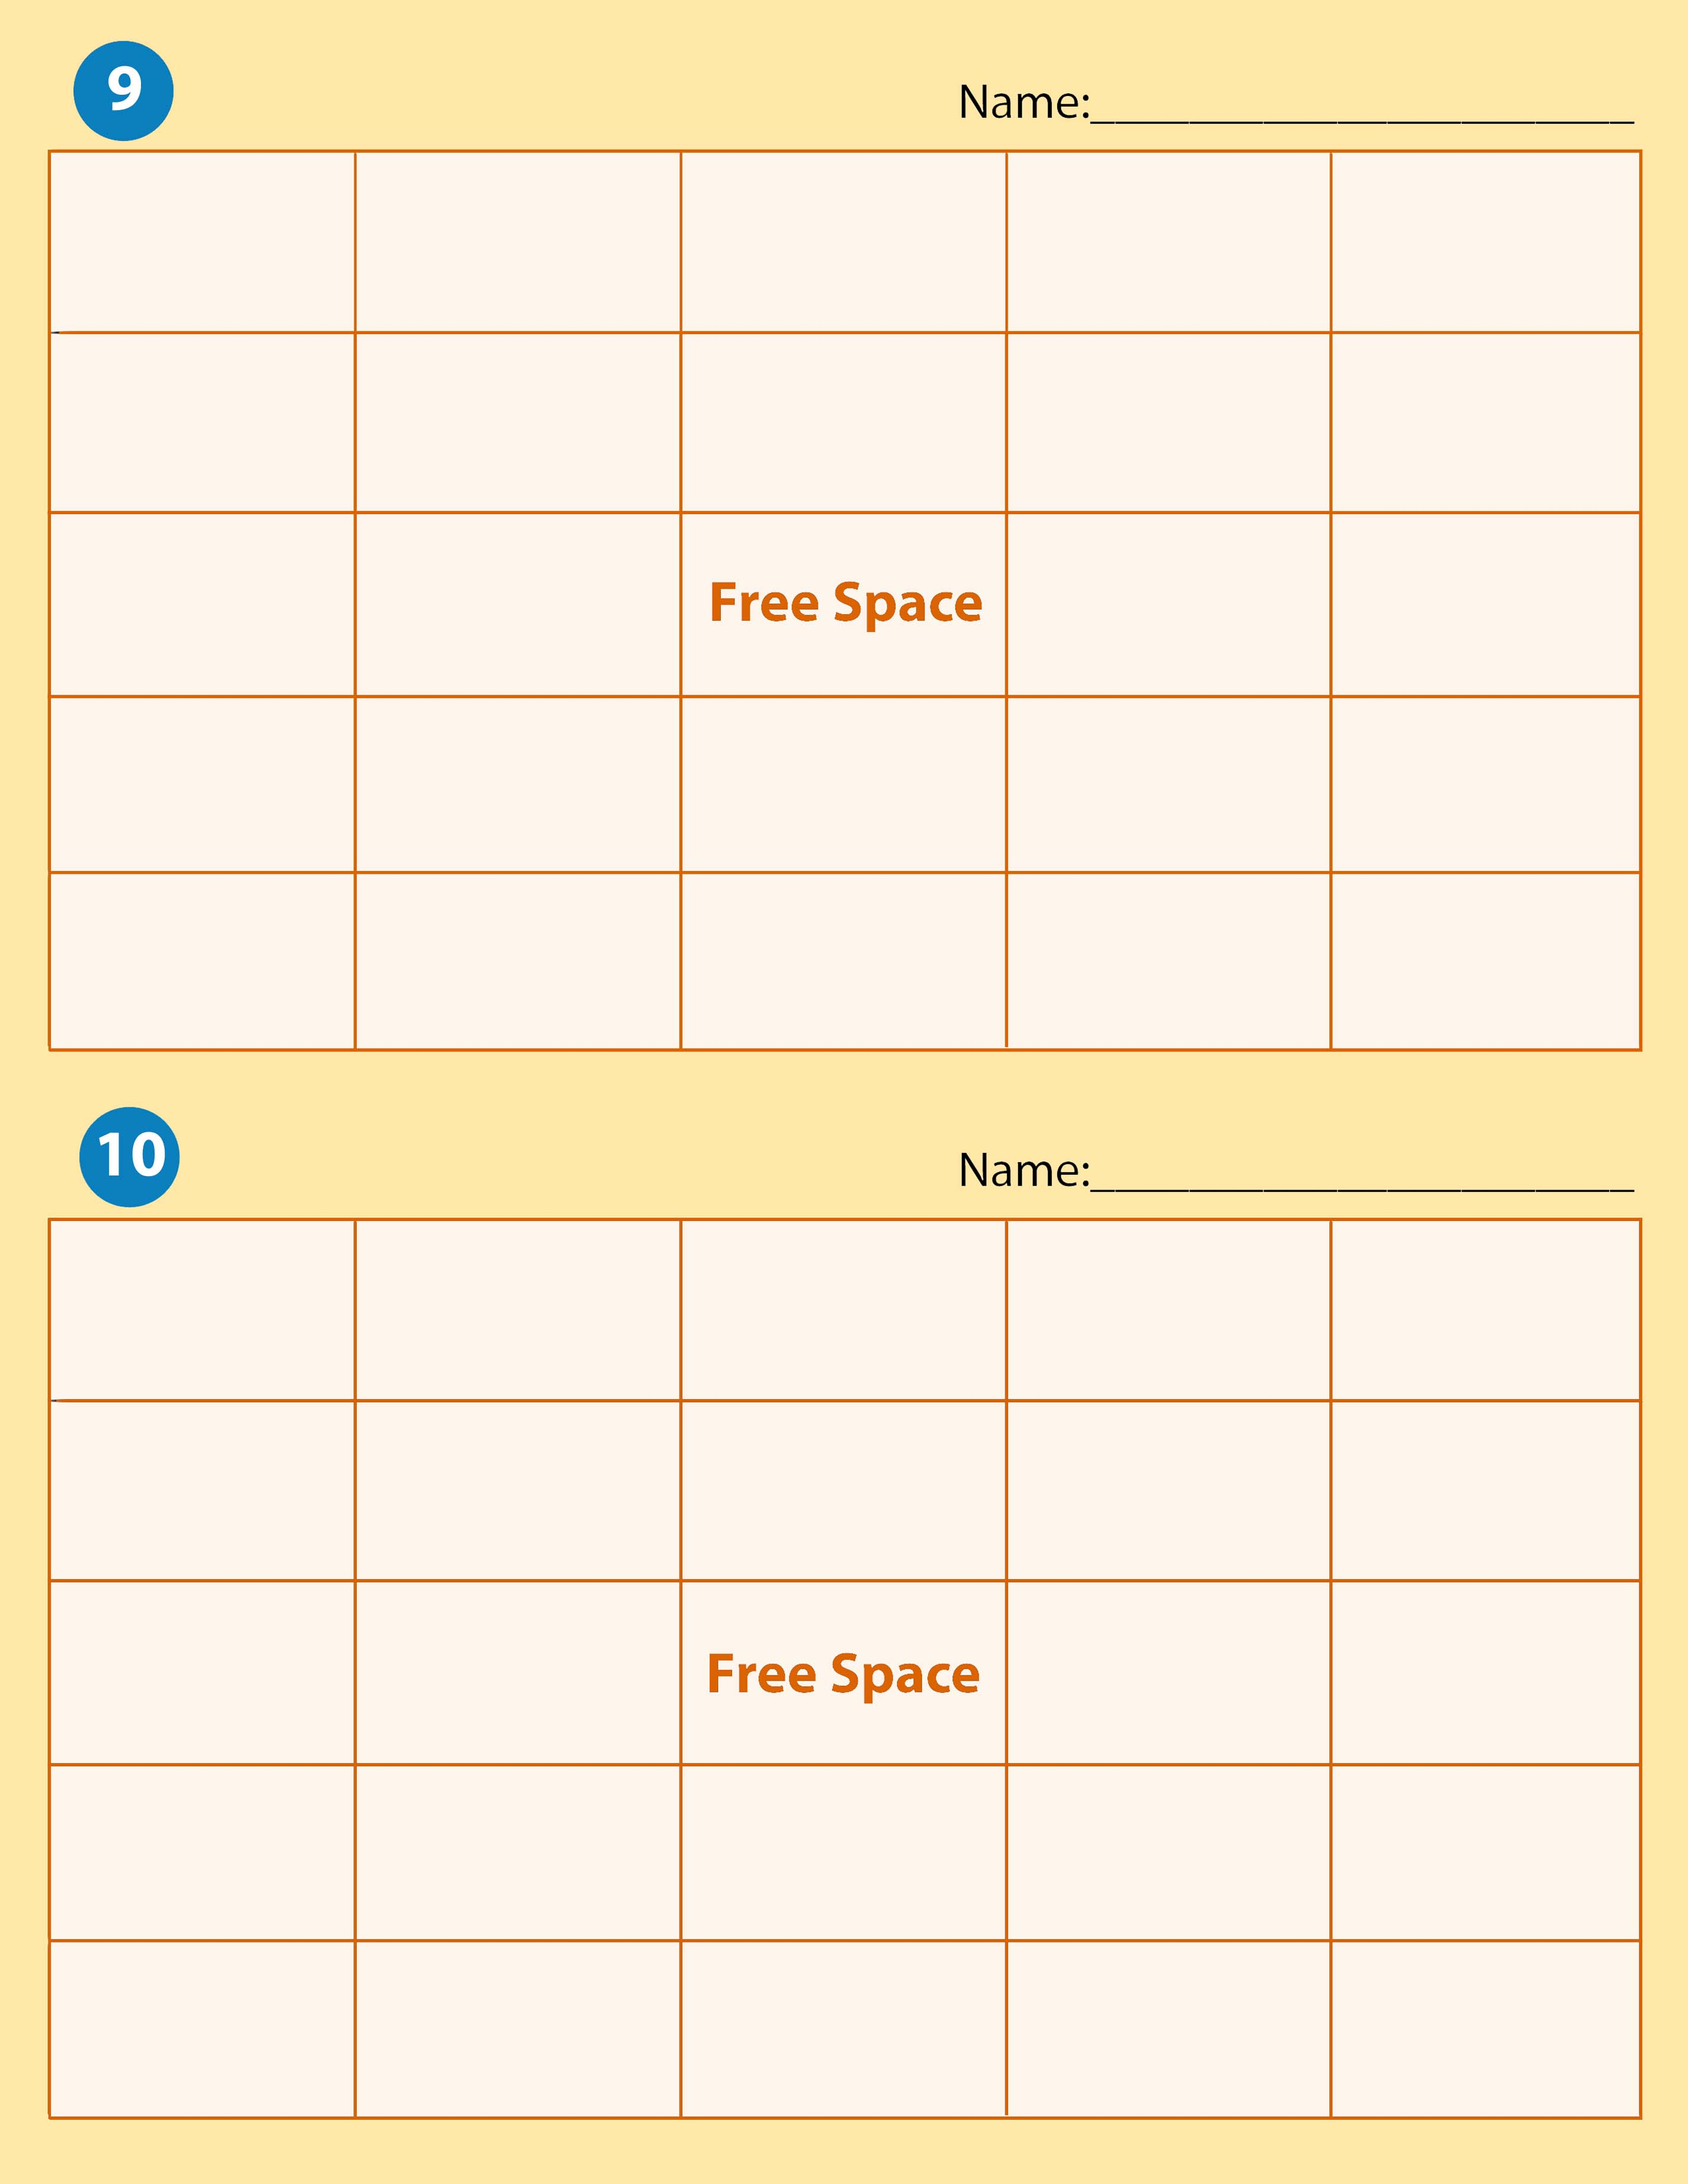

Subsidiary Ledger | Petty Cash | Signature Card | Current Assets | Depreciation
Drawee | Withdrawals | Cash Short | Endorsement | Cash
Reconciliation | Account Balance |  | Fixed Assets | Bank Statement
Revenue | Change Fund | Drawer | Internal Control | Accounts Receivable
Schedule of Accounts | Cash Over | Check | Expense | Deposit Slip

Bank Statement | Current Assets | Expense | Endorsement | Change Fund
Petty Cash | Fixed Assets | Cash Short | Drawee | Reconciliation
Schedule of Accounts | Revenue |  | Deposit Slip | Drawer
Accounts Receivable | Depreciation | Account Balance | Signature Card | Internal Control
Cash Over | Check | Cash | Subsidiary Ledger | Withdrawals

Expense | Asset | Accounting Equation | Fixed Assets | Withdrawals
Financial Statement | Ethics | Equities | Service Business | Revenue
Account Balance | Accounting System |  | Owner’s Equity | Current Assets
Account Title | Proprietorship | Accounting Records | Account | Accounting
Transaction | Capital | Liability | Business Ethics | Sale on Account
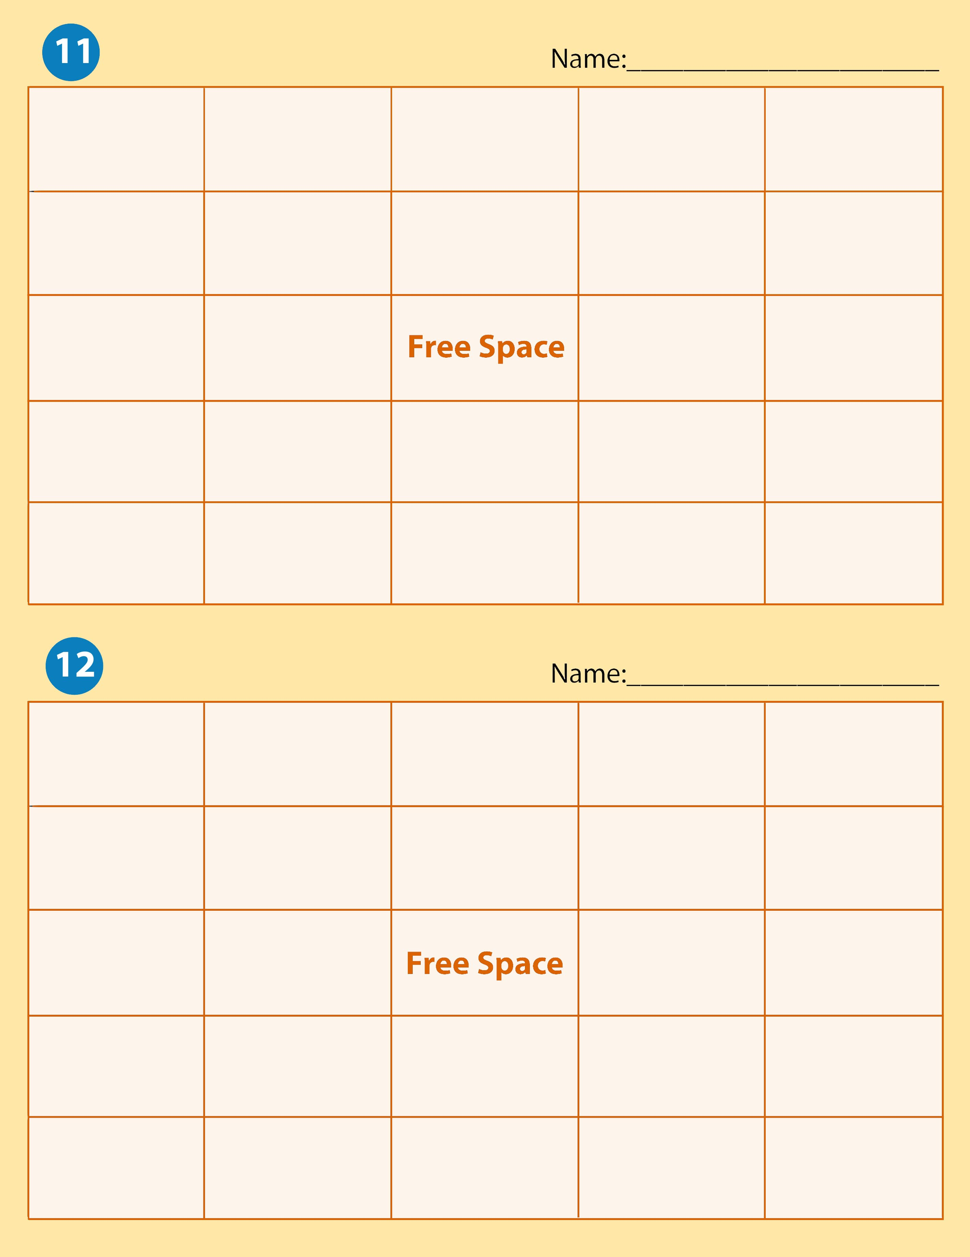

Check | Reconciliation | Petty Cash | Schedule of Accounts | Account Balance
Internal Control | Endorsement | Bank Statement | Current Assets | Depreciation
Withdrawals | Accounts Receivable |  | Drawer | Cash Short
Change Fund | Fixed Assets | Cash Over | Deposit Slip | Expense
Cash | Revenue | Signature Card | Drawee | Subsidiary Ledger

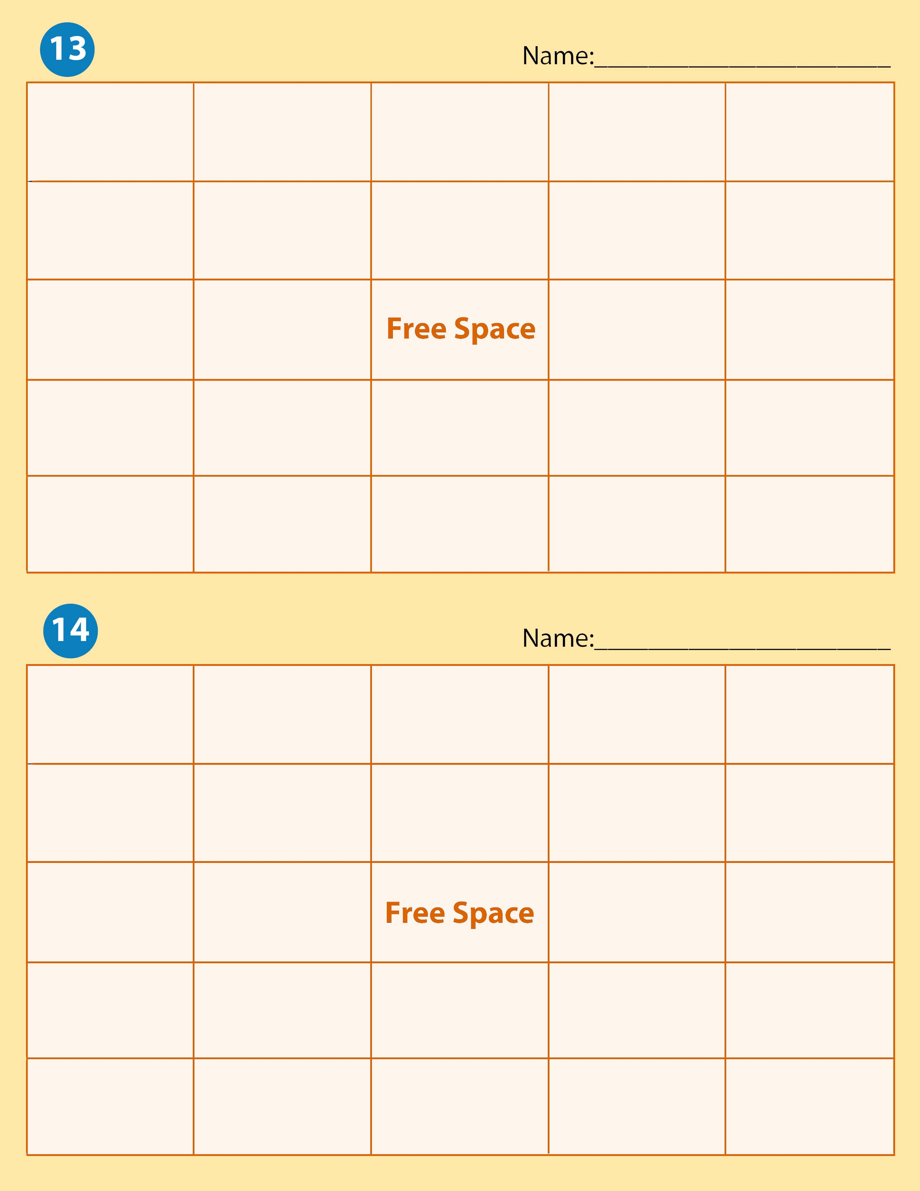

Schedule of Accounts | Check | Bank Statement | Petty Cash | Cash Over
Subsidiary Ledger | Revenue | Reconciliation | Drawer | Signature Card
Accounts Receivable | Cash |  | Cash Short | Endorsement
Account Balance | Current Assets | Change Fund | Drawee | Withdrawals
Internal Control | Deposit Slip | Depreciation | Expense | Fixed Assets

Fixed Assets | Deposit Slip | Account Balance | Withdrawals | Depreciation
Revenue | Accounts Receivable | Internal Control | Cash Short | Signature Card
Subsidiary Ledger | Drawee |  | Petty Cash | Current Assets
Drawer | Schedule of Accounts | Expense | Check | Reconciliation
Endorsement | Change Fund | Cash | Cash Over | Bank Statement

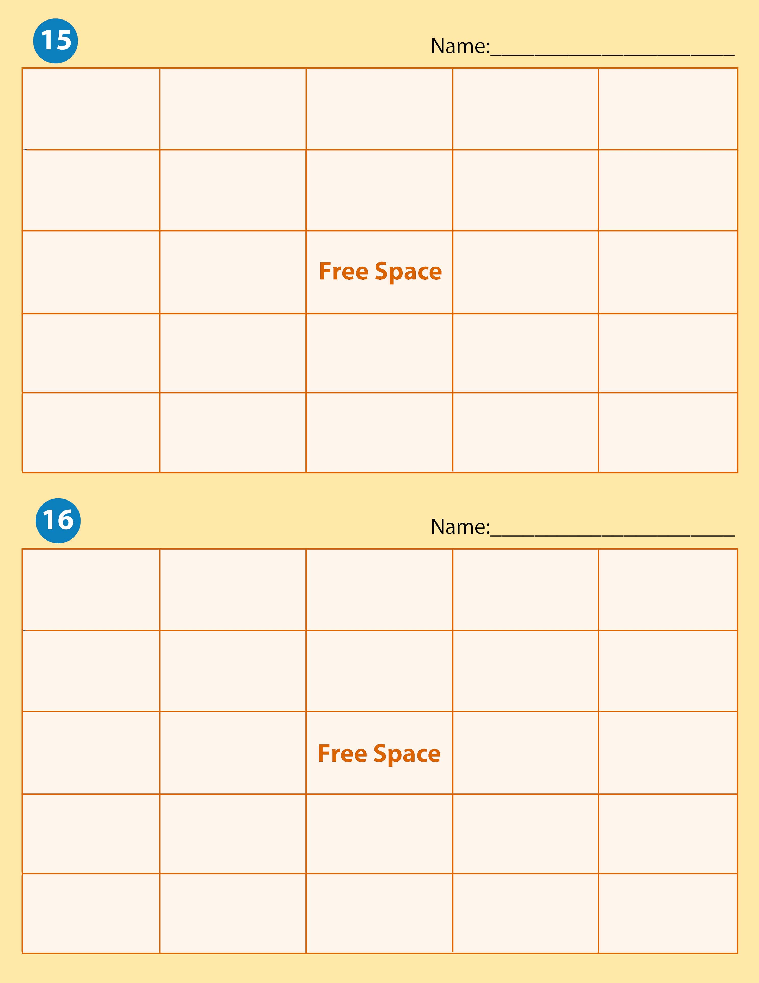
Drawee | Cash Over | Account Balance | Cash | Petty Cash
Deposit Slip | Current Assets | Drawer | Depreciation | Revenue
Accounts Receivable | Endorsement |  | Subsidiary Ledger | Expense
Fixed Assets | Reconciliation | Withdrawals | Change Fund | Schedule of Accounts
Check | Internal Control | Bank Statement | Cash Short | Signature Card

Drawee | Bank Statement | Drawer | Reconciliation | Check
Accounts Receivable | Endorsement | Subsidiary Ledger | Deposit Slip | Depreciation
Signature Card | Schedule of Accounts |  | Change Fund | Cash Short
Petty Cash | Cash Over | Internal Control | Account Balance | Cash
Expense | Fixed Assets | Withdrawals | Current Assets | Revenue

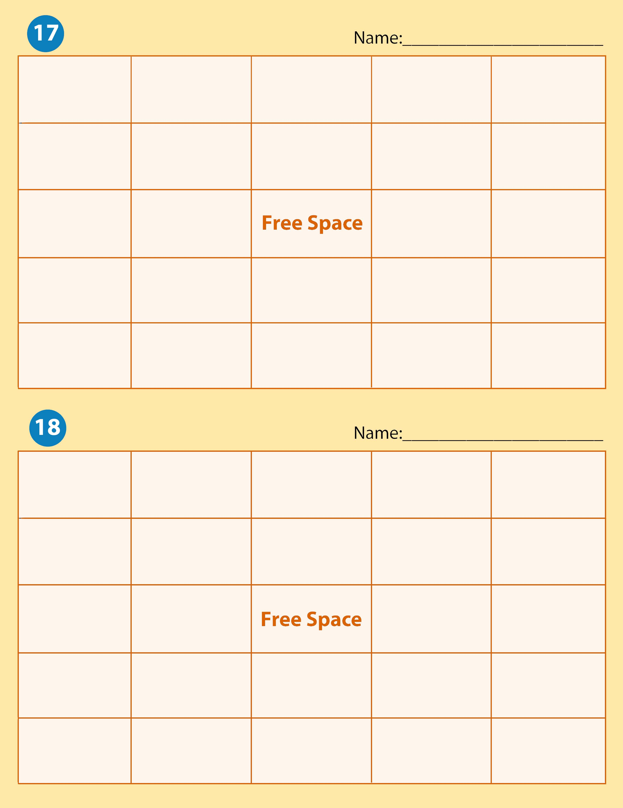

Change Fund | Accounts Receivable | Drawer | Cash Short | Current Assets
Reconciliation | Account Balance | Deposit Slip | Cash | Bank Statement
Petty Cash | Expense |  | Subsidiary Ledger | Check
Fixed Assets | Signature Card | Revenue | Drawee | Internal Control
Withdrawals | Depreciation | Endorsement | Cash Over | Schedule of Accounts

Internal Control | Signature Card | Depreciation | Revenue | Reconciliation
Deposit Slip | Cash | Cash Short | Check | Subsidiary Ledger
Fixed Assets | Withdrawals |  | Accounts Receivable | Expense
Change Fund | Drawer | Account Balance | Drawee | Current Assets
Endorsement | Petty Cash | Cash Over | Bank Statement | Schedule of Accounts

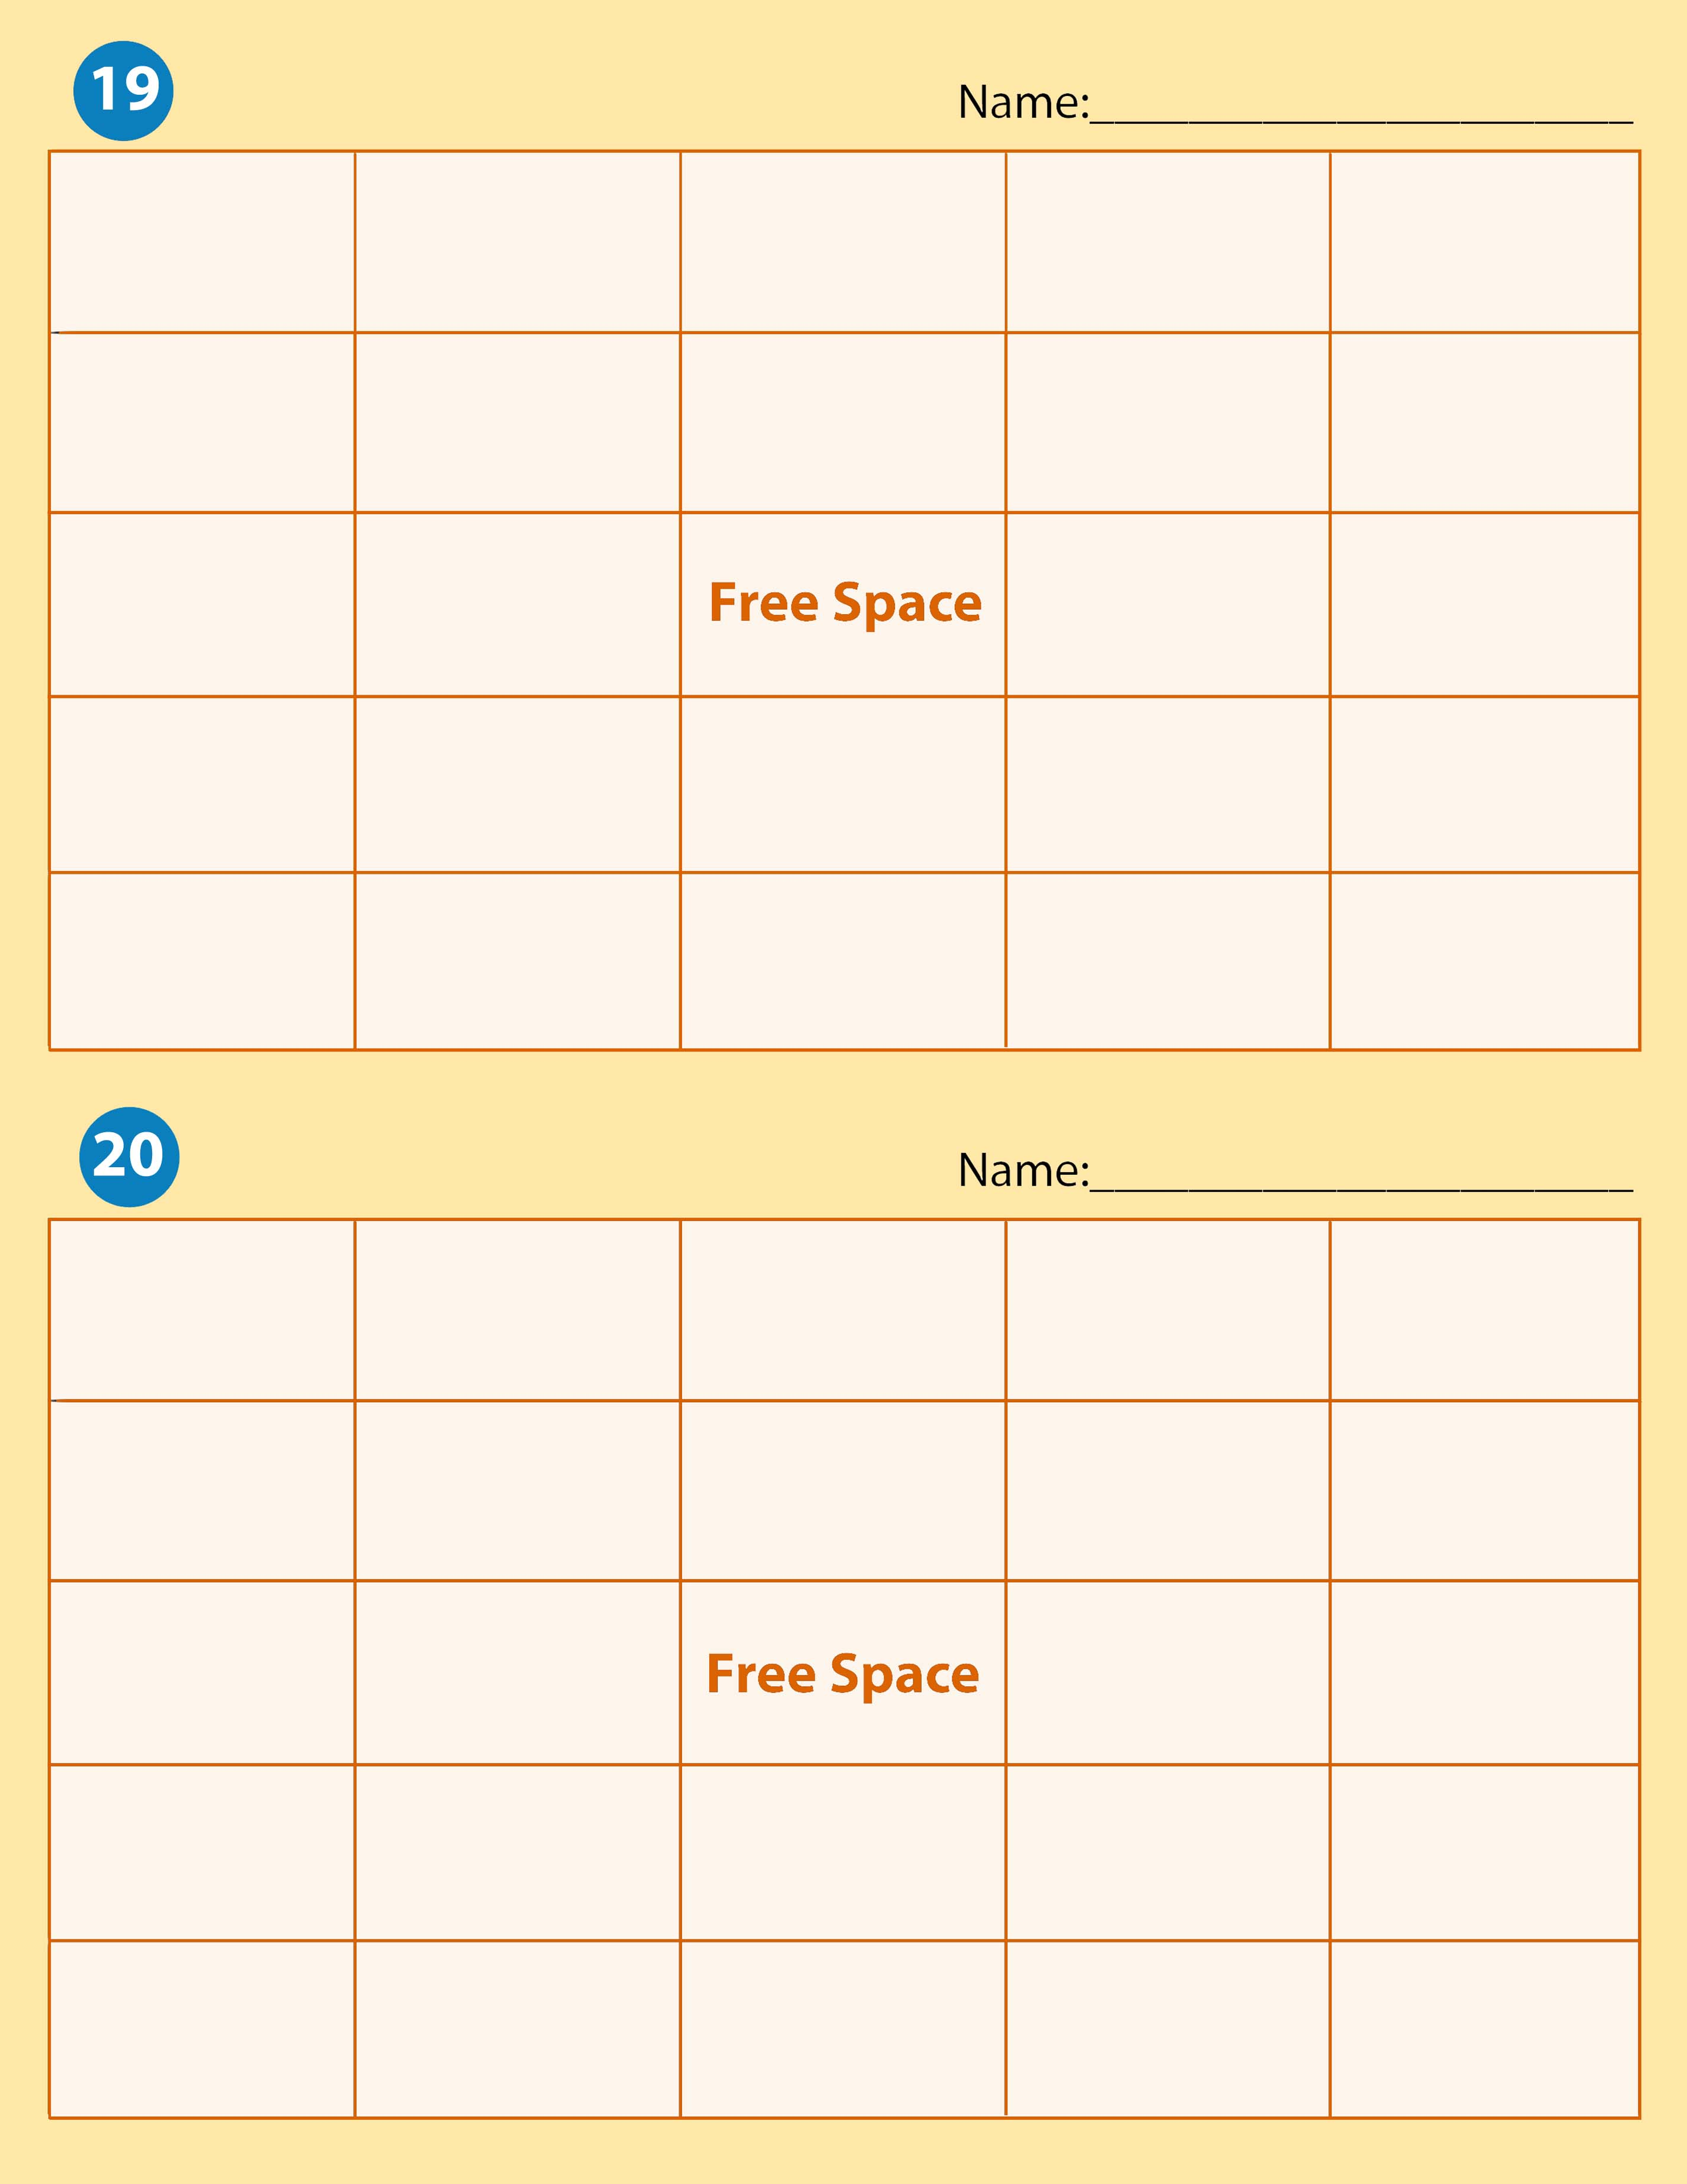
Check | Bank Statement | Deposit Slip | Subsidiary Ledger | Petty Cash
Schedule of Accounts | Drawee | Fixed Assets | Cash Over | Revenue
Reconciliation | Change Fund |  | Current Assets | Expense
Endorsement | Withdrawals | Internal Control | Accounts Receivable | Signature Card
Account Balance | Drawer | Cash | Cash Short | Depreciation

Cash | Check |  | Reconciliation | Current Assets | Depreciation
Deposit Slip |  | Cash Over | Change Fund | Expense | Drawee
Petty Cash |  | Drawer |  | Fixed Assets | Schedule of Accounts
Endorsement |  | Account Balance | Accounts Receivable | Revenue | Signature Card
Withdrawals |  | Subsidiary Ledger | Internal Control | Cash Short | Bank Statement

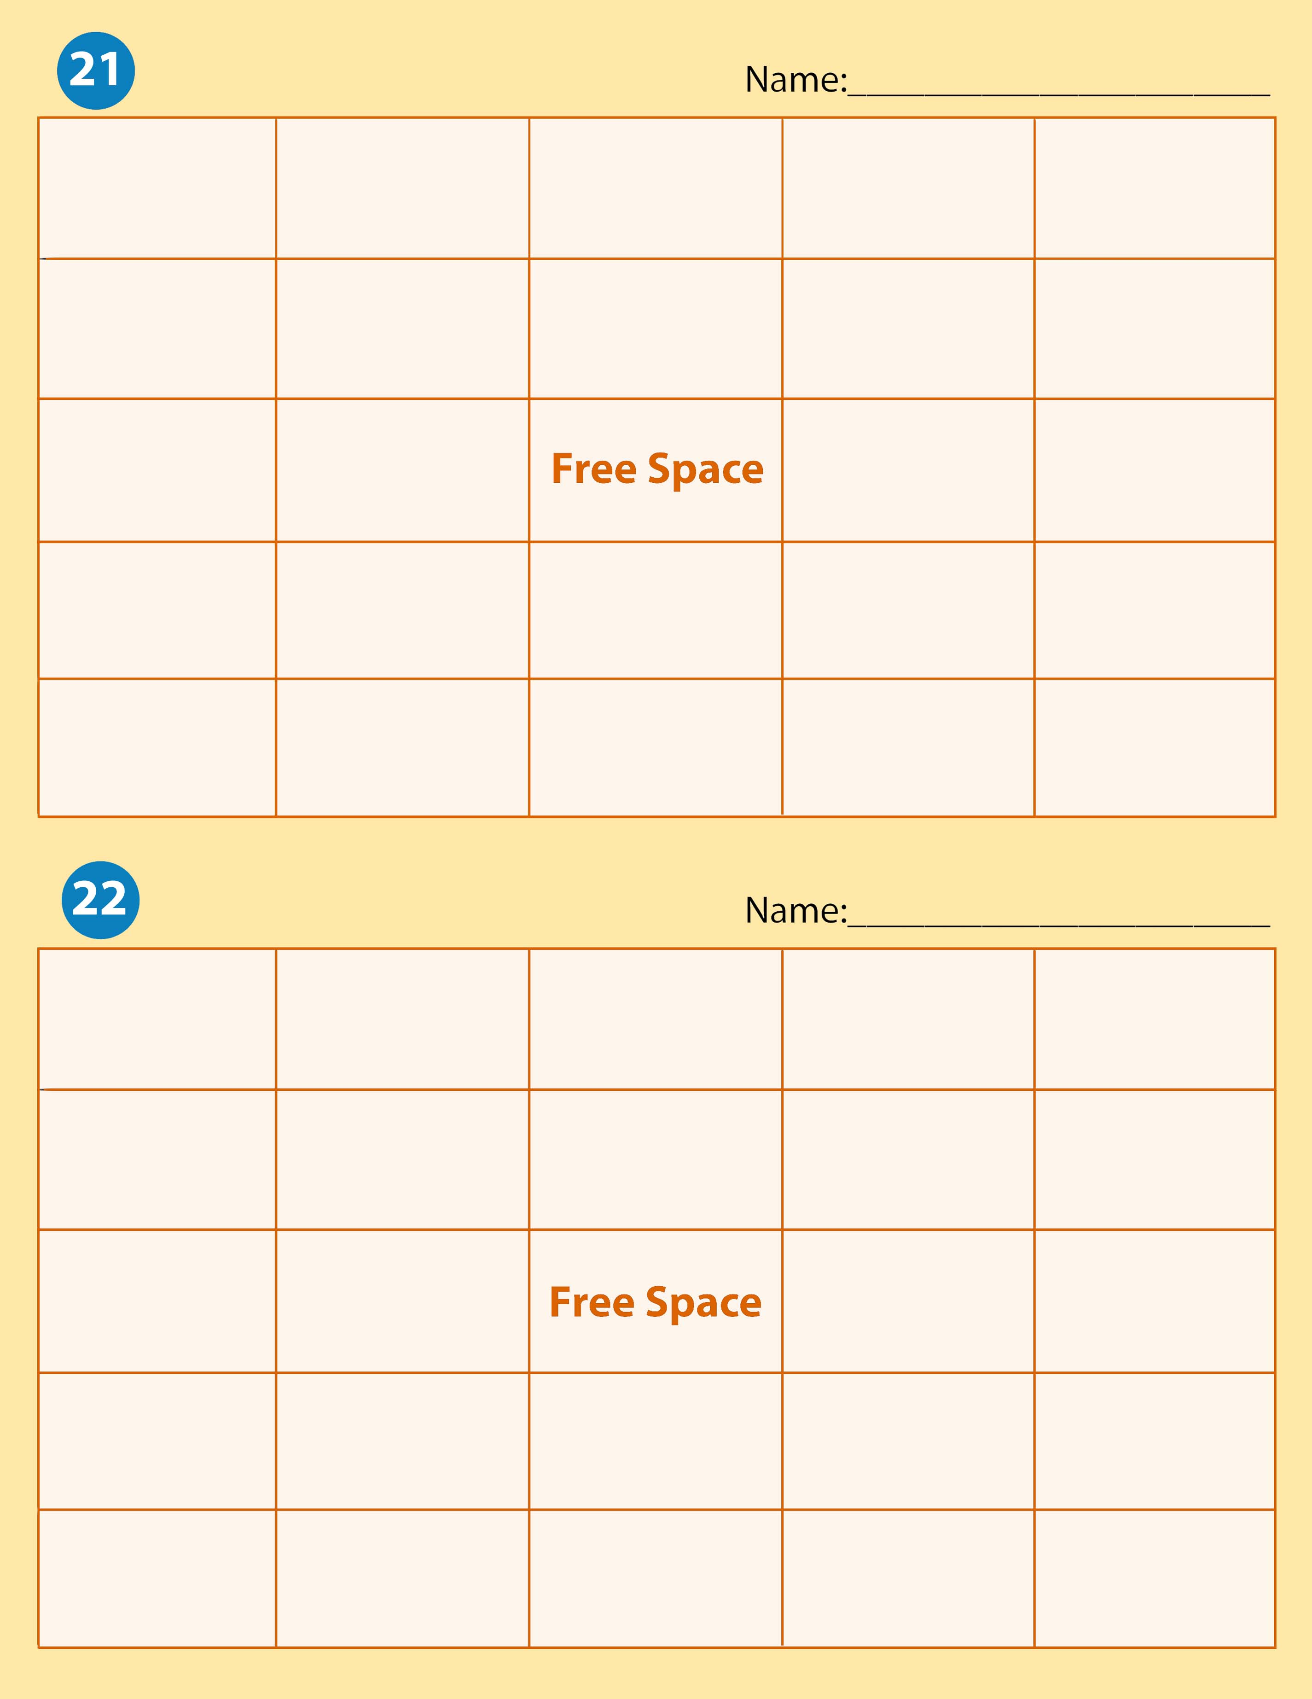

Internal Control | Deposit Slip | Bank Statement | Depreciation | Account Balance
Withdrawals | Current Assets | Petty Cash | Endorsement | Reconciliation
Schedule of Accounts | Expense |  | Fixed Assets | Change Fund
Check | Accounts Receivable | Cash Short | Revenue | Cash
Signature Card | Drawer | Subsidiary Ledger | Cash Over | Drawee

Change Fund | Endorsement | Internal Control | Drawee | Cash
Accounts Receivable | Check | Cash Short | Depreciation | Expense
Drawer | Current Assets |  | Petty Cash | Cash Over
Withdrawals | Account Balance | Reconciliation | Signature Card | Revenue
Fixed Assets | Bank Statement | Deposit Slip | Subsidiary Ledger | Schedule of Accounts

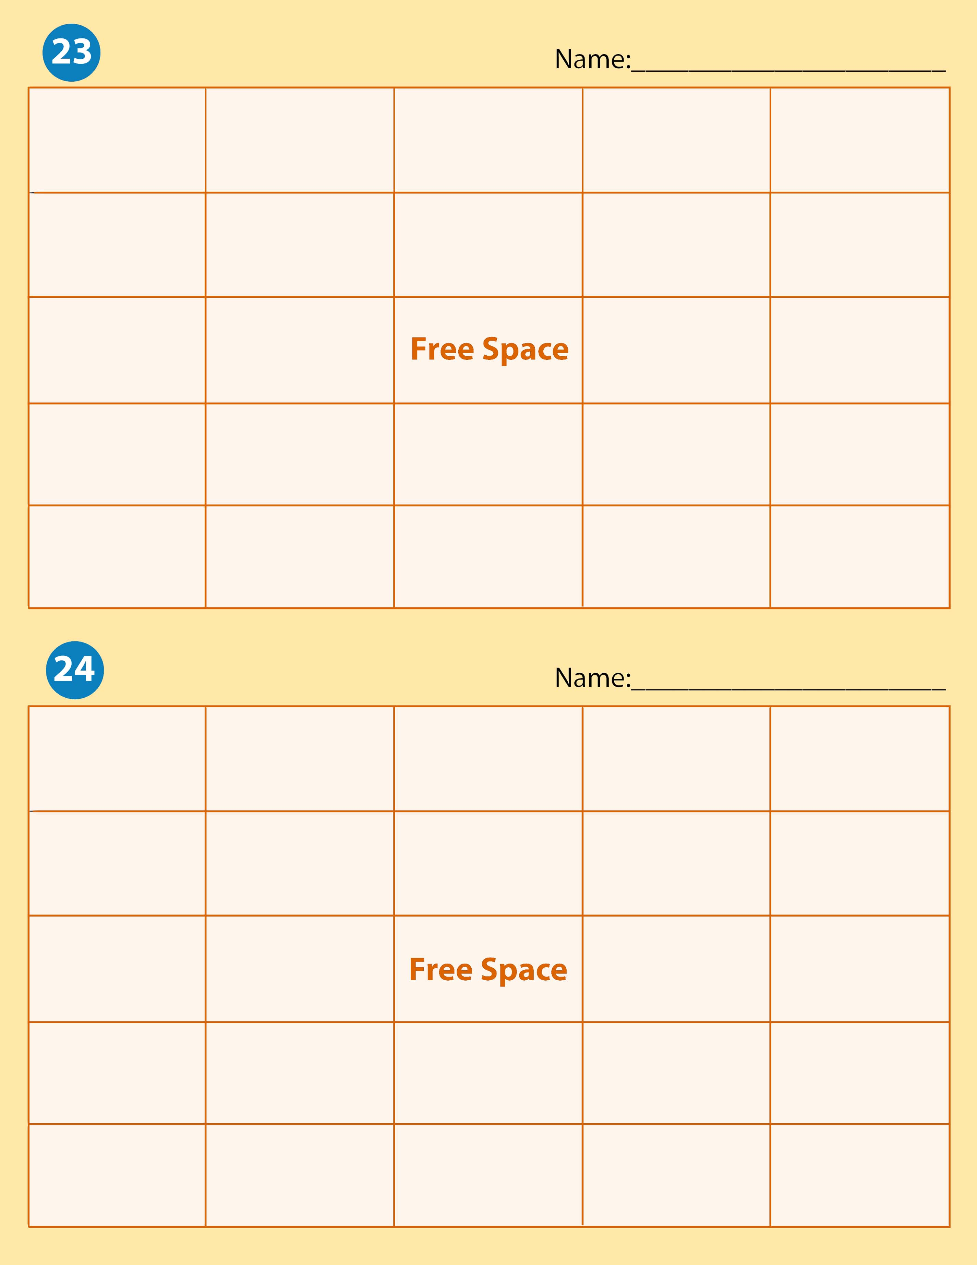

Endorsement | Deposit Slip | Fixed Assets | Drawee | Expense
Petty Cash | Check | Bank Statement | Subsidiary Leger | Cash Over
Revenue | Drawer |  | Cash Short | Withdrawals
Cash | Reconciliation | Change Fund | Depreciation | Account Balance
Schedule of Accounts | Current Assets | Signature Card | Internal Control | Accounts Receivable

Cash Short | Subsidiary Ledger | Expense | Cash | Deposit Slip
Current Assets | Withdrawals | Cash Over | Reconciliation | Change Fund
Endorsement | Fixed Assets |  | Schedule of Accounts | Accounts Receivable
Revenue | Signature Card | Check | Petty Cash | Bank Statement
Depreciation | Account Balance | Internal Control | Drawee | Drawer

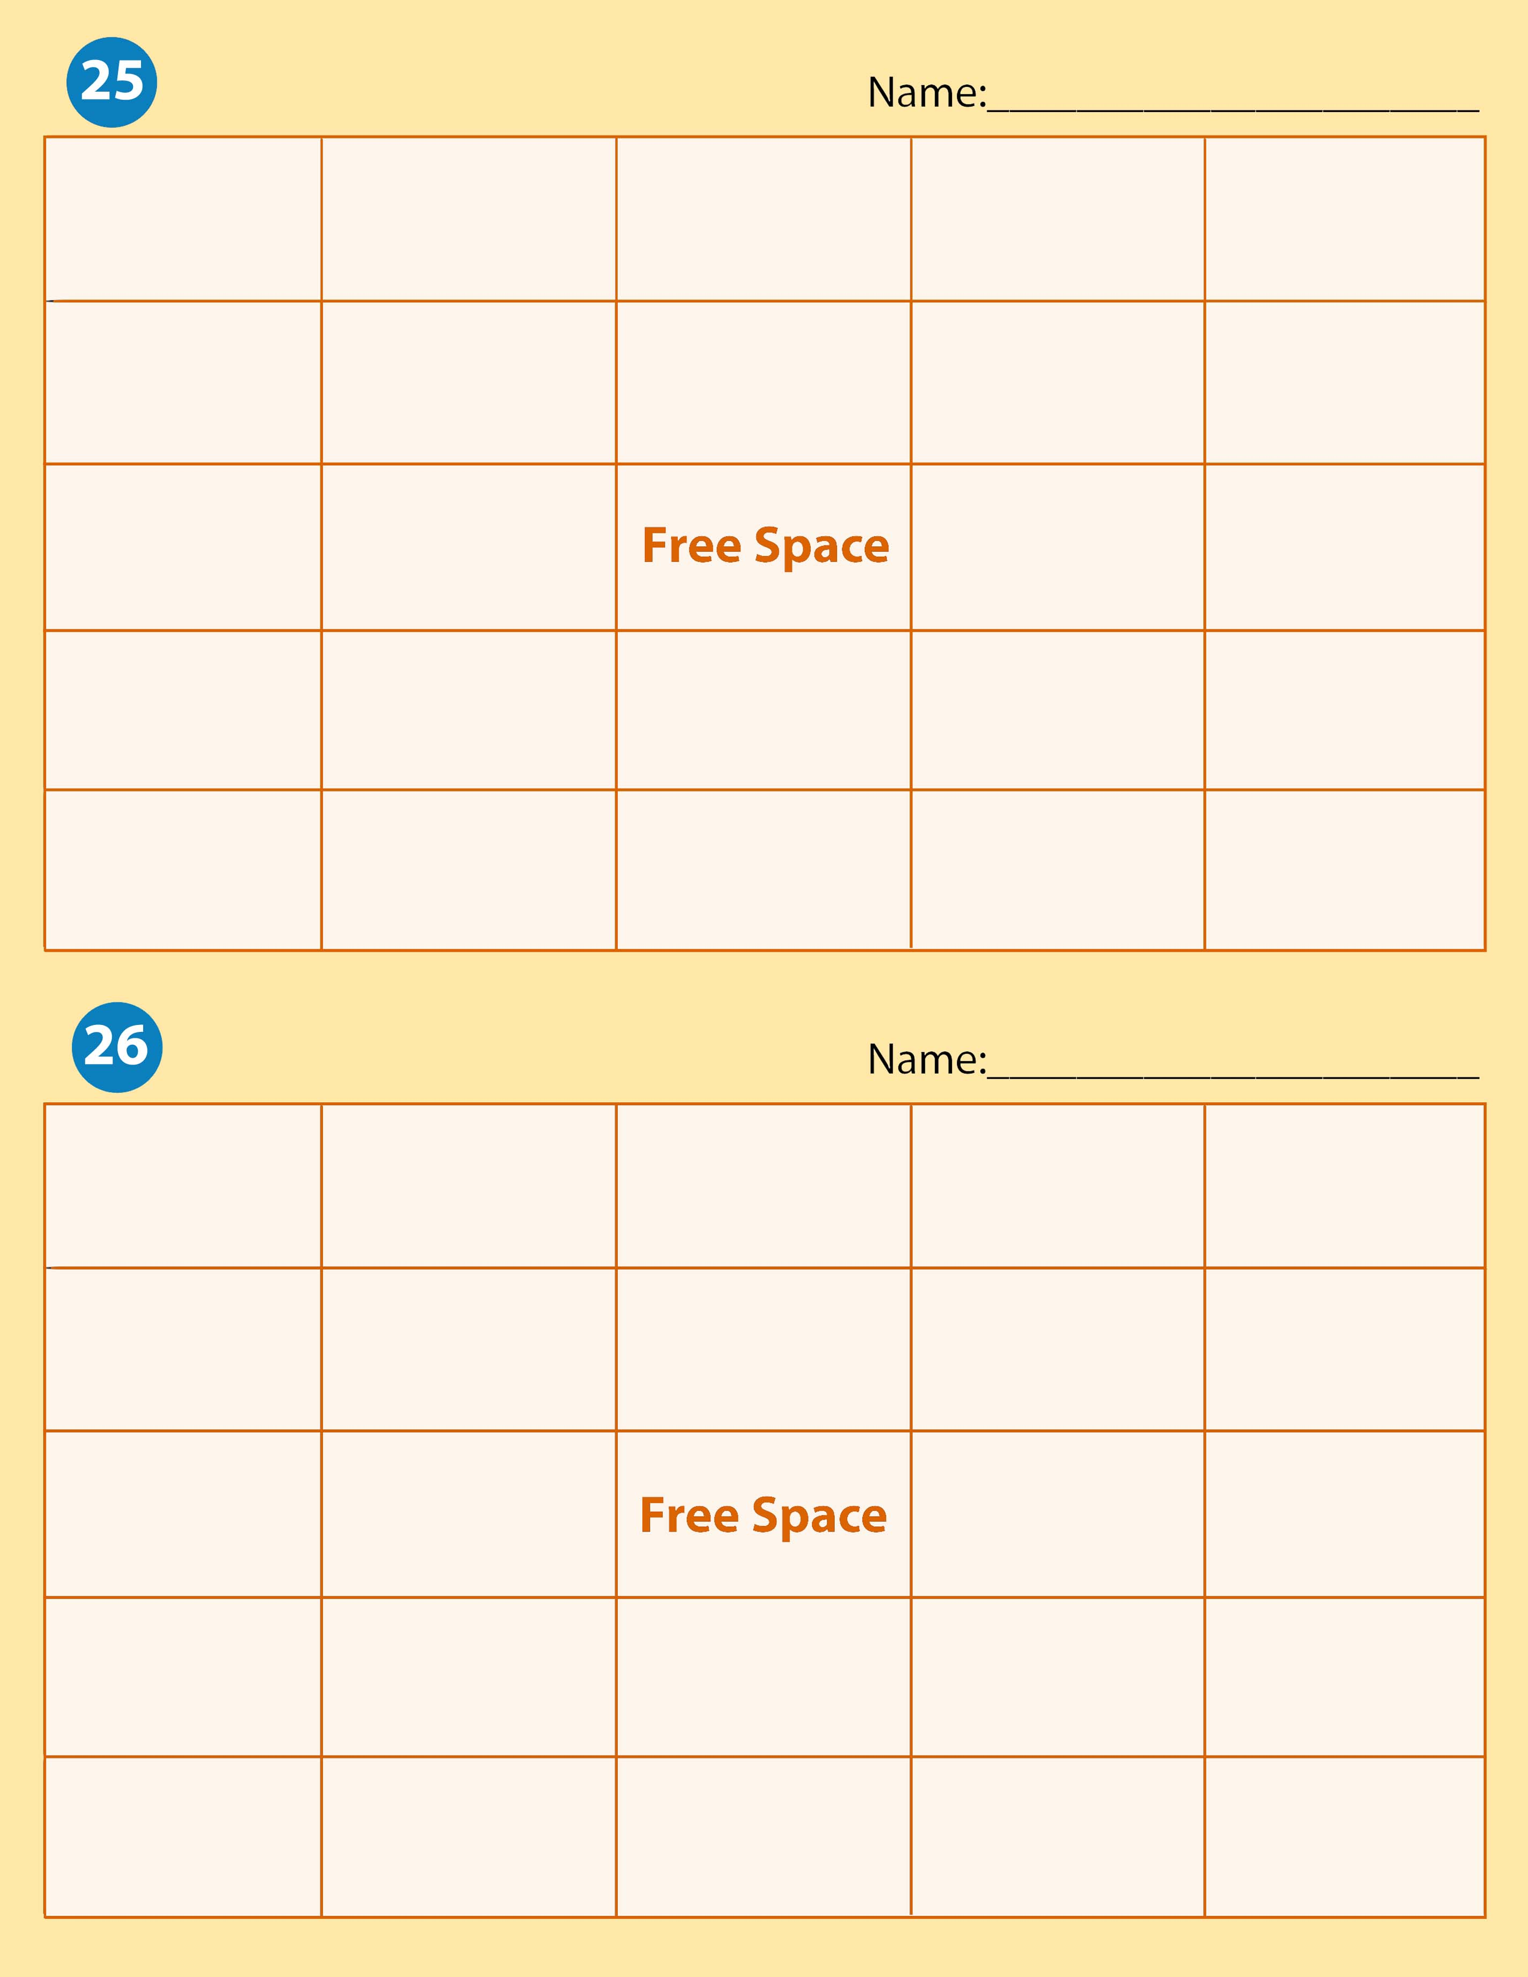
Reconciliation | Drawee | Subsidiary Ledger | Check | Schedule of Accounts
Deposit Slip | Cash Over | Change Fund | Expense | Internal Control
Withdrawals | Signature Card |  | Bank Statement | Depreciation
Fixed Assets | Drawer | Current Assets | Accounts Receivable | Cash
Cash Short | Endorsement | Account Balance | Petty Cash | Revenue

Current Assets | Fixed Assets | Cash | Internal Control | Petty Casdh
Change Fund | Signature Card | Deposit Slip | Endorsement | Check
Drawer | Drawee |  | Bank Statement | Reconciliation
Accounts Receivable | Subsidiary Ledger | Depreciation | Schedule of Accounts | Cash Short
Cash Over | Account Balance | Expense | Revenue | Wtihdrawals

