In-Basket Project
Community-Based Promotional/Informational Activity

Teacher Resources

Skill Level: Intermediate

Time Line: 12-15 hours over a nine-week grading period

Description: In this project the student will research a not-for-profit organization in order to create a promotional/informational medium for the benefit of the selected organization. The student will research the organization and the selected target markets. Activities may include interviews, surveys, letter writing, brochures, and presentations.

SCANS Proficiencies

Resources: Allocates Time
Meet deadlines
Ste appointments

Information: Acquires and Evaluates Information
Collect information on not-for-profit organization
Research markets and mediums
Interprets and Communicates Information
Prepare oral and written report
Uses Computers to Process Information
Key thank you letters
Prepare promotional materials
Design presentation materials/documents
Access Internet for research

Interpersonal: Participates as a Member of a Team
Contribute to group effort
Serves Clients/Customers
Prepare promotional/informational documents

Technology: Selects Technology
Choose appropriate software to prepare promotional material/information
Applies Technology to Task
Use word processing, desktop publishing, and presentation software effectively

Basic Skills

Reading: Read research information

Writing: Compose promotional/informational material
Compose thank you letters
Plan oral presentation

Listening: Interpret validity of information provided through interviews
Consider ideas of team members
Speaking: Present effective presentation

Thinking Skills

Creative Thinking: Use creative ideas to form promotional elements/ideas

Decision Making: Decide what promotional/information methods to use

Problem Solving: Identify and recognize needs of organization

Personal Qualities

Responsibility: Meet commitments

NBEA Standards

Marketing IV: The Marketing Mix

Analyze the elements of the marketing mix, their interrelationships, and how they are used in the marketing process.
D. Promotion
1. Sales Promotion
Level 4
- Plan a comprehensive sales promotion campaign for a business

Community- Based Promotional/Informational Activity
Teacher Instructions/Guidelines

Description/Jobs

In this activity, students will work in teams of three or four. Each team will have the responsibility to choose and research a not-for-profit organization in their community. From this research they will develop a promotional/informational medium to assist the organization in increasing community awareness of services.

Research: The student will research the target markets to help them decide what promotional elements will best inform the community on the organization=s benefits, services, and contributions.

Promotional/Informational Plan of Action: The student will decide what promotional tool will best grab the attention of the target market to increase community awareness. For example, a video, a brochure, pamphlet, flyer, or billboard may be used.

Development of Promotional/Informational Medium: From the plan, the team will develop a written and oral presentation of their marketing strategy.

Equipment/Software

Computer with word processing and/or desktop publishing software and Internet access

Supplies/Materials

Various reference materials
Samples of promotional mediums
Poster board
Markers
Rulers/stencils
Scissors
Plain paper
VCR camera and tape

Recommended Uses

This project can be used in Marketing I and II as a culminating simulation after the promotional/advertising unit.

This project can be used as a Tech Prep integration activity with the Marketing/Business and Computer Application courses.

Community- Based Promotional/Informational Activity
Example Output/Solutions

Because the layout and actual content of both the promotional medium and oral presentation will vary, no solution has been provided. A checklist for evaluating the oral presentation is attached.

Suggestion: By the end of Week 1, have the teams turn in the organization they have selected and also a projected timeline with due dates. Once you approve their organization selection and timetable, a deadline will be established. Each team might have a different timeline.
Community- Based Promotional/Informational Activity
Oral Presentation Evaluation

Name__________________________________________

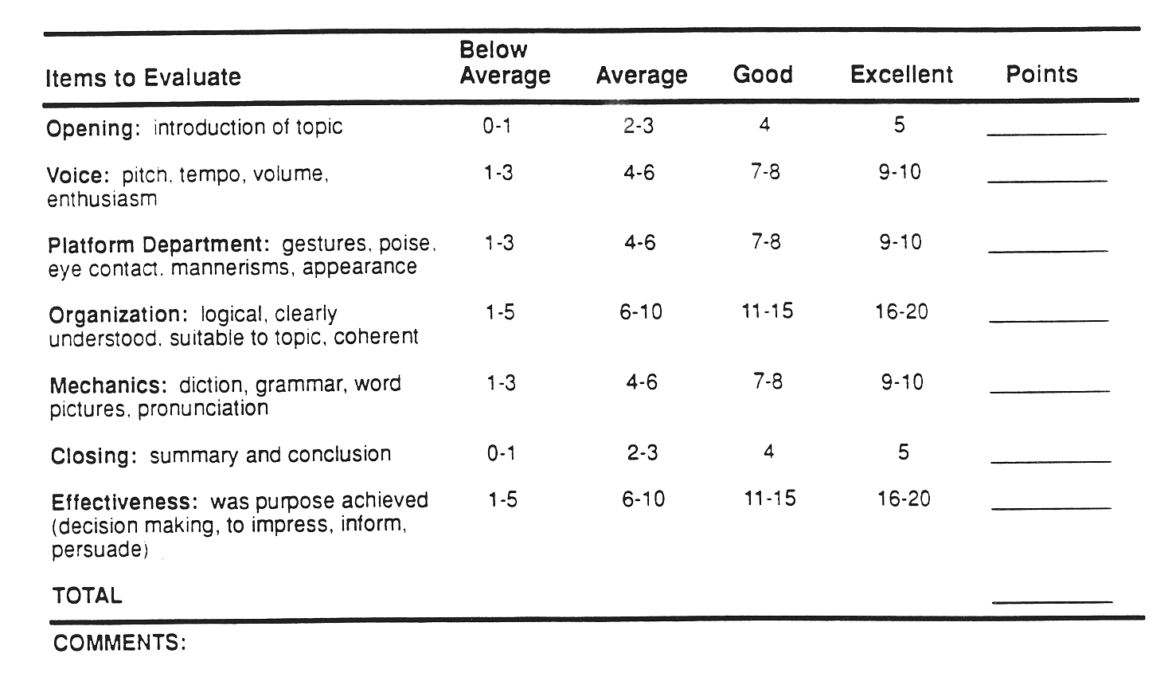
Community- Based Promotional/Informational Activity

As a team of three or four, you will research a not-for-profit organization in order to create a promotional/informational medium for the benefit of the selected organization. This will include research of the organization and the selected target markets. Research may include interviews, surveys, letter writing, brochures, and presentations. This activity will require 12-15 hours during this nine-week grading period.
Community- Based Promotional/Informational Activity
Oral Presentation Evaluation

Name__________________________________________

