T Shirt Organizer
Design a T-shirt that you might sell to your classmates. Draw a sketch of your T-shirt below.
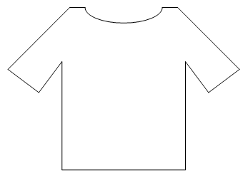
For each price listed below, record the number of your classmates who would be willing to pay that amount for your T-shirt.

$3 _________________
$5 _________________
$8 _________________
$10 _________________
$12 _________________
$15 _________________
$20 _________________

