In-Basket Project
Ethics in Today’s Business World

Teacher Resources

Skill Level: Advanced

Time Line: 8 hours

Description: The student is a business employee who has been invited to attend a seminar entitled, “Ethics in Today’s Business World.” The student will be expected to do the following:
- Evaluate ethical values on the job
- Assess his/her honesty
- Participate in ethical scenarios
- Compose a letter and format a questionnaire to business owners requesting information regarding ethical conduct questionnaire results
- Participate in a group discussion regarding the questionnaire results
- Develop ethical codes applicable to his/her Business Cooperative Experiences position

SCANS Proficiencies

Resources: Allocates Time
Complete project in allotted time

Information: Acquires and Evaluates Information
Compile business owners’ responses to questionnaire
Organizes and Maintains Information
Arrange questionnaire responses in a usable format
Interprets and Communicates Information
Discuss questionnaire responses
Create a personal code of ethics
Uses Computers to Process Information
Utilize word processing software to generate letter, questionnaire, and code of ethics

Interpersonal: Participates as a Member of a Team
Maintain working relationships with team members
Work with team members to arrive at solutions for ethical scenarios
Teaches Others
Explain importance of positive ethical standards
Exercises Leadership
Elect team leader
Resolve conflicts within the team
Negotiates to Arrive at a Decision
Gather data regarding ethical standards
Discriminate between best solutions for ethical scenarios
Works with Cultural Diversity
Interact with a variety of people

Basic Skills

Reading: Read/disseminate ethical scenarios, letters, and questionnaires

Writing: Compose letter to business owner
Take notes
Produce a personal code of ethics

Listening: Share ideas/solutions in a group situation

Speaking: Communicate/interact with team members
Ask questions

Thinking Skills

Creative Thinking: Compose effective letter/questionnaire/personal code of ethics

Decision Making: Determine a personal code of ethics
Evaluate/choose best solutions to ethical scenarios

Problem Solving: Select best solution to ethical scenarios
Devise/implement a personal code of ethics

Reasoning: Use logic to draw conclusions

Personal Qualities

Responsibility: Assume she of project responsibility

Self-Esteem: Maintain a positive attitude with team members

Social: Cooperate with others

Self-Management: Meet deadlines

NBEA Standards

Communication V: Organizational Communication

Incorporate appropriate leadership and supervision techniques, customer service strategies, and personal ethics standards to communicate effectively with various business constituencies.

E. Personal Ethics

Level 3

Discuss common types of unethical behavior in the workplace
- Define ethics and identify the process by which individuals develop the foundation for making ethical decisions

Employment Test

Teacher Instructions/Guidelines

Description/Jobs

The student is a business employee who has been invited to attend a seminar entitled, “Ethics in Today’s Business World.” The student will be expected to do the following:
- Evaluate ethical values on the job
- Assess his/her honesty
- Participate in ethical scenarios
- Compose a letter and format a questionnaire to business owners requesting information regarding ethical conduct questionnaire results
- Participate in a group discussion regarding the questionnaire results
- Develop ethical codes applicable to his/her Business Cooperative Experiences position

Note: There are no right or wrong answers in arriving at an ethical decision, but usually a prevailing opinion does exist. The teacher has the option to select which activities will be evaluated. For the purpose of evaluation, the teacher may want to establish a point system for assessment of the project. The example output/solutions are merely offered as suggestions.

Activity 1: The student will complete an on-the-job ethical values inventory and be prepared to defend his/her responses in a group discussion.

Activity 2: The student will complete an honesty assessment and rank his/her degree of honesty.

Activity 3: The student will participate as a team member and prepare an oral response to ethical scenarios.

Activity 4: The student will compose a cover letter and design a questionnaire to be mailed to a local business. The responses will be shared in a group discussion.

Activity 5: The student will create personal ethical statements for the values presented in Activity 1 that will apply to his/her Business Cooperative Experiences position.

Equipment/Software

A computer and word processing software are necessary to complete Activities 4 and 5.

Supplies/Materials

Supplementary materials regarding ethics can be found in your school or public library and on the Internet.

Recommended Uses

This ethics unit was designed especially for Business Cooperative Experiences; however, certain sections could be used in other career and technology education classes.
Ethics in Today’s Business World
Example Output/Solutions

Activity 1

Answers will vary

Activity 2

This honesty assessment may indicate future student behavior.

Point Values Honesty Level

0 points for A 28-30 points Marvelous

1 point for B 20-27 points Essentially honest but with signs of weakening

2 points for C 10-19 points Fairly dishonest but with some level of conscience

3 points for D 0-9 points Big trouble

*The U.S. average is 20-27 points.

Activity 3

Scenario #1 Truthfulness/loyalty/definition of professionalism

Discussion may evolve with all cases in the following manner: Loyalty is wonderful, but loyalty of today differs from blind loyalty of the past. Employees should not be expected to compromise their integrity.

Scenario #2 Protecting your superior/obedience to law/security tips/loyalty

Scenario #3 Safeguarding documents and information/loyalty/respect for others /fairness

Scenario #4 Judgment/responsibility/accountability

Scenario #5 Honesty/loyalty/information sharing versus gossip

Scenario #6 Trust/the importance of confidentiality

Scenario #7 Honesty/loyalty/judgment/responsibility/accountability/obedience to law

Scenario #8 Obedience to law/confidentiality/loyalty/fairness

Scenario #9 It’s not my job/judgment/responsibility/accountability/professionalism

Activity 4

Any acceptable format may be used for the letter and questionnaire. See the evaluation checklist for a list of items to evaluate.

Activity 5

Any acceptable format may be used to prepare the personal ethical statements. The student needs to apply his/her ethical statements to his/her Business Cooperative Experiences position.

Examples could be:

Honesty: I will not use company supplies for personal use.
Fairness: I will continue to do my job well even though an employee is hired in the same position at a higher rate.

Ethics in Today’s Business World
Evaluation Checklist

Name______________________________________________________________________
Date Started_______________________ Date Completed_____________________

Performance Indicators | Yes  ✓ | No  ✓ | Comments
Activity 1—Ethical Values on the Job
Rated each value
Defended responses in discussion with team members
Activity 2—Honesty Assessment
Completed assessment
Activity 3—Ethical Scenarios
Discussed scenarios with team members
Arrived at a reasonable solution to scenario
Activity 4a—Letter
Used an acceptable letter format
Created a letter free of typographical, grammatical, and punctuation errors.
Included all necessary information
- Purpose of the questionnaire
- Deadline for completing questionnaire
- Self-addressed stamped envelope enclosed
- Enclosure notation
Activity 4b—Questionnaire
Used an acceptable format for questionnaire
Created a questionnaire free of typographical, grammatical, and/or punctuation errors
Activity 5—Personal Ethical Statements
Developed personal ethical statements for the following values:
- Honesty
- Fairness
- Obedience
- Compassion
- Respect for others
- Loyalty
- Dependability
- Courage
- Helpfulness
- Self-control
- Truthfulness
Applied personal ethical statements to Business Cooperative Experiences position
Created personal ethical statements free of typographical, grammatical, and/or punctuation errors
Work Habits Observation
Completed project in acceptable amount of time
Remained on task
Worked independently

Ethics in Today’s Business World

The Indiana Chamber of Commerce will be hosting a seminar on “Ethics in Today’s Business World.” As a business employee, you have been invited to attend. As a participant, you will be involved in ethical decision-making activities. This eight-hour seminar will define “ethics,” evaluate your moral/ethical position, and incorporate ethics into your personal life. The attached flyer will provide you with information regarding the seminar.
Indiana Chamber of Commerce
Presents

“Ethics In Today’s Business World”

Seminar Leader: Jan Endicott, CPS September 7, 2xxx

Designed Especially For: Executive/Administrative Assistants and all Administrative Support Personnel

Today’s Professionals Are - Accountable

Gone. . . . . are the Assistants of Yesteryear. . . . when their positions were looked upon as “coffee and copier” jobs - and, one could use those scapegoat words, “My boss told me to do it!”

There is a new accountability for administrative support personnel today. The office assistants of the past have more professional responsibilities than ever before; and, with these increased responsibilities. . . .come greater ethical responsibilities.

Business executives are not only seeking assistants who are professional in attitude - behavior - and performance - but, who also understand they must be accountable for their own actions.

“Rights” As a Professional

A professional has the right to be treated with respect; to express his or her feelings; to be taken seriously—and listened to; to set his or her own priorities; and to say no without feeling guilty.

Ethics in Business

“Ethics” is defined as relating to what is right or wrong. It is also the way we identify good behavior. Consideration should be given to the needs of others and society as well as oneself.
Obey rules, laws, and cultural standards, or implement a process to have them changed. Ask yourself, “Is this the right thing to do? Is it fair? Is it honest? Is there a better way?” Don’t lose your objectivity! Be sure to put your biases aside and look at all aspects of the issue.

A few of the topics addressed in this Seminar:
- Ethical values of our society
- Ethical values on the job
- Honesty assessment
- The importance of confidentiality
- Definition of a “professional”
- Judgment/responsibility/accountability
- The syndrome - “It’s not my job”
- Protecting your superiors
- Proving yourself worthy of trust
- Safeguarding documents/information
- Obedience to the law
- The issue of loyalty
- Security tips
- Information sharing versus gossip

All participants will gain a new and progressive perspective on the career of the administrative support professional of the 21st century.
Activity 1: Ethical Values on the Job

Business ethics cannot be separated from ethics in general, and the individual must deal with problems on the job on the basis of fundamental ethical standards. The list below identifies several commonly accepted ethical values of our society. Indicate with a check mark what importance each value has in your job? Be prepared to defend your responses.

 | Very  Important | Somewhat  Important | Not  Important
Honesty
Fairness
Obedience
Compassion
Respect for others
Loyalty
Dependability
Courage
Helpfulness
Self-Control
Truthfulness

Activity 2: Honesty Assessment

How Honest Are You?

1. These days an increasing number of people believe that each person has the right to decide for himself what is right and wrong, as long as his behavior doesn’t harm anyone else, rather than abide by the traditional standards of society. How does this philosophy strike you?

[a] Totally agree [c] Disagree
[b] Agree [d] Totally disagree

2. As part of trying to move up the career ladder, you’re updating your resume. You’ve heard from various go-getters that the smart thing to do is “beef up” the record a bit - give yourself more educational background than you actually have and inflate your past salary and achievements somewhat. It won’t hurt anyone, but it will increase your chances of getting a better job and higher pay. Will you do so?

[a] Sure [c] Probably not
[b] Probably [d] No way

3. Arriving at a good hotel on a business trip, you find that your room is not yet made up. You admire the bath mat, which is luxurious and just the color you’ve been looking for in vain. It occurs to you that if you put it in your suitcase, the chambermaid, when she makes up the room, would think that the previous tenants of the room took it and bring you another; you’d be able to take one home, and no one would be the wiser. Would you actually do so?

[a] Of course [c] I doubt it
[b] I might [d] Certainly not

4. At work, you requisition an expensive new software program from Supply; you sign for one set, but through some error two are delivered to your desk. You put the extra one in a drawer; after a month, it’s clear no one knows you have it. You’ve wanted to buy that very program for your home computer; if you took the extra set home, no one would ever know, and the big firm you work for would never feel the loss. Would you do so?

[a] Sure [c] Probably not
[b] Probably [d] No way

5. A kitchen fire does $5,000 worth of damage in your house. You’re insured, but according to the terms of your policy, you must pay the first $500. The adjuster is a sly fellow who hints that if you made it worth his while, he’d report that you suffered $6,000 worth of damage, with the result that even if you gave him a couple hundred, you’d still get away scot-free. Would you follow up on the hint and make a deal with him?

[a] Of course
[b] Most likely, but with qualms
[c] Most likely not, though tempted
[d] Absolutely not

Activity 2: Honesty Assessment continued

6. Your daughter, a college student, is worried about her upcoming final exam in biology, with which she is having a hard time; if she doesn’t maintain a B+ average, she’ll lose her scholarship. She tells you that someone is selling stolen copies of the exam for $20 each; she’s thinking of buying one. What is your reaction?

[a] All for it
[b] In favor, but with qualms
[c] Against it, though conflicted
[d] Totally opposed to the idea

7. At a big house wares store, you pick out a dozen items. In the checkout line, the clerk at the register overlooks a $55 coffee machine that you didn’t remove from the shopping cart onto the counter. If you say nothing, she probably won’t notice it as you leave; even if she does, you can say you hadn’t realized she’d missed it. Would you keep quiet about it?

[a] Of course [c] Probably not
[b] Probably [d] Certainly not

8. You’ll soon be moving across the country. A knowledgeable but somewhat shady acquaintance says that if you leave without paying your rent, telephone, fuel oil, or lighting bills, none of the companies involved will spend money to try to collect from you in court at long distance. Take his advice, he says, and you can save quite a bundle. Would you?

[a] Yes
[b] Probably, but with qualms
[c] Probably not though tempted
[d] Absolutely not

9. After office hours, you sometimes do consulting work to earn extra money. One customer runs up a sizable bill, and then says, “Will you take less if I pay cash? You wouldn’t have to report it on your income tax, so you’d save a good bit.” You mentally calculate: even if you cut his bill by $200, not reporting the cash transaction would bring you out several hundred dollars ahead. Would you do so?

[a] Yes [c] Probably not
[b] Probably [d] Absolutely not

10. You own an old farmhouse in an area where farming has been dying out. You haven’t been able either to sell it or rent it for years and are losing thousands on the mortgage payments each year. You keep hoping that lightning or vandals will burn it down, so you can collect the insurance and tear up the mortgage. But neither lightning nor vandals gives you the needed relief - and you find yourself thinking that perhaps you can do so yourself. If you felt that you could burn down the house without being caught or suspected, would you do so?

[a] Yes
[b] Probably, but with qualms
[c] Probably not, though tempted
[d] Absolutely not
Activity 3 “What Would You Do?”

Using problem-solving skills and working as a team, develop responses that will be discussed orally.

Ethics Scenario No. 1

You are an assistant to Mr. Jones, Sales Manager, of a large manufacturing firm.

During the five years since Mr. Jones joined the company, his career has been spectacular; and he has increased sales by 35%.

His job dictates that he is out of the city about half the time; and, because of his extended hours, he has not hesitated to take an occasional day off after a strenuous trip.

During the past two months, however, his unaccounted-for-absences have reached alarming proportions. He did not come to the office at all during the previous week, although he was not on official vacation. He telephoned from home every day and dictated letters and telegrams.

On Monday, Mr. Jones called and asked you to tell the President of the company that he was in San Francisco working on the Johnson order.

When the President telephones, what should you do?

What should you do about the entire situation?

Ethics Scenario No. 2

At United States Congressional hearings on the Iran-Contra affair, Ms. Fawn Hall, former Secretary to Lt. Colonel Oliver North, testified that, at his request, she shredded a foot and a half of documents and altered five other sensitive documents in National Security Council files.

On her own, she added phone logs and interoffice memos to the shredding and, on the day her boss was fired, smuggled other papers out of the White House in Washington DC by hiding them in her clothing.

Hall said, in her testimony, she was a dedicated and loyal secretary and that her policy was “not to ask questions and just to follow orders.”

If you had been in Hall’s or a similar position, what would YOU have done? Why?

Ethics Scenario No. 3

You are an administrative assistant to Mr. Anderson, President of a medium-sized company.

Mr. Anderson has told you recently that he has just separated from his wife. (His wife is not involved in the firm).

This is all he has told you, however, about their current arrangements.

One day, when your boss is out of town (unreachable by telephone), his wife comes in, enters her husband’s office, shuts the door, and begins rummaging through his “personal” file drawer (she apparently knows where these particular files are).

You become aware of this, because you go into his office to find something yourself. You offer to assist her; and she refuses your assistance, says she can handle it, and asks to be left alone.

What, if anything, should you do?

Ethics Scenario No. 4

You are legal secretary to an attorney who is often involved in controversial cases.

The attorney asks you to work with her on a case involving an abortion (the attorney is defending the woman’s right to have an abortion).

You do not personally believe in the right of abortion. As a result, you do not wish to work on this particular case with your boss. Do you have the right to refuse?

If you refuse, how would you do so?

(Please discuss the ramifications of any action on your part).

Ethics Scenario No. 5

You are Executive Assistant to Ms. Newberry, the Sales Manager.

Ms. Newberry is ready to hire a new Sales Representative by the name of Mr. Dickson. All interviews, reference checks, etc., have been completed.

Several years ago, you dated Mr. Dickson.

Due to this relationship, you are aware of some most unethical “dealings” in Mr. Dickson’s professional past that obviously did not surface in the interviewing procedures.

You do not personally believe it would be in the best interests of your boss or the company if Mr. Dickson were hired.

What, if anything, should you do?

Ethics Scenario No. 6

You are Administrative Assistant to Ms. Clements, President of a small construction firm.

By virtue of your position, you know that negotiations to sell the company to a large corporation are under way.

While Ms. Clements has not specifically told you that the information is to be considered top secret until the arrangements are completed, you have been with her long enough to know that she is trusting you to keep everything you hear under wraps.

The problem is that one of your personal friends at the company—someone whose job you know may be endangered if the sale goes through—is about to buy a new house.

You are certain that, if your friend had any idea about the uncertainty of her future, she wouldn’t even be contemplating the purchase of this larger, more expensive home.

If you tipped her off, you would be saving your friend considerable anxiety later on.

What, if anything, would you do?

Ethics Scenario No. 7

You are Executive Assistant to Mr. Wilson, President of the Wilson Construction Company.

You have been Mr. Wilson’s assistant for over five years, you have a high regard and respect for each other, and you enjoy a professional working relationship.

Mr. Wilson told you (in confidence) about six months ago that he was planning to divorce his wife within the next year. He asked that you not discuss this with anyone else; and you assured him you would not do so.

Since that time, however, you have assisted him (via your daily duties) in the transferring and changing of titles, etc., of several of his assets. All of these activities appear to be “legal” to you. However, you have suddenly realized (in your estimation) that Mr. Wilson is in the process of “burying his assets”—preparing himself for the divorce.

What, if anything, should you do?

Ethics Scenario No. 8

You have been an Administrative Assistant to Mr. Anderson, Vice President of your large manufacturing firm, for over 10 years. You enjoy your job; and, to your knowledge, Mr. Anderson has performed his job expertly over those years and enjoys a high respect from his peers and co-workers.

One day, Mr. Anderson calls you into his office and shows you a special file (sealed envelope) in his personal file desk drawer.

He tells you that if he should ever die while he is still with the firm (he is in his sixties), he would like you to go into this file drawer, pull out this particular file package, take it home, and burn it.

How would you respond to Mr. Anderson’s request?

What would you do about the entire situation?

Ethics Scenario No. 9

You are Executive Secretary to Mr. Hobson, Vice President of the Human Resources Department of a large organization.

Mr. Hobson has recently expressed his concern to you, confidentially, that he believes a few of the other secretaries in the department are “abusing” some privileges, e.g., taking longer lunch hours than others, arriving at the office in the morning later than others, and leaving the office at night earlier.

You have personally noticed these transgressions on the part of your co-workers also.

Mr. Hobson asks you to keep a “close watch” on the activities of these employees in the next few weeks and report to him if you see that his suspicions are correct.

You interpret this as being asked to “spy” on your co-workers.

How would you respond to Mr. Hobson’s request? What should you do?
Activity 4: “Ethical Considerations on the Job?”

Upon your return from the seminar, compose a letter to the owner of a local business requesting him/her to complete a questionnaire dealing with ethics. Be sure to include all necessary information such as the purpose of the questionnaire, deadline for completing the questionnaire, etc. Include a self-addressed stamped envelope in with the letter. Also, set up the questionnaire in an attractive format. Discuss the responses to the questionnaire with the other seminar participants.
Activity 4 continued

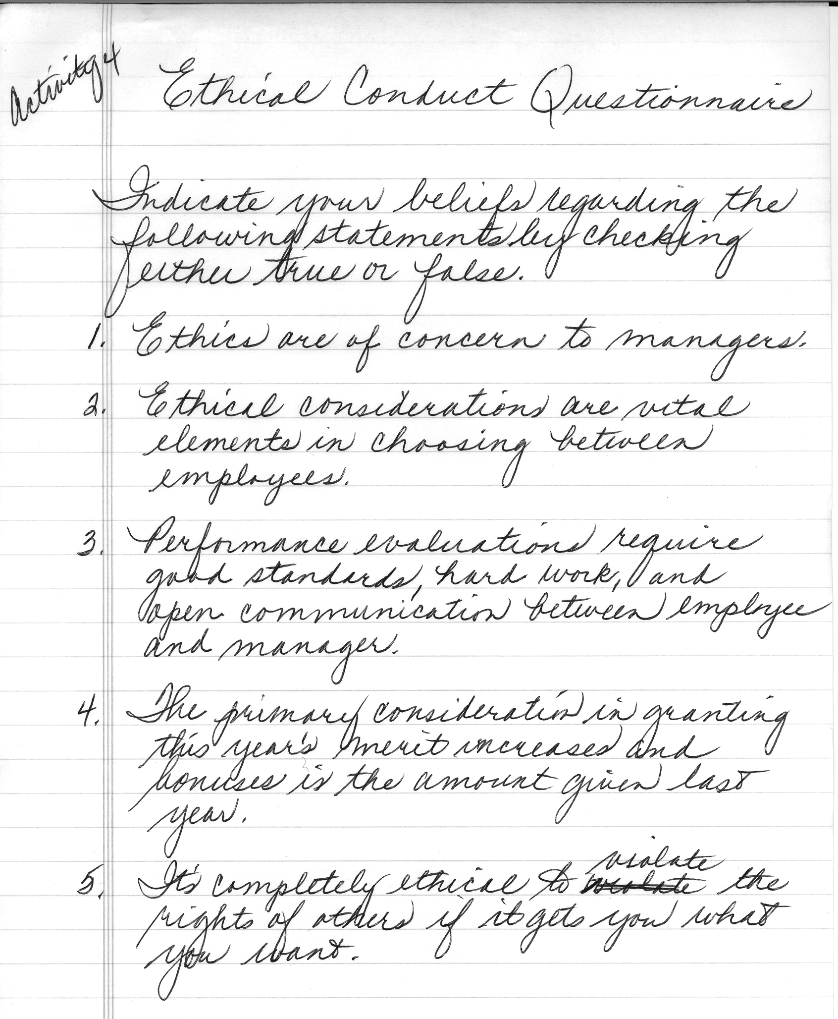
Job 4 continued

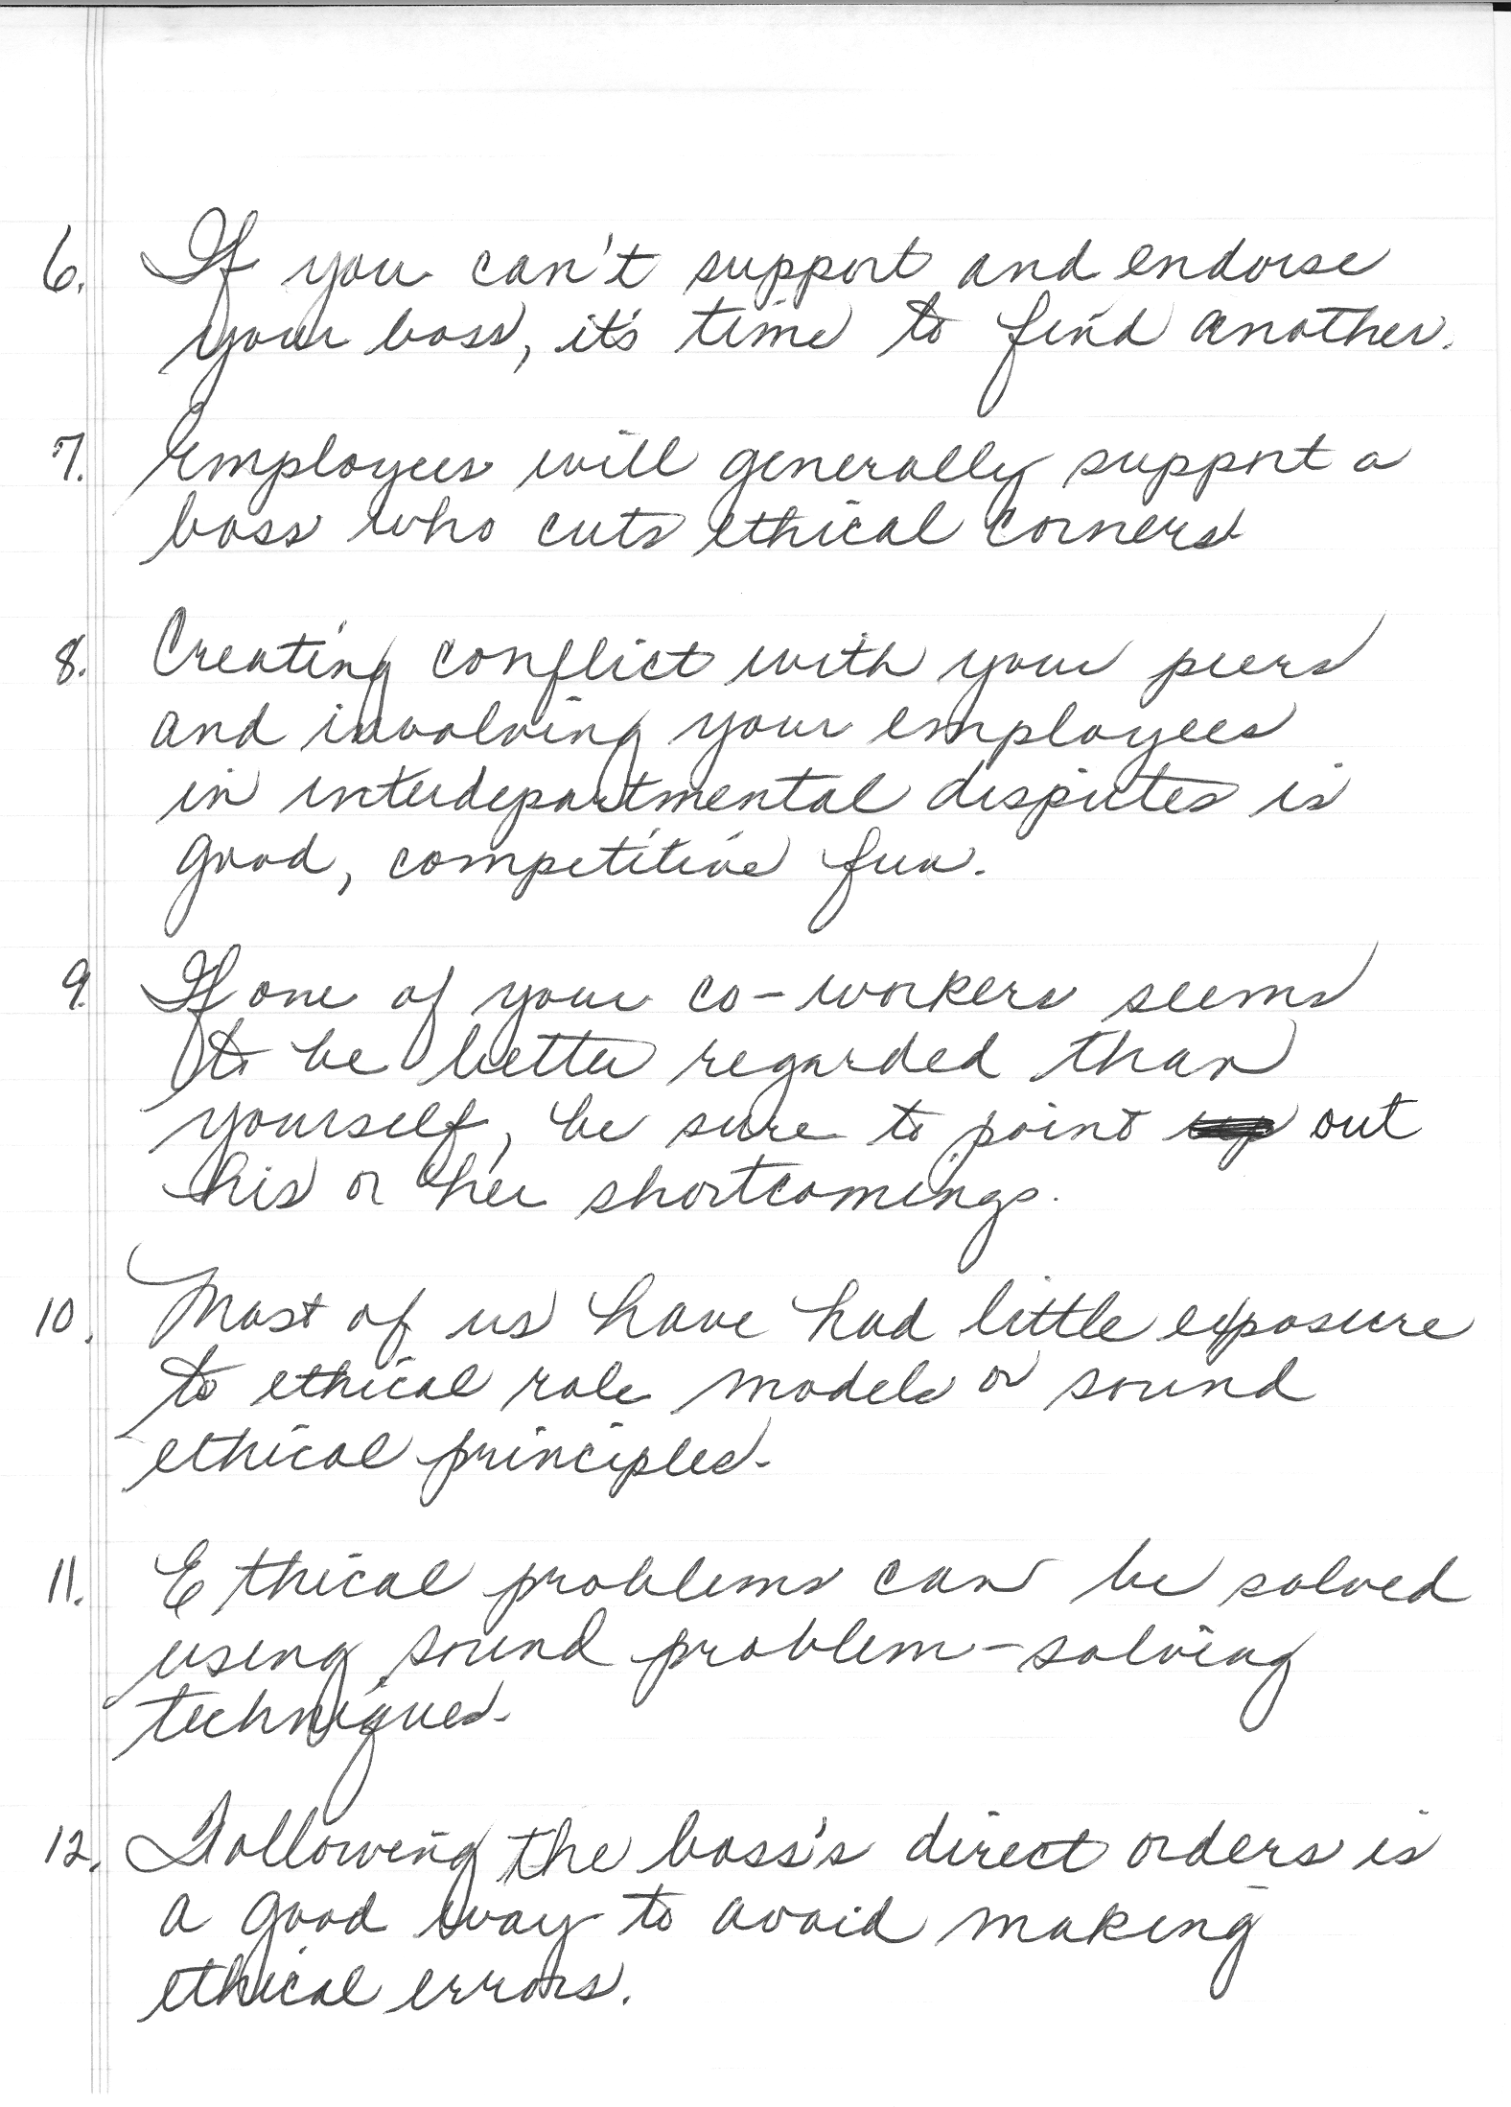
Job 4 continued

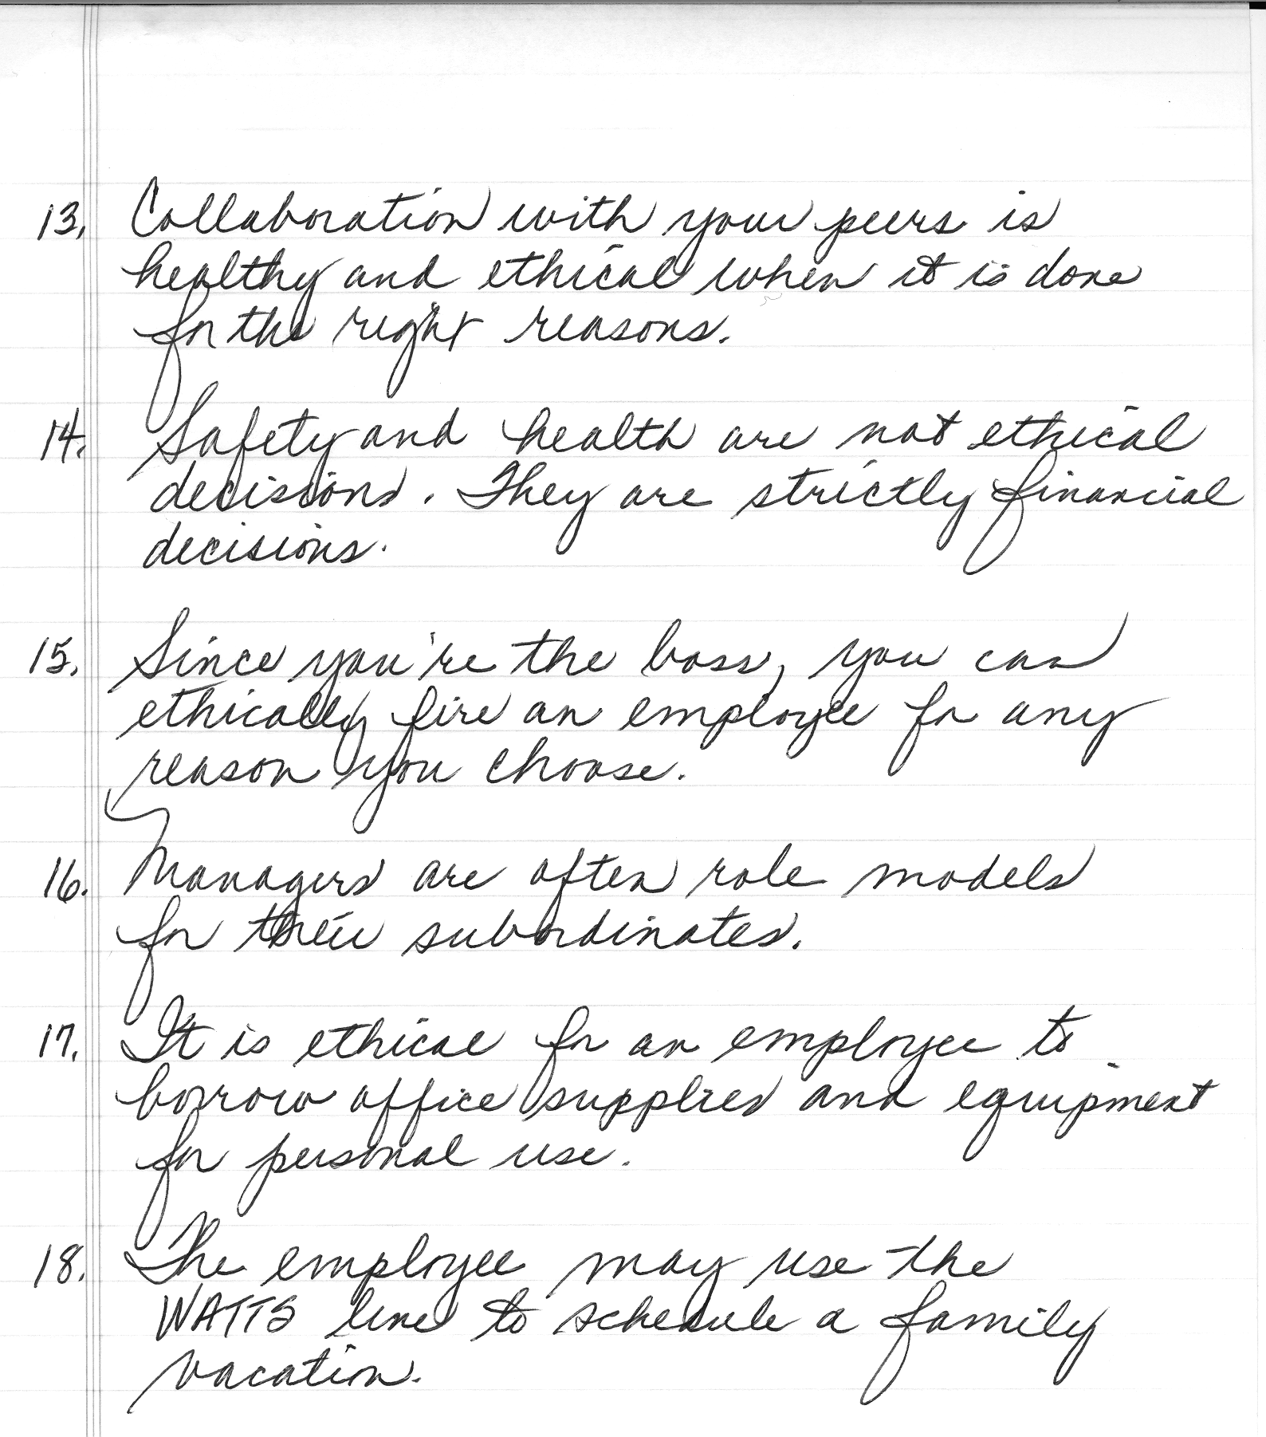
Activity 5: “Can You Apply Ethics Now?”

Using all the information gathered at the seminar, prepare your personal ethical statements for the values presented in Activity 1 that will apply to your Business Cooperative Experiences position. Below are two examples:

Honesty: I will not use company supplies for personal use.
Fairness: I will continue to do my job well even though an employee is hired in the same position at a higher rate.

Format your personal ethical statements in a format that can be used throughout the year. (Note: additional ethical statements could be added to this list during the year.)
Ethics in Today’s Business World
Evaluation Checklist

Name______________________________________________________________________
Date Started_______________________ Date Completed_____________________

Performance Indicators | Yes  ✓ | No  ✓ | Comments
Activity 1—Ethical Values on the Job
Rated each value
Defended responses in discussion with team members
Activity 2—Honesty Assessment
Completed assessment
Activity 3—Ethical Scenarios
Discussed scenarios with team members
Arrived at a reasonable solution to scenario
Activity 4a—Letter
Used an acceptable letter format
Created a letter free of typographical, grammatical, and punctuation errors.
Included all necessary information
- Purpose of the questionnaire
- Deadline for completing questionnaire
- Self-addressed stamped envelope enclosed
- Enclosure notation
Activity 4b—Questionnaire
Used an acceptable format for questionnaire
Created a questionnaire free of typographical, grammatical, and/or punctuation errors
Activity 5—Personal Ethical Statements
Developed personal ethical statements for the following values:
- Honesty
- Fairness
- Obedience
- Compassion
- Respect for others
- Loyalty
- Dependability
- Courage
- Helpfulness
- Self-control
- Truthfulness
Applied personal ethical statements to Business Cooperative Experiences position
Created personal ethical statements free of typographical, grammatical, and/or punctuation errors
Work Habits Observation
Completed project in acceptable amount of time
Remained on task
Worked independently

