Create your Own Algorithm!

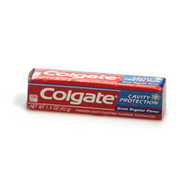
Now it's your turn. Your goal is to write an algorithm for an average task. Speed doesn't count - what counts are accurate instructions for each step, and consider that there may be many possible exceptions, rules, and tests.
Some examples of everyday situations: brushing your teeth (starting from when you are standing in front of the sink), opening your locker and switching books, driving a car, and more!
Save this algorithm for the discussion, it will be used there!
Here's a short sample of an algorithm for brushing your teeth:
- Assume the person is standing within reach of the brush and paste, awake, and ready to brush.
1. Elevate hand, and lower it onto the paste.
2. With other hand, rotate cap on paste until it is removed from the tube.
3. Drop cap from cap hand and lower hand on top of the brush.
4. Grasp the brush, with bristles pointed up.
5. Elevate paste-holding hand to the point where the tube opening is immediately over the brush bristles.

Part 1b
Change the verbs and the nouns in your directions. Then exchange them with fellow students to see if they can figure out what your algorithm is accomplishing.

Example from steps 1 & 2 above:
1. Dinkle stimp, and flurp it onto the fing.
2. With other stimp, cim jum on fing until it is tuynm from the dorn.

Part 2
Your challenge now that we are done?
- List three problems that can't be resolved by algorithms.
- After reviewing the many problem solving techniques, discuss which ones you think are fastest and which ones are slowest. Explain your selection.

