Beginning Activities

Major Programming Topics

- Form of a program
- Constructors
- Basic Actions

Activity 1: Today’s Class Is Brought To You By The Letter “J”
Elmo starts at (0,0) with a pouch full of flowers (how many will he need?) on an empty island. Write a program to have Elmo plant flowers to form the letter "J" as shown in figure 1.

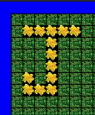

Figure 1 – The Island After Elmo Plants The Letter “J”

Activity 2: Plant Your Initials
Write a program that directs a Jeroo to plant flowers in the shape of your initials. The Jeroo can start anywhere on an empty island, but must start with enough flowers to complete the task. A typical solution is shown in figure 2. Be sure to use your initials instead of those shown in the figure.

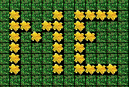

Figure 2 – The Island After Planting The Initials “ME”

Activity 3: Beautifying Lake Island
Susan starts on Lake Island at location (6.8) facing SOUTH with 4 flowers in her pouch. Her task is to plant the flowers to make the island look like the one shown in figure 3.

Island File LakeIsland.jev

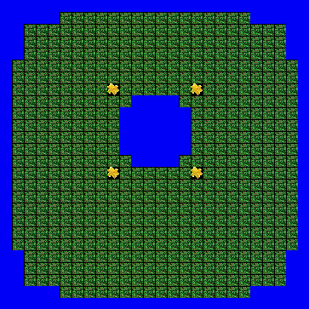

Figure 3 – Lake Island After Susan Plants The Flowers

Activity 4: Look Homeward Angel
Angel is ready to leave school (location (0,0)) and head for home. Shortly before the last bell, the students were cautioned about the possibility that a North-to-South line of nets had been placed on the island. Write a program to get Angel from the East door of the school into his house of nets in the Northeast portion of the island. Since Angel has no flowers at school, he must pick up a flower on the way home, toss it into a net to get through the barrier, then go into the house.

Island File Angel.jev.

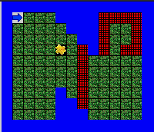

Figure 4 – Suggested Island for Activity 4

Activity 5: The Relay
Three Jeroos (you give them names) are practicing for the Santong Relays. Figure 5 shows the course at the start of the race. The first Jeroo begins at (4,9) facing EAST. It must pick the flower and give it to the second Jeroo who begins at (7,13) facing NORTH. The second gives the flower to the third Jeroo who begins at (4,15) facing WEST. The third Jeroo must plant the flower at (3,16), run to (3,21) and stop.

Island File RelayCourse.jev

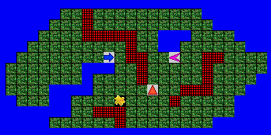

Figure 5 – The Relay Course

Activity 6: Scavenger Hunt
Two Jeroos start at opposite ends of Long Island, one at (3,5) facing EAST, and one at (5,18) facing WEST. Each Jeroo is supposed to pick two flowers. The first one can be from anywhere along the edge of the island, and the second must be the one in the center. The first one to pick the center flower is declared the winner. There are a few rules to this scavenger hunt.
- The Jeroos can only turn LEFT
- The Jeroos must take turns, each doing only thing in each turn: hop(), turn(LEFT), or pick().
- A Jeroo can only hop forward one space in its turn.
Figure 6 shows Long Island at the start of the scavenger hunt.

Island File ScavengerHunt.jev

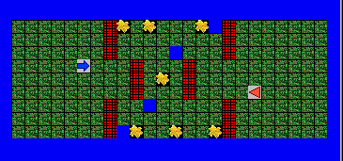

Figure 6 – Long Island at the Beginning of the Scavenger Hunt
Activity 7: Imagination Island
Design an original island with an original problem to solve. Write a description of your problem. Create an initial island and provide a solution to your problem.

Suggestion Randomly distribute the problems to other students to solve.

Activity 8: Artistic Landscaping
Start with one or more Jeroos on an empty island. Each Jeroo begins with several flowers in its pouch (you decide how many). Have the Jeroos plant the flowers to form an interesting pattern.

Suggestion: Post the resulting designs for all to see. You might even want to have a design contest with various categories such as “most interesting”, “most complex”, or “most artistic”.

